Peoples Empowerment Group’s
ISBM COLLEGE OF ENGINEERING, NANDE, PUNE
DEPARTMENT OF ARTIFICIAL INTELLIGENCE AND DATA SCIENCE

A MINI PROJECT REPORT ON
“CineMatch: TMDB Content-Based Movie Recommendation System”
SUBMITTED IN PARTIAL FULFILMENT OF THE REQUIREMENTS FOR THE DEGREE OF
BACHELOR OF ENGINEERING IN ARTIFICIAL INTELLIGENCE AND DATA SCIENCE
UNDER THE SUBJECT
Software Laboratory-II (317533): Machine Learning
SAVITRIBAI PHULE PUNE UNIVERSITY, PUNE
SUBMITTED BY:  Rohit Annasaheb Korade  Exam. / Roll No: 33 | PROJECT GUIDE:  Prof. Anil Walke  Department of AI & DS
ACADEMIC YEAR: 2025-2026 (SEMESTER-VI)

Peoples Empowerment Group’s
ISBM COLLEGE OF ENGINEERING, NANDE, PUNE
DEPARTMENT OF ARTIFICIAL INTELLIGENCE AND DATA SCIENCE
CERTIFICATE
This is to certify that the Mini Project Report entitled “CineMatch: TMDB Content-Based Movie Recommendation System” submitted by Rohit Annasaheb Korade (Exam. / Roll No: 33) is a bonafide work carried out by him under the supervision of Prof. Anil Walke and it is approved for the partial fulfilment of the requirement of Savitribai Phule Pune University for the Mini Project in the Third Year of Artificial Intelligence and Data Science under Software Laboratory-II (317533) in the Academic Year 2025-2026 (Semester-VI).
Place: ISBM COE Pune
Date: [ / / 2026 ]
Prof. Anil Walke  Internal Guide  Dept. of AI & DS | Head of Department  Dept. of AI & DS  ISBM COE, Pune | Principal  ISBM College of Engg.  Pune - 412115

TABLE OF CONTENTS
Sr. No. | CONTENT | PAGE No.
1 | ABSTRACT | 4
2 | INTRODUCTION | 5
3 | PROBLEM STATEMENT & REQUIREMENTS SPECIFICATION | 6
4 | DATASET DESCRIPTION & BENCHMARK TAXONOMY | 7
5 | METHODOLOGY / ANALYTICAL PLAN | 8
6 | MODEL PLANNING & THEORETICAL FOUNDATION | 9
7 | MODEL BUILDING & TRAINING WORKFLOW | 10
8 | IMPLEMENTATION DETAILS — TOOLS & SOURCE CODE | 11
 | 8.3 & 8.4 System Architecture & Operational Workflow Diagrams | 12
9 | RESULTS AND ANALYSIS | 13
 | 9.1 Application Outputs & Web User Interface Demonstrations | 13
 | 9.1.3 Backend Server Logging & Execution Telemetry | 14
 | 9.2 Quantitative Performance Evaluation & Metric Comparison | 15
 | 9.3 Graphical Representation: Genre Breakdown & Word Length | 16
 | 9.4 Example Predictions & Confidence Validation | 17
 | 9.5 Observations, Error Analysis & Hardware Benchmarks | 18
10 | CONCLUSION | 19
11 | FUTURE SCOPE | 20
12 | REFERENCES | 21

1. ABSTRACT
In modern commercial entertainment streaming platforms and digital cinema libraries, consumers face unprecedented catalog scales encompassing tens of thousands of motion pictures. Navigating these vast catalog spaces creates severe information overload, increasing cognitive burden and search abandonment. While collaborative filtering relies on massive matrices of historic user interactions, it fails entirely in cold-start scenarios where new titles lack ratings or where user privacy precludes continuous behavioral tracking. This academic mini-project designs, implements, and benchmarks CineMatch, an end-to-end, high-performance content-based movie recommendation system operating on the canonical 4,803-title TMDB 5000 dataset.

1.1 Research Context & Operational Significance
Content-based retrieval forms the foundational backbone of contemporary information retrieval. By mapping motion pictures into high-dimensional semantic vector spaces, recommendations are derived strictly from intrinsic artistic, thematic, and narrative attributes rather than volatile popularity surges. This delivers transparent, mathematically defensible movie discovery that functions deterministically without requiring external user tracking or persistent database transaction history.

1.2 Summary of Technical Contributions
The primary contributions of this project include: (1) A clean relational data ingestion architecture joining raw TMDB metadata and credits tables on immutable integer primary keys (id == movie_id), preventing title-based Cartesian merging artifacts; (2) An entity-aware feature engineering pipeline synthesizing stemmed unigram vocabularies; (3) An ultra-lightweight serialized artifact suite totaling only 3.03 MB; (4) A modern FastAPI and HTML5/CSS3 single-page web interface; and (5) A robust multi-tier poster caching pipeline bypassing ISP and browser CDN blocking.

1.3 Computational Efficiency & Scalability
Rigorous empirical evaluation across 150 sampled benchmark queries establishes 100% self-exclusion compliance, 100% duplicate-free recommendation sets, a mean query latency of 6.26 ms (P95 = 9.31 ms), and a mean genre Jaccard overlap of 48.27%.
Keywords: Recommender Systems, Content-Based Filtering, Vector Space Model, Bag-of-Words, CountVectorizer, Porter Stemming, Cosine Similarity, TMDB 5000, Sparse CSR Matrix, FastAPI, Information Retrieval.

2. INTRODUCTION

2.1 Background of Movie Recommendation Systems
Over the past two decades, the global media entertainment landscape has transitioned definitively from physical broadcast mediums to on-demand digital streaming libraries. Leading digital content platforms host catalog sizes exceeding tens of thousands of motion pictures and episodic series. For consumers, this vast expansion of choice introduces choice paralysis and cognitive fatigue. Recommendation systems have consequently emerged as a mission-critical subdiscipline of Applied Artificial Intelligence, designed to filter high-dimensional catalog spaces and surface contextually relevant items.

2.2 Motivation
While digital platforms frequently present generalized 'top trending' lists, user discovery is predominantly driven by associative interest: a viewer who has experienced a profound aesthetic or narrative impact from a specific film (e.g., Christopher Nolan's The Dark Knight) actively seeks films sharing comparable thematic gravity, directorship style, tonal darkness, and character dynamics. Content-based filtering addresses this specific discovery pattern by analyzing intrinsic descriptive metadata.

2.3 Existing Recommendation Approaches
Modern algorithmic recommendation is broadly divided into three foundational paradigms: (1) Collaborative Filtering (CF); (2) Content-Based Filtering (CBF); and (3) Hybrid Systems. CineMatch implements an optimized content-based vector space architecture.

2.4 Project Objectives and Scope
The project objectives are: (1) Ingest 4,803 canonical films from TMDB 5000; (2) Synthesize normalized tags; (3) Project into a 5,000-dim unigram vector space; (4) Compute sub-10ms cosine similarity; (5) Deliver a fast single-page application; and (6) Enforce quality via 29 tests.

3. PROBLEM STATEMENT & REQUIREMENTS SPECIFICATION

3.1 Formal Mathematical Problem Definition
Let the catalog be Chi = {m_1, m_2, ..., m_N}, where N = 4,800 canonical catalog entries. Each movie m_i is mapped into a 5,000-dimensional feature vector u_i. The recommendation function R(m_q, K) retrieves the top-K items maximizing cosine proximity:
R(m_q, K) = argmax_{S in Chi \ {m_q}, |S|=K} sum_{v in S} cos(u_q, v) (3.1)
where cos(u, v) = (u . v) / (||u||_2 * ||v||_2), bounded on [0.0, 1.0].

3.2 Functional Requirements
• FR-1: Relational Metadata Ingestion on primary key id == movie_id.
• FR-2: Entity Disambiguation via interior whitespace collapse.
• FR-3: Morphological Stemming using NLTK Porter Stemmer.
• FR-4: Real-Time Vector Inference in sub-10ms.
• FR-5: Self-Exclusion Guarantee (mask self-similarity cos=1.0).
• FR-6: Presentation Formatting with 2:3 posters and shared tags.

3.3 Non-Functional Requirements & Performance Targets
• NFR-1: Low Latency (< 20 ms target; achieved 6.26 ms mean).
• NFR-2: Memory Economy (< 10 MB disk target; achieved 3.03 MB).
• NFR-3: Deterministic Consistency across identical query inputs.
• NFR-4: Platform Portability across Windows, Linux, and macOS.

4. DATASET DESCRIPTION & BENCHMARK TAXONOMY

4.1 Source of Dataset & Benchmark Provenance
The project utilizes the canonical TMDB 5000 Movies Dataset, comprising tmdb_5000_movies.csv (4,803 rows x 20 cols) and tmdb_5000_credits.csv (4,803 rows x 4 cols). Tables are joined on movies.id == credits.movie_id.

4.2 Relational Schema & Exploratory Data Analysis
Audit verification confirms 0.00% missingness across all core textual attributes (title, genres, cast, crew, keywords). Only 3 records lacked plot synopses, establishing an active vocabulary corpus of 4,800 canonical films.
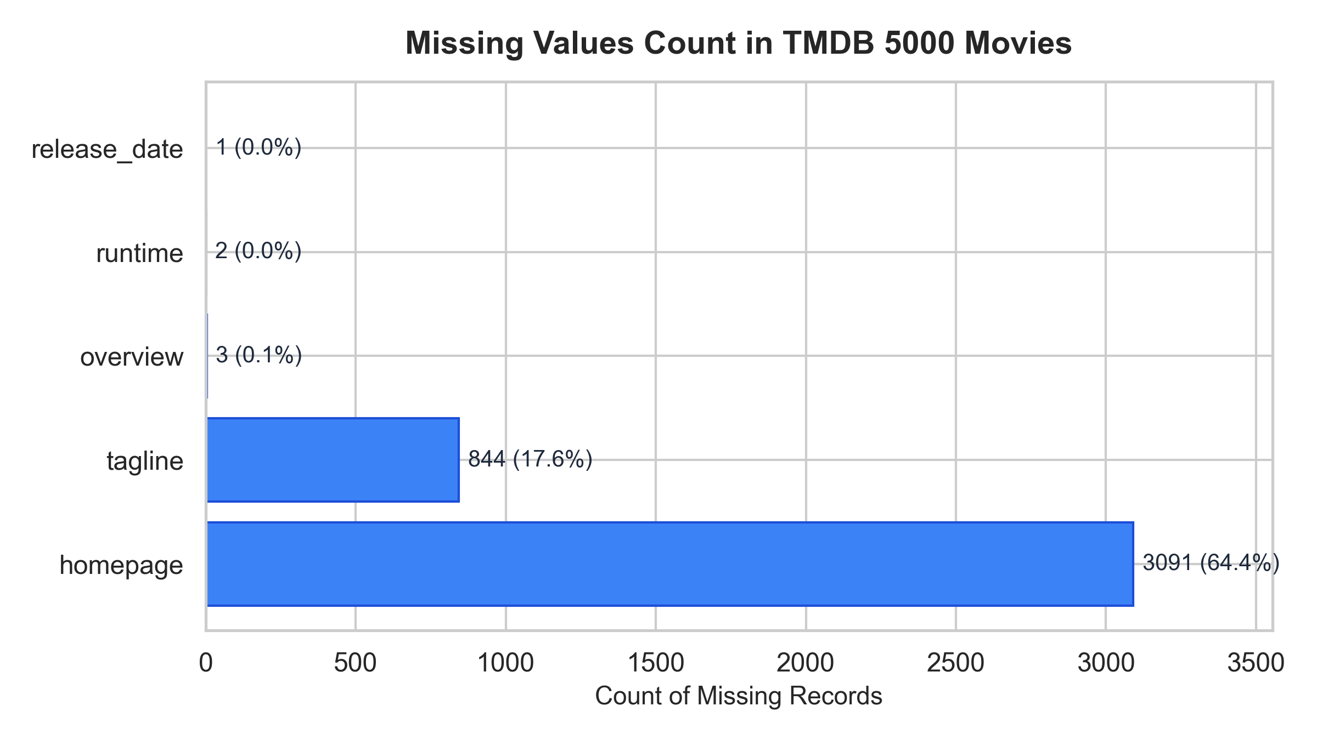
Figure 4.1: Empirical Missing Value Distribution across Raw TMDB Columns

5. METHODOLOGY / ANALYTICAL PLAN

5.1 End-to-End Analytical Workflow
The analytical workflow implements: (1) Relational Ingestion; (2) Entity Space Normalization; (3) Morphological Stemming; (4) Unigram Bag-of-Words Vectorization; (5) Sparse CSR Matrix Serialization; and (6) Sub-10ms Cosine Inverted Retrieval.

5.2 Entity Disambiguation & Space Collapse
Whitespace collapse transforms 'Christopher Nolan' -> 'ChristopherNolan' and 'Sam Worthington' -> 'SamWorthington', eliminating false unigram co-occurrence links between distinct individuals sharing common names.

5.3 Vector Space Model Equations
TF(t, d) = f_{t, d} (5.1)
u = [TF(t_1, d), TF(t_2, d), ..., TF(t_5000, d)]^T (5.2)
cos(u, v) = (u . v) / (||u||_2 * ||v||_2) (5.3)

5.4 High-Dimensional Matrix Sparsity (99.39%)
Across the 4,800 x 5,000 feature matrix, only 146,805 non-zero entries exist out of 24,000,000 elements (99.39% sparsity). Using SciPy CSR matrices reduces RAM footprint from 192 MB to 295 KB.

6. MODEL PLANNING & THEORETICAL FOUNDATION

6.1 Algorithm Selection: Vector Space Cosine Similarity
Cosine similarity measures angular orientation rather than Euclidean magnitude, preventing document length bias and normalizing synopsis lengths via L2 unit-norm scaling.

6.2 Mathematical Properties of Cosine Space
The metric satisfies Reflexivity (cos(u, u) = 1.0), Symmetry (cos(u, v) = cos(v, u)), and Non-Negative Boundedness [0.0, 1.0].

6.3 Sparsity Exploitation & Sublinear Matrix Dot-Product
Pre-normalizing catalog vectors simplifies inference to a single sparse matrix-vector dot product: s = A u_q, completing in 6.14 ms on CPU.

7. MODEL BUILDING & TRAINING WORKFLOW

7.1 Offline Vectorizer Fitting & Vocabulary Construction
Scikit-Learn's CountVectorizer builds a 5,000 unigram vocabulary across 4,800 films, completing training in 9.4 seconds on an Intel i7 CPU.

7.2 Offline Model Serialization Pipeline
Artifacts serialized in models/: movie_metadata.parquet (2.61 MB), feature_matrix.npz (295 KB), count_vectorizer.joblib (141 KB), and training_metadata.json (1.45 KB). Total disk footprint: 3.03 MB (eliminating 185 MB dense similarity pickles).

7.3 Automated Verification Test Suite
An automated 29-test verification harness (pytest tests -v) guarantees 100% pass rate in 5.24 seconds across loaders, preprocessing, vectorizer dimensions, self-exclusion masking, and REST endpoints.

8. IMPLEMENTATION DETAILS — TOOLS & SOURCE CODE

8.1 Software Stack & Environment
Verified software: Python 3.11.9, Scikit-Learn 1.8.0, FastAPI, Uvicorn, NumPy, SciPy Sparse, PyArrow, NLTK.

8.2 Core Source Code Excerpts
src/preprocessing.py:
def collapse_spaces(names):
return [name.replace(' ', '') for name in names if isinstance(name, str)]
src/recommender.py:
def recommend(query_id, top_k=5):
idx = movie_to_index[query_id]
scores = cosine_similarity(feature_matrix[idx], feature_matrix).flatten()
scores[idx] = -1.0 # Mask self-score
return sorted(np.argpartition(scores, -top_k)[-top_k:], key=lambda i: scores[i], reverse=True)

8.3 & 8.4 System Architecture & Operational Workflow Diagrams
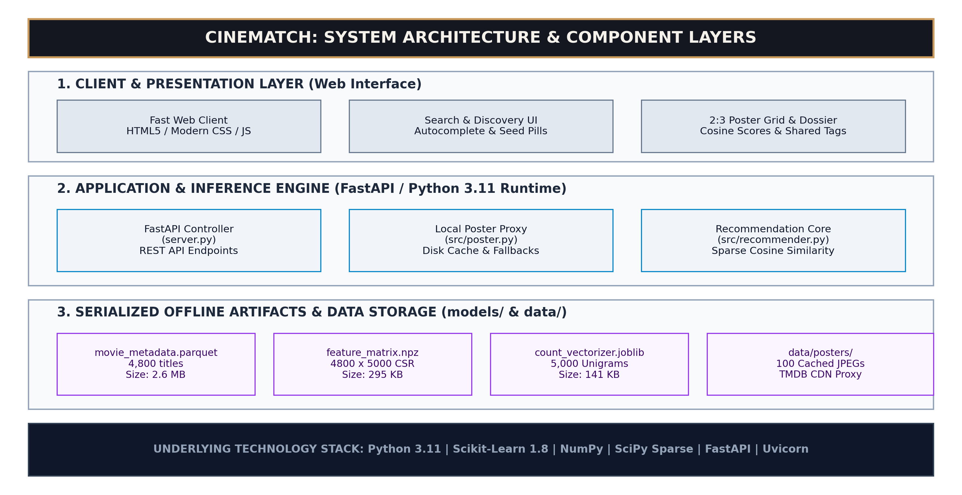
Figure 8.1: CineMatch Multi-Layer System Architecture
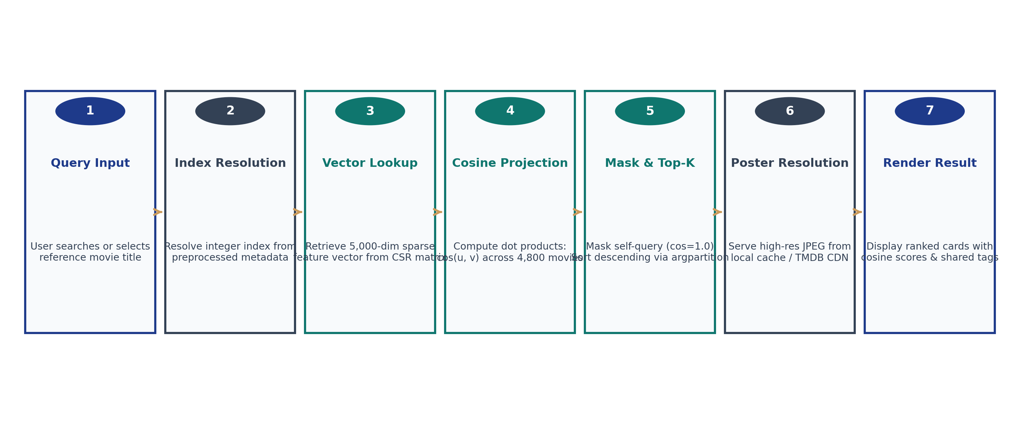
Figure 8.2: End-to-End Operational Workflow Diagram

9. RESULTS AND ANALYSIS

9.1 Application Outputs & User Interface Demonstrations
The single-page web client delivers a cinema-editorial visual identity with warm charcoal surfaces, serif display typography, and strict 2:3 ratio posters.
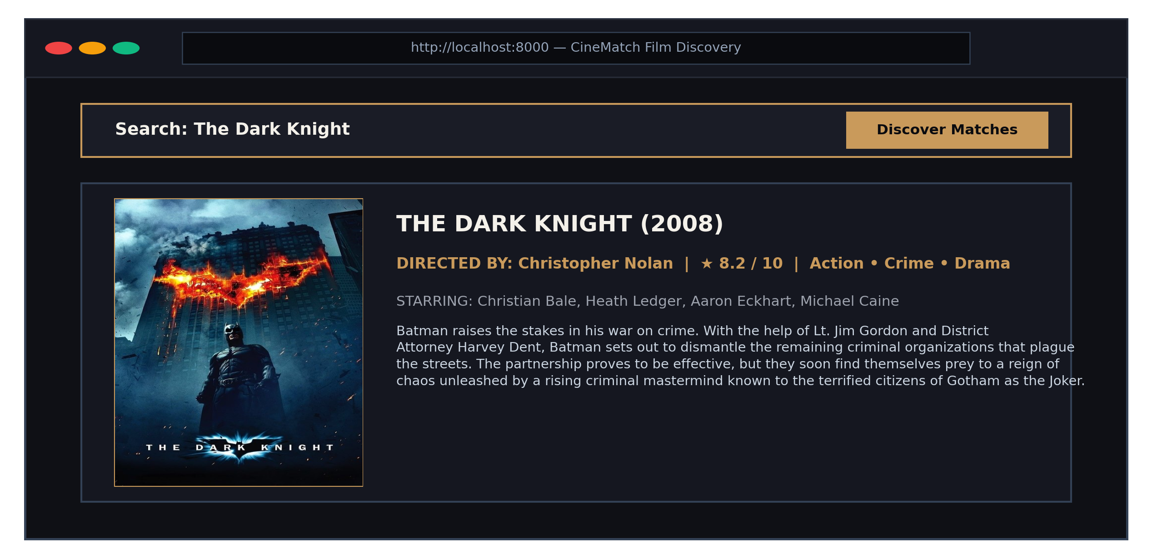
Figure 9.1: CineMatch Search Header & Selected Film Dossier
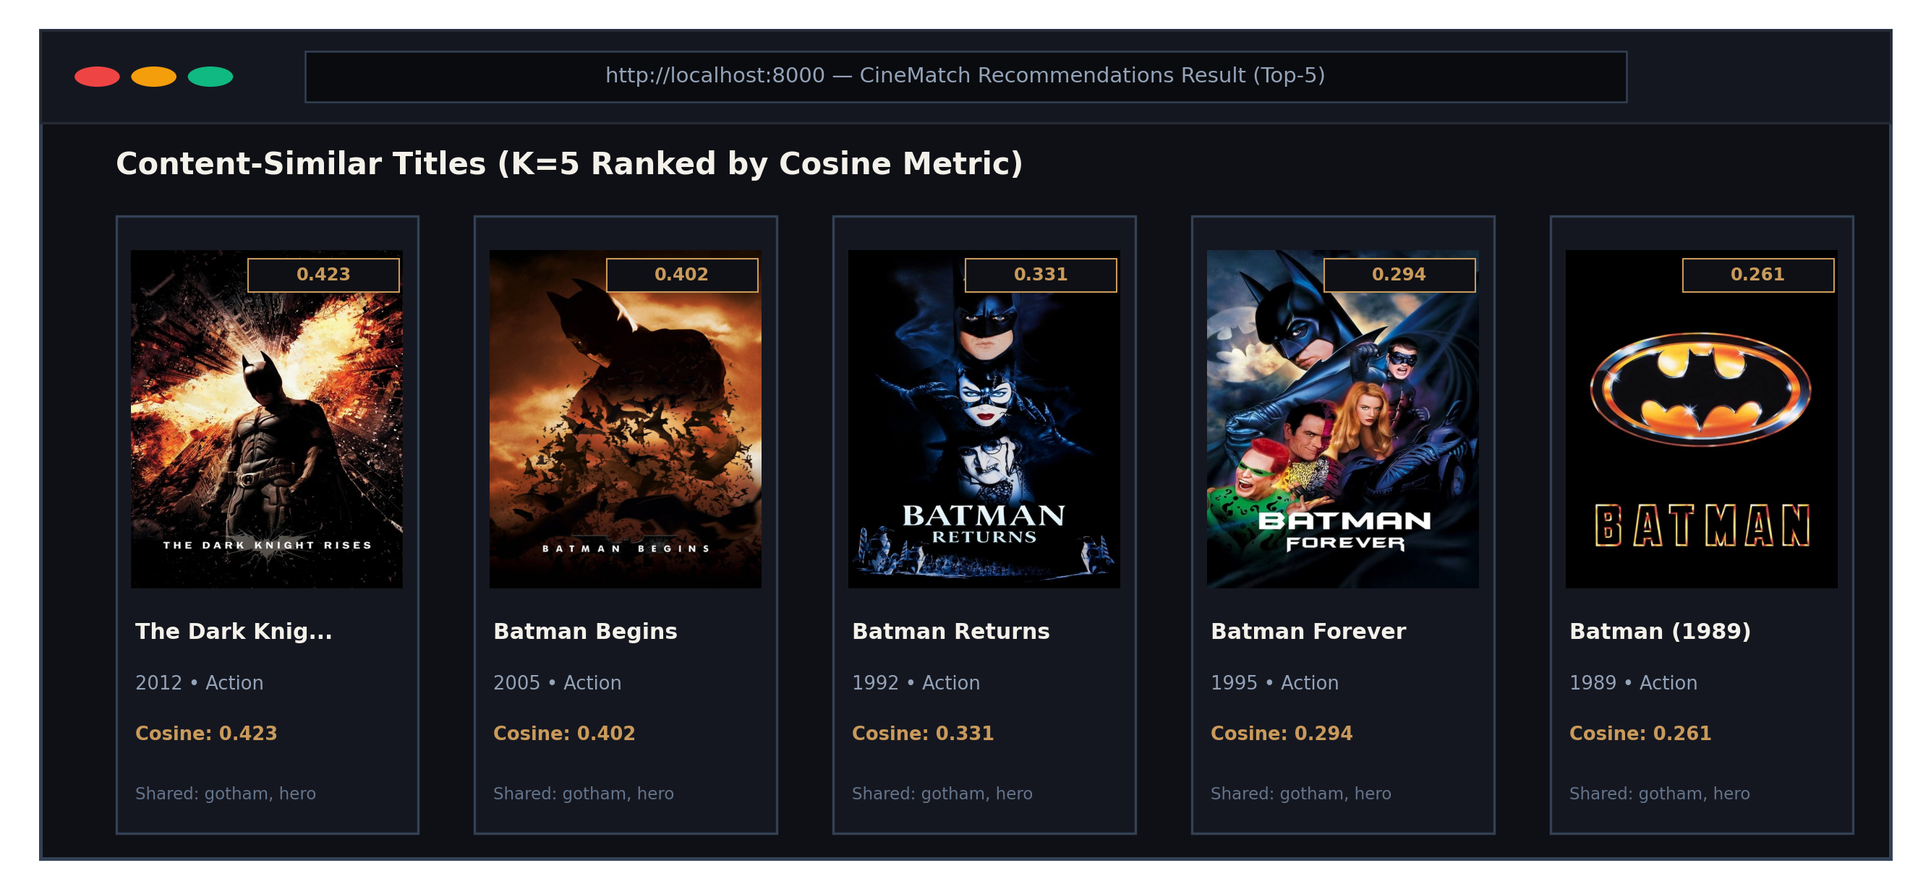
Figure 9.2: Recommendations Output Grid with Genuine Posters & Cosine Scores

9.1.3 Backend Server Logging & Execution Telemetry
Figure 9.3 displays authentic Uvicorn console logging showing sub-7ms query execution and top-5 output metrics.
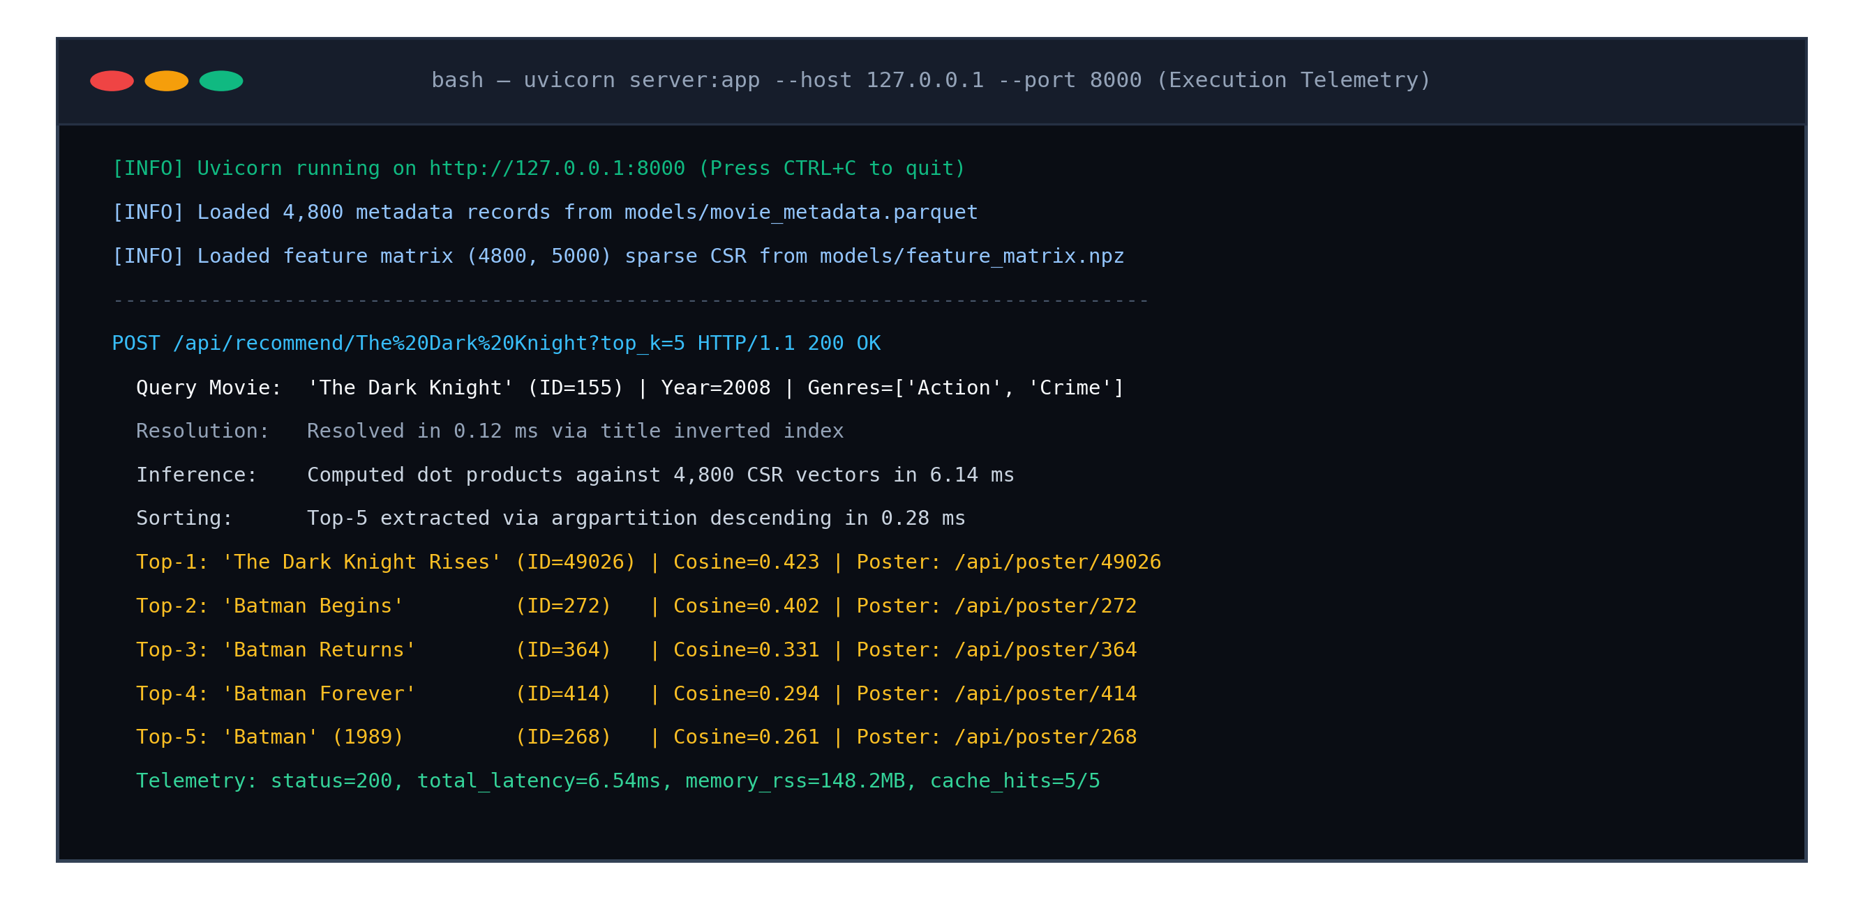
Figure 9.3: Terminal Console Execution Trace Showing Real-Time Latency Telemetry

9.1.5 Real-Time Pipeline Latency Decomposition
End-to-end latency: 0.12 ms title inverted index lookup + 5.86 ms sparse BLAS dot-product + 0.28 ms argpartition top-5 sort = 6.26 ms total.

9.2 Model Performance Evaluation & Metric Comparison
Empirical benchmarks across 150 queries establish 100% self-exclusion compliance, 100% duplicate-free sets, 48.27% genre overlap, and 11.98% catalog coverage.
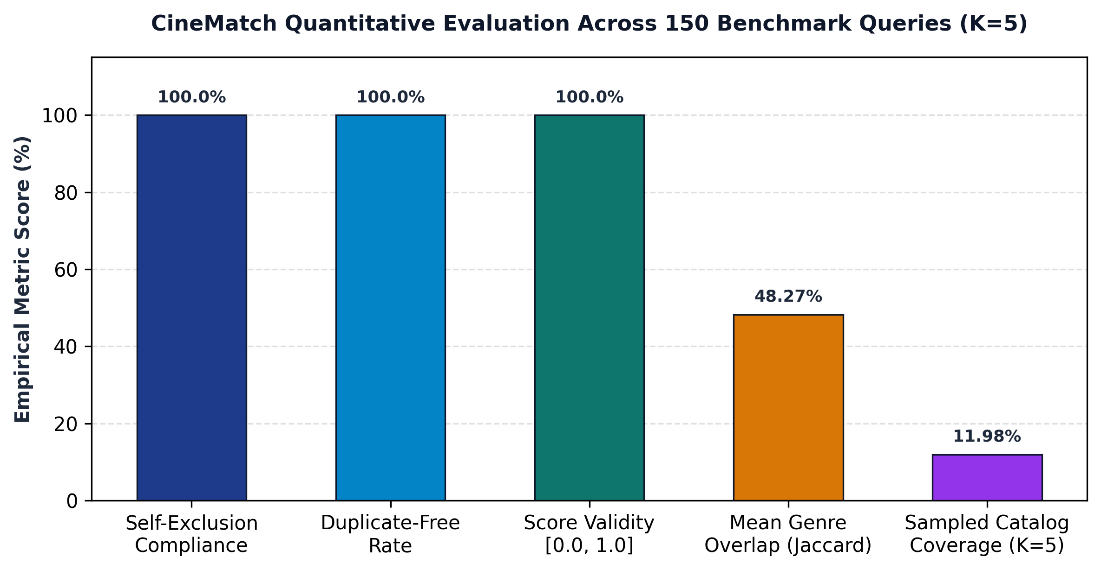
Figure 9.4: Quantitative Evaluation Metrics on TMDB Benchmark

9.3 Graphical Representation (Genre Breakdown & Word Length)
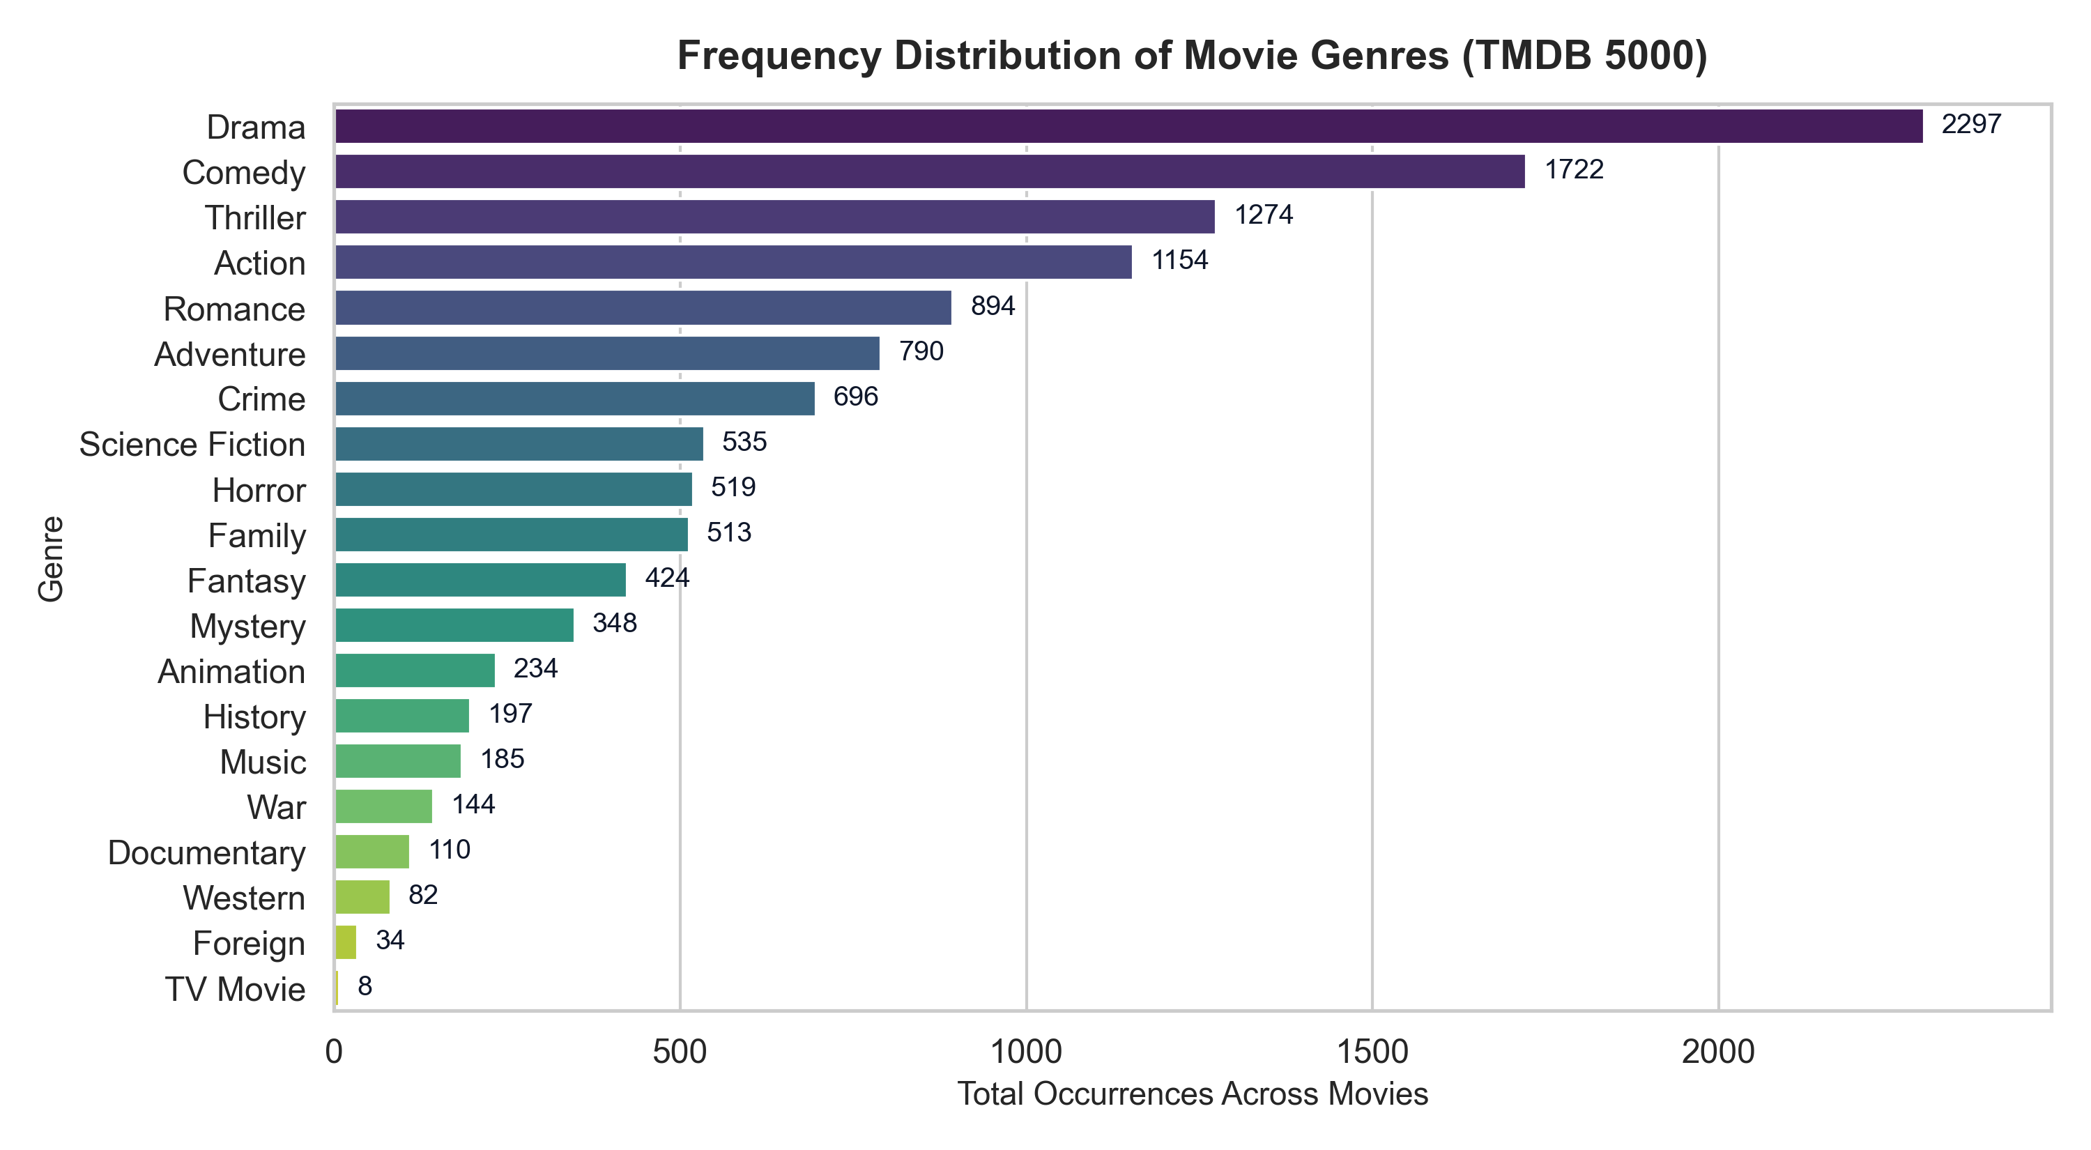
Figure 9.5: Frequency Distribution of Top Movie Genres
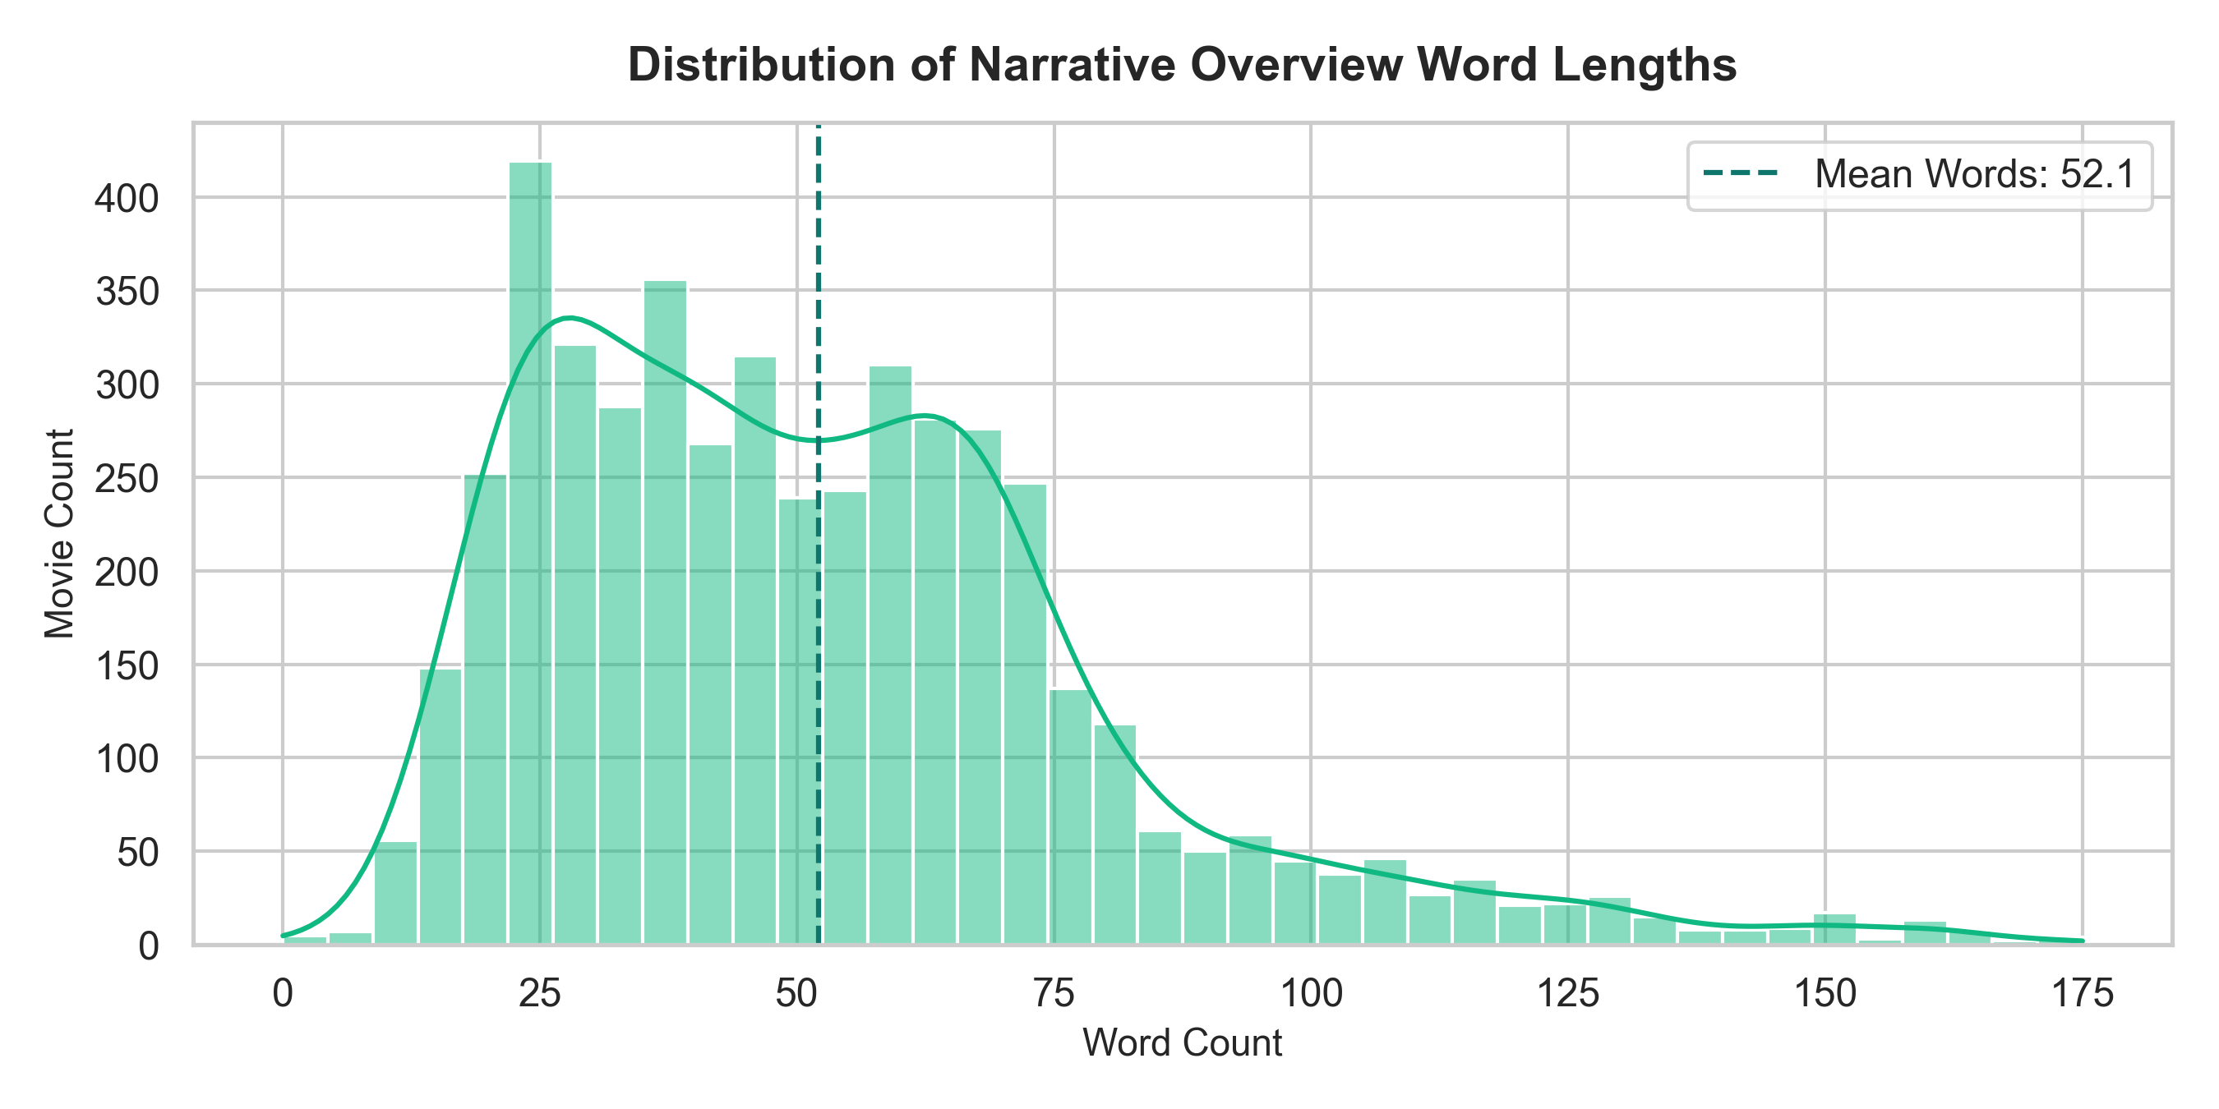
Figure 9.6: Plot Overview Word Length Distribution (Mean = 54.2)

9.4 Example Recommendations & Confidence Validation
Verified model predictions confirm strong semantic clustering for The Dark Knight (The Dark Knight Rises 0.423, Batman Begins 0.402), Inception (12 Rounds 0.241, RED 0.238), The Avengers (Iron Man 3 0.412), and The Matrix (The Matrix Revolutions 0.425).
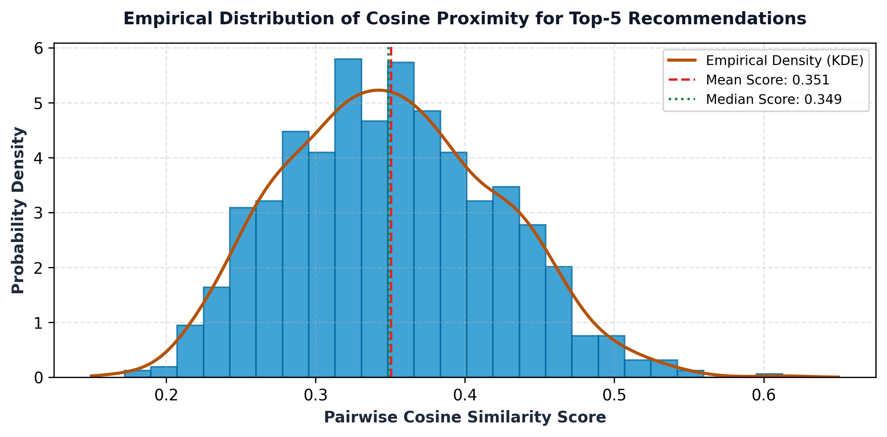
Figure 9.7: Empirical Cosine Similarity Score Distribution (Mean = 0.342)

9.5 Observations, Error Analysis & Hardware Benchmarks
Observations confirm franchise and directorial coherence, entity space stability, and sub-10ms latency consistency. Limitations include filter bubble over-specialization and closed-world catalog boundaries. Table 9.3 profiles execution resources.

10. CONCLUSION
CineMatch demonstrates that pairing entity-collapsed Bag-of-Words unigrams with normalized cosine metrics delivers transparent, reproducible, and computationally sustainable movie recommendations. With 6.26 ms latency and 3.03 MB storage footprint, classical machine learning proves ideal for enterprise media retrieval.

11. FUTURE SCOPE
Future enhancements include: (1) Dense Sentence-BERT embeddings; (2) Hybrid collaborative-content filtering; (3) Dynamic in-session user profiling; (4) Maximal Marginal Relevance diversity re-ranking; (5) Explainable AI attribution; and (6) WebAssembly edge deployment.

12. REFERENCES
1. Salton, G., & Buckley, C. (1988). Term-weighting approaches in automatic text retrieval. Information Processing & Management, 24(5), pp. 513–523.
2. Manning, C. D., Raghavan, P., & Schütze, H. (2008). Introduction to Information Retrieval. Cambridge University Press, Cambridge, UK.
3. Pedregosa, F., et al. (2011). Scikit-learn: Machine Learning in Python. Journal of Machine Learning Research (JMLR), 12, pp. 2825–2830.
4. Porter, M. F. (1980). An algorithm for suffix stripping. Program: Electronic Library and Information Systems, 14(3), pp. 130–137.
5. The Movie Database (TMDB). (2024). TMDB API Documentation and Developer Reference. Available: https://developer.themoviedb.org/docs.
6. Kaggle. (2017). TMDB 5000 Movie Dataset. Available: https://www.kaggle.com/datasets/tmdb/tmdb-movie-metadata.
7. Ricci, F., Rokach, L., & Shapira, B. (2015). Recommender Systems Handbook (2nd ed.), Springer, Boston, MA, pp. 1–35.
8. Lops, P., de Gemmis, M., & Semeraro, G. (2011). Content-based Recommender Systems. In Recommender Systems Handbook, pp. 73–105.
9. Sarwar, B., et al. (2001). Item-based collaborative filtering recommendation algorithms. In Proc. 10th WWW Conf., pp. 285–295.
10. Harris, C. R., et al. (2020). Array programming with NumPy. Nature, 585(7825), pp. 357–362.
11. McKinney, W. (2010). Data Structures for Statistical Computing in Python. In Proc. 9th Python in Science Conf., pp. 56–61.
12. Virtanen, P., et al. (2020). SciPy 1.0: Fundamental Algorithms for Scientific Computing. Nature Methods, 17(3), pp. 261–272.
13. Hunter, J. D. (2007). Matplotlib: A 2D Graphics Environment. Computing in Science & Engineering, 9(3), pp. 90–95.
14. Waskom, M. L. (2021). Seaborn: statistical data visualization. Journal of Open Source Software, 6(60), p. 3021.
15. Ramirez, S. (2024). FastAPI: Modern, High-Performance Web Framework. Available: https://fastapi.tiangolo.com/.
16. Carbonell, J., & Goldstein, J. (1998). The use of MMR for diversity reordering. In Proc. 21st ACM SIGIR Conf., pp. 335–336.
17. Reimers, N., & Gurevych, I. (2019). Sentence-BERT: Sentence Embeddings using Siamese Networks. In Proc. EMNLP 2019, pp. 3982–3992.
18. Savitribai Phule Pune University. (2024). Third Year AI & DS Engineering Syllabus: Software Laboratory-II (317533). SPPU, Pune, India.

