**Project Charter Document**



**Project Name:** Sales Forecasting for Pharmaceutical Industry

**Department:** Sales Planning

**Focus Area:** Sales Forecasting

**Product/Process:** Sales Forecasting, Pipeline, Deployment



**Prepared By**

|  |  |
| --- | --- |
| **Document Owner(s)** | **Project/Organization Role** |
| Chaithra S G | Sales Forecasting : Intern - Innodatatics |
| Chetan Wanjare | Sales Forecasting : Intern - Innodatatics |
| Hemalatha | Sales Forecasting : Intern - Innodatatics |
| Karuna Singh | Sales Forecasting : Intern - Innodatatics |
| Radhakrishna Naik | Sales Forecasting : Intern - Innodatatics |
| Rohit Katkar | Sales Forecasting : Intern - Innodatatics |
| Shweta Tongire | Sales Forecasting : Intern - Innodatatics |

**Project Charter Version Control**

|  |  |  |  |
| --- | --- | --- | --- |
| **Version** | **Date** | **Author** | **Change Description** |
| 1.0 | 16/05/2022 | Team | Document created |
|  |  |  |  |

**TABLE OF CONTENTS**

**1** **PROJECT CHARTER PURPOSE 3**

**2** **PROJECT EXECUTIVE SUMMARY 3**

**3** **PROJECT OVERVIEW 3**

**4** **PROJECT SCOPE 4**

4.1 Goals and Objectives 4

4.2 Project Deliverables 4

4.3 Deliverables Out of Scope 4

4.4 Project Duration 4

**5** **PROJECT CONDITIONS 5**

5.1 Project Assumptions 5

5.2 Project Issues 5

5.3 Project Risks 5

5.4 Project Constraints 5

**6** **Project Structure Approach 6**

**7** **Project Team Organization Plans 6**

**8** **PROJECT REFERENCES 6**

**9** **APPROVALS 6**

**10** **APPENDICES 8**

10.1 Document Guidelines 8

10.2 Project Charter Document Sections Omitted 8

# PROJECT CHARTER PURPOSE

The project charter defines the scope, objectives, and overall approach for the work to be completed. It is a critical element for initiating, planning, executing, controlling, and assessing the project. It should be the single point of reference on the project for project goals and objectives, scope, organization, estimates, work plan, and budget. In addition, it serves as a contract between the Project Team and the Project Sponsors, stating what will be delivered according to the budget, time constraints, risks, resources, and standards agreed upon for the project.



# PROJECT EXECUTIVE SUMMARY

* **Project goals :** To Predict the daily sales of various Pharmaceutical Products.
* **Objectives :** 
  + - Enhance the sales
    - Improve inventory management & Warehouse Planning
    - Better Staffing & workforce management
* **Scope**
  + **Data Collection** : Extracted from Client’s database server
  + **Data prepossessing** : Auto EDA & Manual
  + **Visualization** : Heat map, Line graph
  + **Model** : FB Prophet
  + **Deployment** : Flask, HTML & CSS
* **Assumptions :** The given data is primary data and all values are realistic.
* **Risks :** The predictions on given dataset, if data given is manipulated then actual results may be differ the predictions done by the model
* **Costs :** There are seven people are working on said problem statement including team lead. The cost involved is total man hours of these resources and billing will be as per the agreement.
* **Timeline:** Project Start date : 12/05/2022 ; Project end date : 25/06/2022
* **Approach :** Time series predictions are used for modeling of data
* **Organization :** ABC Pharma Ltd.



# PROJECT OVERVIEW

Sales forecasting proactively develops best practices to achieve revenue goals of the organization and hence is the major contributor towards the overall growth of the organization.

The Project focuses on Sales forecasting of Medicines on the basis of their historical sales data to address the demand of these medicines in advance.



# PROJECT SCOPE

## Goals and Objectives

|  |  |
| --- | --- |
| **Goals** | **Objectives** |
| * To develop an effective Sales forecasting model on the basis of historical daily Sales data provided by the Client. | * An effective Sales forecast helps the organization to manage its resources to meet the future demands more efficiently and hence stimulating better productivity, inventory management and profitability of the organization. |

## Project Deliverables

|  |  |
| --- | --- |
| **Milestone** | **Deliverable** |
| * Identifying Constraints and design the project architecture, explore various public forums to collect relevant data, Data Preparation. | * Deliverable 1.1—Identifying Constraints and design the project architecture. * Deliverable 1.2—Explore various public forums to collect relevant data. * Deliverable 1.3— Data Preparation |
| * EDA and Descriptive Analytics, Model Building for Sales forecasting | * Deliverable 2.1— EDA and Descriptive Analytics * Deliverable 2.2— Model Building for Time series |
| * Model Evaluation, tuning and insights, Deployment | * Deliverable 3.1— Model Evaluation, tuning and insights. * Deliverable 3. 2— Deployment |
| * Show case and review, Final Presentation and documentation, Handover and KT. | * Deliverable4.1 – show case and review * Deliverable4.2 – Final Presentation and documentation * Deliverable4.3 – Handover and KT |

## Deliverables Out of Scope

* MYSQL Database connectivity file
* Models & Performance evaluation
* Pickle file
* Flask Deployment code

## Project Duration (start date: 15/05/2022 End date: 25/06/2022)

|  |  |  |  |
| --- | --- | --- | --- |
| **Project Milestone** | **Date Estimate** | **Deliverable(s) Included** | **Confidence Level** |
| * Identifying Constraints and design the project architecture, explore various public forums to collect relevant data, Data Preparation. | [12/05/2022]  -  [17/05/2022] | * Deliverable 1.1—Identifying Constraints and design the project architecture. * Deliverable 1.2—Explore various public forums to collect relevant data. * Deliverable 1.3— Data Preparation | [High] |
| * Establishing database connectivity with clients PostgreSQL server and importing csv | [18/05/2022]  -  [22/05/2022] | * Deliverable 2.1—Database connectivity using MYSQL and establishing importing and exporting csv files for further processing | [High] |
| * EDA and Descriptive Analytics, Model Building for Association (Fuzzy Algorithm) and Recommendation | [23/05/2022]  -  [25/05/2022] | * Deliverable 3.1— EDA and Descriptive Analytics * Deliverable 3.2— Model Building for Association (Fuzzy Algorithm) and Recommendation | [High] |
| * Model Evaluation, tuning and insights, Deployment | [26/05/2022]  -  [20/06/2022] | * Deliverable 4.1— Model Evaluation, tuning and insights. * Deliverable 4. 2— Deployment | [High] |
| * Show case and review, Final Presentation and documentation, Handover and KT. | [24/05/2022] | * Deliverable 5.1 – show case and review * Deliverable 5.2 – Final Presentation and documentation * Deliverable 5.3 – Handover and KT | [Medium] |



# PROJECT CONDITIONS

## Project Assumptions

* Data should be from primary source.
* Predictions should be based on dates provided in the database.
* Seasonality considered is based on weekly data.
* Pickle file & deployment will be provided.
* Robust Tested:Application should be tested for noise data also.

## Project Issues

**Priority Criteria**

1 − High-priority/critical-path issue; requires immediate follow-up and resolution.

2 − Medium-priority issue; requires follow-up before completion of next project milestone.

3 − Low-priority issue; to be resolved prior to project completion.

4 − Closed issue.

|  |  |  |  |  |  |
| --- | --- | --- | --- | --- | --- |
| **#** | **Date** | **Priority** | **Owner** | **Description** | **Status & Resolution** |
| 1 | 15/05/2022 | High | Team | MYSQL Connector | Closed |
| 2 | 12/06/2022 | High | Team | Model Deployment | Closed |

## Project Risks

|  |  |  |  |  |
| --- | --- | --- | --- | --- |
| **#** | **Risk Area** | **Likelihood** | **Risk Owner** | **Project Impact-Mitigation Plan** |
| 1 | [Project Risk] | [High/Medium/Low] | Team | Follow the CRISP ML(Q) methodology & applicable procedures |
| 2 | [Project Risk] | [High/Medium/Low] | Team | Follow the CRISP ML(Q) methodology & applicable procedures |

## Project Constraints

* Ensure the raw material availability.
* Company should comply to applicable legal terms & conditions.
* Environmental clearance from relevant authorities.
* Presence of existing competition in the market.



# Project Structure Approach

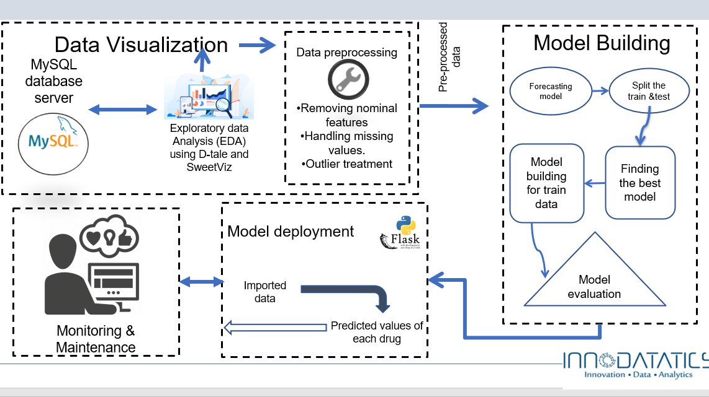



# Project Team Organization Plans

|  |
| --- |
| * Deliverable 1.1— Data * Deliverable 1.2— Data * Deliverable 1.3—Project Overview |
| * Deliverable 2.1—MYSQL Connector |
| * Deliverable 3.1—Auto EDA & Manual EDA * Deliverable 3. 2—Python implementation |
| * Deliverable4.1 – Model Evaluation * Deliverable4.2 – Choosing Flask |
| * Deliverable5.1 – Deploying the model in flask * Deliverable5.2 –Document preparation. * Deliverable5.3 – Handover and KT |



# PROJECT REFERENCES

|  |  |
| --- | --- |
| **Milestone** | **Deliverable** |
| Data Collection | EDA |
| Model Preparation | Python Code |
| Deployment | Flask |

# APPROVALS

**Prepared by** Team ____________________________

Project Manager

**Approved by** Sharat Chandra M__________________

Project Sponsor

_________________________________

Executive Sponsor

_________________________________

Client Sponsor



# APPENDICES

## Document Guidelines

## Project Charter Document Sections Omitted

