ASSIGNMENT

Q.1. How HTTPS works behind the scene?

ANS:-

- HTTPS stands for HyperText Transfer Protocol Secure which is the secure version of the HTTP.
- The SSL (secure sockets layer) certificate encrypts the information that users supply to the site, which basically translates the data into a code.
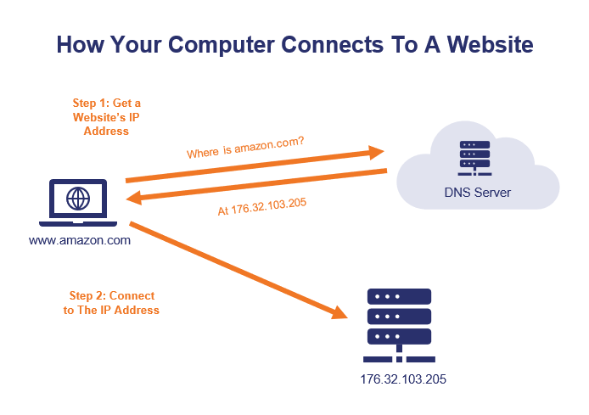
- HTTPS is also secured via TLS (Transport Layer Security) protocol.
- Users can identify whether a site uses HTTPS protocol by the web address.
- The SSL/TLS handshake is a fascinating process that is critical for a secure internet, and yet it happens quickly and quietly behind the scenes where most people never give it a second thought.

Q.2. What are different http methods available and what they exactly do.

ANS:-

The primary or most commonly-used HTTP methods are:-
- POST
- GET
- PUT
- HEAD
- TRACE
- OPTIONS
- PATCH AND
- DELETE

- GET - Retrieves the content of an existing resource.
- POST - Submits a request to an existing resource. Can update the resource.
- PUT - Creates a new resource at the specified URI.
- DELETE - Removes the resource defined at the specified URI.
- HEAD - Returns just the HTTP response headers as if a GET request had been submitted to the specified URI.
- TRACE - Echoes back the supplied request to see what modifications may have been made to the request by intermediaries in-flight.
- OPTIONS - Returns what options and features the web server supports.
- CONNECT - Used to establish TCP connections to a server. Used to support SSL secure communications.
These methods correspond to create, read, update, and delete (or CRUD) operations, respectively.
Http methods are used to determine what action you want to execute on a specific ressource helping the server to understand the nature of the request.

Q.3. Understand and explain the use of various http response codes.

ANS:- HTTP response status codes indicate whether a specific HTTP request has been successfully completed.

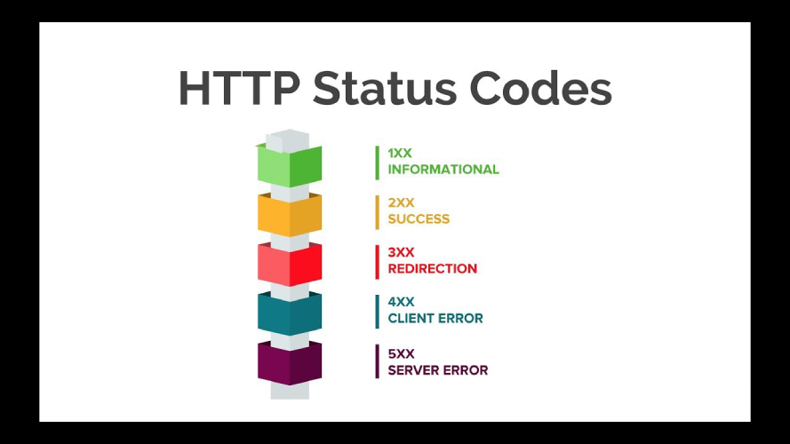
.Informational responses ( 100 – 199 )
- Successful responses ( 200 – 299 )
- Redirection messages ( 300 – 399 )
- Client error responses ( 400 – 499 )
- Server error responses ( 500 – 599 ).

Q.4. What are the different web communication protocols and their use cases?
ANS:-

There are various types of protocols that support a major and compassionate role in communicating with different devices across the network. These are:
1.Transmission Control Protocol (TCP)
2. Internet Protocol (IP)
3. User Datagram Protocol (UDP)
4. Post office Protocol (POP)
5. Simple mail transport Protocol (SMTP)
6. File Transfer Protocol (FTP)
7. Hyper Text Transfer Protocol (HTTP)
8. Hyper Text Transfer Protocol Secure (HTTPS)
9. Telnet
10. Gopher

1. Transmission Control Protocol (TCP): TCP is a popular communication protocol which is used for communicating over a network. It divides any message into series of packets that are sent from source to destination and there it gets reassembled at the destination.
2. Internet Protocol (IP): IP is designed explicitly as addressing protocol. It is mostly used with TCP. The IP addresses in packets help in routing them through different nodes in a network until it reaches the destination system. TCP/IP is the most popular protocol connecting the networks.

3. User Datagram Protocol (UDP): UDP is a substitute communication protocol to Transmission Control Protocol implemented primarily for creating loss-tolerating and low-latency linking between different applications.
4. Post office Protocol (POP): POP3 is designed for receiving incoming E-mails.
5. Simple mail transport Protocol (SMTP): SMTP is designed to send and distribute outgoing E-Mail.
6. File Transfer Protocol (FTP): FTP allows users to transfer files from one machine to another. Types of files may include program files, multimedia files, text files, and documents, etc.
7. Hyper Text Transfer Protocol (HTTP): HTTP is designed for transferring a hypertext among two or more systems. HTML tags are used for creating links.
8. Hyper Text Transfer Protocol Secure (HTTPS): HTTPS is abbreviated as Hyper Text Transfer Protocol Secure is a standard protocol to secure the communication among two computers one using the browser and other fetching data from web server.

9. Telnet: Telnet is a set of rules designed for connecting one system with another. The connecting process here is termed as remote login. The system which requests for connection is the local computer, and the system which accepts the connection is the remote computer.
10. Gopher: Gopher is a collection of rules implemented for searching, retrieving as well as displaying documents from isolated sites. Gopher also works on the client/server principle.

Q.5.Pros and cons of Single page and multi page applications.
ANS:-Multi-page applications follow a high-security standard, while single-page applications are less secure.

Single-page applications, (short-form SPAs) are web applications that download all the data at the time of the first click of the page.
It won't trouble you, once you have opened the app and won't reload every time you click on something. Multi page applications are web applications that have more than one page.
Single Page Application Pros and Cons
.Quick Loading Time. ...
- Seamless User Experience. ...
- Ease in Building Feature-rich Apps. ...
- Uses Less Bandwidth. ...
- Doesn't Perform Well With SEO. ...
- Uses a Lot of Browser Resources. ...
- Security Issues.

