Employee Lifecycle & Attrition Analytics
Complete Project Documentation

1. Project Overview
An end-to-end Azure data engineering solution for employee lifecycle, attrition, salary, tenure, department, and workforce analytics. The implementation uses Azure Data Lake Storage Gen2, Azure Data Factory, Azure Databricks, PySpark/Delta, SQL, Power BI, and GitHub.

2. Architecture
Raw Employee Data
↓
Azure Data Lake Storage Gen2
↓
Azure Data Factory
↓
Databricks Bronze
↓
Databricks Silver
↓
SCD Type 2 / Incremental Processing
↓
Gold Business Analytics
↓
SQL + Power BI
The supplied implementation document shows the Azure resource group, ADLS Gen2 storage, Databricks deployment, and ADF pipeline evidence. fileciteturn2file0L2-L10

3. Azure Resources
Resource | Name / Purpose
Resource Group | rg-employee-lifecycle-dev
ADLS Gen2 | strohitattrition01
Databricks | dbw-employee-lifecycle-dev
Data Factory | adf-employee-lifecycle
The storage account screenshot shows hierarchical namespace enabled, with raw, bronze, silver, gold, and logs containers. fileciteturn2file0L5-L8
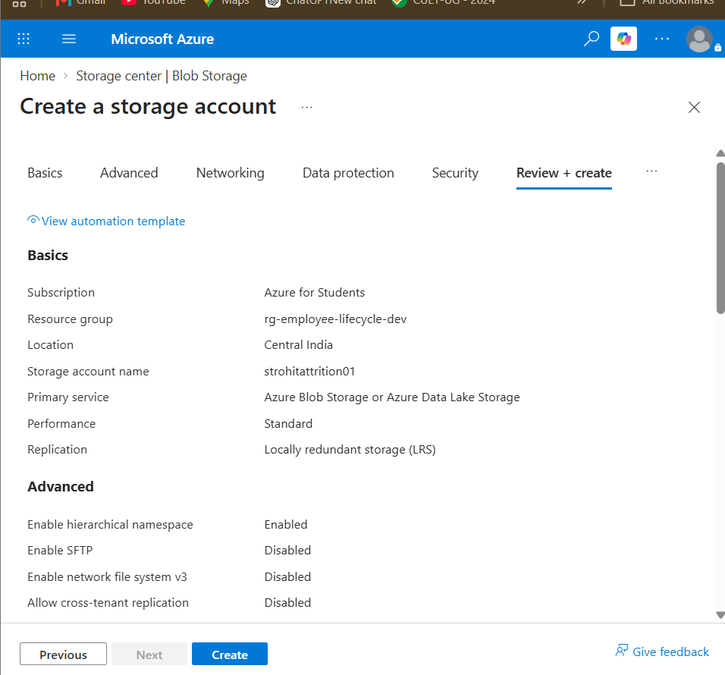

4. Databricks — Bronze Layer
The Bronze process reads CSV files from the raw ADLS location, checks the data, and saves a Delta table named bronze_employee.
df = spark.read \
.option("header", "true") \
.option("inferSchema", "true") \
.csv("abfss://raw@<storage-account>.dfs.core.windows.net/")
df.write \
.format("delta") \
.mode("overwrite") \
.saveAsTable("bronze_employee")
The supplied document records the Bronze read, schema/count checks, Delta write, and verification steps. fileciteturn2file0L21-L44
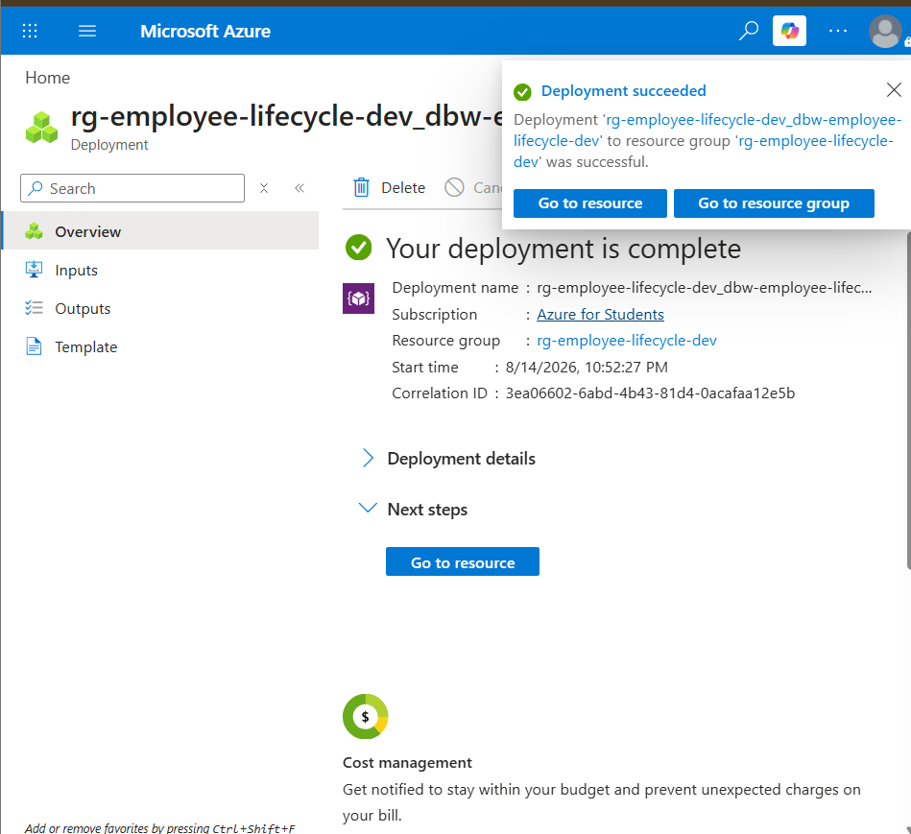

5. Databricks — Silver Layer
The Silver process reads bronze_employee, converts data types, checks nulls and duplicate employee IDs, and writes silver_employee.
silver_df = bronze_df \
.withColumn("emp_id", col("emp_id").cast("int")) \
.withColumn("salary", col("salary").cast("int")) \
.withColumn("join_date", to_date(col("join_date")))
silver_df.write \
.format("delta") \
.mode("overwrite") \
.saveAsTable("silver_employee")
The source specifies the expected Silver fields and validation steps. fileciteturn2file0L51-L98

6. SCD Type 2 / Incremental Processing
The completed project includes an SCD2 incremental-load stage to preserve historical employee changes instead of simply overwriting previous versions.
- Track changes to employee attributes over time.
- Preserve historical versions.
- Maintain the current employee state.
- Support lifecycle and attrition analysis.

7. Gold Business Analytics
The Gold layer provides business-ready datasets for workforce and HR analytics, including employee counts, salary, status, HR summary, and top-salary analysis.
Analysis | Business use
Current employees | Current workforce size
Department count | Workforce distribution
Department salary | Average salary comparison
Department/status | Active vs resigned analysis
HR summary | Headline HR metrics
Top salaries | Highest salary analysis

8. Azure Data Factory
The project pipeline is PL_Employee_Lifecycle and orchestrates the notebook stages in sequence.
Bronze_Ingestion
↓
Silver_Transformation
↓
SCD2_Incremental_Load
↓
Gold_Business_Analytics
The supplied screenshots show the pipeline being validated and later showing successful activity states. fileciteturn2file0L95-L100

9. SQL Analytics
A SQL query named employee_count_by_department was created and pushed to the project's sql/ folder.
SELECT
department,
employee_count
FROM gold_department_count
ORDER BY employee_count DESC;
Department | Employee Count
HR | 50
Sales | 49
IT | 48
Finance | 41
Marketing | 32
An additional average-salary-by-department query was executed successfully during project completion.

10. Power BI
The completed Power BI report presents the Gold-layer HR analytics.
- Current Employees
- Attrition Rate (%)
- Average Tenure (Years)
- Employees by Department
- Average Salary by Department
- Active vs Resigned by Department
- Top Salary Employees
The Power BI .pbix file was added to the GitHub powerbi/ folder.

11. GitHub Repository
Employee-Lifecycle-Attrition-Analytics/
├── architecture/
├── azure-data-factory/
├── data/
├── databricks/
│ ├── 01_bronze_ingestion.ipynb
│ ├── 02_silver_transformation.ipynb
│ ├── 03_gold_business_analytics.ipynb
│ └── 04_SCD2_Incremental_Load.ipynb
├── docs/
├── powerbi/
├── sql/
└── README.md

12. Security
Do not commit storage account keys, passwords, tokens, or connection secrets to GitHub. The supplied implementation document contains a development-time example showing where a storage key would be entered; that key should never be included in source control. fileciteturn2file0L12-L20

13. Final Outcome
The project demonstrates a complete cloud data engineering workflow: Azure storage, orchestration, Databricks Bronze/Silver processing, historical SCD2 handling, Gold analytics, SQL, Power BI, and GitHub source control.

