Obstacle and range detection for cane Using ultrasonic & gyroscopic sensor

Ashutosh Sharma#1,N.Pratyusha #2, Pratiksha Mishra#2 , Rohit Ku. Dwivedi #4

# Computer science, Bhilai Institute of Technology   
Kendri Raipur Chhattisgarh India

1 ashutoshq1sharma@gmil.com

2 nalakentipratyusha@gmil.com

3 pratikshamishra2018@gmail.com

4 rdwivedi345@gmail.com

Abstract***—* At least once in our life, almost all of us have experienced the suffocation of not being able to navigate due to power cut at night time even in the places which is well known to us. Visually challenged people have to face this suffocation on daily basis. The most useful tool for navigation in these circumstances seems to be a cane but even with the help of a normal cane is a difficult task for a visually challenged person as the cane can only detect obstacles within a range of about a meter.** **Obstacle and range detection for Cane Using ultrasonic & gyroscopic sensor can liberate the visually challenged a better walking experience. This paper reports on a research and study that helps visually-impaired people to walk more confidently. The aim of the paper is to address the design and work of a cane that could communicate with the users through vibration and yet be budget friendly. The work involves coding and instrumental installation. A number of tests and surveys have been carried out on this cane and the results are discussed. This survey found that the obstacle and range detection for Cane Using ultrasonic & gyroscopic sensor functions well as observed, in alerting users about the obstacles in front.**

INTRODUCTION

According to WHO, there are about 36.9 million visually impaired in the world. Out of these, 75% of the people wishes to get rid of the cane because of the feeling of frustration. The Chairman of National Association for the Blind, Kottayam suggested that it would be a great improvement in their society if the use of cane can be avoided. They pointed out that the people on the road never considered the difficulty of a visually impaired while navigating. One member from the Association conveyed his difficulty in navigating through his familiar route because of the puddles and pits formed due to rain.Visually challenged persons face great difficulty in independent mobility and use the white cane as a mobility aid to detect close-by obstacles on the ground.

However, the cane has two major limitations:

* It can only detect obstacles up to knee-level. The cane is unable to detect the obstacles above knee-level like tree branches, elevated bars and raised obstacles which causes collisions.
* The cane can only detect obstacles within one meter from the user. Also, moving obstacles like vehicles cannot be detected until dangerously close to the person. Almost 90% of the blind persons live in developing countries, with a majority below poverty line [1]. Current devices available internationally are unaffordable. In this work we present the design and usability features of a low-cost smart cane which has detection system and report results from controlled field experiments. This paper discusses the development work of a cane that could communicate with the users through vibration, vibratory motors are used to inform about the obstacles. The intensity of vibration depends on the closeness of the obstacles. The gyroscopic sensor provides with the degree of elevation of the obstacle and the ultrasonic sensor with the distance, combining both the parameters, the exact distance and height of the obstacle can be can be calculated using the mentioned algorithm.

1. RELATED WORK

This section narrates many technological attempts to develop a product which could reduce the challenges faced by people with disabilities.

Assistive technology (AT). technology can help in reducing many barriers that people with disabilities face[1].

According to Mazo and Rodriguez [8] the blind Cane is one of the assisting tools for the visually-impaired and it is really important. According to Herman [3],the main problems of the visually-challenged, is that most of these people have lost their physical integrity. By Bouvrie [7]*in* experiment name “Project Prakash” has been carried out that there confidence also get reduced.It was intended at testing the visually-impaired to utilize their brain to identify set of objects. According to Chang and Song [12], this can also be applied to different situation. When the visually-impaired walk into a new environment, they will find it difficult to memorize the locations of the object or obstacles.

Another work is done by Fernandes, Costa**,** Filipe, Hadjileontiadis and Barroso [2]. The device can detect specific landmarks and will inform the user the distance from the obstacle. Depths are identified using two cameras which generate images suitable to extract both the position and distance of objects according to their relative brightness. Another device HALO can be mounted on the existing white cane and can detect low hanging obstacles such as branches of trees[4]. It consists of ultrasonic range sensor with an eccentric-mass vibrating motor which vibrates distinctly for ground obstacle and low hanging obstacle. An intelligent guide stick detects obstacles using ultrasonic sensors but it is unable to tell whether the obstacle is in motion or not[6].

A wireless ultrasonic ranging system detects obstacles using an ultrasonic sensors and the PIC16F877 microcontroller finds out the distance from the obstacle[5]. The phone that is linked to the microcontroller converts the information to speech and the data is sent to the Bluetooth earphone to alert the user. In the work by Amirhossein Tamjidi, Cang Ye and Soonhac Hong a portable indoor localization aid for 6 Degree of Freedom device post estimation is proposed[9]. This method is used as an indoor GPS system for position estimation of the visually impaired. It also supports obstacle detection and help the visually impaired to move around freely. In another work by C.Ye and X.Qian a RANSAC based plane detection method is proposed wherein the complex geometry of the 3D data ensures accuracy[10] .This method would be used by a robotic navigational device assisting the visually challenged. The work done by S. Gallo, D. Chapuis, L. Santos- Carreras, Y. Kim, P. Retornaz, H. Bleuler and R. Gassert, “Augmented White Cane with Multimodal Haptic Feedback” involves Haptics feedback to imitate the behavior of a longer cane [6]. The feedback is given by a shock generating module which releases the kinetic energy stored in a spinning wheel in a controlled amount. In case of a moving obstacle, the spatiotemporal vibration pattern, stimulated on the user’s hand creates the sensation of an apparent movement. A different approach is seen in the work presented by Larisa Dunai, Guillermo PerisFajarnes, Victor Santiago Praderas, Beatriz Defez Garcia on “Real– Time Assistance Prototype – a new Navigation Aid for blind people”.This integrates stereo-vision technology and real time static and moving obstacle and free path detection [7]. The system offers three dimensional information of the environment, relaying it to the user by transmitting acoustical signals. The device consists of a helmet fitted with a pair of stereo camera, which captures the image. The image is processes by a laptop and the user is alerted through a headphone.

1. SYSTEM ARCHITECTURE

Arduino UNO ( Arduino, Italy) is a microcontroller board based on ATmega328. It consists of 14 digital I/O pins out of which 6 pins can be used as PWM pins. In addition to this it contains 6 analog input pin.

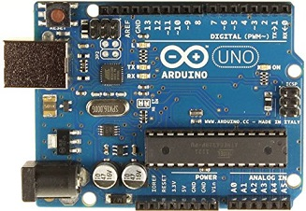

Fig Arduino uno

The setup is light in weight and encapsulates two sensors and two vibrator motors in it. The ultrasonic sensor(HC-SR04) works similar to that of echolocation in bats. It sends an ultrasonic wave when triggered and waits for the wave to strike the surface and bounce back. As soon as the echo is received, the distance can be measured using relation $speed= \frac{distance}{time}$. Here speed is the speed of sound in air i.e. 343m/s with dry air at 20°c.

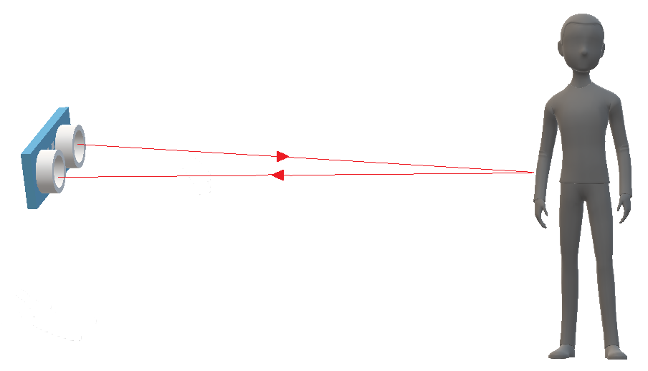

Fig: functioning of ultrasonic sensor

The sensor can measure accurately up to 3m with an accuracy of 3mm. The deviation is due to humidity and temperature change from place to place.

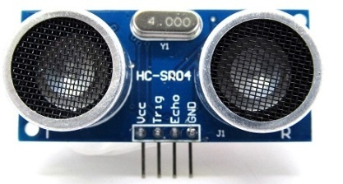

Fig: HC-SR04

The MPU-6050 is capable of recording 3-axis gyroscopic deviation and 3-axis acceleration. In our project, we measure the change in angle of the cane through MPU-6050

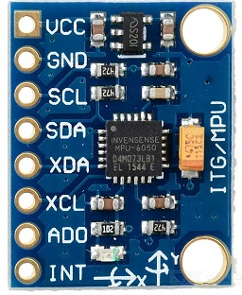

Fig: MPU-6050

Together with the help of distance and angle, the exact distance and height of the obstacle can be calculated using basic trigonometric relations. The warning is conveyed to the user through vibrations. The motors from old mobile phones are used consuming and recycling the e-waste. The vibrators are any common motors to which an unbalanced weight is attached. The rotation of the unbalanced weight produces a unbalanced angular momentum, which causes the vibration.

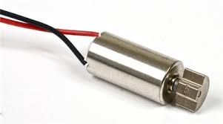

Fig: mobile phone vibrator

The projected cost of the device is under 1000 INR making it a wallet friendly device for users in developing countries. 57% of obstacle awareness increased by Smart Cane And 91% of obstacle collision-rate decreased by using the device & reported successful detection of railings, raised bars, raised sides of trucks and presence of a gate, people, trees etc.

1. System Description

We developed a navigation aid that detects hazardously raised obstacles and increases detection range to 3m, which improves safety of the user. In this section we first describe the structure of the device and the functioning algorithm used. Next we discuss the key features of the device.

The device encompasses an ultrasonic sensor. The ultrasonic sensor extends the range of obstacle awareness from 1m to 3m,ie three time the traditional cane with a negligible error of 0.1% error. Different vibrational patterns are assigned to different sets of distances which is depicted in the figure below

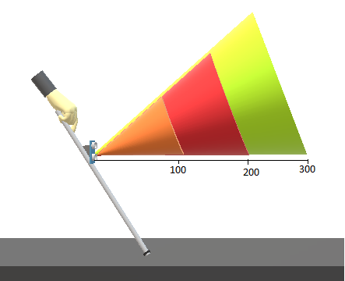

Fig: Differentiation of distances into 3 sets

Differentiation of the distances helps the user to get a clear idea of the closeness of the obstacle. These 3 sets of distances corresponds to the 3 different patterns of vibrations. Many of the currently existing products use buzzers to indicate the distance. But surrounding sounds play a curtail role in navigation for both, visually able & especially for visually-impaired person. So instead of blocking a sense which is curtail as cane only helps to detect the obstacles in front but for detection of vehicles and other moving objects approaching form behind, ability to hear is the must so we preferred to add one more sense, i.e. sensing distance through touch to facilitate the navigation. The figure below shows the awareness of awareness of obstacles above knee-level

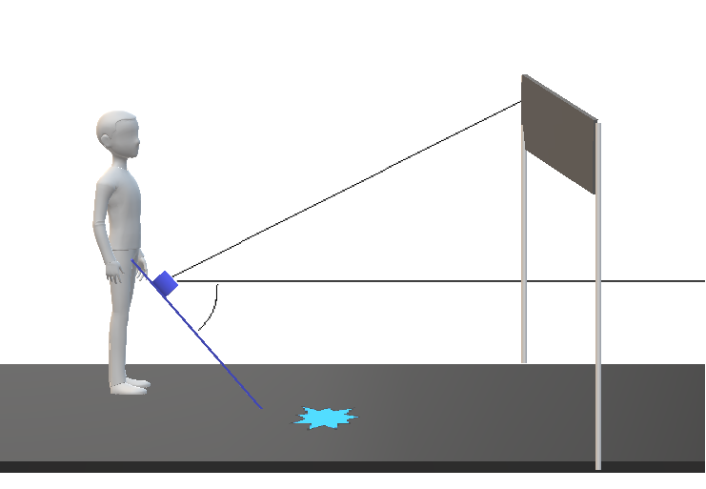

FIG. 2:detection of knee-above obstacles

Instead of adding multiple ultrasonic sensors to increase the ultrasonic cone, we added a gyroscopic sensor which measures the absolute change in angle of the ultrasonic sensor.

The deviation of angle can be used to calculate the height of the obstacle using trigonometric relations

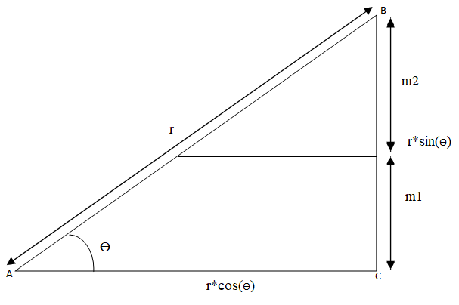

Fig: calculation of height and absolute distance of obstacle

Here

* r is the distance measured through ultrasonic sensor
* Ɵ is the angle made by gyroscopic sensor with respect to the ground

So AC is the absolute distance between the obstacle and sensor or user (neglecting the distance between user and sensor as the cane).

So AC can be calculates as AB*cos(Ɵ).

This AC is responsible for the pattern of vibration which will be issued to the motor.

Two motors are placed in the handle at different heights of the handle. Vibration in the upper motor (m2) indicates that the obstacle is present at a height approximately between head and chest of the user & vibration of lower motor (m1) suggests that the obstacle is present below chest and above knee.

Which motor should vibrate can be decided by calculating BC. If BC lies in the lower range, m1 should vibrate and if value of BC lies in upper range, m2 should vibrate.

BC can be again calculated using trigonometric sin(Ɵ) function.

Here BC=AB*sin(Ɵ), i.e. BC = r*sin(Ɵ)

|  |  |
| --- | --- |
| Range (in cm) | Vibration |
| 0<BC<100 | V1( 100ms 400ms ) |
| 100<BC<200 | V2( 100ms 300ms) |
| 200<BC<300 | V3( 100ms 200ms) |

* In V1 the vibration pattern is that the motor vibrates for 100ms and is silent for 400ms
* In V2 the vibration pattern is that the motor vibrates for 100ms and is silent for 300ms
* In V3 the vibration pattern is that the motor vibrates for 100ms and is silent for 200ms

The circuit diagram of the setup is as following:

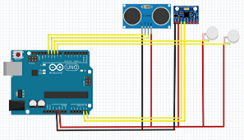

FIG. 3: circuit diagram

1. Reduction in Collision Rate

Using the conventional cane, the users met with collisions with approximately 39.4 ± 2.8% obstacles in average, compared to the 61.7 ± 2.5% collisions in the case of knee-above obstacles. The Smart Cane helped to lower the collision rate to 3.2 ± 0.6%, and a drastic reduction of 90.3 ± .6% for knee-above obstacles the collision rate declined by 91.5 ± 5.2% to 5.3 ± 1.5% thereby lowering down the chances of collision and providing safety to the users. At first, adjusting to the vibrations were a little difficult for users. But after training and practice, the results were above expectations

|  |  |  |  |
| --- | --- | --- | --- |
|  | Normal Cane | Smart Cane | Percentage reduction in collision rate |
| All obstacles | 39.4 ± 2.8% | 3.2 ± 0.6%, | 90.3 ± .6% |
| Knee-above obstacles | 61.7 ± 2.5% | 5.3 ± 1.5% | 91.5 ± 5.2% |

TABLE 1: COLLISION RATE (NUMBER OF COLLISIONS PER DETECTIONS)

1. CONCLUSION

The paper details the architecture and working algorithm of a device that scans the path for a visually challenged person and alerts them in the event of any danger. An algorithm is constructed to detect any objects and obstacles ahead of them. In this work we presented a novel knee-above obstacle-detection and warning system combined with the gyroscope sensor and ultrasonic sensor to enhance personal mobility for the visually-impaired user. The algorithm is capable enough to reduce the use more than one ultrasonic sensor for range detection hence reducing the power consumption and increasing the battery life of the device. Formal commonly encountered obstacles demonstrate

(a) a 57.2 ± 4.1% increase in obstacle awareness,

(b) a 91.5 ± 5.2%reduction in collision-risk and

(c) a 2.61 fold increase in the average of obstacle detection distances with the Smart Cane over the traditional cane cost of the device under 1000rs. The system reduces dependence on sighted assistance, improves independent mobility and paves the way for affordable electronic travel aids for the visually challenged particularly in developing countries.

References

[1] A. Nurulnadwan, M.R. Nur-Hazwani, and A.M. Ariffin, “*Assistive Courseware for Visually-Impaired*,” (2009). in *Proc. IVIC 2009*, LNCS 5857, 2009, pp. 905-915.

[2] Fernandes, Costa, Filipe, Hadjileontiadis and, Barroso,

“*Stereo Vision In Blind Navigation Assistance*”

[3] Herman N. J., “ *Deviance : The Symboli Interactionist Approach-The Making of Blind Men*”, Vol. 24, pp. 236-2 41, Dix Hills N.Y. General Hall, USA, 1999

[4] Katherine J. Kuchenbecker and Yunqing Wang,” *HALO: Haptic Alerts for Low-hanging Obstacles in White Cane Navigation*”, University of Pennsylvania

[5]. A. Tahat*,” A Wireless Ranging System for the Blind Long-Cane Utilizing a Smart-Phone*”, School of Electrical Engineering Princess Sumaya University for Technology Amman, Jordan

[6] Sung Jae Kang', Young Ho, Kim', In Hyuk Moon',” *Development an Intelligent Guide-Stick for the Blind*”, Proceedings of the 2001 IEEE 2001International Conference on Robotics *8,* Automation, Seoul, Korea. May 21-26

[7]BouvrieJ.V,“*Visual Object Concept Discovery: Observation in Congeniality Blind Children , and a Computational Approach*”, Elsevier Science, USA, 2007

[8]Mazo M. and Rodriguez F. J., “ *Wheelchair for Physical Disable People With Voice ,Ultrasonic and Infrared Control*”, Autonomous Robots, Vol. 2, pp. 203-224, 1998

[9]X. Qian and C. Ye, “*NCC-RANSAC: A Fast Plane Extraction Method For Navigating*”

[10] Larisa Dunai, Guillermo PerisFajarnes, Victor Santiago Praderas, Beatriz Defez Garcia,” *Real–Time Assistance Prototype – a new Navigation Aid for blind people*”, Universidad Politecnica de Valencia, Camino de Vera s/n, 8L, Valencia, 46022,sSpain

[11]Paul R., Garg A., Singh V., Mehra D., Balakrishnan M.Paul K.,Manocha D.”*Smart Cane for the Visually Impaired: Technological Solutions for Detecting Knee- above Obstacles and Accessing Public Buses, Proc. Of 11th International conference onMobility and Transport for Elderly and Disabled Persons (TRANSED 2007)”,* Montreal, Canada, June 2007

[12]Chang C. C. and Song K. T., “*Ultrasonic sensor data integrations and its Application to environment Perception*”, IEEE transaction on Ultrasonic, Vol. 1, pp. 3-5, 2000