**Rohit Kude**

**Residential property pricing in Dubai report**

Dubai Residential Pricing 2025 Report

***How can data-driven analysis of Dubai’s 2025 residential property transactions improve pricing accuracy, optimize sales timing, and guide strategic investment decisions for developers, investors, and policymakers?***



***(Economy Middle East,2025)***

Contents

Introduction 3

Distribution of transaction values (AED) – Log scale 3

Business Problem 4

Strategic Solutions 4

Financial & Operational Implications 4

Distribution of property areas 5

Business Problem 5

Strategic Solutions 5

Financial & Operational Implications 5

Transaction value by property type 6

Business Problem 6

Strategic Solutions 6

Financial & Operational Implications 7

Transaction value distribution by number of bedrooms 7

Business Problem 7

Strategic Solutions 7

Financial & Operational Implications 8

Correlation Matrix 8

Business Problem 8

Strategic Solutions 8

Financial & Operational Implications 9

Monthly Trends 9

Business Problem 9

Strategic Solutions 9

Financial & Operational Implications 10

Top 10 Areas by Number of Transactions 10

Business Problem 10

Strategic Solutions 11

Financial & Operational Implications 11

Top 10 Areas by Total Transaction Value 11

Business Problem 11

Strategic Solutions 12

Financial & Operational Implications 12

Conclusion 12

References 13

# Introduction

Dubai’s residential property market in 2025 is a complex ecosystem shaped by high-volume affordable districts, ultra-prime luxury zones, and seasonal cycles that drive sharp fluctuations in liquidity and pricing power. For developers, investors, lenders, and policymakers, understanding these dynamics is not just a matter of tracking prices—it is about identifying actionable levers to maximize return on investment (ROI), manage risk exposure, and capture competitive advantage in a market where supply, demand, and buyer expectations are constantly shifting. This report takes a business analyst’s approach to converting raw transaction data into commercial insights. The purpose is twofold: first, to provide stakeholders with a clear, data-backed playbook for strategic moves in Dubai’s property sector; second, to demonstrate an applied business analytics methodology capable of informing high-stakes investment and operational decisions.

This intelligence report provides a comprehensive commercial interpretation of 110,490 residential real estate transactions in Dubai between January 1 and July 22, 2025. Each visual insight is analyzed to extract concrete business problems, practical solutions, and financial implications, with a focus on maximizing ROI, accelerating revenue generation, mitigating risks, and streamlining operational execution.

# Distribution of transaction values (AED) – Log scale

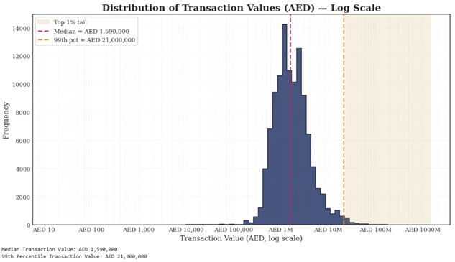

*Distribution of Transaction Values (AED) — Log Scale*

## Business Problem

This real estate transaction data presents a skewed picture, with some high-value luxury sales inflating the average price. Relying on a single pricing model for all properties can lead to significant valuation errors. This practice risks overpricing mid-tier homes during luxury booms, making them unattractive to their intended buyers. It can also cause high-end assets to be undervalued during slower periods. This could lead to wasted marketing budgets on unlikely buyers for developers.

## Strategic Solutions

• Segment the market into mass, upper-mid, and luxury tiers with distinct KPIs, pricing curves, and marketing budgets.

• Apply log-transformed price targets in predictive models to neutralize luxury skew when forecasting for standard inventory.

• Use an outlier monitoring dashboard to trigger separate treatment for ultra-high-value transactions.

## Financial & Operational Implications

• Higher ROI by aligning product pricing more precisely with buyer affordability profiles.

• Faster inventory turnover in the mass segment through competitive pricing not distorted by luxury anomalies.

• Reduced marketing waste by focusing high-spend campaigns only on genuine luxury buyers.

# Distribution of property areas

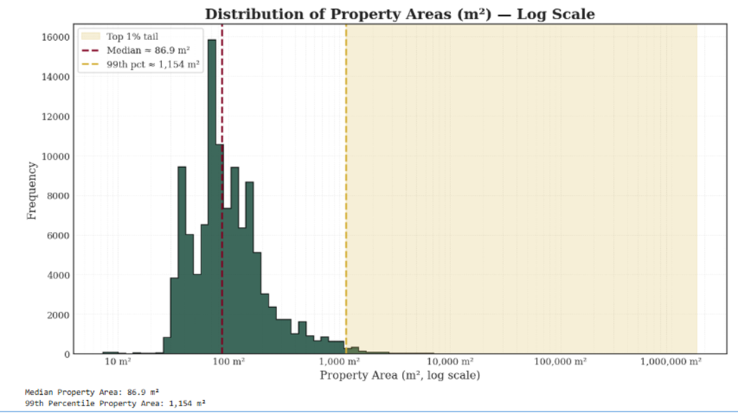

*Distribution of Property Areas (m²) — Log Scale*

## Business Problem

Property sizes range from compact 7 m² units to massive multi-hectare land plots. This dispersion complicates average size metrics and obscures true market demand for specific configurations. Misreading the dominant 50–150 m² cluster could lead to oversupplying large, slow-moving units or undervaluing development-ready plots. Without granular analysis, developers risk building the wrong unit mix, locking capital into misaligned products, and missing high-ROI land assembly plays.

## Strategic Solutions

·        Anchor design decisions to price-per-m² benchmarks by submarket to avoid distorting averages with mega-plot data.

·        Target the 50–150 m² band in mass-market hubs to maximize absorption velocity.

·        Identify and acquire large parcels in high-growth zones for phased development aligned with absorption rates.

## Financial & Operational Implications

·     Optimized unit mix improves sell-through rates and cash flow predictability.

·        Land banking in emerging zones offers long-term capital appreciation with strategic resale or build-out options.

·        Lower carrying costs from reduced mismatch between supply and demand.

# Transaction value by property type

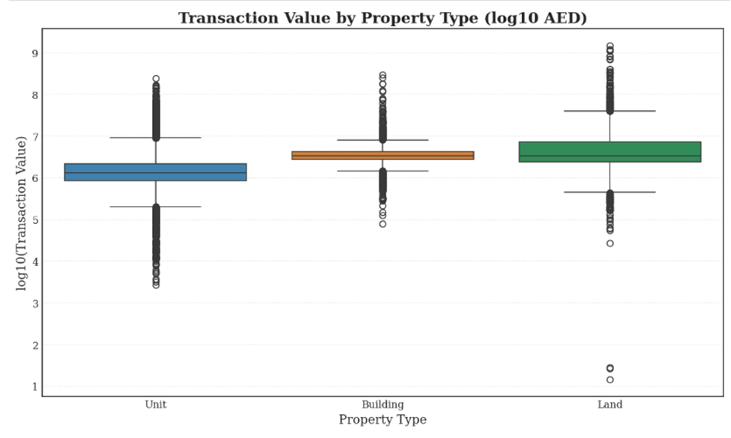

*Transaction Value by Property Type (log10 AED)*

## Business Problem

Mixing apartments, buildings, and land into a single valuation model is a mistake because each property type works differently. They attract different buyers, have unique financing options, and sell at varying speeds.

Combination of apartments, buildings and land into a single valuation model is considered to be a mistake due to each property type working differently. They attract different buyers, have unique financing options and sell at speed that differ.

Treating them the same can cause problems for developers, such as mismatched sales timelines, cash flow problems, and incorrect project plans. For example, a piece of land is considered to be a long term investment, as opposed to an apartment. And marketing an entire building like a single home will miss out on big investors. A tailored strategy will be needed for each type of asset.

## Strategic Solutions

* Run separate ROI models and absorption forecasts for each property type.
* Adjust financing terms: longer tenor for land, faster repayment for high-turnover units.
* Segment marketing: institutional outreach for buildings, retail campaigns for units.

## Financial & Operational Implications

* Higher capital efficiency by aligning financing structure with asset type liquidity.
* Better conversion rates by matching sales approach to buyer psychology.
* Reduced holding risk for slow-moving asset types through tailored disposition plans.

# Transaction value distribution by number of bedrooms

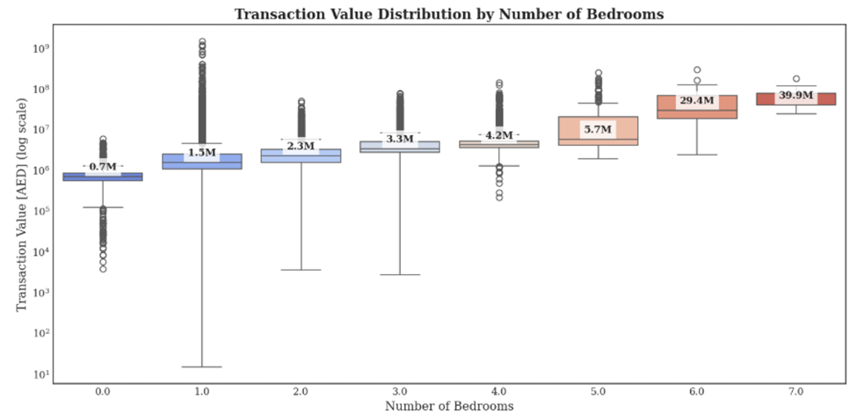

*Transaction Value Distribution by Number of Bedrooms (log scale)*

## Business Problem

Bedroom count drives both size and positioning, but the price curve breaks after 5 B/R units. Failing to separate 6–7 B/R luxury villas from standard inventory can lead to distorted averages and unrealistic appraisals for mid-tier homes. Grouping different types of properties, like standard and luxury, in a single large deal increases risk for both lenders and developers.

## Strategic Solutions

• Separate financial models for 0–5 B/R and 6+ B/R to capture different demand elasticity.

• Market luxury homes with bespoke financing, concierge service tie-ins, and global luxury network exposure.

• For standard inventory, optimize layouts to hit affordability thresholds while retaining aspirational features.

## Financial & Operational Implications

• Maximized profit margins in the luxury segment by justifying premium pricing through experiential value.

• Faster absorption in standard segment by meeting mass affordability without overbuilding.

• Reduced credit risk for lenders through accurate collateral valuation.

# Correlation Matrix

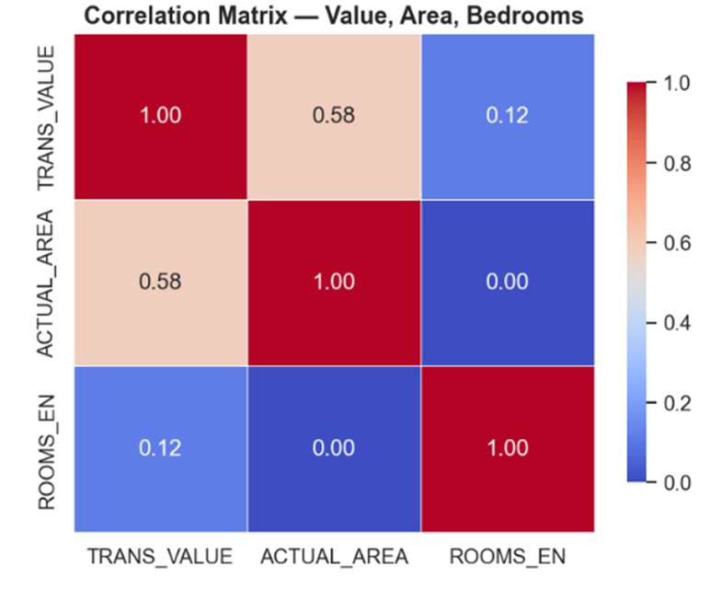

*Correlation Matrix — Value, Area, Bedrooms*

## Business Problem

Due to larger apartments having more bedrooms, the usage of both features in simple pricing models can be problematic. This overlap is known as "Multicolinearity", makes the model unreliable and distorts the true found importance of each factor. For example, if a developer mistakenly builds oversized homes with extra bedrooms, if this model suggests something incorrectly, it will greatly increase the price, leading to a poor return on investment.

## Strategic Solutions

• Prioritize area as a core variable, using bedrooms as a secondary categorical adjustment.

• Apply ridge regression to control for variance inflation when both metrics are essential.

• Cross-validate correlation metrics quarterly to catch shifts in market structure.

## Financial & Operational Implications

• Improved predictive accuracy reduces pricing errors and missed sales windows.

• Better land utilization by aligning build size with actual price drivers.

• Lower financing risk through more stable forecasting models.

# Monthly Trends

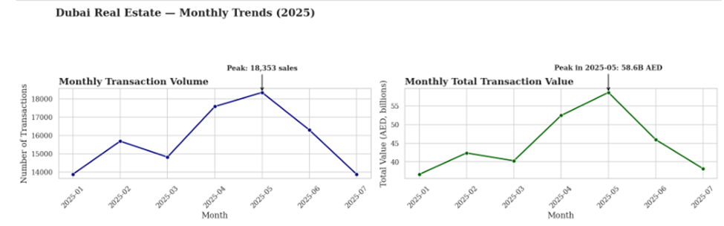

*Dubai Real Estate — Monthly Trends (2025)*

## Business Problem

There is peak demand in april and may offering a bigger chance of getting higher revenue, however this can also create operational challenges, missing this window also means that inventory can sit unsold during slower months, leading to higher costs and also the requirement for discounts. Through not factoring in these seasonal trends when setting prices and launch dates, developers actually miss out on massive amounts of earnings..

## Strategic Solutions

• Align project launches with Q2 peaks and prepare pre-sales campaigns 60–90 days ahead.

• Offer limited-time incentives in slow months to smooth sales curve.

• Integrate seasonal coefficients into pricing models to anticipate market rhythm.

## Financial & Operational Implications

• Increased annual turnover by capitalizing on peak buying seasons.

• Reduced reliance on deep discounts during slow quarters.

• Enhanced investor confidence through predictable sales performance.

# Top 10 Areas by Number of Transactions

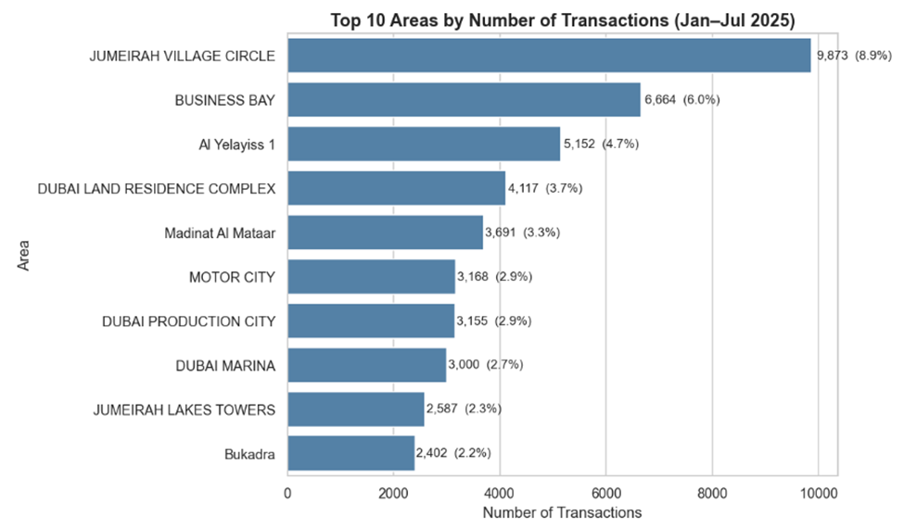

*Top 10 Areas by Number of Transactions (Jan–Jul 2025)*

## Business Problem

Being heavily focused on popular, high-volume areas such as JVC and Business Bay without spreading out investments can lead to big risks. There is very intense competition in these hubs that can lead to price wars, which can massively shrink profit margins. In addition to this, ignoring how quickly properties are selling in a specific sub-market can also result in project delays and expensive, unsold inventory.

## Strategic Solutions

* Diversify portfolio into mid-volume, high-margin areas to balance risk.
* Implement dynamic pricing tied to live absorption data to stay ahead of competitors.
* Bundle amenities with units in competitive hubs to win share without price cuts.

## Financial & Operational Implications

* Maintains price integrity while sustaining market share.
* Faster ROI by reducing unsold stock duration.
* Strengthens competitive positioning in buyer-saturated districts.

# Top 10 Areas by Total Transaction Value

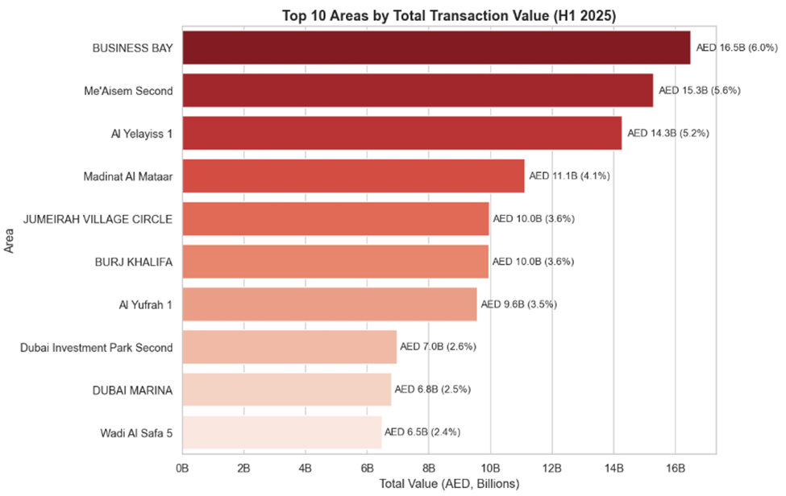

*Top 10 Areas by Total Transaction Value (H1 2025)*

## 

## Business Problem

High-value zones like Business Bay and Burj Khalifa deliver prestige and outsized revenue but suffer from lower liquidity. Overweighting such areas exposes developers to sharper downturn losses if ultra-prime demand contracts. Failure to cross-subsidize with high-turnover projects in other zones can destabilize cash flow.

## 

## Strategic Solutions

* Balance portfolio with both high-value/low-volume and moderate-value/high-volume assets.
* Tailor payment plans and marketing to global investor audiences for ultra-prime projects.
* Leverage brand halo from high-value sales to upsell mid-tier projects.

## 

## Financial & Operational Implications

* Higher blended portfolio ROI through risk-balanced asset allocation.
* Greater resilience against cyclical luxury demand shifts.
* Extended brand reach from luxury segment to broader market tiers.

# 

# Conclusion

Dubai’s residential market in H1 2025 has operated as a dual-speed economy: liquidity is concentrated in high-volume hubs like JVC and Business Bay, while brand prestige and exceptional per-unit revenue are generated in ultra-prime pockets such as Burj Khalifa and Emirates Hills. The analysis shows that treating these segments as one market leads to pricing distortions, poor allocation of marketing budgets, and inefficient portfolio management. By applying segmentation by property type, size, location, and season, and by integrating these variables into predictive pricing and absorption models, stakeholders can unlock significant ROI gains while reducing volatility in sales performance. Equally important is the role of time—synchronizing launches with seasonal peaks and monitoring micro-market absorption rates to preempt oversupply risks. For developers and investors, the next competitive frontier in Dubai real estate lies in operationalizing these insights: deploying agile pricing systems, allocating capital to high-velocity segments without neglecting luxury brand building, and designing product mixes that meet precise demand profiles. A data-informed, strategically segmented approach is no longer optional; it is the decisive factor between market leadership and margin erosion in Dubai’s evolving real estate landscape.

# References

Dubai Land Department (2025) *Dubai residential property transactions January–July 2025*. Dubai: Dubai Land Department.

Economy Middle East (2025) ‘6 reasons why you should invest in Dubai real estate rather than London or New York’, *Economy Middle East*, 28 May. Available at: <https://economymiddleeast.com/news/6-reasons-why-you-should-invest-in-dubai-real-estate-rather-than-london-or-new-york/> (Accessed: 6 August 2025).

The National News (2025) ‘Dubai property market records Dh431bn in transactions in first half of 2025’, *The National News*, 1 July. Available at: <https://www.thenationalnews.com/business/property/2025/07/01/dubai-property-market-records-dh431bn-in-transactions-in-first-half-of-2025/> (Accessed: 6 August 2025).

Dubai Media Office (2025) ‘Dubai real estate market achieves record-breaking performance in H1 2025’, *Government of Dubai Media Office*, 2 July. Available at: <https://mediaoffice.ae/en/news/2025/July/02-07/Dubai-real-estate-market> (Accessed: 6 August 2025).