OUTPUT:

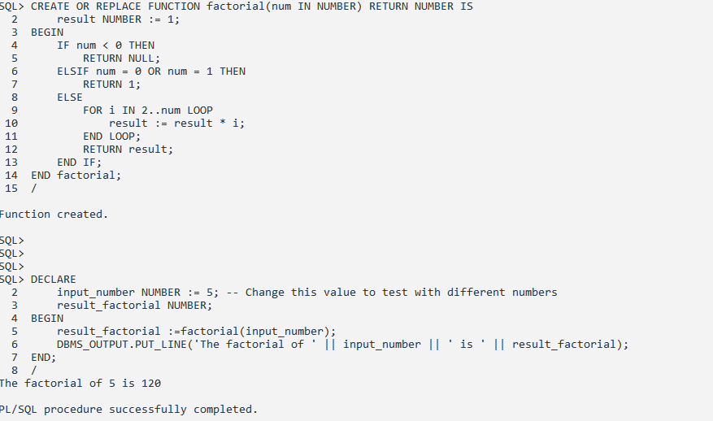

OUTPUT:

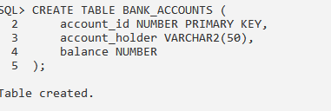

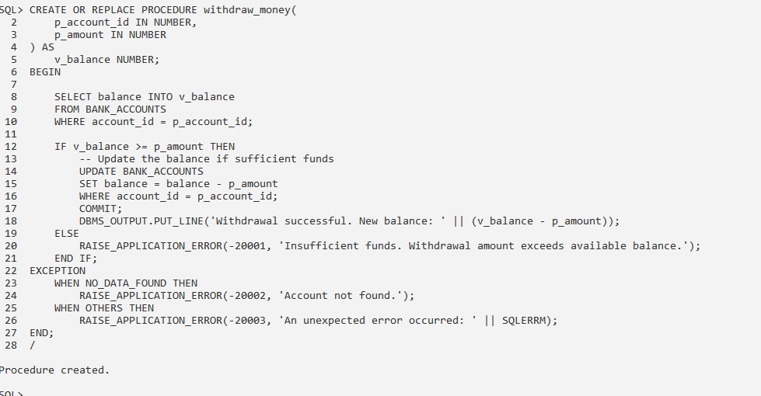

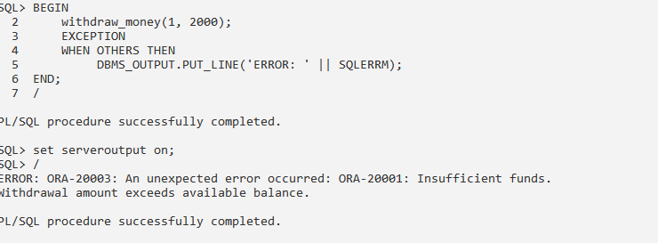

(1,1)

WORKS_ON

EMPLOYEE

DEPARTMENT

PROJECT

Works_on

supervision

(4,N)

(0,N) (0,N)

manager (1,1)

MANAGESS

CONTROLS

(0,N) (1,1) project

supervisor (0,1)

supervise (1,N)

(0,N)

Dependents_of

EMPLOYEE

(1,1) Dependent

DEPENDENT

