**SOMAIYA**

## V I D Y A V I H A R

**K J Somaiya Institute of Technology**

**An Autonomous Institute Permanently Affiliated to the University of Mumbai**

**DEPARTMENT OF INFORMATION TECHNOLOGY**

***Synopsis of IoT based Project On***

Smart Trolley System

Prepared By:

### Aniruddha Zore (Roll No. 52) Rohit Yadav (Roll No. 51) Keyush Thumar (Roll No. 73)

Under the guidance of:

## Mrs. Sarita Rathod

### Department of Information Technology Academic Year: 2022-2023

**Autonomy Syllabus Scheme-II (2022-23) - SEMESTER IV (TY - IT)**

|  |  |
| --- | --- |
|  | **SOMAIYA**  **V I D Y A V I H A R**  **K J Somaiya Institute of Technology**  **An Autonomous Institute Permanently Affiliated to the University of Mumbai** |

**DEPARTMENT OF INFORMATION TECHNOLOGY**

**CERTIFICATE**

This is to certify the following students:

Name of Student 1: **Aniruddha Zore 52**

Name of Student 2: **Rohit Yadav 51** Name of Student 3: **Keyush Thumar 73**

have submitted PBL – IoT Based Project I Report on ***“Smart Trolley System”*** as the partial fulfillment for the requirement of Third Year of Engineering (6th Semester) in T.Y. - Information Technology under my guidance during the academic year 2022-2023.

|  |  |
| --- | --- |
| **Sarita Rathod** | **Dr. Radhika Kotecha** |
| **Project Guide** | **Head of Department** |
| **Assistant Professor** | **Associate Professor** |
| **Department of Information Technology** | **Department of Information Technology** |

### Date of Examination:

**Signature of Internal Examiner Signature of External Examiner**

# Table of Contents

|  |  |
| --- | --- |
| Acknowledgment | i |
| Abstract | ii |
| Introduction | 1 |
| Literature Review | 5 |
| Functionalities of Proposed System | 9 |
| Implementation Details and Results | 14 |
| Conclusion | 17 |
| References | 18 |

**Acknowledgement**

We express our deepest gratitude to all those who have guided us during the course of our project titled **“Smart Trolley System”**. Our heartfelt thanks go out to **Dr. Suresh Ukarande**, our principal, and **Dr. Sunita Patil**, our Vice-Principal, for providing us with the necessary resources and facilities for our research.

We would like to acknowledge the unwavering support and encouragement of **Dr. Radhika Kotecha**, Head of Department, for her consistent motivation throughout the project. Furthermore, we extend our sincere appreciation to our project guide, **Prof. Sarita Rathod**, for her exceptional mentorship, expertise, and valuable advice.

We are grateful to have had the opportunity to work with such a remarkable team, and we thank everyone for their unwavering support and guidance.

# Abstract

The primary objective of our project is to streamline, simplify and reduce human effort and time required while evaluating and paying shopping bills. We understand that all customers have to spend a lot of time in long queues waiting for payment of shopping bills. Our project aims to eradicate long queues by using Internet of Things technology.Through our IoT enabled system users can tap the RFID based labels on the product they want to buy, on the device. Whenever user wants to discard the product again re-tap the product’s label. Whenever user buys a product a green LED blinks and whenever user discards something a red LED blinks resulting into user-friendly and easy to use system. Hence this system becomes an optimal solution to long queues.

We recognize that long queues and payment of shopping bills takes time and hence, consumes man power and time of crowd waiting in the queues. This is w here IoT comes in, ensuring seamless shopping experience and alleviating user concerns.

Our Smart Trolley model is based on Radio Frequency Identification Technology. By enabling rapid communication between various components of our system like RFID tags, reader, Wi-Fi based module, web-server, etc. To further simplify the process, we have added two LEDs i.e. Green and Red LEDs indicating buying and discarding of objects. Our experimental results demonstrate that our recommended system yield better shopping experience, providing reliable Smart Trolley System for both large-scale and small-scale shopping centers.

In addition to automated bill generation, we also provide a channel through which users can make payment once they complete shopping through Razor-Pay.

Overall, KARV aims to enhance the shopping experience for users by reducing waiting time due to long queues efficiently, payment gateway making shopping less time-consuming, easy, and stress-free.

# Chapter 1: Introduction

In today's fast-paced world, where time is of the essence, waiting in long queues to pay for our shopping bills has become a common and frustrating occurrence. Recognizing this issue, our project aims to revolutionize the shopping experience by leveraging cutting-edge Internet of Things (IoT) technology to streamline, simplify, and significantly reduce the human effort and time required in the process of evaluating and settling shopping bills. Our innovative system, known as the "Smart Trolley," is designed to eradicate long queues and make shopping more user-friendly and efficient.

The core of our solution lies in the integration of Radio Frequency Identification (RFID) technology. Shoppers can effortlessly interact with our IoT-enabled system by simply tapping RFID-based labels on the products they intend to purchase, all within the convenience of our smart trolley device. When a user selects an item for purchase, a green LED light blinks, providing a clear visual confirmation. Conversely, when a user decides to discard a product, a red LED light blinks. This intuitive and straightforward system is a significant step toward enhancing the shopping experience, eliminating the need for arduous queues, and providing a time-saving and user-friendly solution.

Long queues not only consume valuable time but also require considerable manpower to manage and cause frustration for those waiting. This is where IoT technology comes to the rescue, ensuring a seamless shopping experience and addressing the concerns of both shoppers and shopping center operators.

Our Smart Trolley model offers rapid communication between various system components, including RFID tags, readers, Wi-Fi-based modules, and web servers. To further enhance the user experience, we have incorporated green and red LEDs, providing a visual cue for the buying and discarding of items, respectively. Our extensive experimental results have demonstrated that our proposed system not only streamlines the shopping process but also enhances the shopping experience, making it a reliable and efficient solution for both large-scale and small-scale shopping centers.

Our system goes beyond simplifying the shopping process. In addition to automating bill generation, we offer a secure channel through which users can complete their payment conveniently using Razor-Pay, reducing the time spent on the final stages of the shopping journey.

Overall, our project, named KARV (Keeping Automated Retail Virtuous), is dedicated to elevating the shopping experience for users. We aim to minimize the inconvenience caused by long queues, provide an efficient and stress-free payment gateway, and ultimately make shopping a more pleasant and expedited process. In the following sections, we will delve into the intricacies of our Smart Trolley system and how it can revolutionize the way we shop, while benefiting both consumers and retailers alike.

## Motivation

The motivation behind embarking on this project is rooted in the recognition of the persistent challenges that shoppers face in today's retail landscape. Long queues at checkout counters have been a perennial frustration, and the time and effort spent waiting to settle shopping bills have continued to be a major pain point for customers. This motivation arises from a deep understanding of the issues that plague the shopping experience and a commitment to making it more convenient and efficient.

1. **Time Efficiency**: Time is a valuable resource in our fast-paced lives. The motivation to develop the Smart Trolley system is driven by the desire to help shoppers regain control over their time. By eliminating long queues and reducing the time spent on bill settlement, we aim to offer shoppers more time to enjoy the things that truly matter to them.
2. **Customer Satisfaction**: A seamless and stress-free shopping experience significantly contributes to customer satisfaction. Motivated by the desire to see shoppers leave stores with smiles on their faces, we believe that the Smart Trolley system has the potential to make shopping a more enjoyable activity.
3. **Resource Optimization**: Long queues not only inconvenience customers but also strain the resources of shopping centers, which need to allocate manpower to manage these lines. The motivation to adopt IoT technology is rooted in the optimization of resources. By automating the shopping process, we aim to reduce the manpower required at checkout counters, allowing retailers to allocate their resources more effectively.
4. **Technological Advancements**: IoT technology is at the forefront of innovation, offering exciting possibilities in various domains. The motivation for our project is to harness the potential of IoT to transform the retail industry. By combining RFID technology, web servers, and a user-friendly interface, we aim to bring the latest technological advancements to the everyday shopping experience.
5. **Enhancing Convenience**: In a world where convenience is king, the motivation behind this project is to provide shoppers with a convenient, user-friendly, and intuitive solution. By offering a payment gateway and product selection process that are easy to use, we intend to make shopping less time-consuming and more convenient.

**1.2 Problem Analysis**

The traditional process of shopping and settling bills at retail stores has long been plagued by several persistent issues, necessitating a more efficient and user-friendly solution. Our project, the Smart Trolley System, seeks to address these problems by employing IoT technology and RFID-based communication. The following problem analysis outlines the significant challenges faced by both shoppers and retailers in the current shopping landscape:

1. **Long Queues and Time Consumption**: One of the most pressing issues is the presence of long queues at checkout counters. Shoppers are required to spend a substantial amount of time waiting in line to pay for their items, resulting in an inefficient and time-consuming shopping experience.
2. **Manpower and Infrastructure Costs**: Managing long queues necessitates a considerable investment in human resources and infrastructure for retailers. The need for additional cashiers and checkout counters further increases operational costs.
3. **User Frustration and Stress**: Waiting in long queues is a common source of frustration and stress for shoppers. This negative experience can impact customer satisfaction and deter potential repeat visits to the store.
4. **Inefficient Payment Processing**: The traditional payment process often involves manual scanning or entry of product details, which can lead to errors, delays, and inefficiencies in the billing process.
5. **Limited Payment Options**: Some stores have limited payment options, which can be inconvenient for shoppers who prefer diverse payment methods such as digital wallets, credit cards, or online payment gateways.
6. **Shoplifting and Product Loss**: In crowded stores, shoplifting can be a concern. Existing systems may lack robust mechanisms to prevent or detect theft effectively.
7. **Lack of Real-time Information**: Shoppers may lack access to real-time information about the cost of their selected items as they shop, making it challenging to manage their budgets and make informed purchase decisions.
8. **Environmental Impact**: Traditional paper receipts generate a significant amount of waste, contributing to environmental concerns. Finding a more sustainable way to generate and manage bills is increasingly important.

The Smart Trolley System, as outlined in our project, aims to mitigate these challenges by introducing an IoT-based solution that not only simplifies the shopping process but also offers real-time billing information, diverse payment options, and efficient anti-shoplifting measures. By addressing these problems, our project offers a comprehensive and innovative approach to enhancing the shopping experience while benefiting both consumers and retailers. The subsequent sections of this synopsis will delve into the technical details and features of our solution, demonstrating how it effectively tackles these issues and transforms the shopping landscape.

* 1. **Objectives**
* The primary objective is to streamline the shopping process, making it more efficient and reducing the time spent in queues for bill payment.
* The system aims to eradicate the problem of long queues at shopping centers by utilizing IoT technology.
* The Smart Trolley will provide a user-friendly interface through RFID-based product labeling and visual cues using LED lights for buying and discarding items.
* By automating the shopping bill generation and payment process, the system aims to reduce the dependency on human cashiers, thereby saving on manpower costs.
* The Smart Trolley system can provide real-time data on product selections, enabling shopping centers to manage their inventory more effectively.
* The system aims to leverage the collected data to provide personalized shopping experiences for customers, making it easier for them to find and purchase the products they need.
* In addition to simplifying the shopping process, the system will offer a secure payment gateway, ensuring the safe and convenient completion of transactions.
* The Smart Trolley system is designed to cater to both large-scale and small-scale shopping centers, offering a versatile solution that can adapt to various retail environments.

## Scope

The Smart Trolley system, powered by IoT technology and RFID integration, offers a wide scope for revolutionizing the retail shopping experience. This innovative solution aims to streamline the entire shopping process, from item selection to payment, while eliminating the need for lengthy checkout queues. Its applications extend to a diverse range of retail environments, encompassing large-scale supermarkets, department stores, and convenience stores, as well as smaller-scale boutique shops. The system not only benefits consumers by saving time and reducing shopping-related stress but also presents substantial advantages for retailers in terms of efficient inventory management and customer satisfaction. Additionally, the Smart Trolley system opens up possibilities for future enhancements, such as personalized shopping recommendations and data analytics, enabling retailers to make informed decisions and further enriching the shopping experience for all stakeholders. Its scalable nature and adaptability to various retail settings make possible.

# Chapter 2: Literature Review

* 1. **Related Work**

### Shopping is really fascinating and alluring; at the same time, it involves getting tired due to standing in a long queue for the bill and payment process. Hence, it is proposed to design a smart trolley which can take care of shopping and billing. By this, the customer can walk straightaway into the shop, purchase products using the smart trolley and walk out of the shop. He gets the e-bill through the mail, and he can view his purchase details using the shop's website. In order to realize this, we need an Arduino board, Radio-Frequency Identification (RFID) reader, RFID tag, LCD display, ESP8266 Wi-Fi module, database manager and a website to maintain product and customer details, which can be accessed by the admin anywhere in the world. This is an IOT based system where the trolley can interact with the network spread worldwide.

### In this fast-running world, time is one of the precious things. People who are shopping in malls and supermarkets spend a lot of time waiting at the billing counter. Tackling this problem and considering the flaws in the current billing system paved the way for the development of an automatic smart trolley for supermarkets. This trolley saves customers’ time and effort by reducing the amount of time they need to spend at the billing counter, during their shopping. Based on the Node MCU (ESP8266) microcontroller and RFID tags, this project scans products. The scanned products will be displayed on the OLED screen which helps the customer to keep track of the total items along with the total cost. This makes the customer enjoy shopping and thus saves time.

### Literature Review: Summary

### The literature review for the Smart Trolley system project examines the role of IoT technology in reshaping the retail industry. Key points include the significance of IoT in retail, the use of RFID technology for product identification, Amazon Go's impact on cashierless stores, the emergence of Smart Shopping Carts, the influence of mobile shopping apps, the adoption of retail automation and self-checkout, the integration of secure payment gateways, and the associated challenges. The review also identifies future trends, such as the potential convergence of AR and AI with IoT. The project aims to bridge existing gaps by offering an innovative Smart Trolley system that combines RFID, IoT, and secure payments to streamline the shopping experience and enhance customer satisfaction.

### Looking forward, the future of IoT-enabled retail presents a wealth of possibilities. One notable trend is the integration of augmented reality (AR) and artificial intelligence (AI) with IoT technology. This fusion offers the potential for highly personalized shopping experiences. With AR, shoppers can receive real-time information about products, reviews, and promotions simply by scanning items with their mobile devices. AI, on the other hand, enables predictive analytics, allowing retailers to anticipate customer preferences and optimize inventory management. The synergistic effect of these technologies promises to make shopping not only convenient but highly tailored to individual preferences, revolutionizing the way we shop.

### While the potential for IoT in retail is immense, challenges need to be addressed for successful implementation. Security and privacy concerns regarding the collection and use of customer data remain at the forefront. Retailers must invest in robust data protection measures and transparent policies to build and maintain trust with their customers. Additionally, the cost of implementing IoT technology can be substantial. However, the long-term benefits, including improved operational efficiency and enhanced customer experiences, often outweigh these initial investments. As the technology matures and economies of scale are achieved, these challenges are likely to diminish, further incentivizing the adoption of IoT in the retail sector.

### In this context, the Smart Trolley system proposed in our project emerges as a solution that not only builds upon the existing literature and technological innovations but also addresses these challenges. By combining RFID technology for product identification, IoT for real-time data processing, and secure payment gateways like Razor-Pay, our project aims to streamline the shopping experience, eliminate long queues, and create a user-friendly, efficient, and secure environment for both customers and retailers. This project, thus, aligns with the broader trends and challenges in IoT-enabled retail while offering a unique and practical solution to enhance the shopping journey.

* 1. **Existing System**

The concept of Smart Trolley systems, driven by the convergence of IoT technology and retail, has garnered significant interest and innovation in recent years. As we embark on our project to enhance the shopping experience, it is important to acknowledge and understand the existing research and implementations in this field. Here, we provide a brief overview of the related work that has influenced and contributed to the development of our Smart Trolley system.

1. **Amazon Go:**

Amazon's cashierless stores have set a precedent in the retail industry. The Amazon Go stores employ a combination of computer vision, sensor fusion, and deep learning to enable shoppers to walk-in, pick up items, and walk out without going through a traditional checkout process. This pioneering approach has redefined the shopping experience by eliminating the need for physical queues and cashiers.

1. **RFID-Based Shopping Carts:**

Several projects and research studies have explored the use of RFID technology in shopping carts to track items added to the cart, generate a virtual bill, and expedite the checkout process. RFID tags on products and readers on the cart facilitate seamless inventory management and provide a foundation for frictionless transactions.

1. **Smart Shopping Apps:**

Mobile applications that assist shoppers in navigating stores, creating shopping lists, and locating products have become commonplace. These apps often incorporate barcode scanning and payment integration to simplify the shopping process. Examples include Walmart's Scan & Go and Kroger's Scan, Bag, Go.

1. **Retail Automation Systems:**

Large retail chains and supermarkets have been investing in automation to enhance the shopping experience. Self-checkout kiosks, automated bagging systems, and the integration of loyalty programs have all aimed at reducing waiting times and streamlining the payment process.

1. **IoT-Driven Retail Solutions:**

IoT technology has found applications in retail beyond just Smart Trolley systems. Smart shelves that monitor inventory, temperature-controlled supply chain management, and personalized shopping experiences based on IoT data are emerging trends in the industry.

1. **Payment Gateways:**

Online payment gateways and digital wallets have gained widespread acceptance for online shopping. However, integrating such secure and efficient payment methods into physical retail stores is an area of active development. Razor-Pay, for instance, offers a platform that could be integrated into the Smart Trolley system to streamline payments.

# Chapter 3: Functionalities of Proposed System

## Proposed Approach and Details

The objective of the proposed system is to enhance the existing facilities by addressing its limitations. By incorporating advanced features, the proposed system can provide better security and reduce manual workload. It aims to offer an improved user experience and overcome the shortcomings of the current system.

### Block Diagram:

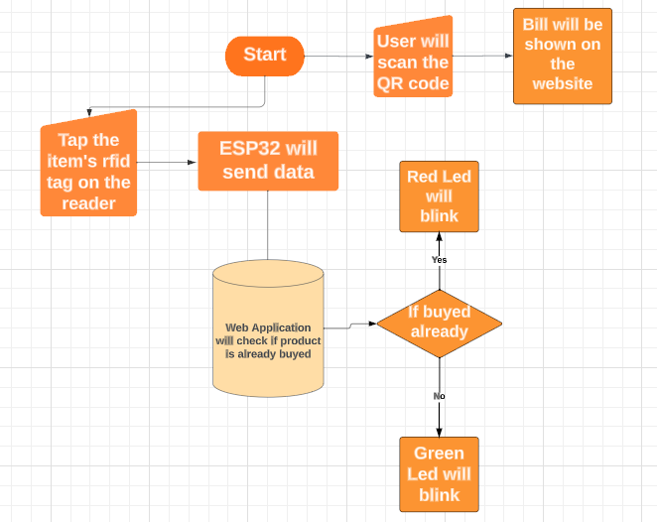

Fig. 3.1: Block Diagram

A block diagram is a diagram of a system in which the principal parts or functions are represented by blocks connected by lines that show the relationships between them. It is a visual representation of a system or process that uses blocks to depict the system's components or stages, and arrows or lines to illustrate their interactions. Our system is divided into two distinct models: the Parameter Tracking model, in which the user enters data that is then verified with live data, and the user is notified via email. The second model is Paper Trading, where the user is provided with some fake coins to perform virtual trading for training purposes. Both models can be used interchangeably and together develop the basic trading skills of beginners and advance the skills of experienced traders.

### System Architecture Diagram:

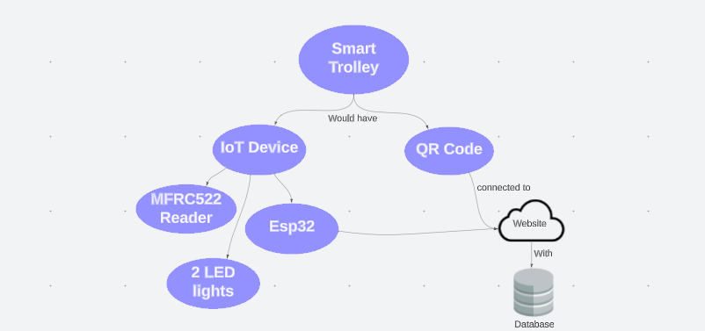

Fig. 3.3: System Architecture Diagram

A system architecture is the conceptual model that defines the structure, behavior, and more views of a system. An architecture description is a formal description and representation of a system, organized in a way that supports reasoning about the structures and behaviors of the system.

## Timeline

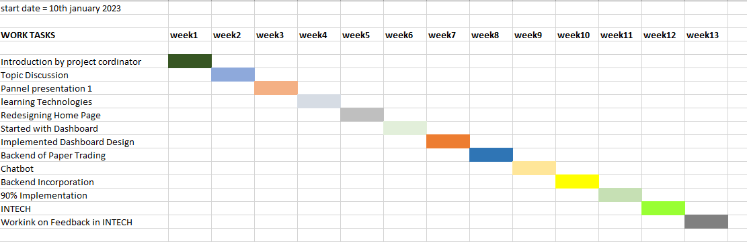

Fig. 3.4: Timeline chart

This chart illustrates the progress of work throughout the week, serving as a valuable tool to ensure timely completion of project tasks. By tracking work progress, this chart helps to maintain focus and stay on schedule, ensuring that project goals are achieved within the specified timeframe.

## Roles and Responsibilities

The tasks for the project were divided in the following manner:

### Frontend:

* Developing User Interface and redesigning the parameter and landing page of website. (Aniruddha Zore)
* Designing and developing User Dashboard for paper Trading. (Viral Makwana)

### Backend:

* Reconfiguring the backend of parameter to stock notification system. (Aniruddha Zore)
* Developing backend for ChatBot. (Keyush Thumar)
* Developing Backend for Dashboard and paper Trading. (Rohit Yadav)

### Documentation:

* Documenting the project by creating synopsis of entire research survey and project implementation. (Viral Makwana and Rohit Yadav)

## Software Lifecycle Model

This section shows the flow of information through a system. Each process transforms inputs into outputs.

### The Choose of SDLC: Waterfall Model

A waterfall model is a sequential (non-iterative) design process, used in software development processes, in which progress is seen as flowing steadily downwards through the phases of conception, initiation, analysis, design, construction, testing, implementation and maintenance. The first phase of the waterfall model is a Requirements in which the developers of the system needed to know what are needed in the system or what is really the clients want in that system in order to meet their satisfaction. Once the client is satisfied with the use of the waterfall model, the developers can draw up the specification document with some assurance that the product meets the client’s real need. So therefore, proponents used the waterfall methodology for the Smart trolley System.

* + - The waterfall model assures that the software meets the user requirements. The working prototype has been validated through the interaction with the client, it is reasonable to expect that the resulting specification is based on the user requirements.
    - Waterfall model is appropriate and useful in this study since it is not a complicated system.
    - With the use of the waterfall model, we can see the progress of the project as it goes to its completion.
    - Since every phase of this model means completion, we think the waterfall model is suitable for this project.

### Requirement analysis

In this phase the proponents fully understand the problems from the informants. The proponents asked questions regarding the system they currently used in their inventory. The proponents also asked on how the process being made during pull-in and pull-out of items. Every question that was answered by the informants are listed in order to analyze the need to build the product requirements.

### Design phase

The proponents design and layout of the new system according to the gathered information from the informants. The proponents designed the layout of the system based from the gathered information. And in this phase the proponents started to analyze the data gathered and started the documentation in each requirement.

### Implementation phase

In this phase, the proponents started to implement the prototype of the system. The coding of the system was done by our project manager. The coding was takes about a month until the system is functional.

### Verification and Testing

Before the system was released to the client’s, the proponents test the functionality of the system as it based on the problem from the informants. The proponents make sure that the system is fully functional in order to meet the client’s satisfaction. Testing was being done in every there’s some adjustments of the system.

### Maintenance

The proponents knew that there would still be updates and patches every year to maintain the system more stable and more efficient. There are some issues which come up in the client environment. To fix those issues, patches are released and also to enhance the product some better versions are released. Maintenance is done to deliver these changes in the customer environment.

Fig 3.4: Waterfall Model

# Chapter 4: Implementation Details and Results

## Technology Stack

* + - RFID tags are attached to products, and RFID readers are integrated into the trolley. These components enable item identification and tracking.
    - ESP32 is a versatile and powerful microcontroller that can be used as the brain of the Smart Trolley system. It provides Wi-Fi and Bluetooth connectivity, making it suitable for IoT applications.
    - Python is a popular high-level programming language known for its simplicity and versatility, with applications ranging from web development to artificial intelligence and data analysis.
    - HTML, CSS, and JavaScript are fundamental web development technologies used for creating and styling web pages and adding interactive elements to them.
    - Django is a high-level Python web framework that follows the model-view-controller (MVC) architectural pattern, offering a streamlined development experience for building scalable and maintainable web applications.

## Implementation Parameters

|  |  |
| --- | --- |
| Language | Python |
| Database | Django |
| Browser | Mozilla, Chrome and Safari |
| Microcontroller | ESP32 |
| Sensor | MFRC522 |

Table 4.1: Software Requirements

## Preliminary Results and Analysis

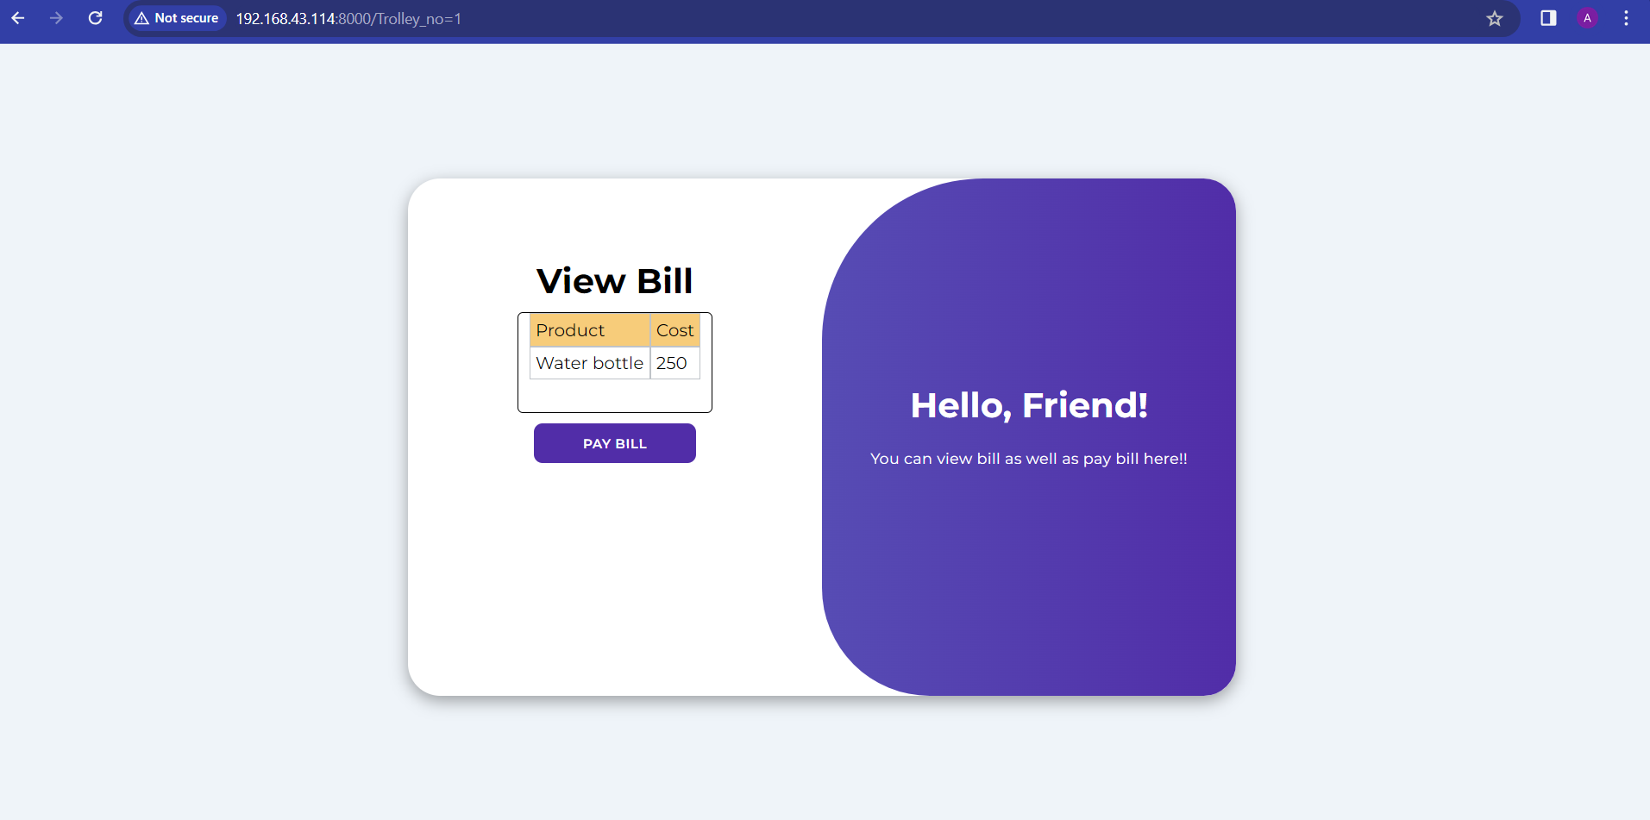

Fig. 4.1: Front Page

This is the main or front or landing page, where users will land after scanning the QR code.

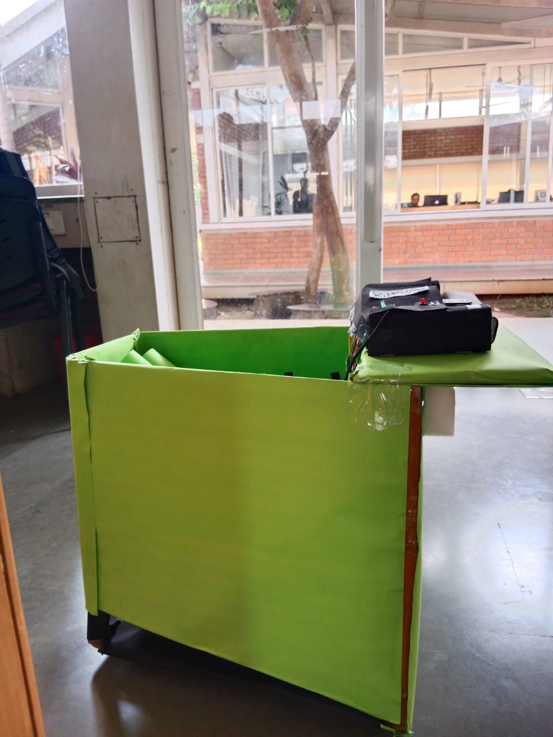

Fig. 4.2: Main Trolley

This figure illustrates our main trolley which customers will use in the shopping mall.

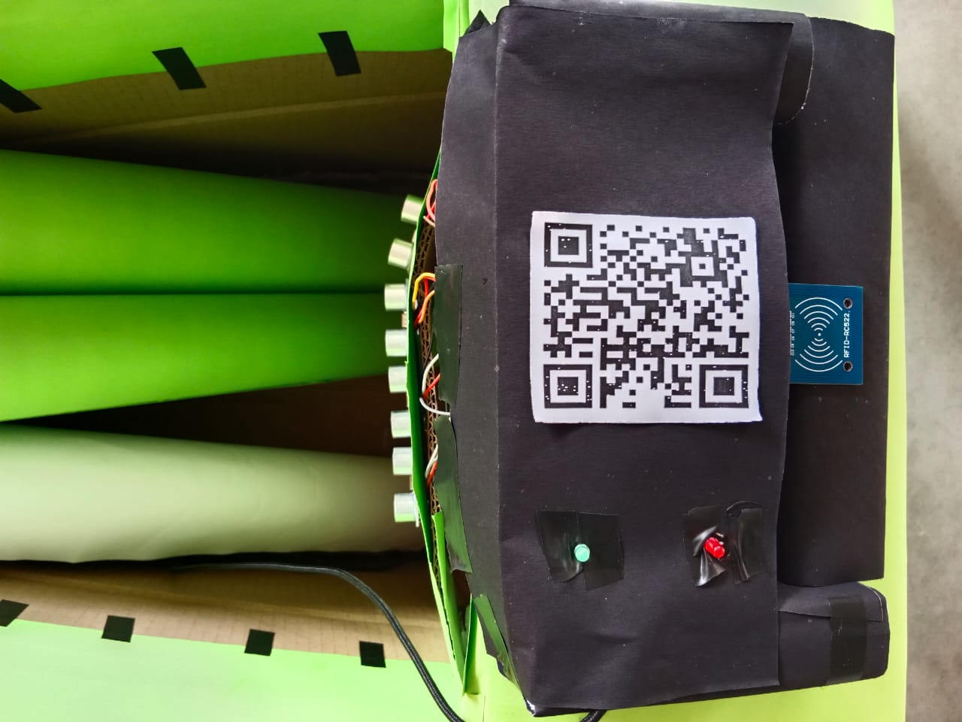

Fig. 4.3: QR code And RFID reader

This QR code allows users to view bill and the RFID reader can read the product when the RFID tag is bought close to it .

# Conclusion

In conclusion, the Smart Trolley project, developed by KARV, represents a significant advancement in the realm of retail shopping by harnessing the power of IoT technology. The primary goal of this innovative system is to streamline the shopping experience, reduce human effort, and eliminate the frustrations associated with long queues during the payment process. By allowing users to interact with RFID-based labels on products, our system simplifies the purchasing and discarding of items, providing a user-friendly and efficient solution.

This project addresses the real-world issues of long queues and time-consuming payment procedures. By leveraging IoT technology, we offer a seamless shopping experience that benefits both shoppers and retailers. With the successful integration of RFID technology, Wi-Fi communication, and the addition of green and red LEDs for visual feedback, we have demonstrated that our system can provide a reliable and convenient shopping solution for both large and small-scale shopping centres.

Furthermore, our system does not stop at simplifying the shopping process. We have incorporated an automated bill generation feature and a secure payment gateway through Razor-Pay, which further reduces the time and effort involved in finalizing purchases. The result is a more efficient, stress-free, and enjoyable shopping experience for all.

The Smart Trolley project aligns with the evolving landscape of retail, catering to the demands of a fast-paced world where time is a valuable commodity. By reducing waiting times, streamlining payments, and enhancing the overall shopping experience, our project aims to make a significant contribution to the retail industry.

As we move forward, we anticipate that the implementation of our Smart Trolley system will not only benefit individual shoppers but also lead to improved operational efficiency and customer satisfaction for shopping center owners and operators. This project symbolizes the future of retail shopping, where convenience, efficiency, and customer satisfaction take center stage. With KARV's commitment to continuous innovation, we look forward to seeing this technology reshape the way we shop in the coming years.

**IEEE Papers**

# References

1. T. K. Das, A. K. Tripathy and K. Srinivasan, "A Smart Trolley for Smart Shopping," *2020 International Conference on System, Computation, Automation and Networking (ICSCAN)*, Pondicherry, India, 2020, pp. 1-5, Doi: 10.1109/ICSCAN49426.2020.9262350.
2. R. R, S. S. N. P, S. P. S, Y. M S and R. R, "Automated Smart Trolley System using RFID Technology," 2023 2nd International Conference on Advancements in Electrical, Electronics, Communication, Computing and Automation (ICAECA), Coimbatore, India, 2023, pp. 1-4, Doi: 10.1109/ICAECA56562.2023.10199259.
3. R. R. Vallabhuni, S. Lakshmanachari, G. Avanthi and V. Vijay, "Smart Cart Shopping System with an RFID Interface for Human Assistance," 2020 3rd International Conference on Intelligent Sustainable Systems (ICISS), Thoothukudi, India, 2020, pp. 165-169, Doi: 10.1109/ICISS49785.2020.9316102.
4. V. Chokshi, M. Shah, P. Mehta, M. Vairale, S. Mehta and K. Talele, "Implementation of RFID-based Lab Inventory System," 2022 IEEE Bombay Section Signature Conference (IBSSC), Mumbai, India, 2022, pp. 1-5, Doi: 10.1109/IBSSC56953.2022.10037518.

### Websites

* + https://www.electronicwings.com/esp32/rfid-rc522-interfacing-with-esp32
  + https://www.donskytech.com/esp32-rfid-web-server/
  + https://www.donskytech.com/arduino-rfid-database-security-system-designing-the-project/
  + https://randomnerdtutorials.com/esp32-esp8266-mysql-database-php/