CUSTOMER CHURN ANALYSIS & PREDICTION
Saiket Systems – Data Analysis Internship
Professional, Simple & Business-Focused Project Report

1. Executive Summary
This project analyzes 7,043 telecommunications customers to understand churn, segment customers, predict churn probability, and translate the findings into retention actions. The observed churn rate is 26.54%. A Logistic Regression baseline achieved 80.55% accuracy and 0.842 ROC-AUC on the held-out test set.

2. Business Problem
The business wants to understand which customer groups have higher observed churn and which current customers may have higher predicted churn risk. The analysis therefore combines descriptive analytics, segmentation, machine learning, and customer-value analysis.

3. Project Objectives
- Clean and prepare the customer data.
- Measure and visualize churn patterns.
- Segment customers by tenure, monthly charges, and contract.
- Build and evaluate a Logistic Regression churn prediction model.
- Estimate customer value using a simple historical revenue proxy.
- Identify active customers with high predicted churn risk and higher customer value.
- Create simple, data-driven retention recommendations.

4. Dataset Overview
Metric | Value
Customers | 7,043
Columns | 21
Churned customers | 1869
Observed churn rate | 26.54%
Blank TotalCharges handled | 11
Duplicate rows | 0

5. Task 1 – Data Cleaning & Preprocessing
TotalCharges was converted from text to numeric format. Its blank values were converted to missing values and filled with 0 because those records have zero tenure. Duplicate records were checked. customerID was excluded from machine learning because it is an identifier. Categorical variables were one-hot encoded and numerical variables were standardized inside the prediction pipeline.

6. Task 2 – Exploratory Data Analysis
The following are observed relationships in this dataset. They are useful for analysis but do not by themselves prove that a variable causes churn.
- Overall observed churn rate: 26.54%.
- Month-to-month customers: 42.7% observed churn; one-year: 11.3%; two-year: 2.8%.
- 0–6 month customers: 52.9% observed churn; 61–72 month customers: 6.6%.
- Electronic-check customers: 45.3% observed churn.
- Fiber-optic customers: 41.9% observed churn.

7. Task 3 – Customer Segmentation
Customers were segmented using tenure, monthly charges, and contract type. To avoid unstable results from tiny groups, segments with fewer than 50 customers were excluded from the main comparison. The highest observed-churn segment was New (0-12) + High + Month-to-month at 73.5%.

8. Task 4 – Churn Prediction Model
Logistic Regression was used as a baseline model because it is simple to explain and produces a churn probability. The dataset was split 80/20 using stratification. Encoding and scaling were performed inside the pipeline.
Metric | Result
Accuracy | 80.55%
Precision | 65.72%
Recall | 55.88%
F1-score | 60.40%
ROC-AUC | 0.842
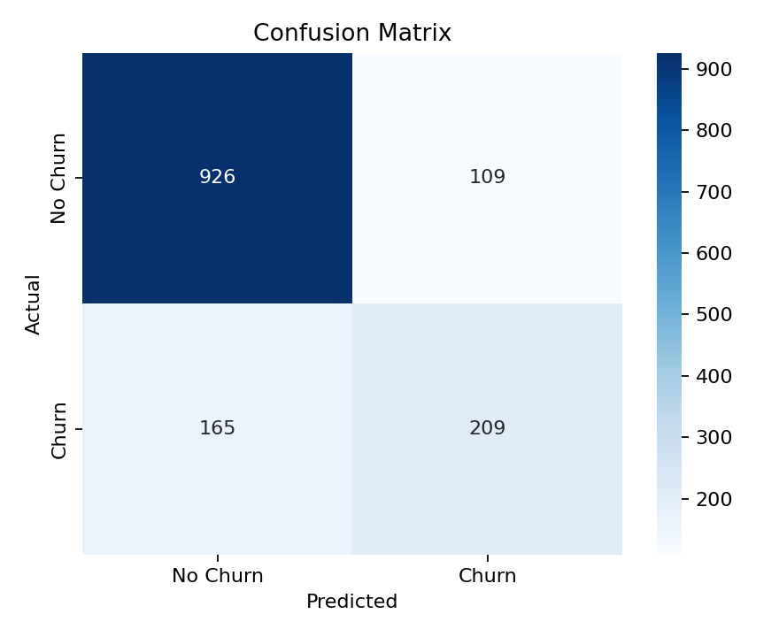
Confusion matrix: TN=926, FP=109, FN=165, TP=209. Recall of 55.88% means the model identified that share of actual churn cases in the test set.
Prediction interpretation:
- A higher predicted probability means the model sees the customer as more similar to customers who churned in the training data.
- A prediction is not a guarantee. Retention decisions should be validated against future customer behavior.
- Accuracy alone should not be used to judge the model; recall, precision, F1-score and ROC-AUC are also important for churn analysis.

9. Task 5 – Customer Retention & Business Logic
Estimated LTV is calculated as MonthlyCharges × Tenure. This is a simple historical revenue proxy, not a complete financial lifetime-value model.
Using project-defined thresholds (<40% Low, 40–70% Medium, ≥70% High), 496 customers are classified as High Risk. Under the strict High Value + High Risk definition, 0 active customers fall into that group.
Because the strict threshold can produce a small or empty priority group, the business can also review the top active High Value customers by predicted probability. The highest current probability in that group is 68.2%.
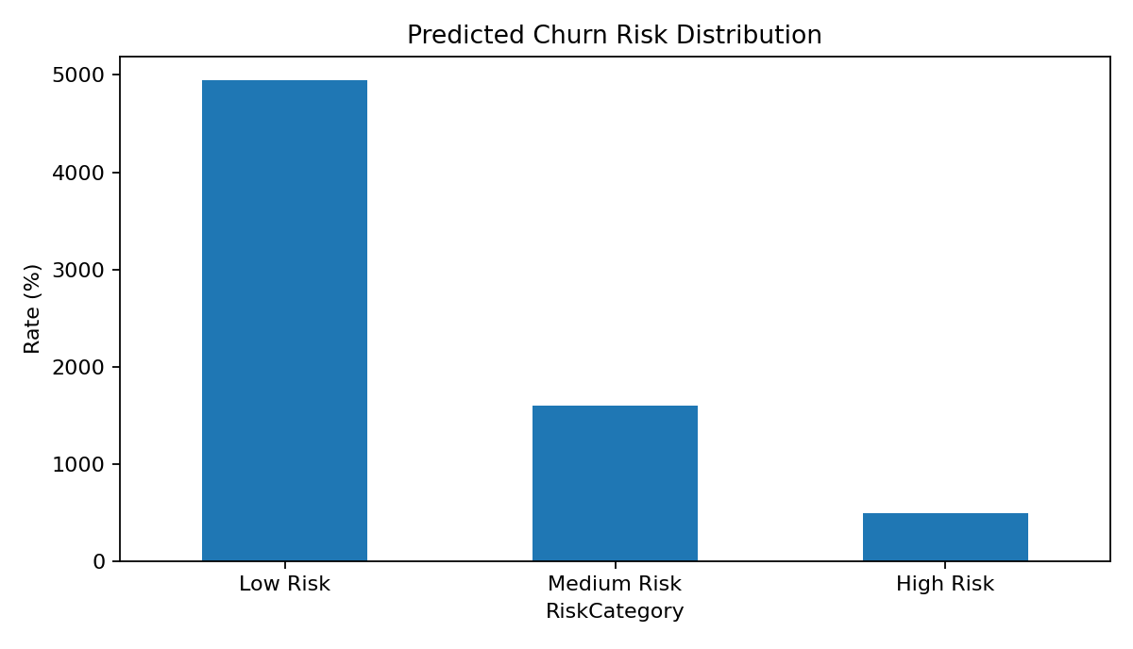

10. Task 6 – Advanced Visualizations
The internship task calls for deeper visualizations such as box plots, violin plots, and pair plots. The following visuals were created to support the analysis.
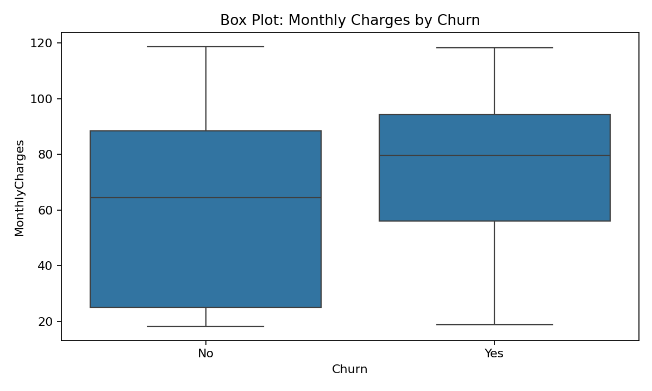
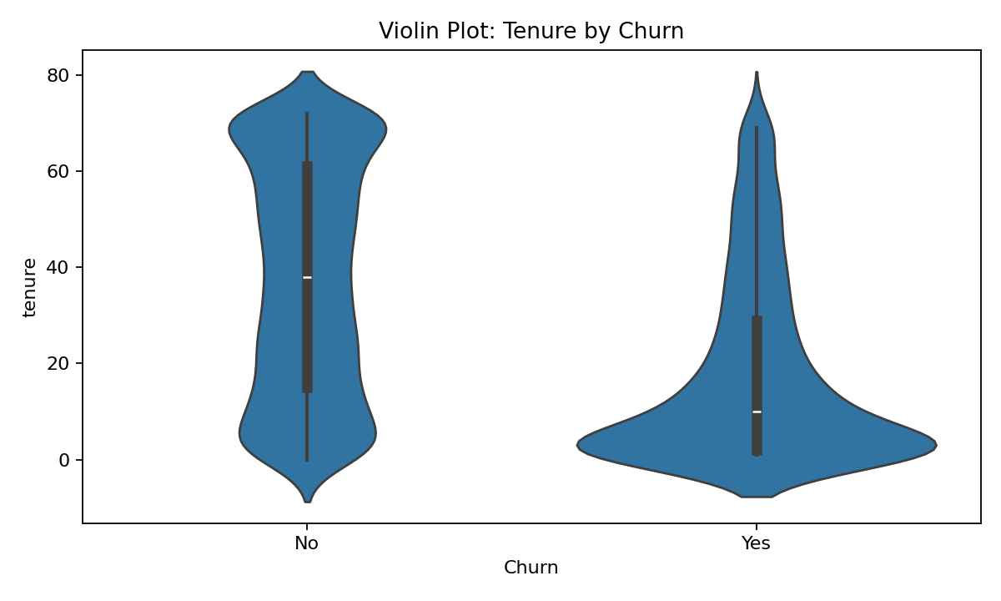
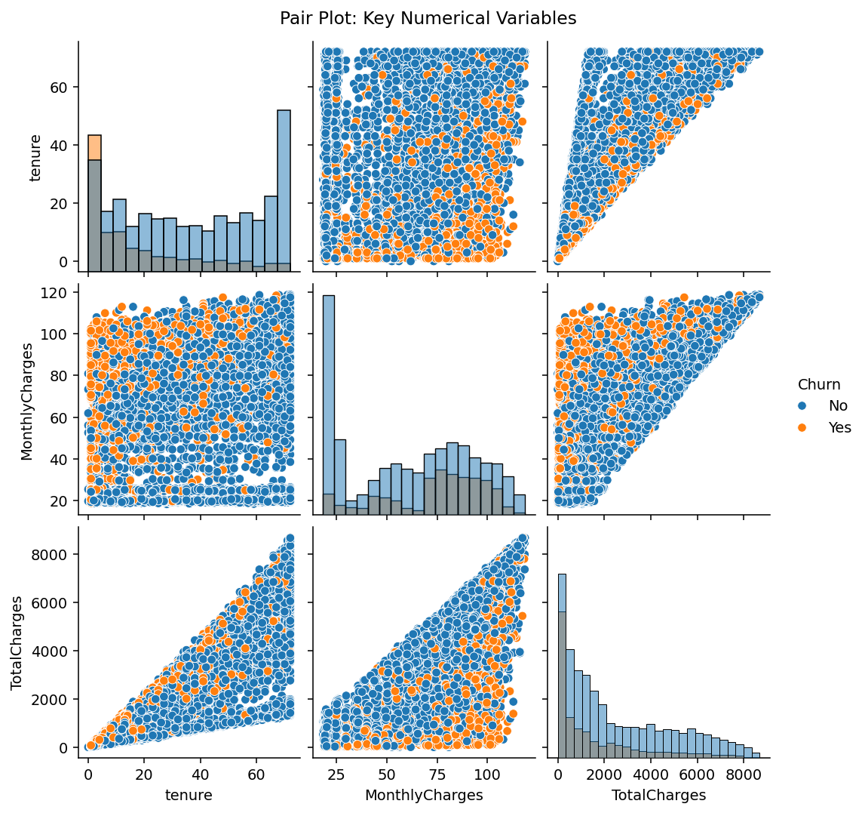
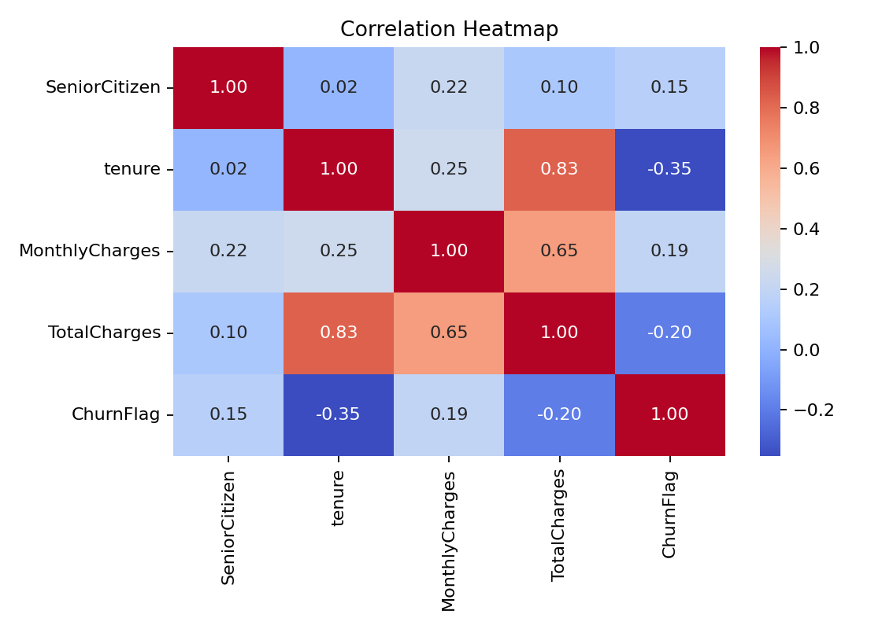

11. Business Recommendations
- Early-tenure focus: evaluate stronger onboarding and engagement during the first 6–12 months.
- Month-to-month customers: investigate the reasons for higher observed churn and test suitable retention or contract-conversion offers.
- Payment experience: investigate the electronic-check customer journey before deciding on a targeted intervention.
- High-charge customers: review pricing, service quality, support, and perceived value.
- Risk + value: use predicted churn probability together with customer value to prioritize retention analysis.
- Continuous monitoring: retrain or recalibrate the model when new customer data becomes available.

12. Important Business & Prediction Checks
- The model is evaluated on unseen test data.
- Preprocessing is performed in a pipeline to reduce data-leakage risk.
- Churn probability is a risk score, not a certainty.
- The 40% and 70% risk thresholds are project-defined and should be validated using business costs and future outcomes.
- LTV is a simplified historical revenue proxy.
- Observed differences are associations, not proof of causation.
- Retention strategies should be tested and measured using future churn, revenue, and customer-experience outcomes.

13. Limitations
- The dataset is historical and may not fully represent current customer behavior.
- Logistic Regression is a baseline model; other models can be evaluated later.
- The dataset does not contain all possible churn drivers, such as detailed complaints or satisfaction scores.
- The LTV calculation is simplified.
- Risk thresholds are not validated business policy.

14. Final Conclusion
The project provides an end-to-end churn analysis for 7,043 telecom customers. The observed churn rate is 26.54%. The analysis identifies important differences across tenure, contract, payment method and other customer groups. Customer segmentation highlights concentrated higher-churn segments, while Logistic Regression provides a probability-based churn score with 80.55% accuracy and 0.842 ROC-AUC on the held-out test set. Combining predicted risk with customer value creates a practical framework for retention analysis. Before operational use, the model and risk thresholds should be validated on future data.
Prepared for Saiket Systems – Data Analysis Internship

