**Rx Blogging web application**

Rx Blogging app prototype of a internet available blogging application and been developed with

java

spring boot

hibernate, jpa

spring security

Other – adding in upcoming sprint

Docker

Kubernetes

Terraform

**Available app endpoints:**

Comment creation

1. createComment -- need user as admin role
2. getAllPostComments
3. getCommentByCommentIdAndPostId
4. updateComment
5. deleteComment -- need user as admin role

Post creation

1. createPost
2. getAllUserPosts
3. getUserPostById
4. updateExistingPost
5. deleteUserPostById

To start with app, install java jdk>8, install maven depedencies with mvn clean install and run spring boot app

App will be hosted on default port localhost:8080 --- can be overide add server.port=custome_port_num in application.properties. This file is omitted from checkouts of git’s as it contains creds. Also I am using mysql db to build this project.

Below is the example properties u can use and set them according.

spring.datasource.url=jdbc:mysql://localhost:port/dbname

spring.datasource.driver-class-name=com.mysql.cj.jdbc.Driver

spring.jpa.hibernate.ddl-auto=update

spring.datasource.username=dbuser

spring.datasource.password=dbpass

spring.jpa.properties.hibernate.dialect=org.hibernate.dialect.MySQL57Dialect

spring.jpa.show-sql=true

To test API's, import RxBlog.postman_collection.json in postman and go ahead.. Below is the sample postman query to create post.

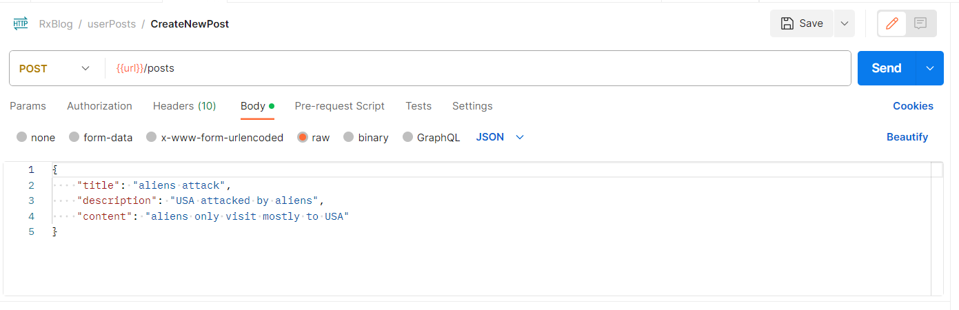

Below is ER diagram for our application.

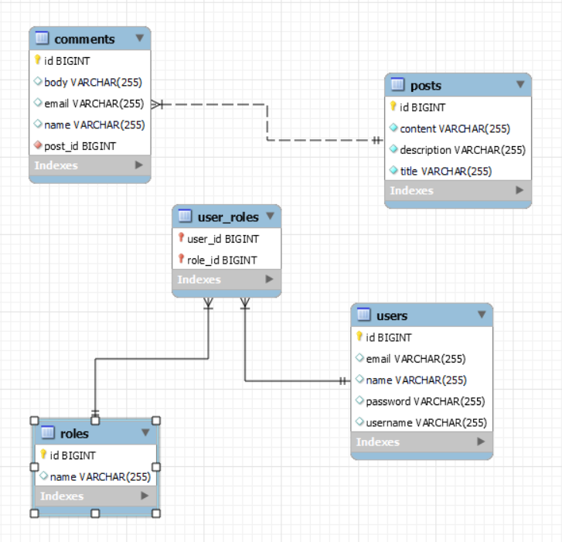

Posts and comments are main tables to save communication data. User, roles and user_roles is the spring security related table. We are creating dummy users and user roles which is registered in spring security context for authenticating any sensitive operations before perform.

Note:- To add/delete comments need to create user with role ADMIN. That user only able to perform delete,update types of sensitive queries as part of administrative things/