CUSTOMER SHOPPING
BEHAVIOR ANALYSIS
End-to-End Data Analytics Project
Python | Pandas | PostgreSQL | SQL | Power BI
Project Report

1. Executive Summary
This project analyses a retail customer shopping-behavior dataset to understand purchasing patterns across demographics, product categories, discounts, subscriptions, shipping preferences, ratings and purchase frequency. The workflow covers data inspection and preparation in Python, storage and analysis in PostgreSQL using SQL, and presentation of key metrics in an interactive Power BI dashboard.
The dataset contains 3,900 customer records and 18 original columns. Each row represents one customer and their latest purchase; it is not a complete transaction-level history. Findings describe this available customer snapshot and should not be interpreted as lifetime customer revenue.

2. Business Problem and Objectives
A retail business wants to better understand customer shopping behavior to improve sales, customer satisfaction and long-term loyalty. Management is interested in patterns across demographics and product categories, and in how discounts, reviews, seasons, payment preferences and repeat-purchase patterns relate to customer behavior.

Main business question
How can the company leverage customer shopping data to identify trends, improve customer engagement, and optimize marketing and product strategies?

Objectives
- Inspect the dataset structure, data types and missing values.
- Clean and prepare fields for reliable analysis.
- Create derived fields for age groups and approximate purchase-frequency intervals.
- Load the prepared data into PostgreSQL.
- Use SQL to answer business questions about revenue, discounts, ratings, subscriptions, repeat buyers and age groups.
- Build an interactive Power BI dashboard.

3. Dataset Overview
Attribute | Description
Records | 3,900 rows
Original columns | 18
Unit of observation | One customer record representing their latest purchase
Customer fields | Customer ID, age, gender, previous purchases, purchase frequency
Purchase fields | Item purchased, category, purchase amount, location, size, colour, season
Experience and fulfilment | Review rating, subscription status, shipping type, payment method
Promotion fields | Discount applied and promo code used

Scope note: previous_purchases is a count of prior purchases, and frequency_of_purchases is a frequency category. The dataset does not contain every historical transaction or the monetary value of all prior purchases.

4. Tools and Technologies
Tool | Role
Python / Pandas | Data loading, inspection, cleaning and feature engineering
PostgreSQL | Relational storage for the prepared customer table
SQL | Business analysis using aggregation, filtering, grouping, CTEs and window functions
Power BI | KPI cards, charts and interactive slicers

5. Data Preparation in Python
The CSV was loaded into a Pandas DataFrame. Initial inspection used head(), info(), describe() and describe(include='all') to review sample records, dimensions, data types and summary statistics.

5.1 Missing values
The review_rating column contained 37 missing values. These were filled using the median review rating within each category, rather than one overall median. This preserves category-level differences and reduces sensitivity to outliers.

5.2 Column standardisation
Column names were converted to lowercase snake_case. The purchase_amount_(usd) field was standardised to purchase_amount.

5.3 Feature engineering
- age_group: customers were divided into four quantile-based groups using pandas qcut: Young Adult, Adult, Middle-aged and Senior.
- purchase_frequency_days: text-based frequency categories were mapped to approximate day intervals. These are derived estimates, not observed transaction dates.

5.4 Redundant column check
discount_applied and promo_code_used were compared and had identical values in this dataset. Therefore, promo_code_used was dropped as redundant. This is specific to this dataset; discounts and promo codes are not necessarily identical in other businesses.

6. PostgreSQL Database Setup
A PostgreSQL database named customer_behavior was created. The cleaned Pandas DataFrame was loaded into a table named customer using Python and SQLAlchemy. The table was checked in pgAdmin and the record count was verified.
Database item | Value
Database | customer_behavior
Schema / table | public.customer
Rows loaded | 3,900
Power BI connection | PostgreSQL on localhost, port 5432

7. SQL Business Analysis and Findings
Ten business questions were analysed using SQL features including SUM, AVG, COUNT, GROUP BY, WHERE, CTEs and the ROW_NUMBER() window function.
Business question | Finding
1. Revenue by gender | Male: $157,890; Female: $75,191.
2. Discount users spending above overall average | 839 customers; their average purchase amount was $59.76.
3. Five highest average product ratings | Gloves 3.86; Sandals 3.84; Boots 3.82; Hat 3.80; Skirt 3.78.
4. Average purchase by shipping type | Standard: $58.46; Express: $60.48.
5. Subscription status comparison | Not subscribed: 2,847 customers, $59.87 average purchase, $170,436 revenue. Subscribed: 1,053 customers, $59.49 average purchase, $62,645 revenue.
6. Highest discount rates by product | Hat 50.00%; Sneakers 49.66%; Coat 49.07%; Sweater 48.17%; Pants 47.37%.
7. Customer segments by previous purchases | Loyal: 3,116; Returning: 701; New: 83. Segment definitions follow the SQL logic used in the project.
8. Top three products within each category | ROW_NUMBER() was used to rank products within each category.
9. Repeat buyers by subscription status | Among customers with more than five previous purchases: not subscribed 2,500; subscribed 958.
10. Revenue by age group | Young Adult: $62,143; Middle-aged: $59,197; Adult: $55,978; Senior: $55,763.

Interpretation caution: revenue figures are sums of purchase_amount for the records in this dataset, not lifetime revenue totals. Gender revenue totals should be considered alongside customer counts before drawing conclusions about average customer value.

8. Power BI Dashboard
The PostgreSQL table was connected to Power BI. Three DAX measures were created:
- Number of Customers = COUNT('public customer'[customer_id])
- Average Purchase Amount = AVERAGE('public customer'[purchase_amount])
- Average Review Rating = AVERAGE('public customer'[review_rating])
The dashboard includes:
- KPI cards for number of customers, average purchase amount and average review rating.
- A donut chart showing the percentage of customers by subscription status.
- Revenue by category and sales by category charts.
- Revenue by age group and customer count by age group charts.
- Interactive slicers for subscription status, gender, category and shipping type.
The slicers allow users to filter the dashboard and observe how the displayed metrics and charts change across selected customer groups and purchase attributes.
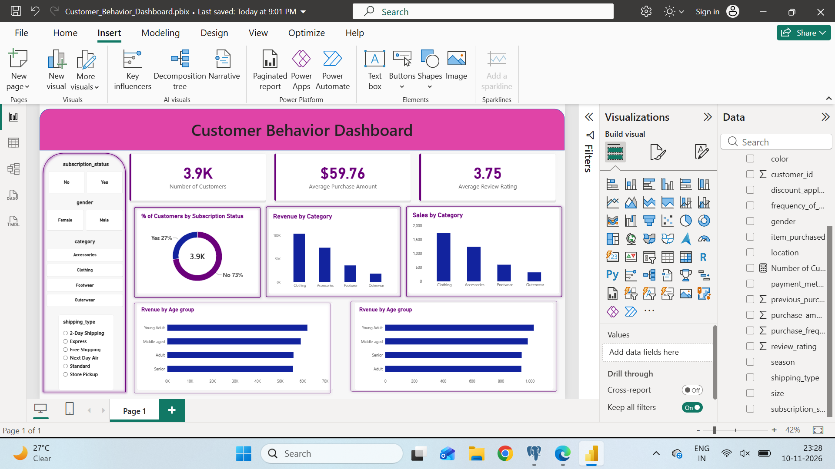
Figure 1. Power BI customer behavior dashboard.

9. Key Insights
- The dataset contains more non-subscribed customers (2,847) than subscribed customers (1,053).
- Average purchase amounts are similar for non-subscribed and subscribed customers ($59.87 and $59.49 respectively); subscription status alone does not show a higher average purchase amount in this snapshot.
- Young Adult customers generated the highest aggregate purchase revenue among the four age groups.
- Average purchase amount for Express shipping ($60.48) was higher than for Standard shipping ($58.46) in this dataset.
- The highest average product ratings were observed for Gloves, Sandals, Boots, Hat and Skirt.
- Several products had discount rates close to 50%, including Hat and Sneakers.

10. Business Recommendations
These are exploratory recommendations based on observed patterns. They should be tested with additional data before being treated as proven causes or guaranteed outcomes.
- Review the subscription value proposition. There are fewer subscribed customers and average purchase amounts are similar across subscription groups. Test targeted benefits and measure conversion and retention.
- Investigate age-group preferences. Young Adults contribute the highest aggregate purchase revenue in this dataset; examine their product and category preferences before designing targeted campaigns.
- Evaluate discount effectiveness by product. Monitor margin impact and incremental sales instead of assuming that a high discount rate is automatically beneficial.
- Evaluate shipping options with delivery cost, fulfilment time and satisfaction data. The current snapshot only compares purchase amounts by shipping type.
- Use review ratings to prioritise further product-quality investigation, ideally with more detailed review-level data.

11. Limitations and Future Improvements
- The dataset is a customer-level snapshot of the latest purchase, not a complete transaction history. It cannot support full time-series, cohort-retention or lifetime-value analysis.
- The purchase_frequency_days feature uses approximate mappings from text categories; it is not calculated from actual purchase timestamps.
- The dataset contains 3,900 records. Findings should be validated on a larger or more recent dataset before being generalised.
- Product costs and profit margins are not available, so revenue analysis cannot establish profitability.
- Future analysis could use transaction-level data, dates, product costs, campaign exposure, delivery performance and detailed customer feedback.

12. Conclusion
This project demonstrates an end-to-end data analytics workflow using Python, Pandas, PostgreSQL, SQL and Power BI. The dataset was inspected and cleaned, analytical features were created, prepared data was stored in PostgreSQL, ten business questions were answered using SQL, and results were presented in an interactive dashboard. The analysis provides a structured view of customer segments, purchase amounts, product ratings, discounts, subscriptions and age-group patterns while recognising the limits of a dataset that captures only each customer's latest purchase.

Appendix: Instructions for Gamma AI
Create a concise 10–12 slide business presentation from this report. Use a professional retail analytics style with a purple, white and dark-navy palette. Cover the business problem, dataset scope, Python preparation, PostgreSQL workflow, SQL findings, Power BI dashboard, key insights, recommendations and limitations. Use the included dashboard screenshot as a visual reference. Preserve all figures exactly; do not invent charts, percentages, causes or statistics. Label revenue figures as purchase-amount totals from the available customer snapshot, not lifetime revenue.

