DEVSECOPS-PROJECT

NAME: ROHIT VARMA

EMAIL-ID: [rohitvarmamuthyam123@gmail.com](mailto:rohitvarmamuthyam123@gmail.com) BATCH NO: 6304908843

COURSE NAME: AWS WITH DEVOPS

pipeline{ agent any stages{

stage('checkout'){ steps{

checkout scmGit(branches: [[name: '*/dev']], extensions: [], userRemoteConfigs: [[url: 'https://github.com/Rohitvarma123/taxi-booking.git']])

}

}

stage('validate'){ steps{

sh 'mvn validate'

}

}

stage('compile'){ steps{

sh 'mvn compile'

}

}

stage('test'){ steps{

sh 'mvn test'

}

}

stage('package'){ steps{

sh 'mvn package'

}

}

stage('sonarqube code quality'){ steps{

sh "mvn clean verify sonar:sonar -Dsonar.projectKey=rohit - Dsonar.host.url=http://18.183.224.233:9011 - Dsonar.login=sqp_b27cdead8260bcfe3e99b25a8dd23fb325154b2a"

}

}

stage('dependency check'){ steps{

dependencyCheck additionalArguments: '--scan ./ --format XML ', odcInstallation: 'Dp-

check'

dependencyCheckPublisher pattern: '**/dependency-check-report.xml'

}

}

stage('nexus to deploy'){ steps{

nexusArtifactUploader artifacts: [[artifactId: 'maven-project', classifier: '', file: '/var/lib/jenkins/workspace/petshotproject/taxi-booking/target/taxi-booking-1.0.1.war', type: 'war']], credentialsId: 'nexus-artifact', groupId: 'com.example.maven-project', nexusUrl: '57.180.42.66:8081', nexusVersion: 'nexus3', protocol: 'http', repository: 'maven-snapshots', version: '1.0-SNAPSHOT'

}

}

stage ('Build war file'){ steps{

sh 'mvn clean install -DskipTests=true'

}

}

stage('deploy to tomcat'){ steps{

deploy adapters: [tomcat9(credentialsId: 'tomcat', path: '', url: 'http://54.168.151.150:8080/')], contextPath: null, war: '**/*.war'

}

}

}

}

MANAGE JENKINS:

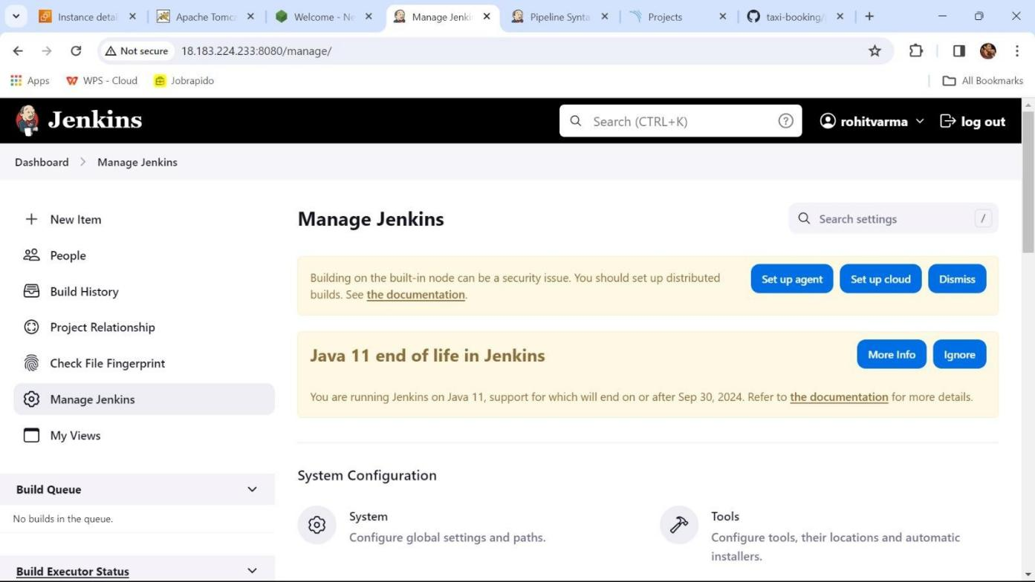

AVALIABLE PLUGINS:

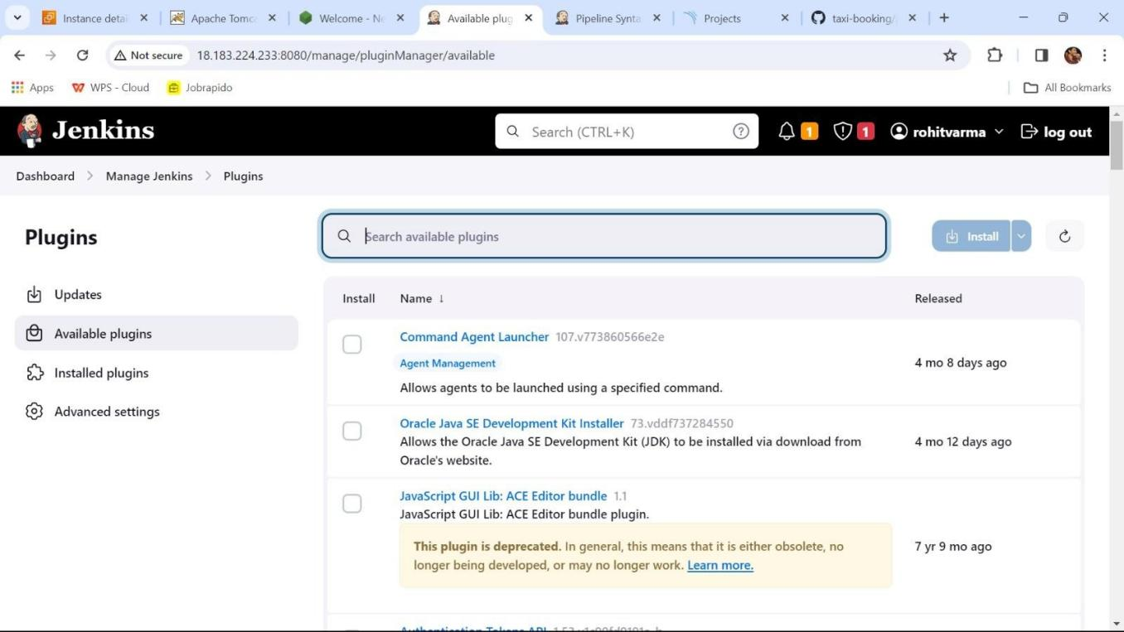

TOOLS:

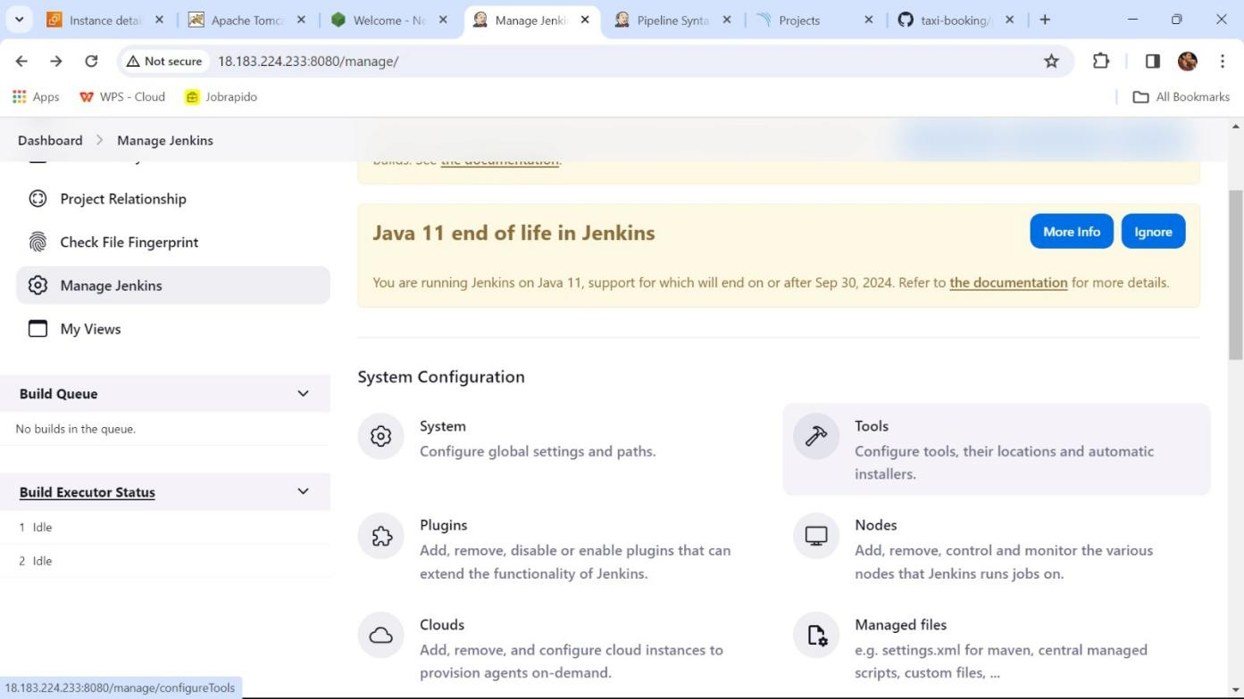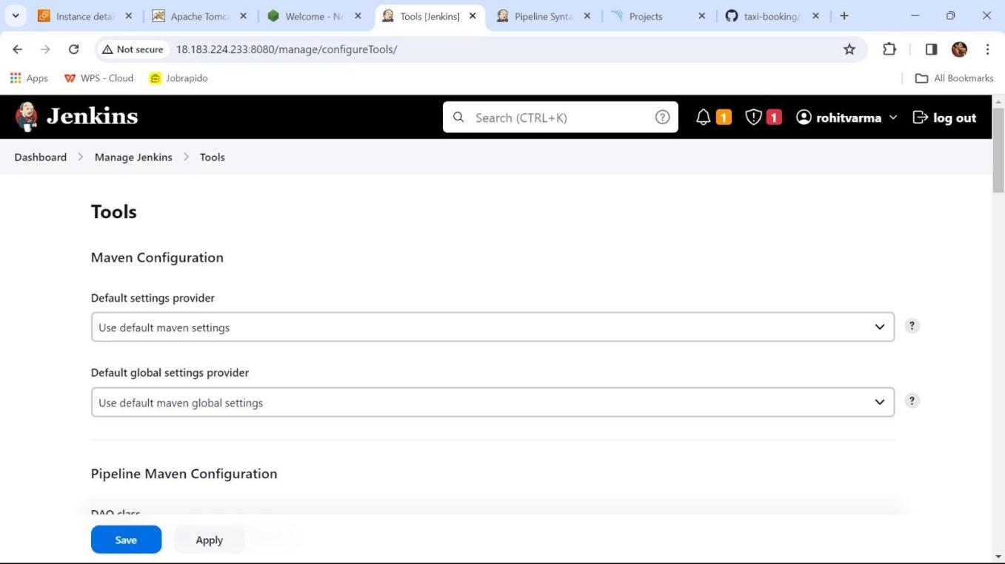

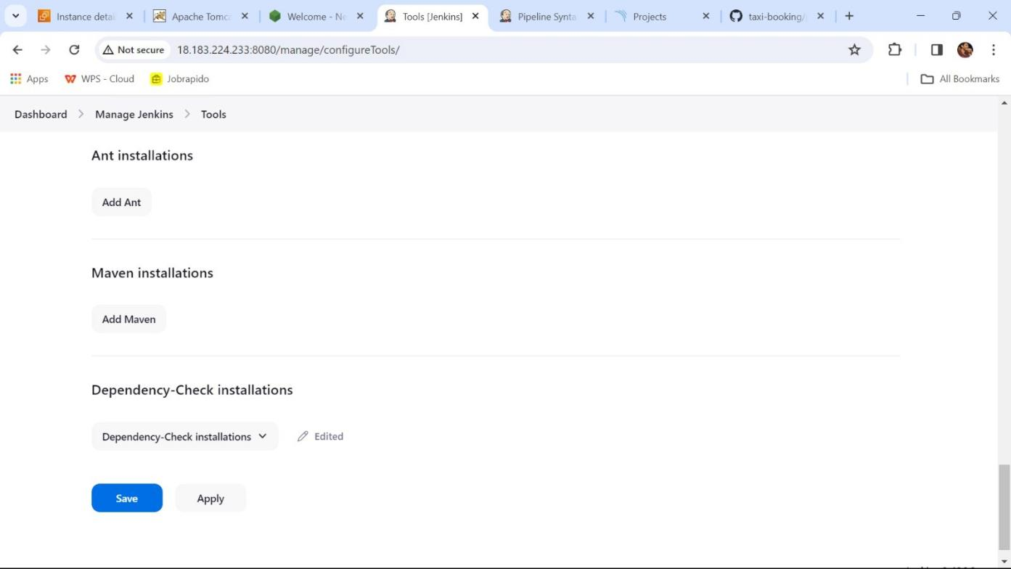

DASHBOARD: click on pipeline

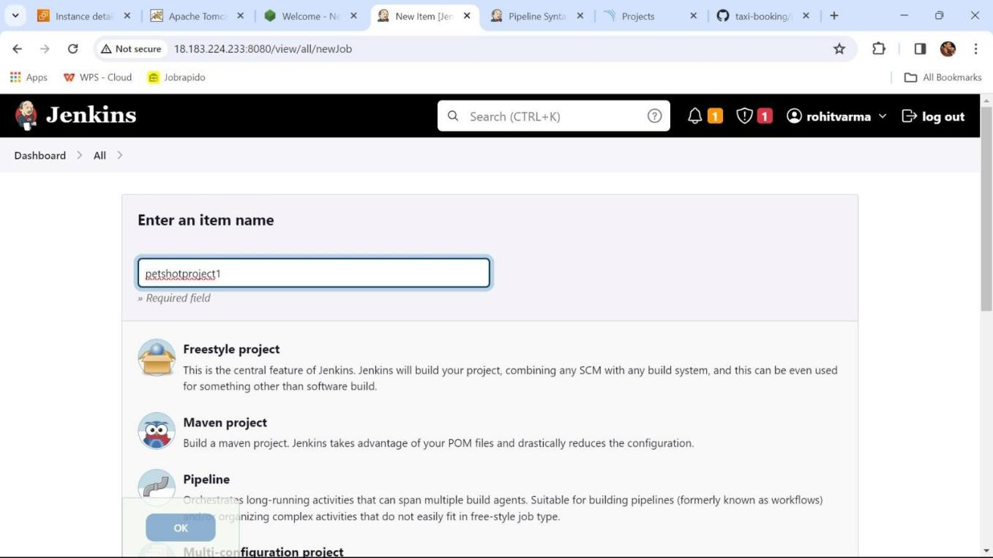

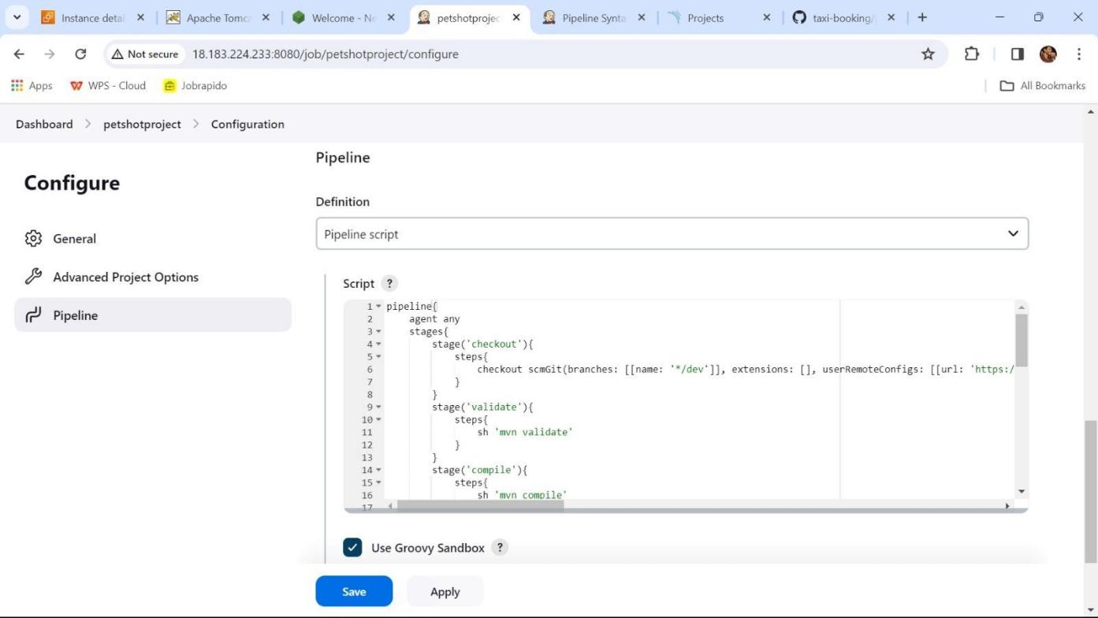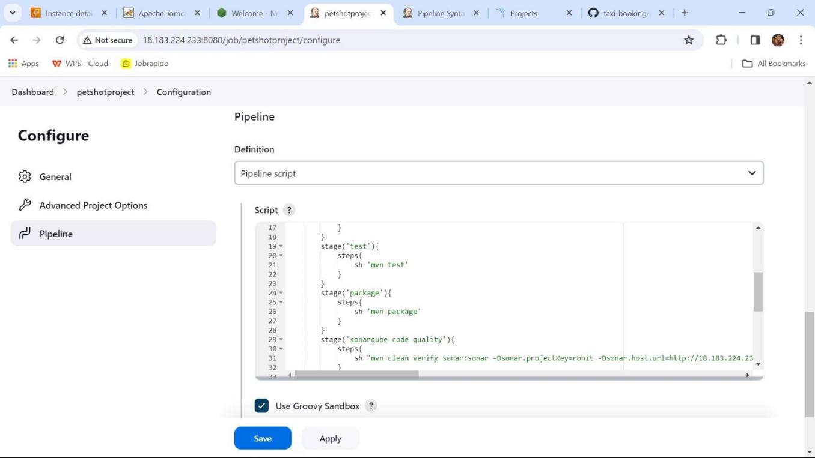PIPELINE SCRIPT:

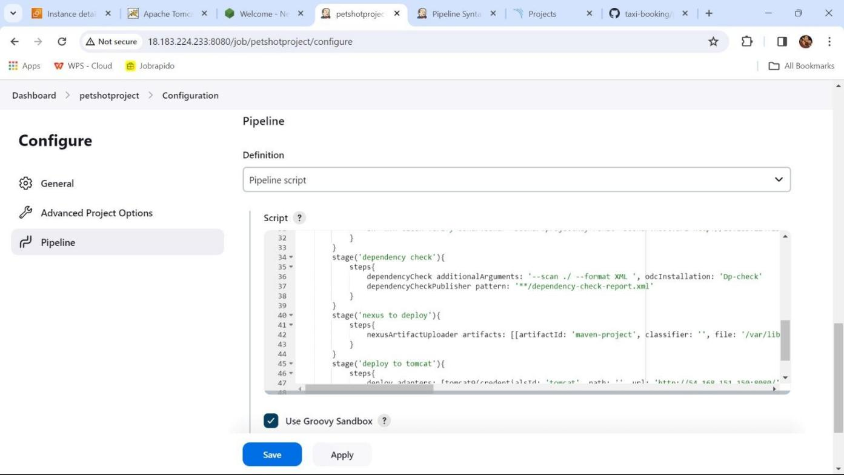

BULID OUTPUT:

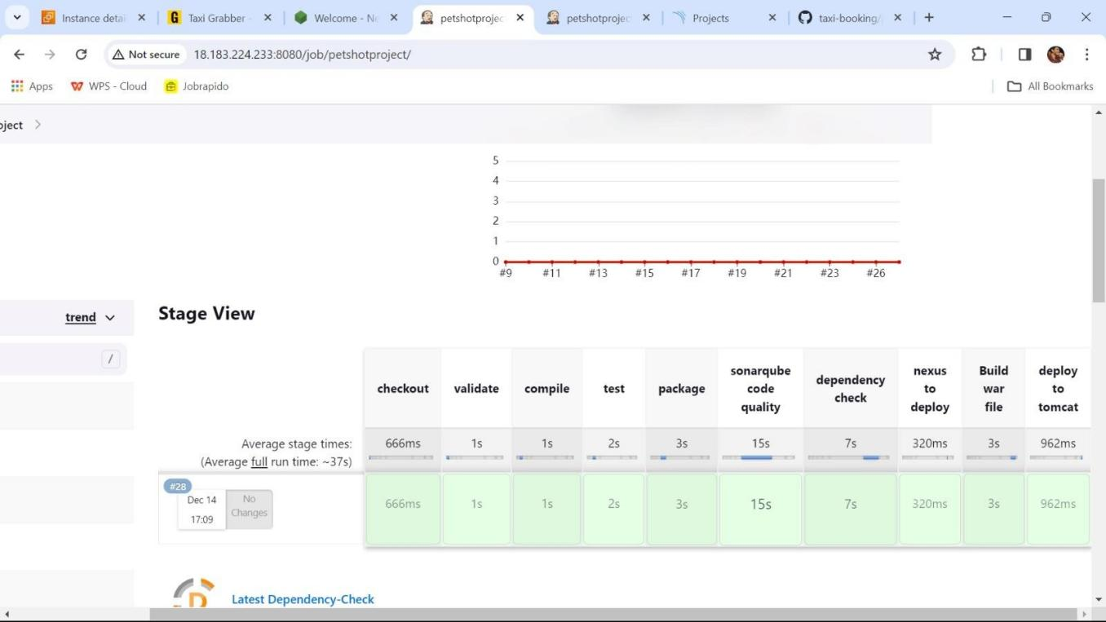

SONARQUBE CODE ANALYSIS:

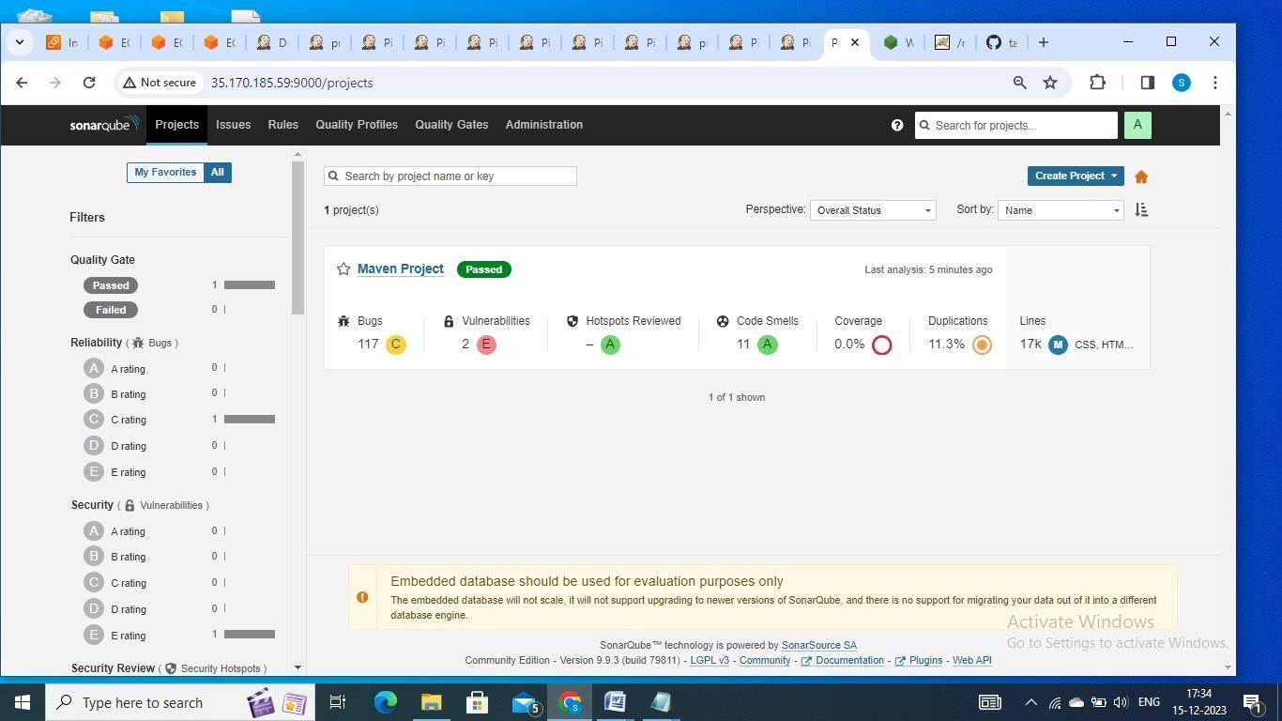

NEXUS ARTIFACT:

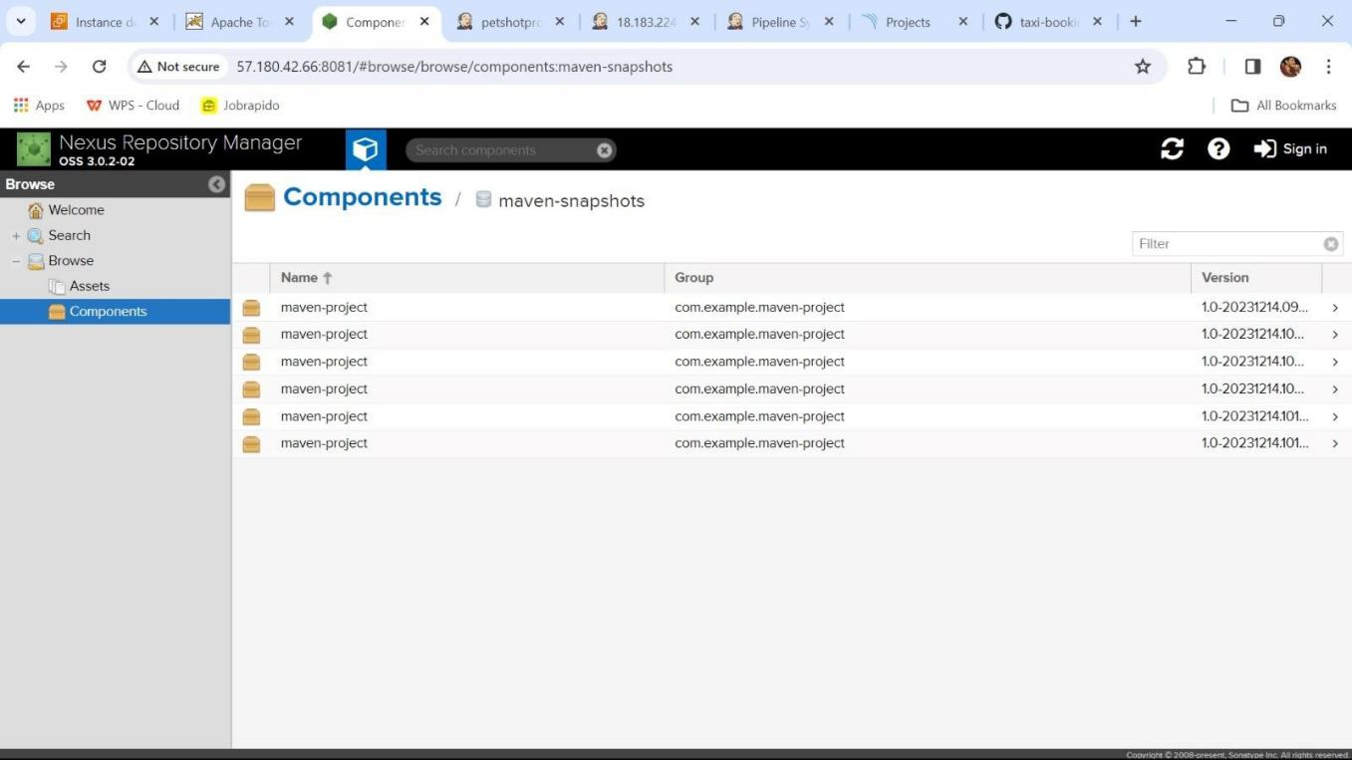

DEPLOY TO TOMCAT

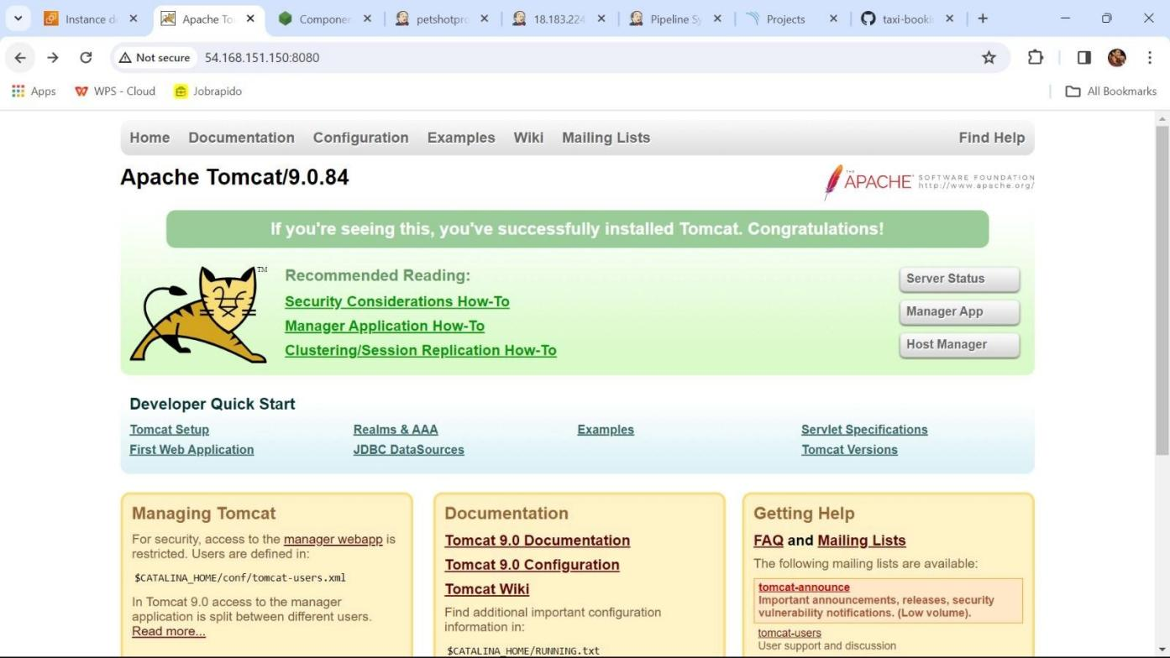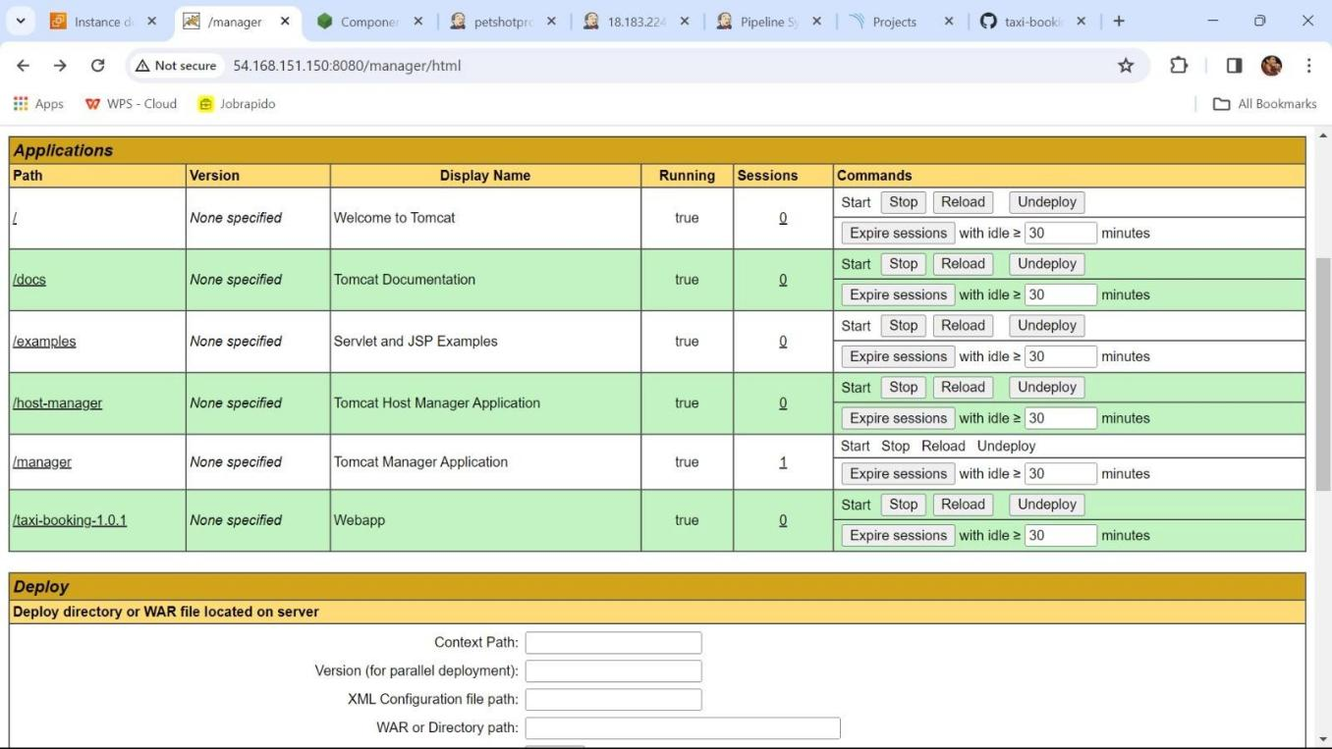

FINAL OUTPUT

