* Read the problem statement carefully and understand what is being asked. Failure to comprehend the problem statement may result in incorrect assumptions and answers.
* Write a clear and concise pseudocode that solves the problem without any extra steps.
* Draw a flowchart that represents the logic of your pseudocode. Use proper notation and avoid any ambiguity or confusion.
* Ensure that your pseudocode and flowchart are easy to read and understand. Unclear or hard-to-follow submissions may receive reduced marks.
* **Plagiarism will not be tolerated. Any evidence of copied work, including minor instances, will result in a grade of zero for the entire assignment.**
* Late submissions will not be accepted under any circumstances. Submit your work on time to avoid penalties.
* Complete the assignment on paper, then create a PDF version using apps like CamScanner or NoteBlock. Submit the PDF file to Google Classroom.
* Name your PDF file using the following convention: ROLLNO-NAME, e.g. (23P-8743-Zain.pdf).
* If you have any questions or concerns, ask before submitting your work. Lame excuses or attempts to justify plagiarism or late submissions will not be accepted.

___________________________________________________________________

**Problems:**

1. Design a pseudocode and a flowchart for a program that calculates the squares and cubes of the integers from 0 to 10. (10 marks)
2. Develop a flowchart that outputs a grade based on the following criteria: (10 marks)

| Grade | Percentage Range |
| --- | --- |
| A | Above or equal to 80% |
| B | From 70% to 80% |
| C | From 60% to 70% |
| D | From 50% to 60% |
| F | Below 50% |

1. Draw a flowchart for the following pseudocode that calculates the average grade of a class: (15 marks)
   1. Set the total and average to zero.
   2. Set the grade counter to one.
   3. While the grade counter is less than or equal to ten.
      1. Ask the student to input the next grade.
      2. Add the grade to the total.
      3. Add one to the grade counter.
   4. Set the class average to the total divided by ten.
   5. Print the total of the grades for all students in the class.
   6. Print the class average
2. Write the pseudocode for an algorithm that checks if an entered word is a palindrome.

**Hint:** A palindrome is a word or phrase that is spelled the same backwards as it is forwards.

**Examples:** civic, radar, level, rotor, kayak, madam, and refer. (15 marks)

1. Write a pseudocode that inputs a number from the user and checks whether the number is prime or not. (20 marks)
2. What is the output of the following flowchart when the input is the numbers: 3, 2, 1, 5, 0? Fill out the trace table below to show the values of the variables at each step of the flowchart. (20 marks)

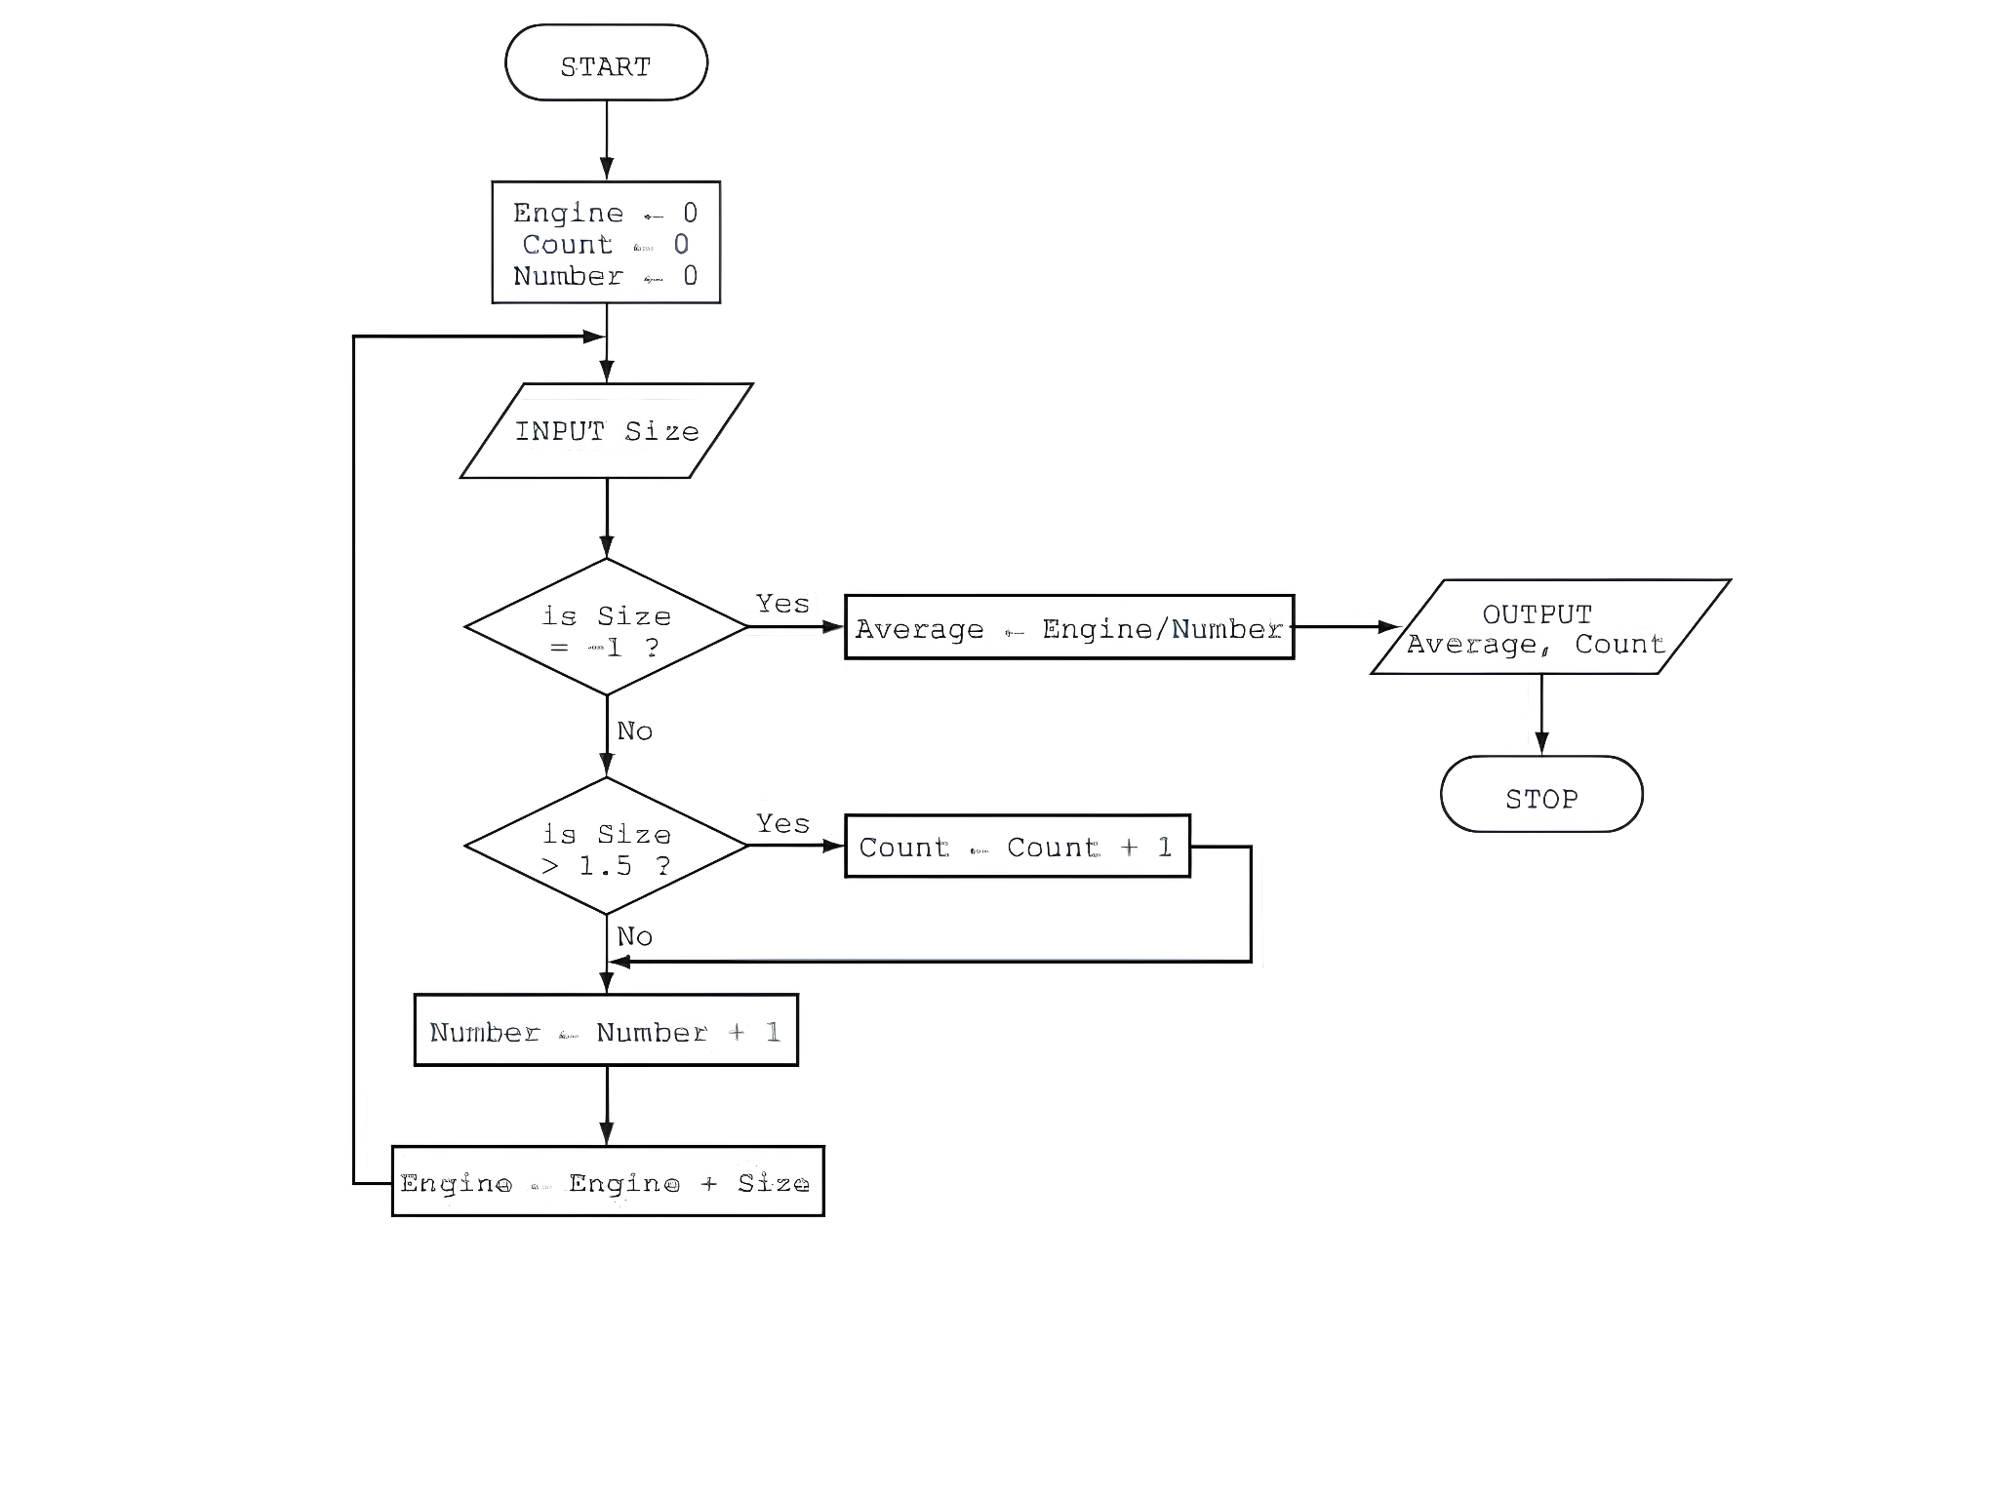

| Engine | Count | Number | Size | Average | Output |
| --- | --- | --- | --- | --- | --- |
|  |  |  |  |  |  |
|  |  |  |  |  |  |
|  |  |  |  |  |  |
|  |  |  |  |  |  |
|  |  |  |  |  |  |
|  |  |  |  |  |  |
|  |  |  |  |  |  |
|  |  |  |  |  |  |
|  |  |  |  |  |  |
|  |  |  |  |  |  |
|  |  |  |  |  |  |
|  |  |  |  |  |  |
|  |  |  |  |  |  |
|  |  |  |  |  |  |
|  |  |  |  |  |  |
|  |  |  |  |  |  |
|  |  |  |  |  |  |
|  |  |  |  |  |  |
|  |  |  |  |  |  |

Goodluck 🙂

**Answers**

# **Answer 1: (10 marks)**

1. Begin with the number 0.
2. For each number from 0 to 10, do the following:
3. Multiply the number by itself to get the square.
4. Multiply the number by itself twice to get the cube.
5. Write down the number, its square, and its cube.
6. Move to the next number in the sequence.
7. Repeat steps 2 and 3 until you reach 10.
8. You're done when you've found the squares and cubes for all the numbers from 0 to 10.

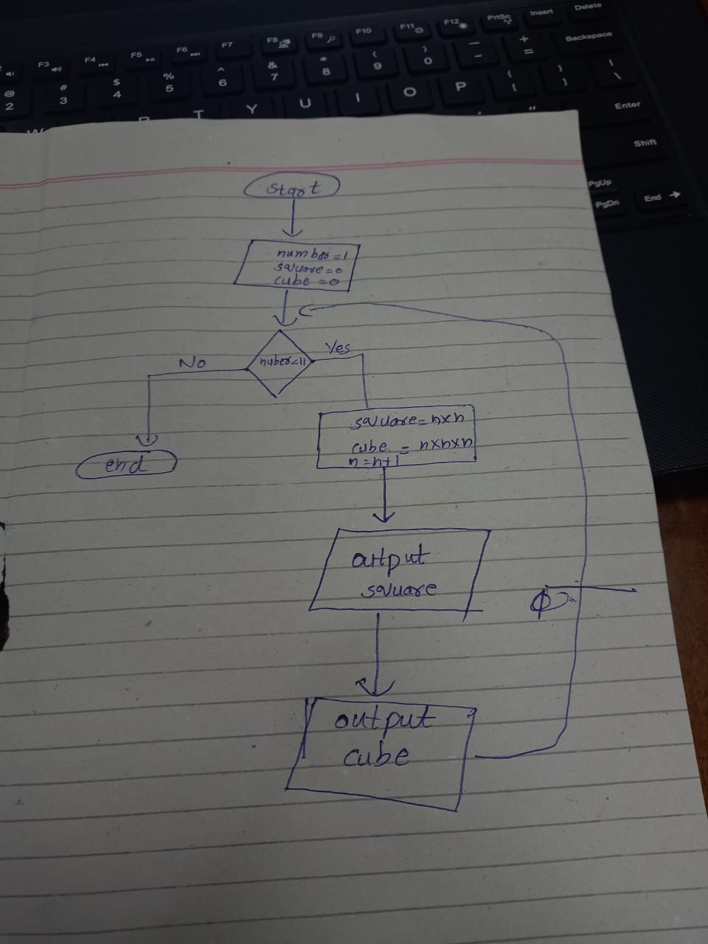

# **Answer 2: (10 marks)**

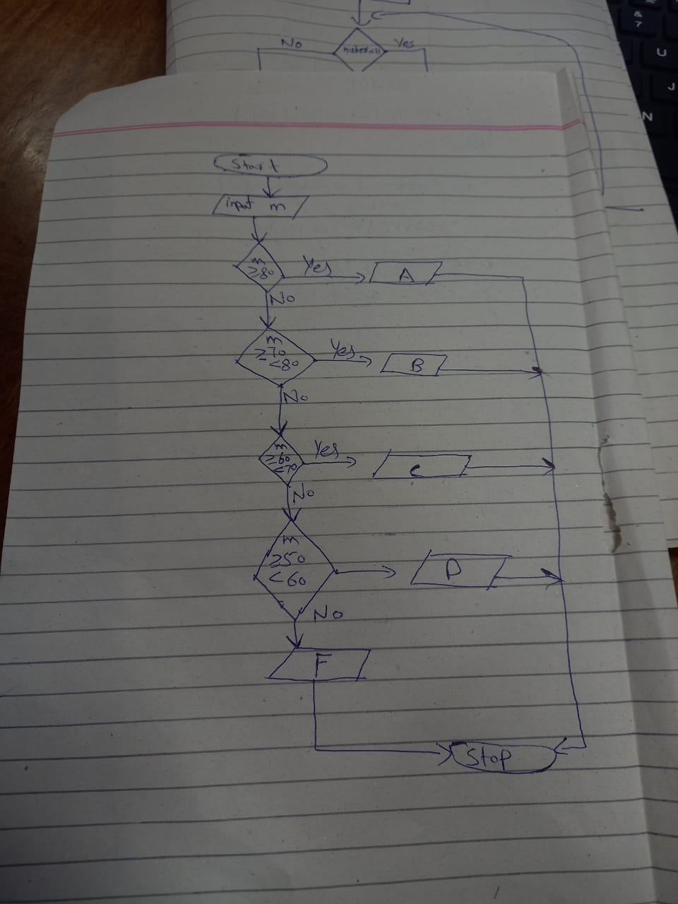

**Answer 3: (15 marks)**

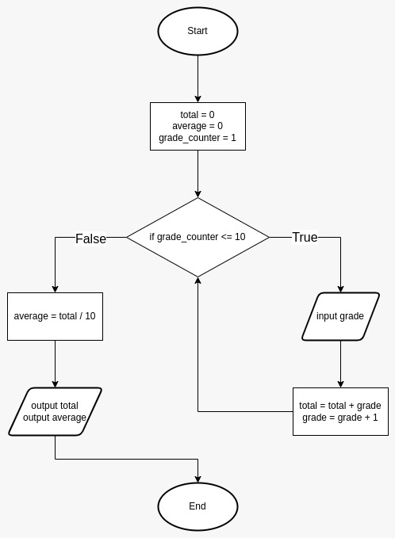

# 

# **Answer 4: (15 marks)**

1. Start
2. Ask the user to give you a word and remember it as 'word'
3. Create an empty word called 'reversedWord'
4. Count how many letters are in 'word' and remember it as 'length'
5. Starting from the last letter of 'word', and going backward to the first letter, do the following:
   1. Add each letter to the 'reversedWord'
6. If 'word' is the same as 'reversedWord', then:
   1. Tell the user, "It's a palindrome."
7. Otherwise:
   1. Tell the user, "It's not a palindrome."
8. End

Or

1. Start
2. Take a word
3. Rewrite the word in reverse order
4. Compare the original word with the rewritten word
5. If they are same
6. Then the word is palindrome
7. Otherwise, it aint a palindrome..

# **Answer 5: (20 marks)**

1. Begin
2. Ask the user to enter a positive number and call it 'num'
3. If 'num' is less than or equal to 1, then:
   1. Tell the user, "It's not a prime number because it's less than or equal to 1."
4. Create a flag called 'isPrime' and set it to true
5. Create a variable called 'divisor' and set it to 2
6. While 'divisor' is less than the square root of 'num', do the following:
7. If 'num' is evenly divisible by 'divisor', then:
   1. Set 'isPrime' to false
   2. Exit the loop
8. If 'isPrime' is still true, then:
   1. Tell the user, "It's a prime number."
9. Otherwise:
   1. Tell the user, "It's not a prime number."
10. End

Or

1. Take a number n
2. Divide that number by all the numbers from 1 to n,
3. If there are only two numbers that completely divides the n, then it is a prime number.
4. Otherwise it's not a prime number.

# **Answer 6: (20 marks)**

| Engine | Count | Number | Size | Average | OUTPUT |
| --- | --- | --- | --- | --- | --- |
| 3 | 1 | 1 | 3 |  |  |
| 5 | 2 | 2 | 2 |  |  |
| 6 | 2 | 3 | 1 |  |  |
| 11 | 3 | 4 | 5 |  |  |
| 11 | 3 | 5 | 0 |  |  |

