- -

of Computer & Emerging Sciences

NATIONAL UNIVERSITY



Course: Software Requirements Engineering

Instructor: Lecturer Sara Rehmat

Submitted by:

Muhammad Rehan | 22P-9106

Hasnain Saleem | 22P-9123

Class: BSE-3A

Date: Oct 15th, 2023.

Assignment no 02

**Project : Cloud Native Development Servie**

**Vision and Scope Document**

**1. Business Requirements**

**1.1 Background**

The move to cloud-native solutions happened because of a few main reasons. First, old IT systems were inflexible and costly, so companies sought cheaper and more flexible options. New technologies like containers and Kubernetes made building and managing software easier. Companies also wanted to work faster to keep up in a competitive world and needed reliable and secure systems. Many had old computer systems causing problems, so they switched to cloud-native ways to modernize. A bunch of tools and help from the community made this shift more accessible for businesses aiming to do well in the digital world.

**1.2 Business Opportunity**

In the ever-evolving digital landscape, businesses seek to enhance their corporate information systems' scalability, efficiency, and agility. Traditional IT infrastructures struggle to meet these demands cost-effectively. Cloud-native solutions, aligning with market trends favoring **agility** and **cost-efficiency**, offer seamless **scalability**, **cost savings**, **rapid software deployment**, and improved **system resilience**. Critical components for a complete cloud-native solution include **microservices** **architecture**, **CI/CD pipelines, container orchestration** (e.g., **Kubernetes**), **robust security**, **DevOps practices**, **scalable cloud infrastructure**, and skill development programs. These elements cater to customer needs such as scalability, cost-efficiency, agility, security, **competitiveness**, **modernization**, **compliance**, and **skill development**. The new cloud-native product effectively addresses these needs, facilitating seamless scalability, cost efficiency (e.g., server cost reduction during off-peak hours), rapid **software updates**, and other critical enhancements for a competitive edge.

**1.3 Business Objectives**

**BO-1:** Aim to accelerate development speed by around **50%** during the initial development phase. Once the project transitions to the maintenance phase, maintain this increased pace to handle ongoing updates and support efficiently.

**BO-2:** Achieve a **2x** reduction in operational costs by paying for resources based on your application's actual usage, optimizing expenditure while maintaining performance.

**BO-3:** This goal aims to improve system robustness and capacity, aiming to achieve a **60%** enhancement within the initial year.

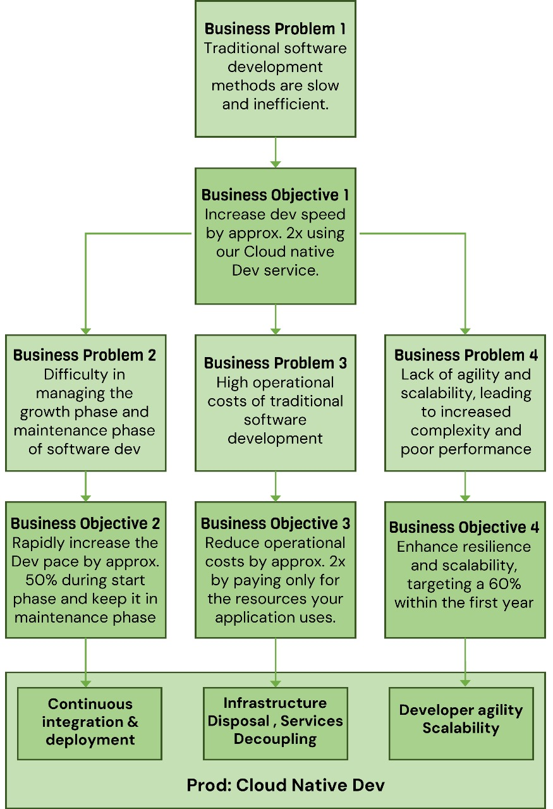

**Figure 1: Business Objectives Model**

**1.4 Vision Statement**

**We offer a** cloud-native development service **for** businesses and organizations seeking an edge in the competitive and rapidly evolving world of software development. This service is designed to provide a comprehensive understanding of the requirements and principles driving the shift toward cloud-based solutions. **Unlike** traditional software development methods, our approach is focused on scalability, enhanced customer experience, developer agility, continuous integration and deployment (CI/CD), disposable infrastructure, and decoupling of services.

**By** leveraging the expertise of the Cloud Native Computing Foundation (CNCF), we can deliver software development at approximately **twice (2x) the speed** of traditional methods. Our service thoroughly analyzes the tools and technologies used in cloud-native development, such as Kubernetes, Microservices, Containers, and Terraform. These tools help rapidly increase the development pace **~=50%** in the start phase of development, which continues even in the maintenance phase of the project.

**Unlike** traditional development methods, **our project** allows businesses to utilize cloud-native technologies' benefits fully. It provides a practical application of these technologies, showcasing the benefits of embracing this paradigm shift diversity.

**Compared** to the traditional approach, our cloud-native service ensures your applications' availability, resilience, and scalability. It also allows for **twice (2x) cost-effective** operations as you only pay for the resources your application uses. It makes it a more efficient and economical choice for businesses.

With **our project**, businesses will gain a deep understanding of the reasons behind the shift to cloud-native development. It will **enable them** to create innovative, scalable, and reliable software solutions that meet the demands of the modern digital landscape. By choosing **our service**, businesses can ensure they stay ahead of **10x times** the curve and are equipped to meet future challenges in the software development landscape.

**1.5 Business Risks**

**RI-1**: This risk pertains to the potential entry of new competitors or intensified competition in the market, which could lead to a loss of market share and reduced profitability. (Probability = 0.4; Impact = 4)

**RI-2**: This risk involves the possibility of project delays, resulting in missed market opportunities and potential revenue losses.

(Probability = 0.3; Impact = 3)

**RI-3**: This risk relates to the product not meeting user expectations, leading to decreased sales and potential damage to the brand's reputation. (Probability = 0.2; Impact = 4)

**RI-4**: This risk concerns the potential occurrence of a data security breach, resulting in data loss, legal consequences, and damage to the company's reputation. (Probability = 0.5; Impact = 5)

**RI-5**: This risk involves failing to comply with relevant regulations and facing legal penalties, fines, and reputational harm. (Probability = 0.3; Impact = 4)

**2. Scope and Limitations**

**2.1 Major Features**

**FE-1:** Encapsulate applications and their dependencies in portable units, ensuring consistent performance and easy deployment across various environments, enhancing application reliability and scalability.

**FE-2:** Streamlines repetitive tasks and processes, making software development and operations more efficient and error-free, resulting in faster and more reliable services.

**FE-3:** Breaks down complex applications into more minor, independently deployable services, enabling quicker development, easier maintenance, and more flexible scalability.

**FE-4:** Provides standardized interfaces for software components to interact, allowing seamless integration between different services, applications, and systems.

**FE-5:** Fosters collaboration between development and operations teams, automating software delivery pipelines for faster feature releases and improved product quality.

**FE-6:** Efficiently manages and scales containers and services, ensuring applications run smoothly in dynamic, cloud-native environments, enhancing performance and resource utilization.

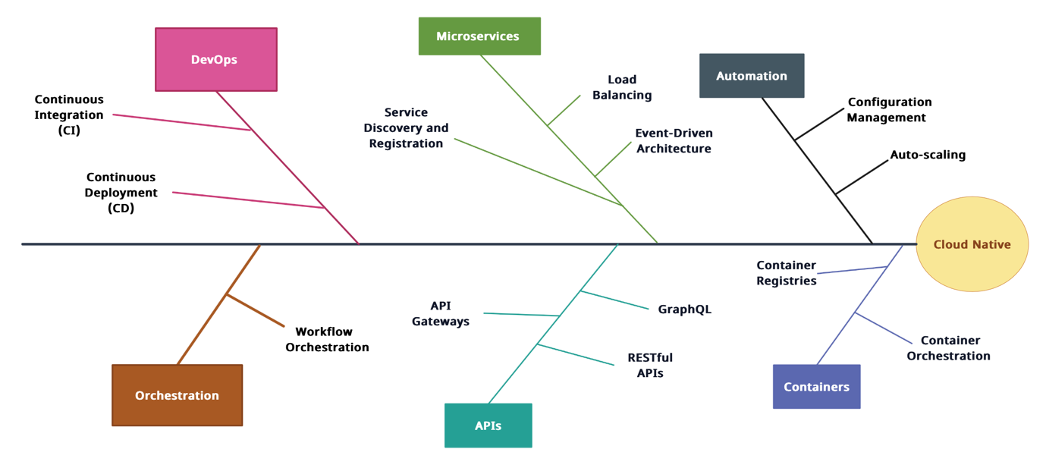

***Figure 2 : Feature tree for Cloud Native***

**2.2 Scope of initial and subsequent releases**

|  |  |  |  |
| --- | --- | --- | --- |
| **Feature** | **Release 1** | **Release 2** | **Release 3** |
| **FE-1**, Scalability | Basic horizontal scaling using load balancers | Advanced horizontal scaling with auto-scaling groups | Full implementation of horizontal and vertical scaling with auto-scaling, load balancing, and caching |
| **FE-2**, Enhanced Customer Experience | Basic user interface improvements | Advanced user interface enhancements with responsive design and accessibility features | Full implementation of user interface improvements with optimized performance and personalized experiences |
| **FE-3**, Developer Agility | Essential integration with version control systems | Advanced integration with CI/CD pipelines and automated testing | Full implementation of developer agility with continuous deployment, feature flagging, and automatic rollback mechanisms |
| **FE-4**, CI/CD | Basic setup of CI/CD pipelines for build and deployment | Advanced CI/CD pipelines with automated testing and release management | Full implementation of CI/CD with continuous integration, automated testing, deployment pipelines, and release orchestration |
| **FE-5**, Disposable Infrastructure | Not Implemented | Basic implementation of infrastructure as code using Terraform | Full implementation of disposable infrastructure with automated provisioning, scaling, and teardown using Terraform and Kubernetes |
| **FE-6**, Decoupling of Services | Essential service decoupling using API gateways | Advanced service decoupling with event-driven architecture and microservices | Full implementation of service decoupling with microservices, event-driven communication, and service mesh |
| **FE-7**, Cloud Native Technologies (Kubernetes, Microservices, Containers, Terraform) | Basic containerization using Docker | Advanced container orchestration with Kubernetes | Full implementation of cloud-native technologies with containerization, orchestration, and infrastructure as code using Kubernetes, Docker, and Terraform |

**2.3 Limitations**

**LI-1:** The reliance on a stable internet connection can be a critical limitation, as it affects the accessibility and usability of cloud-native applications. Users may experience disruptions or loss of functionality without a reliable internet connection.

**LI-2:** Users place a high value on the privacy and security of their data. Any perceived or actual data privacy breaches can have serious consequences, making this a top concern.

**LI-3:** Users expect cloud services to be highly reliable. Downtime or service outages can significantly impact their ability to access and use cloud-native applications, making service reliability a top priority.

**LI-4:** Security is paramount for users, as they want assurance that their data and transactions are secure. Any perceived or actual security vulnerabilities can erode trust and confidence in cloud-native solutions.

**LI-5:** Users are concerned about the financial aspect of cloud-native solutions. The uncertainty of variable costs and potential budgetary concerns can be a significant limitation, especially for businesses and organizations.

Assignment no 02 | Remaining Document

**3. Business Context**

**3.1 Stakeholder Profiles**

**3.2 Project Priorities**



**3.3 Deployment Considerations**

To ensure effective deployment of cloud-native solutions using the Cloud Native Computing Foundation (CNCF) ecosystem, several considerations are essential. CNCF projects typically serve a global and diverse user base. Access requirements can vary, with users distributed across multiple time zones, and they may need to access the system at various times. It's crucial to accommodate this distributed user base effectively. Infrastructure changes might be necessary to support the software's capacity, network access, data storage, and data migration requirements. These changes should align with CNCF's scalability, interoperability, and security principles. Additionally, comprehensive documentation is vital to assist those preparing training materials or adapting business processes in coordination with deploying new solutions, ensuring a seamless transition for users and stakeholders.

**3.4 Scope representation techniques:**

**Context Diagram**

**Businesses & Organizations (Clients) <-> Cloud-Native Development Service**

Clients provide the requirements for the software projects they want to develop. The service, in turn, delivers the developed software applications back to the clients.

**CNCF <-> Cloud-Native Development Service**

The CNCF provides principles and guidelines for cloud-native development. The service uses these guidelines to ensure the software development adheres to the best practices in cloud-native development.

**Cloud-Native Tools & Technologies <-> Cloud-Native Development Service**

The Cloud-native tools and technologies provide the necessary infrastructure and capabilities for the Cloud-native development service to build, deploy, and manage software applications in a cloud environment. In return, it receives Build logs, deployment logs, application logs, performance metrics, and error events that can be monitored and analyzed for insights into the development process in our service.

**Applications Developed using the Service <-> Cloud-Native Dev Service**

These applications provide feedback, like runtime errors and usage statistics, to the service. In return, these apps receive deployment information, configurations, monitoring management, and compliance from our service.

**The Modern Digital Landscape <-> Cloud-Native Development Service**

The "Modern Digital Landscape" refers to the vast collection of technologies, trends, and practices that shape the digital infrastructure and how we interact with technology. This landscape constantly evolves, giving us insights to stay up-to-date with the new standards and regulations.

**Cloud Service Providers <-> Cloud-Native Development Service**

These services deploy the applications on these cloud service providers. The provider gives our service Infrastructure, Platform, Services, Scalability, Security, Cost-effectiveness, and many more benefits.

**Cloud-Native Software Developers <-> Cloud-Native Development Service**

Developers and engineers provide inputs like code, configuration, testing, and maintenance to the service and receive feedback like build status, deployment status, Guidelines from the CNCF, and requirements from clients (as it is an indirective receiving from other external terminators that's why these are not mentioned in the context diagram.).

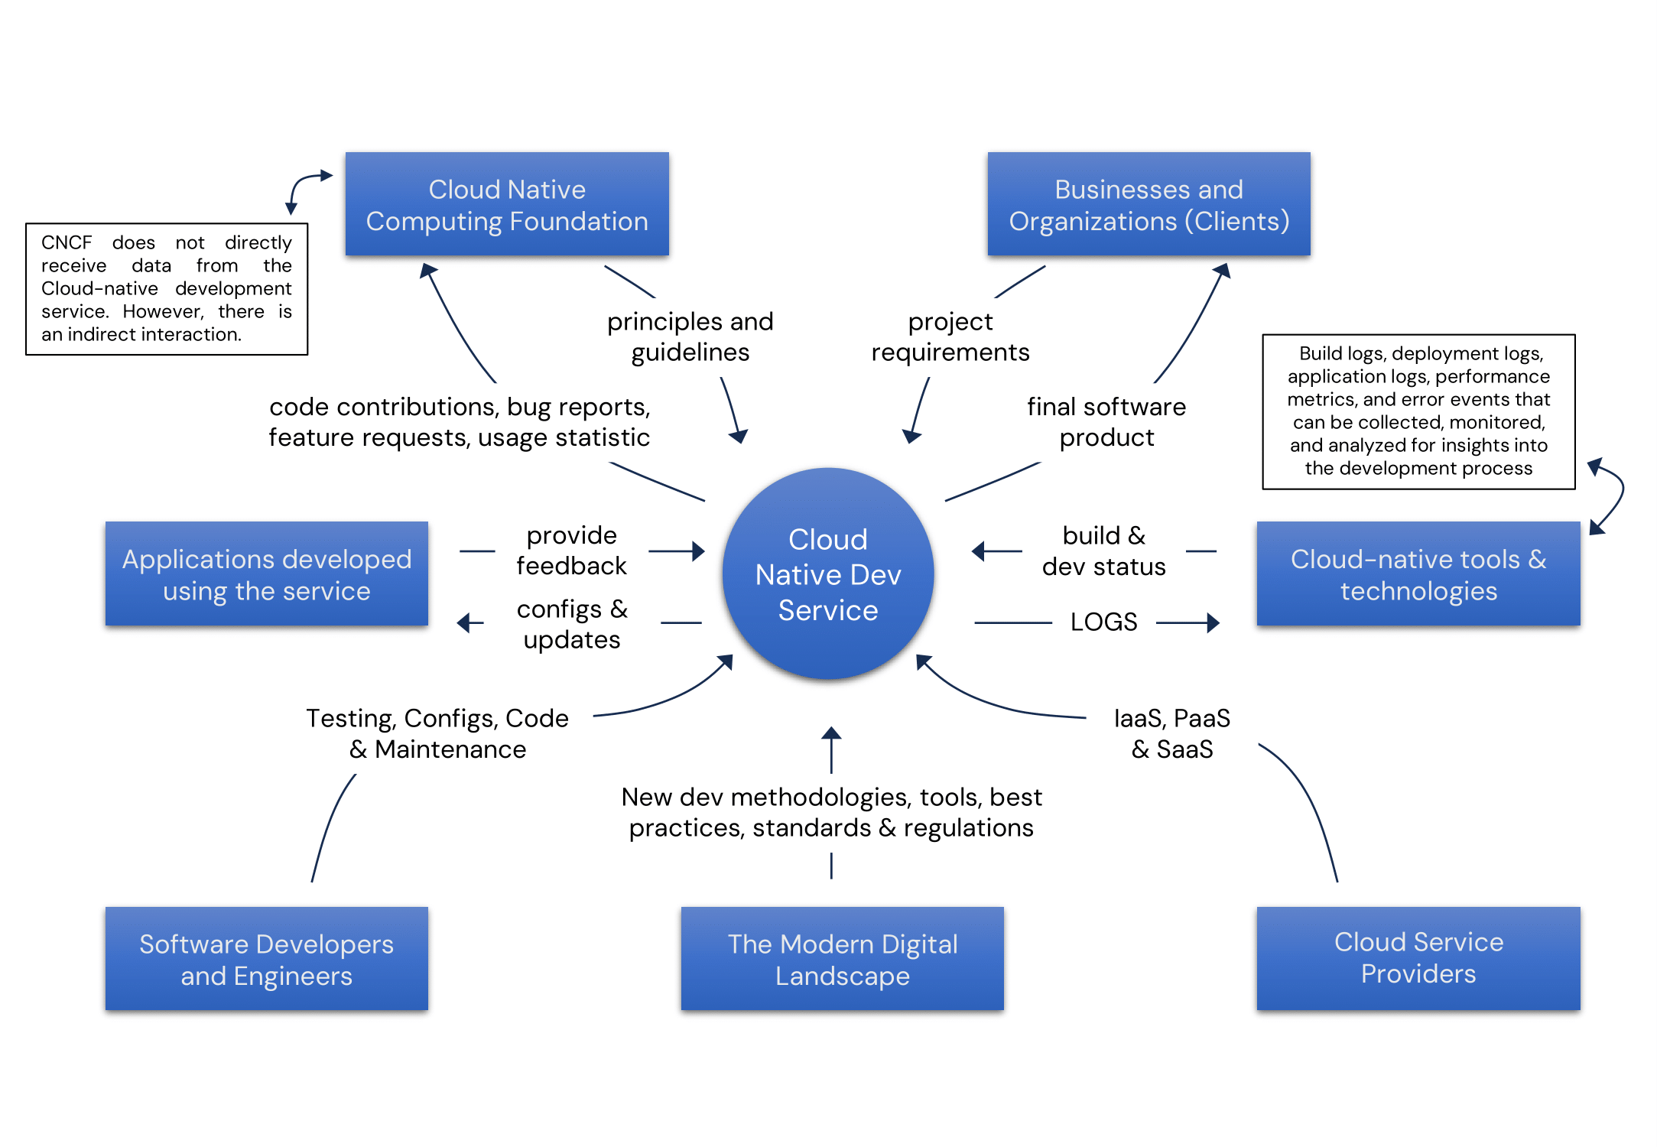

***Figure 3 :Context Diagram for Cloud Native***

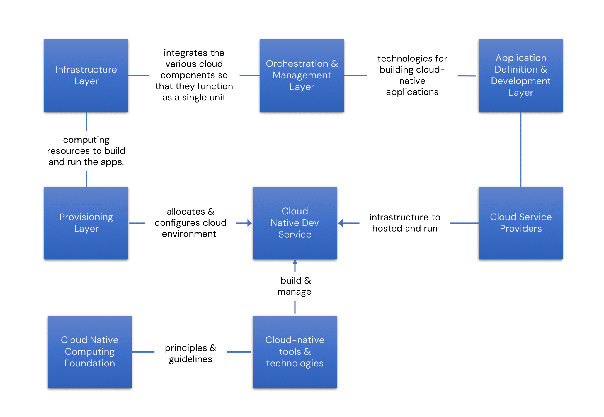**Ecosystem Map**

***Figure 5 :Ecosystem map for Cloud Native***

**The Infrastructure Layer, Provisioning Layer, Application Definition and Development Layer, and Cloud Service Providers** work together to deliver an excellent cloud-native development service.

**The Infrastructure Layer**, which includes operating systems, storage, network, and other computing resources, forms the foundation of the cloud-native stack. It provides the computing resources the service uses to build and run the applications.

**The Provisioning Layer**, which consists of cloud services that allocate and configure the cloud environment, manages the cloud resources for the service. It ensures that the necessary resources are available when needed.

**The Application Definition and Development Layer**, which includes software technologies for building cloud-native applications, provides the tools and technologies the service uses to make the applications. It defines the structure and behaviour of the applications.

**Cloud Service Providers**, such as AWS, Google Cloud, and Azure, provide the infrastructure where the applications developed by the service are hosted and run. They manage the hardware and computing resources in their own data centres, and the service interacts with these providers to deploy and manage the applications.

**The CNCF and Cloud-native tools and technologies** work together to provide a comprehensive platform for cloud-native development. The CNCF provides the guidelines and support, and the tools and technologies provide the capabilities for building and managing cloud-native applications.

Together, these layers and technologies work to deliver a comprehensive cloud-native development service that is scalable, flexible, and resilient, meeting the demands of the clients.

**Event List**

* **Client Requirements Submission:** Businesses and organizations submit their software project requirements to the Cloud-native development service.
* **Project Initiation:** The service initiates a new project based on the client's requirements.
* **CNCF Guidelines Application:** The service applies the principles and guidelines provided by the CNCF to the project.
* **Tool & Technology Utilization:** The service uses the Cloud-native tools and technologies (Kubernetes, Microservices, Containers, and Terraform) to develop the software project.
* **Build Logs & Deployment Logs Generation:** The Cloud-native tools and technologies generate build logs, deployment logs, application logs, performance metrics, and error events.
* **Application Development:** The service develops software applications based on the client's requirements and the guidelines provided by the CNCF.
* **Application Feedback:** The applications developed by the service provide feedback, like runtime errors and usage statistics, to the service.
* **Deployment Information & Configurations:**The service provides the applications with deployment information, configurations, monitoring management, and compliance.
* **Infrastructure Provisioning:** The service provides the necessary infrastructure for the Cloud Service Providers applications.
* **Application Deployment:** The service deploys the applications on the provisioned infrastructure.
* **Application Monitoring:** The service monitors the applications for performance, usage, and errors.
* **Application Maintenance:** The service performs application maintenance, including updates, patches, and upgrades.
* **Project Completion:** The service completes the project and delivers the developed software applications back to the clients.

*This event list may seem unconventional, but it's crucial to understand that our project is a cloud-native development service. The nature of cloud-native development is fundamentally different from traditional software development methods.*

*The events listed reflect a cloud-native development service's key actions and data exchanges. For example, the "****Tool & Technology Utilization****" event represents using cloud-native tools and technologies in the development process, a fundamental aspect of cloud-native development. Similarly, the "****Application Feedback****" event represents the continuous feedback loop in cloud-native development, where applications provide real-time data that can be used to improve the system.*