QUIZ APP

Wireframe Documentation

HOME PAGE

Homepage have Start button along with some guideline, user need to click on “Start Button” to access Quiz

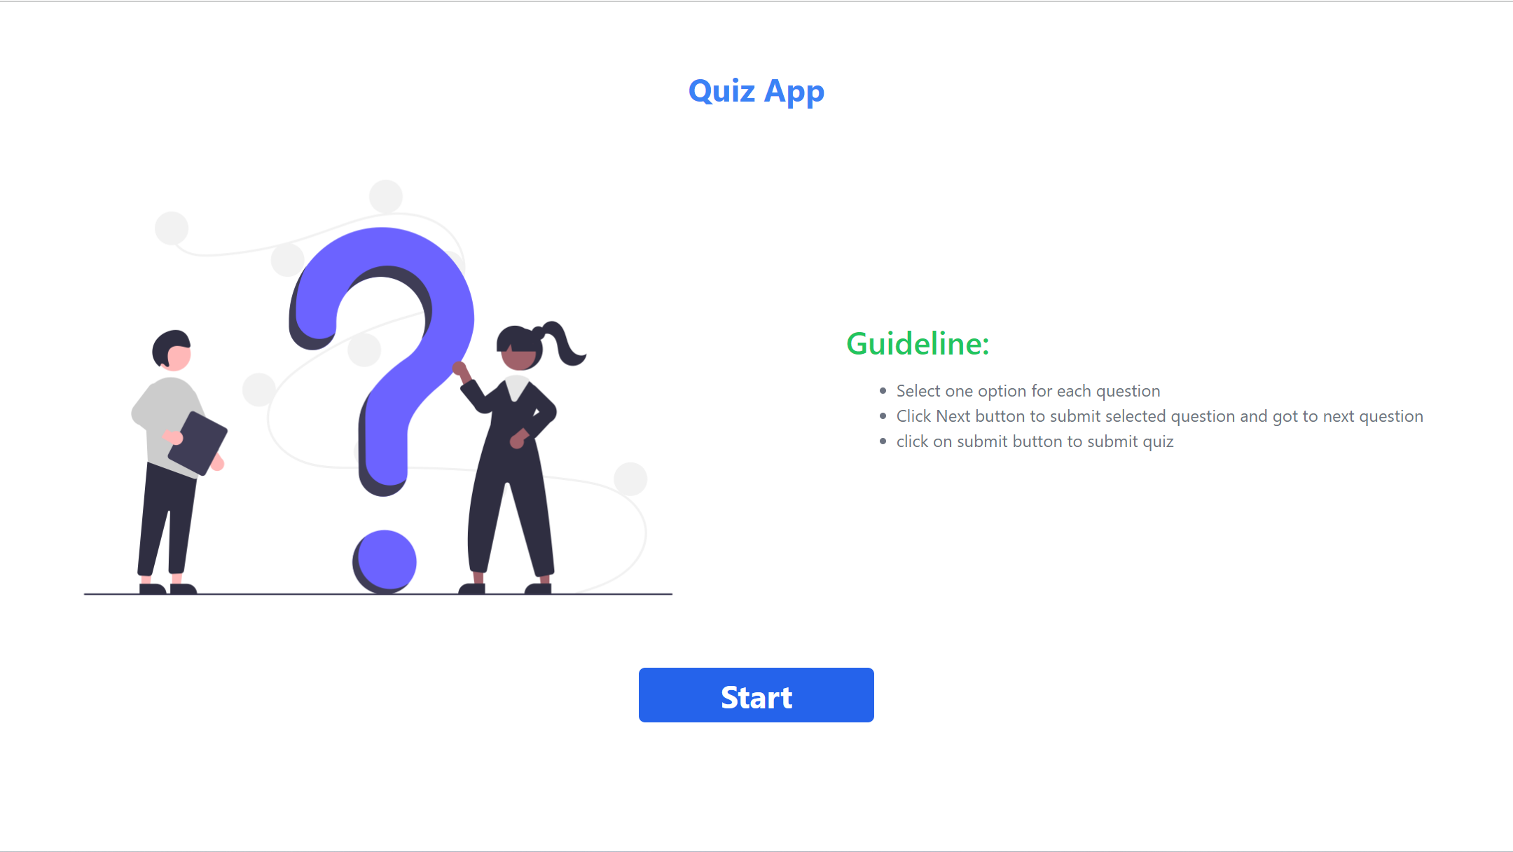

Quiz Page

On this page user will served by quiz along with 3 question “Previous” (to go previous question), “Next” (to submit and load next question) & Submit (user need to click submit to submit the quiz)

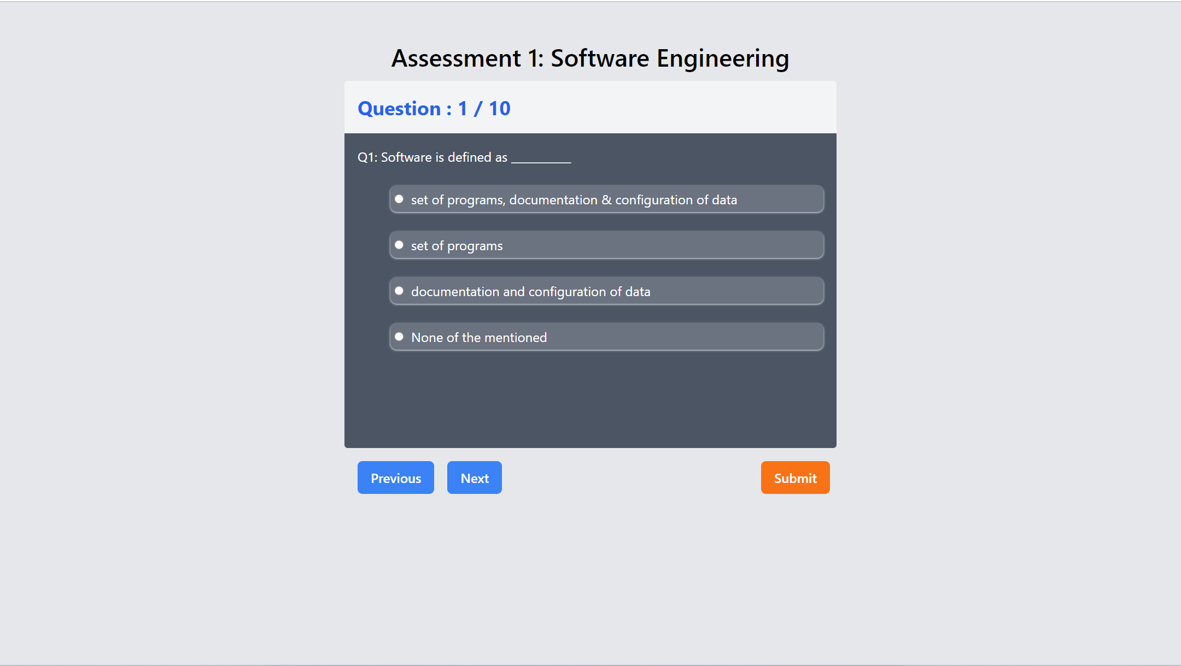

**Result Page**

On this page Score and questions along with user selected & correct answer showed to user

