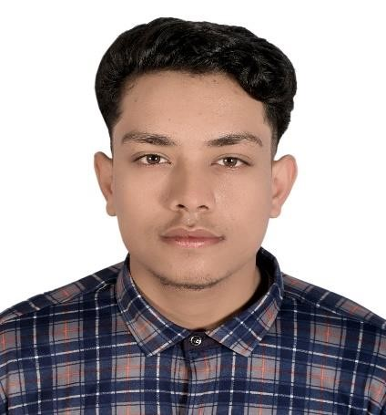**ROHAN GHIMIRE**

UI/UX DESIGNIER

* +977 9824371258

 rylancosta789@gmail.com

 [Rohan-Ghimire](https://www.linkedin.com/in/rohan-ghimire-8246862a6/)

# SUMMARY

UI/UX Designer with over 2 months of expertise in creating user-friendly interfaces and engaging experiences. Skilled in remote work environments, managing projects efficiently from a home-based setup. Strong collaborator with experience in working with cross-functional teams and communicating effectively with clients. I am seeking an internship to further develop my skills and build a career in UI/UX and professional life.

# TECHNICAL SKILLS

* **Design Tools: Adobe XD, Sketch, Figma, and InVision.**
* **Collaboration Tools:** **Slack, Trello, or Asana**
* **Programming Languages: *HTML, CSS, JavaScript***
* **Wireframing & Prototyping:** **Creating low-fidelity wireframes and high-fidelity prototypes**

# EXPERIENCE

**Freelance UI/UX Designer**

***Self-Practice Projects*** ***Jan 2024 – Present***

* **Project Development**
* **User research**
* **Design Tools**
* **Responsive Design**

# EDUCATION

Bal Bikas Boarding High School  ***July 2020***

**Diploma in computer engineering**

Budhanilkantha Technical School ***NOVEMBER 2020 - OCTOBER 2024***

# REFERENCES

References on request