1)

b) for n = 1:



for n = 2:



for n = 3:

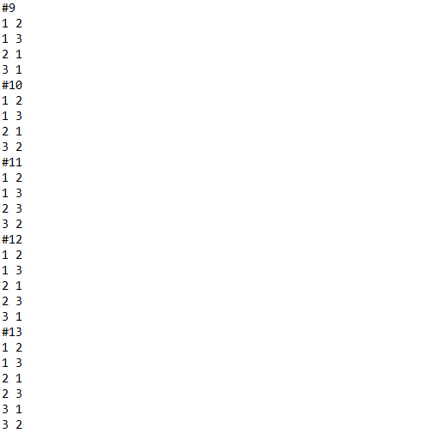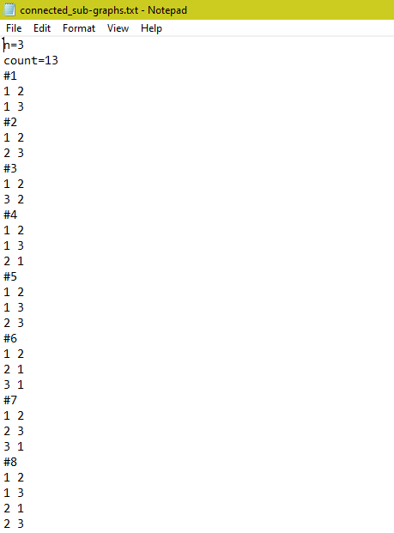

for n = 4: (n=4 file is included for full output)



c) The maximum value of 'n' for which the program can successfully complete within one hour of computing time is 'n = 4'. This is because when 'n = 4', the program only takes 7 seconds to compute, whereas for 'n = 5', it takes approximately 75,366 seconds, which is equivalent to around 20 hours of computing time.

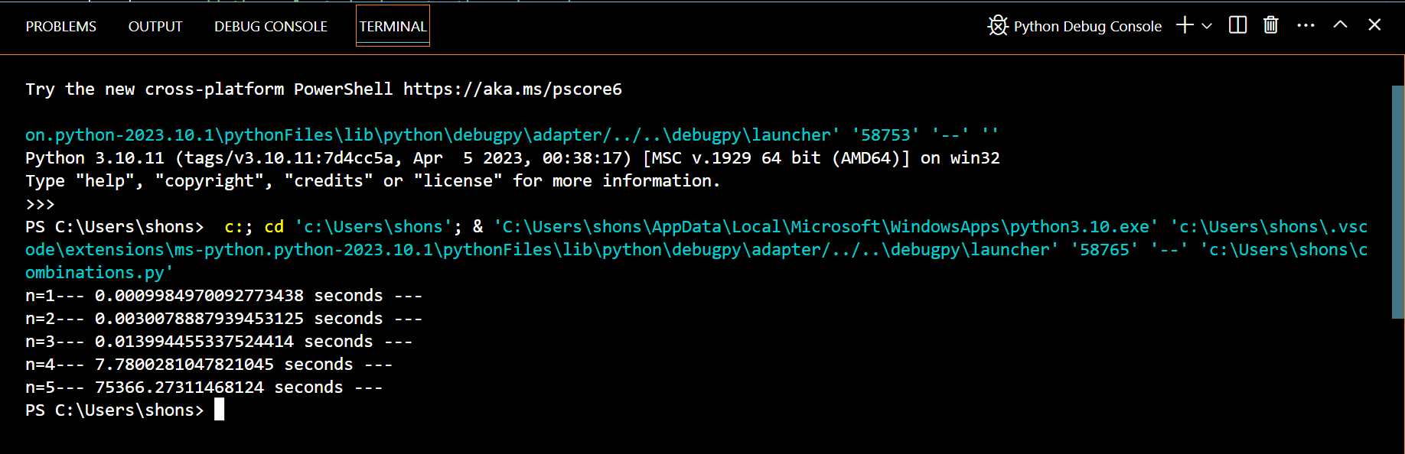

d) The maximum value of 'n' for which the program can successfully complete within 2, 4, or 8 hours of computing time is 'n = 4'. This is because when 'n = 4', the program only takes 7 seconds to compute, while for 'n = 5', it takes approximately 75,366 seconds, which is approximately 20 hours of computing time.