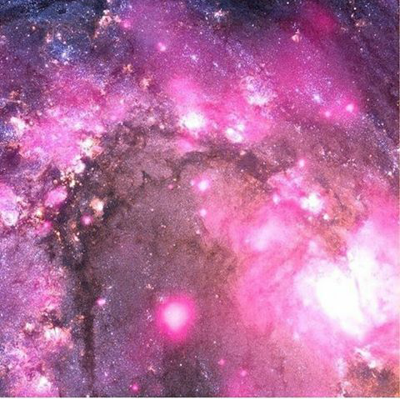

FORMULA

**d= vt v= d/t**

**UNIFORMLY ACCELERATED MOTION**

$$V_{f=} at+ V_{i}$$

$$d= v_{i }t+\frac{{at}^{2}}{2}$$

$$d=(\frac{v_{f+}v_{i}}{2})t$$

$${ v}_{f^{2 }} = v_{i^{2 }}+2ad$$

**HORIZONTAL**

$d=v_{i}t+\frac{1}{2}at²$

**VERTICAL**

$${ v}_{f}= v_{i}+a_{g}t$$

**MOMENTUM**

**p= mv**

**IMPULSE MOMENTUM**

**Ft= m $∆$ v**

**PROJECTILES**

**y= $\frac{1}{2}$ at²+ $V_{i}$ t+ $y_{i}$**

**POWER WORK**

**p= $\frac{w}{t}$ w= fd**

**ENERGY**

**E= ${mc}^{2}$**

**KINETIC ENERGY**

$KE=\frac{1}{2}$**mv²**

**POTENTIAL ENERGY**

***PE =* mgh**

**ABIFE R.AMATONG G9 APOLLO**