***WELCOME TO MOBILE LEGENDS!***

***5***

***4***

***3***

***2***

***1***

***ADMIN SIDE***

**Profile > Personal Information**

-must clear the textboxes after saving new data.

**Settings > School Year**

-can’t set a school year. There’s no data in the drop down box.

**Home > ICS Details**

-need to show “Success” or any appropriate term after updating the data.

**Student List > Add Student**

-add additional field “Curriculum” as for what curriculum is the student/s enrolled.

*to be able to sort the subject/s of the curriculum for the student/s.

-need to show “Success” or any appropriate term. After saving a new data, it must reload and view to Student List.

-**Suggestion**

-regarding to username format and password. HAHAHAHA

**Faculty List > Add Faculty**

-need to show “Success” or any appropriate term. After saving a new data, it must reload and view to Faculty List.

-**Suggestion**

-regarding to username format. HAHAHAHA

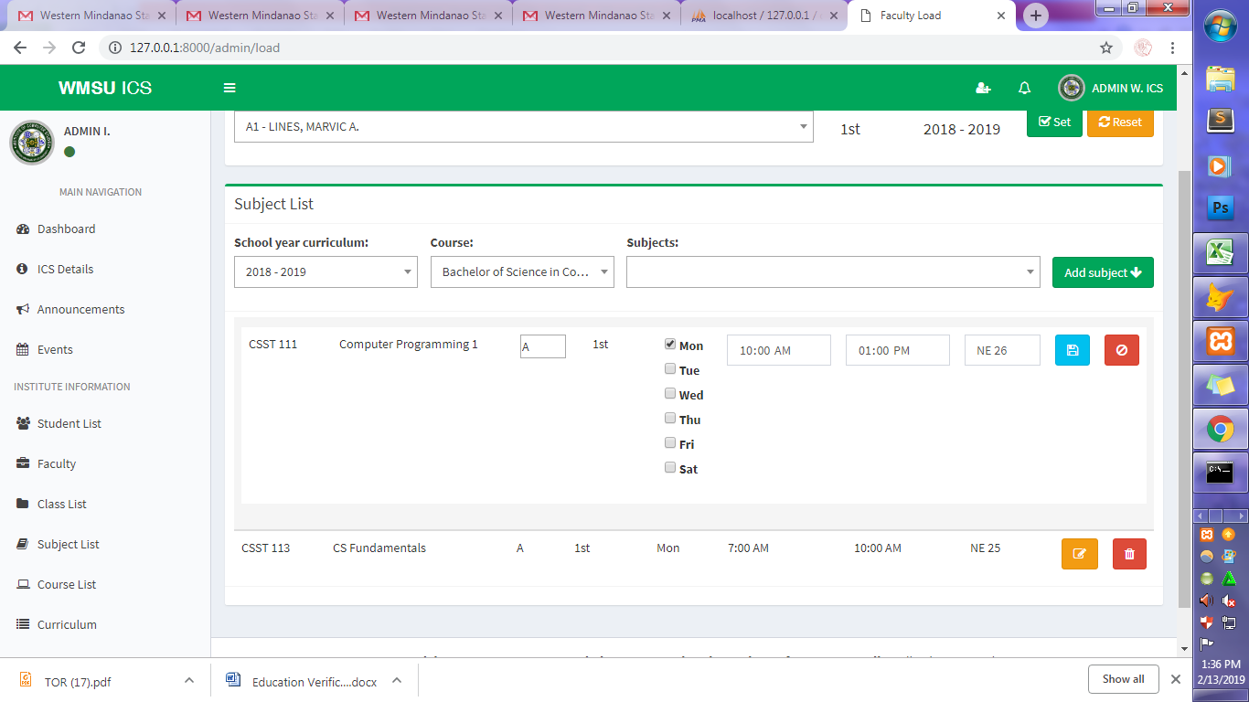 **Faculty Load > Subject List**

-

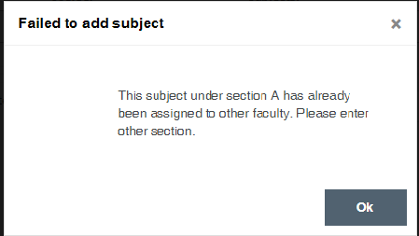

-One professor must accept many subject as long as it is not the same section..  
 (Since the system has been approved to not have validation regarding to subject  
 scheduling **((hopefully) huhubells)** )

-when adding a subject, it saves two same subject (sometimes). “trial and error basis”

-“School year curriculum” must be change to “Curriculum Year”

-**Classes**

-Student/s must not be in the “Official Student List” when he/she enroll to  
 a certain subject unless the Professor assign in the said subject accepted the  
 request.

**-Subject List**

-the value 0.0 must be acceptable (eg. 3.0)

-the value 0 must also be acceptable especially it applies to OJT and LAB UNITS.  
 -must save same subject & description except number of units.

**-Curriculum**

-“School Year” under curriculum must be change to “Year”. It reads as  
 “Curriculum Year” since it’s under the Curriculum section.

-the “Year” must be in textbox form. Since we’re not sure what year does  
 the curriculum change. So we need to input the data manually. **tsarot HAHAHA**

***TEACHER SIDE***

**Dashboard**

-MAY FOREVER SA LOADING <3 HAHAHA HAPPY VALENTINES DAY! :D

**Profile > Personal Information**

-after saving, it must clear the data and reload to the “Dashboard”.

**Subject > Posts > Add Post**

-can’t attached/upload file. (sa link/unlink mag-attached ng file?)

***STUDENT SIDE***

**Dashboard**

-MAY FOREVER SA LOADING <3 HAHAHA HAPPY VALENTINES DAY! ULIT :D

-SUBJECTS NEW MESSAGES IS 0 even if there’s an unread chat by the student.

**Subjects > Homeworks**

-MAY FOREVER SA LOADING <3 HAHAHA HAPPY VALENTINES DAY! And AGAIN :D

**TITLE TEXT REVISION/CONCERS/SUGGESTIONS**

**HOMEPAGE**

-today to “Today” (Calendar Section)

-Upcoming events to “Upcoming Events”

**ADMIN SIDE**

*Curriculum

-Save new school year to “Save New School Year”

-Save new semester to “Save New Semester”

**TEACHER SIDE**

-Dashboard

*Current School year to “Current School Year”

**STUDENT SIDE**

-Dashboard

*Current School year to “Current School Year”

*New messages to “New Messages”

*Enroll subjects to “Enroll Subjects”

*Can we do the naming first name, middle name and last name?

*Home works to “Homework”

-Subject > Posts

-Can we do the naming first name, middle name and last name?

-Home works to “Homework”