Enterprise AI Token Redistribution
Engineers are blocked. PMs have unused tokens. Same account. Same budget. Here is how to fix it.

The Problem
Engineers use Claude Code — agentic sessions that read entire codebases and loop autonomously, burning 50K-500K tokens per run. PMs and designers use Claude.ai — short conversational sessions, 2K-50K tokens per day. Both draw from the same company account.

One Claude Code session consumes what a PM uses in a week. The engineer hits the rate limit and stops dead. The PM's unused allocation sits idle and expires at month end. The company paid for both.

Role | Tool | Typical daily usage
Engineers | Claude Code | 200K-500K tokens
PMs / Designers | Claude.ai | 10K-50K tokens
HR / Finance / Legal | Claude.ai | 2K-5K tokens

The Market

Monthly AI spend  $85,000 | Tokens wasted monthly  12B (43%) | Annual waste  $432,000

Source: Ramp AI Index 2026 · CloudZero 2025 · 700-person tech company · Claude Sonnet $3/M tokens

Today — Engineers Blocked, PM Tokens Wasted
Usage follows a power law. Engineers exceed their cap and get blocked. Everyone else's allocation expires unused every month.

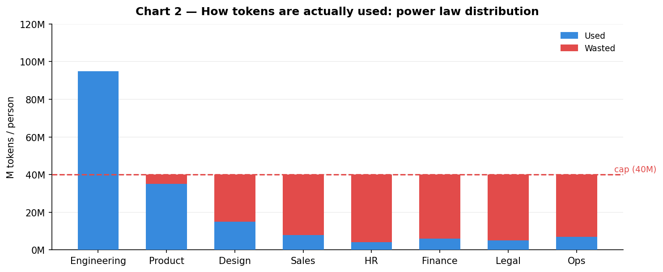
After Redistribution — Same Budget, Zero Waste
The proxy detects idle PM and designer bandwidth and routes it to blocked engineers automatically. No one notices. No one waits.

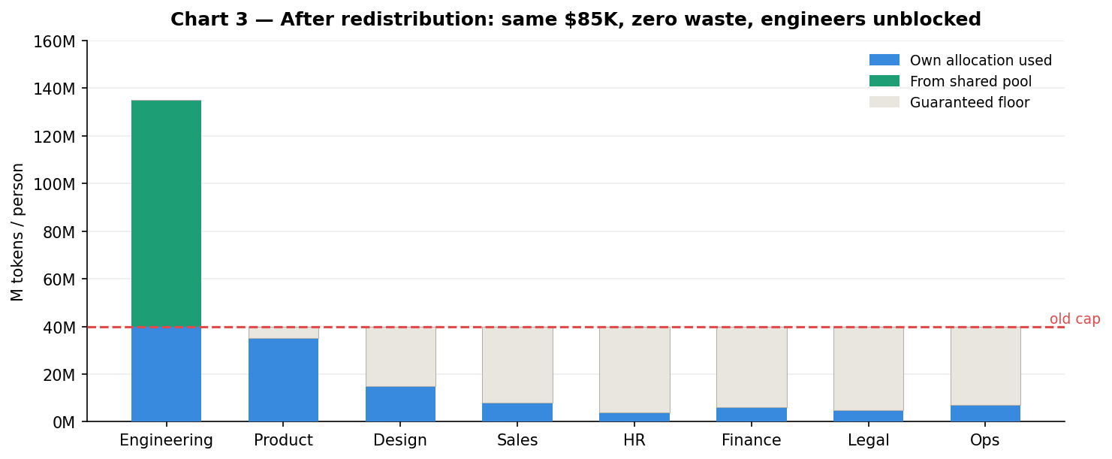

The Solution
A proxy layer sits between every employee's tool and Anthropic. It identifies who is calling, tracks usage live, and routes idle PM and designer bandwidth to engineers the moment they need it.

- Engineer hits limit → proxy finds idle PM bandwidth → call goes through instantly
- Daily job pulls Anthropic Analytics API → recalculates allocations → updates proxy
- Employee changes one thing: paste a virtual key into their IDE. Everything else is invisible.
- No changes to the Anthropic contract, account, or model

What Gets Built

Component | What it does | When
Identity layer | Maps each virtual key to a real user in <1ms | Week 1-2
Token counter | Counts every token live — input and output streams | Week 1-2
Pool manager | Routes idle PM/designer bandwidth to engineers in real time | Week 3-4
Daily rebalancer | Pulls Anthropic Analytics API every 24h, resets allocations | Week 3-4
Admin dashboard | Usage per person, pool balance, waste recovered, alerts | Week 5-6

Anthropic provides per-user visibility via the Enterprise Analytics API. What does not exist is acting on that data in real time. The proxy is that missing layer. Same budget. Same contract. Same Anthropic account. Engineers unblocked. Zero waste.

Sources: Ramp AI Index 2026 · CloudZero 2025 · docs.anthropic.com/en/api/rate-limits

