**Phonology**

|  |  |  |  |  |
| --- | --- | --- | --- | --- |
| Trans | IPA | Variant | Letter | Name |
| ’ | [ʔ] |  | א | alef |
| b | [b] |  | בּ | bet |
| v | [β] ([v]) |  | ב |
| g | [g] |  | גּ | gimel |
| gh | [ɣ] |  | ג |
| d | [d] |  | דּ | dalet |
| dh | [ð] |  | ד |
| h | [h] |  | ה | he |
| w (v) | [w] ([v]) |  | ו | waw |
| z | [z] |  | ז | zayin |
| ch | [χ] |  | ח | chet |
| t | [t] |  | ט | tet |
| y (i) | [j] |  | י | yod |
| k | [k] | ךּ | כּ | kaf |
| kh | [x] ([χ]) | ךך | כ |
| l | [l] |  | ל | lamed |
| m | [m] | ם | מ | mem |
| n | [n] | ן | נ | nun |
| s | [s] |  | ס | samekh |
| ‘ | [ʕ] |  | ע | ayin |
| p | [p] | ףּ | פּ | pe |
| f | [f] | ף | פ |
| ts | [ts] | ץ | צ | tsadi |
| k | [q] ([k]) |  | ק | qof |
| r | [ɾ] ([ʁ]) |  | ר | resh |
| sh | [ʃ] |  | שׁ | shin |
| s | [s] |  | שֹ |
| t | [t] |  | תּ | taw |
| th | [θ] |  | ת |

Dagesh Qal(Lene): ּ appears in ב, ג, ד, כ, פ, ת when there is not a vowel preceding it

Dagesh Chazaq(Forte): can occur in any consonant (ex gutturals and ר) and lengthens it

Guttural: some pharyngeal and laryngeal consonants צ, ח, ה, א

Weak C: guttural and ר

|  |  |  |  |
| --- | --- | --- | --- |
| Long | Short | Reduced | IPA |
| ָ | ַ | ֲ | [ä] |
| ֵ | ֶ | ֱ | [e̞] |
| ֹ | ָ | ֳ | [o̞] |
|  | ֻ |  | [u] |
|  | ִ |  | [i] |

Shewa(ְ ): [e̞] or silent

[e̞]: at the beginning of a syllable, following a long vowel, 2nd of 2 consecutive shewas in the middle of a word, under a consonant with a dagesh chazaq

silent: at the end of a word, following a short vowel, 1st of 2 consecutive shewas in the middle of a word

In most words, the last syllable is stressed.

**Noun**

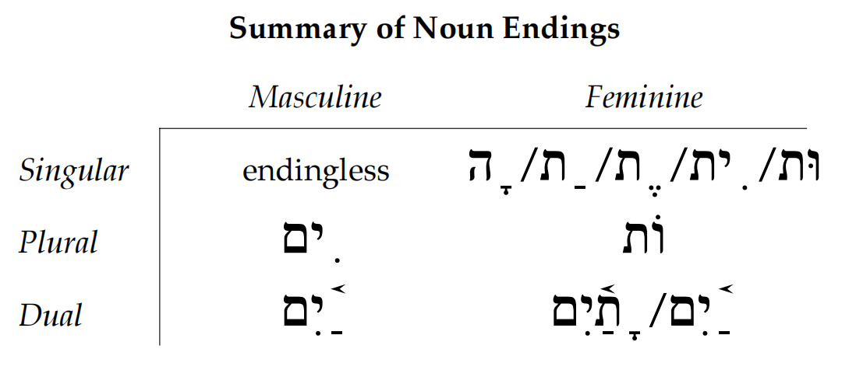

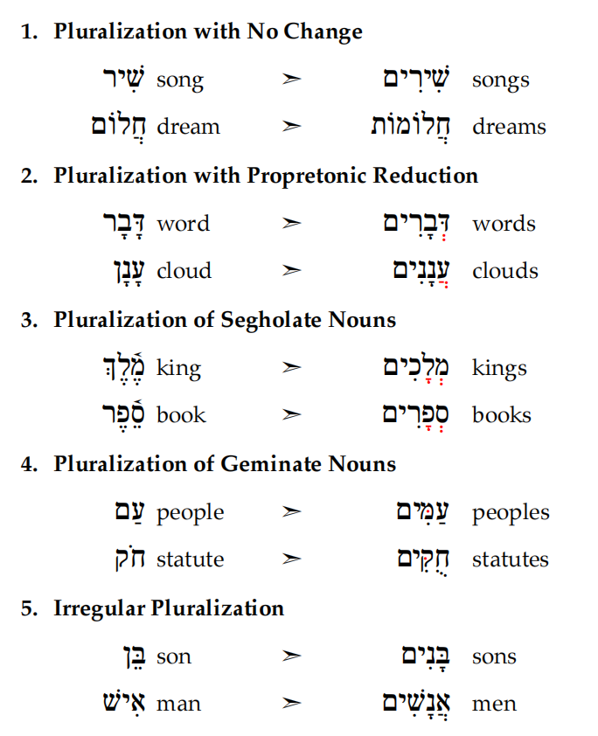

**Number**

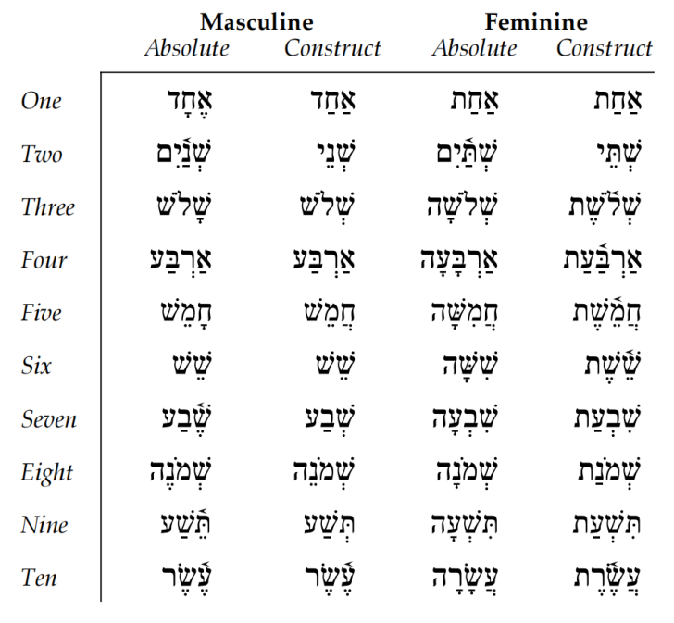

**Article**

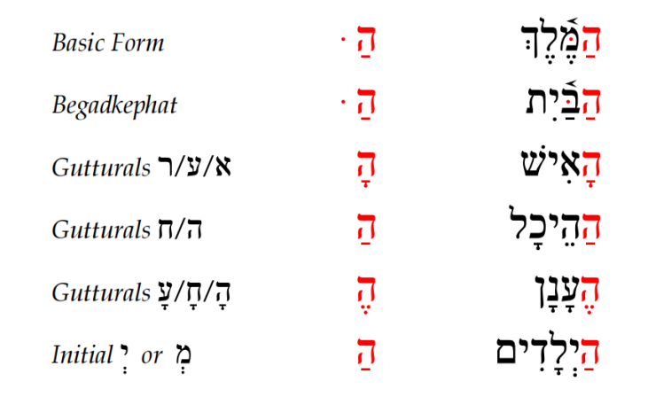

**Conjunction**

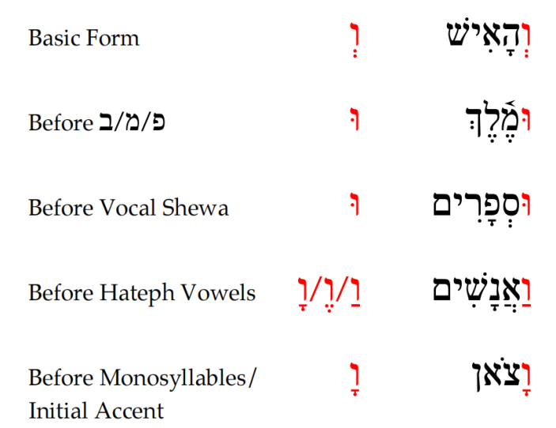

**Demonstrative**

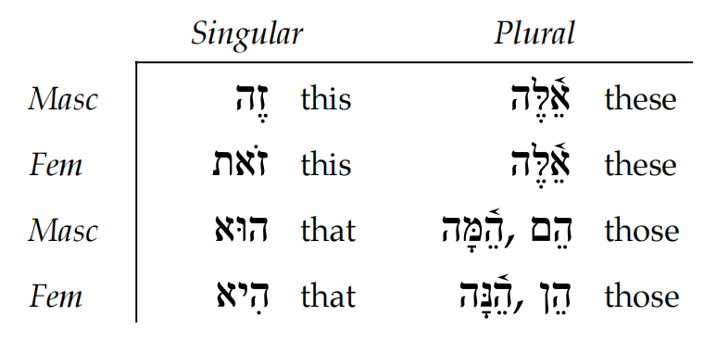

When a noun is modified by both an attributive adjective and a demonstrative adjective (as in “this good book”), all three must agree in gender, number, and definiteness. In terms of word order, the noun will be first, the attributive adjective will be second, and the demonstrative adjective will be last.

**Interrogative(Indefinite)**

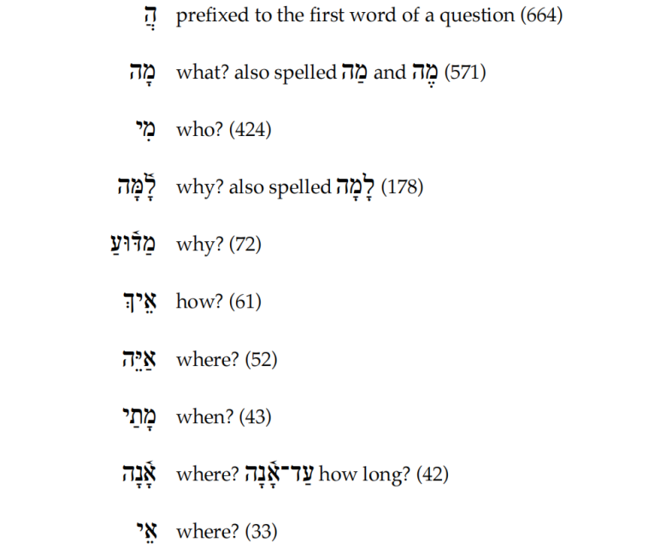

**Personal**

Independent

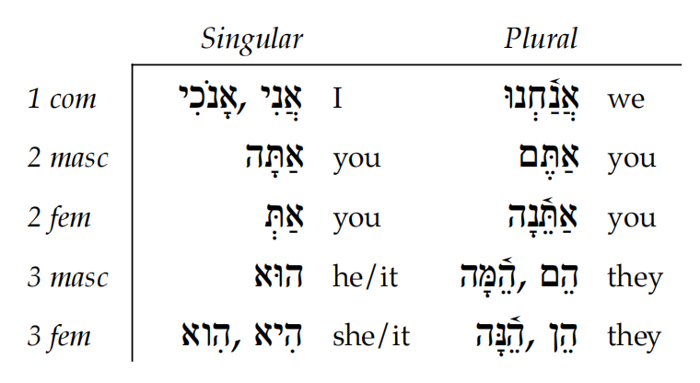

Suffix

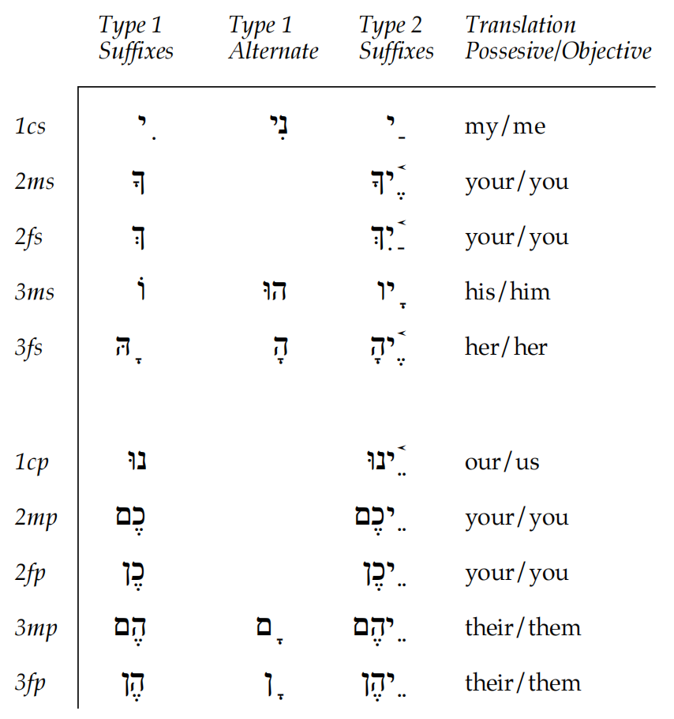

Type 1 suffixes occur with singular nouns and the definite direct object marker. Type 2 suffixes occur with plural nouns. When pronominal suffixes are added to masculine plural nouns, the masculine plural ending is dropped.

**Relative** א

אֲשֶׁר

The form of this word does not change in order to indicate the gender or number of its antecedent. It may appear with or without Maqqef. When functioning as a relative pronoun introducing a relative clause, it immediately follows the noun it is modifying.

**Adjective**

|  |  |  |
| --- | --- | --- |
|  | S | P |
| M | / | םיִ |
| F | הָ | וֹת |

In the attributive usage, the adjective modifies a noun and agrees with that noun in gender, number, and definiteness. In this usage, the adjective follows the noun that it modifies.

In the predicative usage, the adjective is used as part of a verbless clause and agrees with its noun in gender and number, but not in definiteness. The predicative adjective never takes the definite article. In this usage, the adjectivemay either precede or follow the noun.

Comparison:

comparative: add ממִן before the word that acts as the object of comparison

superlative: add art.D or ממְאֹד after the adj

**Adverb**

Biblical Hebrew does not contain many words that are classified directly as adverbs. However, many different kinds of words can function as adverbs. A general rule is that when a particle occurs after the verb, it functions as an adverb; but when a particle appears before the verb, then it functions in some other way.

**Verb**

|  |  |  |  |
| --- | --- | --- | --- |
|  | Simple | Intensive | Causative |
| Active | Qal | Piel | Hiphil |
| Passive | Niphal | Pual | Hophal |
| Reflexive | Niphal | Hithpael | / |

Personal Ending

|  |  |  |  |  |  |  |  |  |  |  |  |
| --- | --- | --- | --- | --- | --- | --- | --- | --- | --- | --- | --- |
|  | | S | | | | | P | | | | |
| 1 | 2-M | 2-F | 3-M | 3-F | 1 | 2-M | 2-F | 3-M | 3-F |
| Pf | Suf | תּי | תָּ | תְּ | / | הָ | נוּ | תֶּם | תֶּן | וּ | |
| Impf | Pre | אאֶ | תִּ | תִּ | ייִ | תִּ | ננִ | תִּ | תִּ | ייִ | תִּ |
| Suf | / | / | יִ | / | / | / | וּ | ננָה | וּ | ננָה |

Strong verb diagnostics

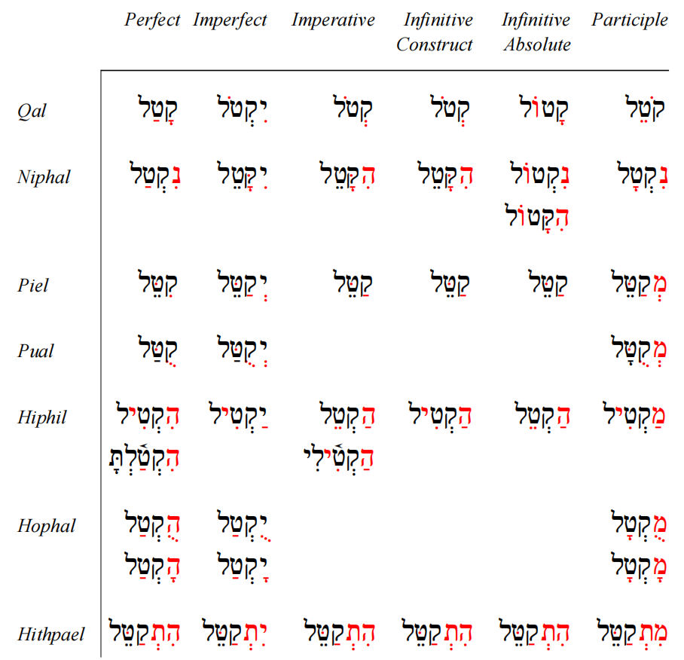

**Syntax**

Word order: VSO.

S and O.D can stand at the beginning of a sentence for the purpose of emphasis. O.D may either precede or follow O.I.