**Phonology**

|  |  |  |  |  |  |
| --- | --- | --- | --- | --- | --- |
| 字母 | IPA | Trans | 字母 | IPA | Trans |
| अ | [ɐ] | a | आ | [aː] | ā |
| इ | [i] | i | ई | [iː] | ī |
| उ | [u] | u | ऊ | [uː] | ū |
| ए | [eː] | ē | ऐ | [aj] | ai |
| ओ | [oː] | ō | औ | [aw] | au |
| ऋ | [r̩ ] | r̥ | (ॠ) | [r̩ː] | r̥̄ |
| ऌ | [l̩ ] | l̥ | ॡ | [l̩ː] | l̥̄ |
| अॅ | [æ] | ê | आॅ | [ɒ] | ô |

|  |  |  |  |  |  |  |  |  |  |  |  |  |
| --- | --- | --- | --- | --- | --- | --- | --- | --- | --- | --- | --- | --- |
|  | Labial | | Labiodental | | Dental | | Retroflex | | Palatal | | Velar | |
| Occlusive | प | [p] |  |  | त | [t̪] | ट | [ʈ] | च | [tʃ] | क | [k] |
| फ | [pʰ] |  |  | थ | [t̪ʰ] | ठ | [ʈʰ] | छ | [tʃʰ] | ख | [kʰ] |
| ब | [b] |  |  | द | [d̪] | ड | [ɖ] | ज | [dʒ] | ग | [ɡ] |
| भ | [bʱ] |  |  | ध | [d̪ʱ] | ढ | [ɖʱ] | झ | [dʒʱ] | घ | [ɡʱ] |
| Nasal | म | [m] |  |  | न | [n] | ण | [ɳ] | ञ | [ɲ] | ङ | [ŋ] |
| Approximant |  |  | व | [ʋ] | ल | [l] | र | [r] | य | [j] |  |  |
| Fricative |  |  |  |  | स | [s] | ष | [ʂ] | श | [ʃ] |  |  |
|  |  |  |  |  |  |  |  |  |  | ह | [ɦ] |

Stress

penultimate(when long) → antepenultimate(when short)

Sandhi

Internal

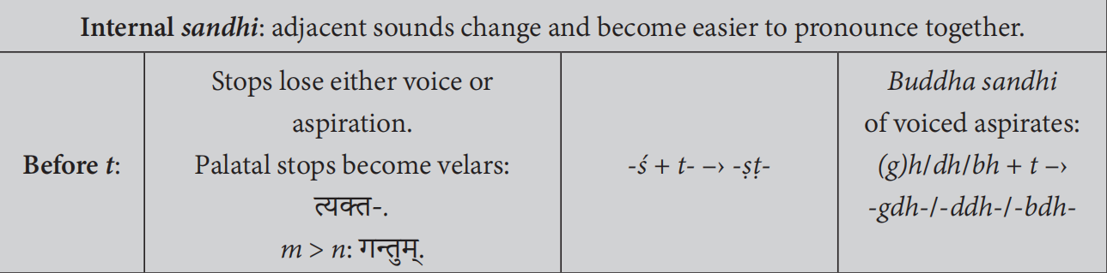

External

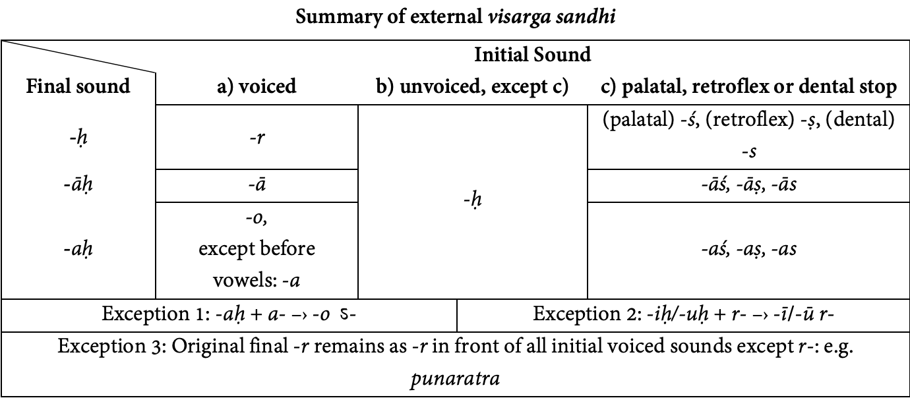

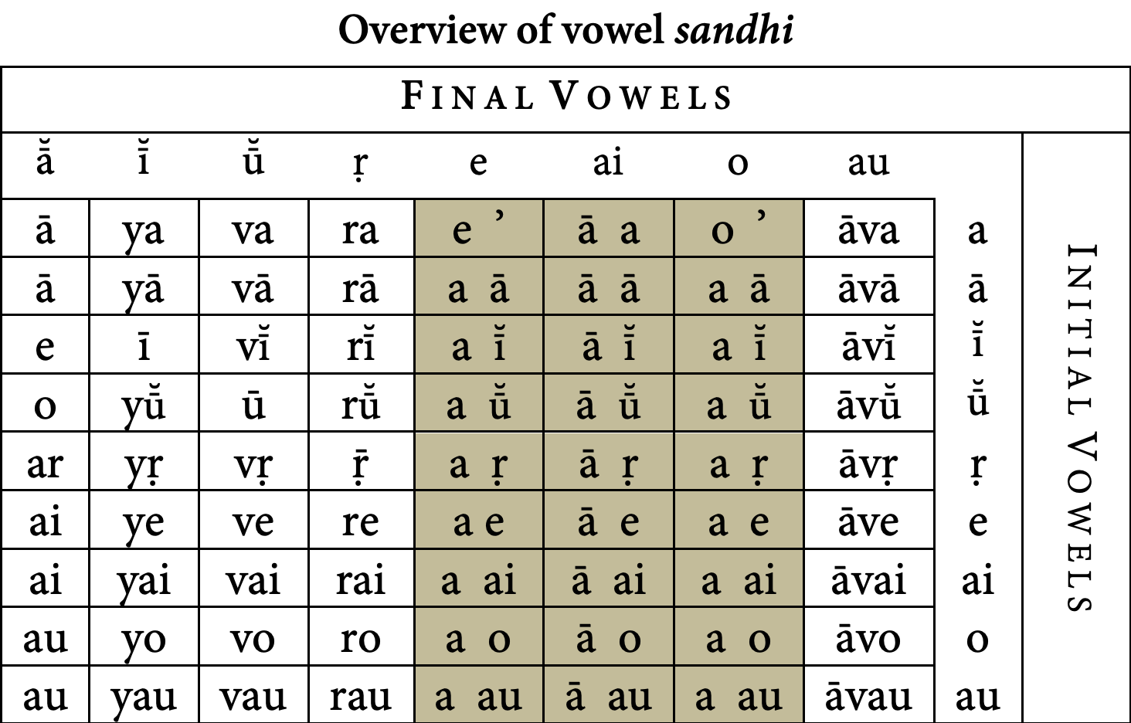

Reduplication

C: aspirated→unaspirated, velar→palatal, h→j, C cluster→only the first C

V:

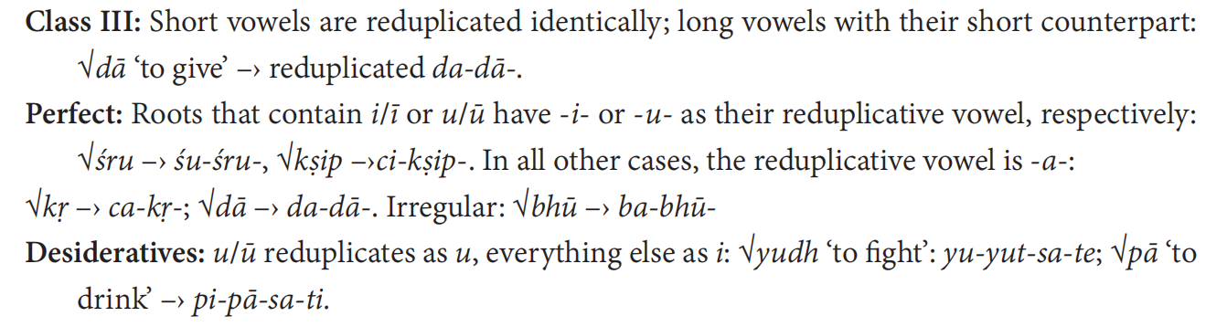

**Noun**

|  |  |  |  |  |  |  |  |  |  |  |  |
| --- | --- | --- | --- | --- | --- | --- | --- | --- | --- | --- | --- |
|  | a | | ā | i(u: e→o, y→v) | | | ī(ū) | r̥ | | C | |
| M | N | F | M | N | F | F | M | F | M/F | N |
| Single | | | | | | | | | | | |
| N. | aḥ | am | ā | iḥ | i | iḥ | ī(ḥ) | ā | | / | / |
| V. | a | | e | e | i | e | i | aḥ | | / | / |
| A. | am | | ām | im | i | im | īm | aram | | am | / |
| D. | āya | | āyai | aye | iṇe | yai | | re | | e | |
| Ab. | āt | | āyāḥ | eḥ | iṇāḥ | yāḥ | | uḥ | | aḥ | |
| I. | ena | | ayā | inā | iṇā | yā | | rā | | ā | |
| G. | asya | | āyāḥ | eḥ | iṇāḥ | yāḥ | | uḥ | | aḥ | |
| L. | e | | āyām | au | iṇi | yām | | ari | | i | |
| Dual | | | | | | | | | | | |
| N. | au | e | e | ī | iṇī | ī | yau | arau | | au | ī |
| V. | au | e | e | ī | iṇī | ī | yau | arau | | au | ī |
| A. | au | e | e | ī | iṇī | ī | yau | arau | | au | ī |
| D. | ābhyām | | | i(ī)bhyām | | | | r̥bhyām | | ābhyām | |
| Ab. | ābhyām | | | i(ī)bhyām | | | | r̥bhyām | | ābhyām | |
| I. | ābhyām | | | i(ī)bhyām | | | | r̥bhyām | | ābhyām | |
| G. | ayoḥ | | | yoḥ | iṇoḥ | yoḥ | | roḥ | | oḥ | |
| L. | ayoḥ | | | yoḥ | iṇoḥ | yoḥ | | roḥ | | oḥ | |
| Plural | | | | | | | | | | | |
| N. | āḥ | āni | āḥ | ayaḥ | īṇi | (a)yaḥ | | araḥ | | aḥ | i |
| V. | āḥ | āni | āḥ | ayaḥ | īṇi | (a)yaḥ | | araḥ | | aḥ | i |
| A. | ān | āni | āḥ | īn | īṇi | īḥ | | r̥̄n | r̥̄ḥ | aḥ | i |
| D. | e(ā)bhyaḥ | | | i(ī)bhyaḥ | | | | r̥bhyaḥ | | bhyaḥ | |
| Ab. | e(ā)bhyaḥ | | | i(ī)bhyaḥ | | | | r̥bhyaḥ | | bhyaḥ | |
| I. | aiḥ | | ābhiḥ | i(ī)bhiḥ | | | | r̥bhiḥ | | bhiḥ | |
| G. | ānām | | | īn(ṇ)ām | | | | r̥̄ṇām | | ām | |
| L. | eṣu | | āsu | i(ī)ṣu | | | | r̥̄ṣu | | su | |

Gradation

strong(guṇa): n.M.S.Nom.(Voc./Acc.), n.M.D.Nom.(Voc./Acc.), n.M.P.Nom.(Voc.)

weak(zero): elsewhere

**Demonstrative**

|  |  |  |  |  |  |  |  |
| --- | --- | --- | --- | --- | --- | --- | --- |
|  | | this | | | that | | |
| M | N | F | M | N | F |
| S | Nom. | ayam | idam | iyam | asau | adaḥ | asau |
| Acc. | imam | idam | imām | amun | adaḥ | amūm |
| Ins. | anena | | anayā | amunā | | amuyā |
| Dat. | asmai | | asyai | asmuṣmai | | amuṣyai |
| Abl. | asmāt | | asyāḥ | amuṣmāt | | amuṣyāḥ |
| Gen. | asya | | asyāḥ | amuṣya | | amuṣyāḥ |
| Loc. | asmin | | asyām | amuṣmin | | amuṣyām |
| D | Nom. | imau | ime | ime | amū | | |
| Acc. | imau | ime | ime | amū | | |
| Ins. | ābhyām | | | āmūbhyām | | |
| Dat. | ābhyām | | | āmūbhyām | | |
| Abl. | ābhyām | | | āmūbhyām | | |
| Gen. | anayoḥ | | | amuyoḥ | | |
| Loc. | anayoḥ | | | amuyoḥ | | |
| P | Nom. | ime | imāni | imāḥ | amī | amūni | amūḥ |
| Acc. | imān | imāni | imāḥ | amūn | amūni | amūḥ |
| Ins. | ebhiḥ | | ābhiḥ | amībhiḥ | | amūbhiḥ |
| Dat. | ebhyaḥ | | ābhyaḥ | amībhyaḥ | | amūbhyaḥ |
| Abl. | ebhyaḥ | | ābhyaḥ | amībhyaḥ | | amūbhyaḥ |
| Gen. | eṣām | | āṣām | amīṣām | | amūṣām |
| Loc. | eṣu | | āṣu | amīṣu | | amūṣu |

**Interrogative**

“ka-”, declined like “tad” below.

**Personal**

|  |  |  |  |  |  |  |
| --- | --- | --- | --- | --- | --- | --- |
|  | | 1 | 2 | 3-tad | | |
| S | Nom. | aham | tvam | saḥ | tat | sā |
| Acc. | mām, mā | tvām, tvā | tam | tat | tām |
| Ins. | mayā | tvayā | tena | | tayā |
| Dat. | mahyam, me | tubhyam, me | tasmai | | tasyai |
| Abl. | mat | tvat | tasmāt | | tasyāḥ |
| Gen. | mama, me | tava, te | tasya | | tasyāḥ |
| Loc. | mayi | tvayi | tasmin | | tasyām |
| D | Nom. | āvām | yuvām | tau | te | te |
| Acc. | āvām | yuvām | tau | te | te |
| Ins. | āvābhyām | yuvābhyām | tābhyām | | |
| Dat. | āvābhyām | yuvābhyām | tābhyām | | |
| Abl. | āvābhyām | yuvābhyām | tābhyām | | |
| Gen. | āvayoḥ | yuvayoḥ | tayoḥ | | |
| Loc. | āvayoḥ | yuvayoḥ | tayoḥ | | |
| P | Nom. | vayam | yūyam | te | tāni | tāḥ |
| Acc. | asmān, naḥ | yuṣmān, vaḥ | tān | tāni | tāḥ |
| Ins. | asmābhiḥ | yuṣmābhiḥ | taiḥ | | tābhiḥ |
| Dat. | asmabhyam, naḥ | yuṣmabhyam, vaḥ | tebhyaḥ | | tābhyaḥ |
| Abl. | asmat | yuṣmat | tebhyaḥ | | tābhyaḥ |
| Gen. | asmākam, naḥ | yuṣmākam, vaḥ | teṣām | | tāṣām |
| Loc. | asmāsu | yuṣmāsu | teṣu | | tāṣu |

**Relative**

“ya-”, declined like “tad” above.

**Adjective**

Adjectives are placed most often before their substantives.

Comparison

comparative: adj: (1) stem+ -tara- (2) stem(unpredictable)+ -(ī)yas-

superlative: adj: (1) stem+ -tama- (2) stem(unpredictable)+ -iṣṭha-

**Verb**

Personal Ending

|  |  |  |  |  |  |  |  |  |  |  |
| --- | --- | --- | --- | --- | --- | --- | --- | --- | --- | --- |
|  | | S | | | D | | | P | | |
| 1 | 2 | 3 | 1 | 2 | 3 | 1 | 2 | 3 |
| Pr, F | A | mi | si | ti | vaḥ | thaḥ | taḥ | maḥ | tha | (a)nti |
| M | e | se | te | vahe | e(ā)the | e(ā)te | mahe | dhve | (a)nte |
| Impf,  A,  Con,  Opt | A | (a)m | ḥ | t | va | tam | tām | ma | ta | an/uḥ |
| M | i/(y)a | thāḥ | ta | vahi | ethām  āthām | etām  ātām | mahi | dhvam | (a)nta  ran |
| Pf | A | a | (i)tha | a | (i)va | athuḥ | atuḥ | (i)ma | a | uḥ |
| M | e | (i)ṣe | e | (i)vahe | āthe | āte | (i)mahe | (i)dhve | ire |
| Imp | A | āṇi | -/(d)hi | tu | āva | tam | tām | āma | ta | (a)ntu |
| M | ai | sva | tām | āvahai | ethām  āthām | etām  ātām | āmahai | dhvam | (a)ntām |
| Inf | root(guṇa)+tum | | | | | | | | | |

Root → Stem

|  |  |  |  |  |  |
| --- | --- | --- | --- | --- | --- |
| Tense | Class | Root | Gradation | Suffix | |
| Pr,  Impf(a-),  Con,  Imp | 1 | / | guṇa | a | |
| 2 | / | guṇa, zero | / | |
| 3 | reduplicated | guṇa, zero | / | |
| 4 | / | zero | ya | |
| 5 | / | / | no(strong)/nu(weak) | |
| 6 | / | zero | a | |
| 7 | infix na/n | / | / | |
| 8 | / | / | o(strong)/u(weak) | |
| 9 | / | / | nā(strong)/n(ī)(weak) | |
| 10 | / | various | aya | |
| A | 1(ā) | a- | various | / | |
| 2(a) | a- | zero | a | |
| 3 | reduplicated | guṇa or zero | a | |
| 4(s) | / | vr̥ddhi(active), zero(middle) | s/ṣ | |
| 5(iṣ) | / | (vr̥ddhi), guṇa | iṣ | |
| 6(siṣ) | / | guṇa | siṣ | |
| 7(sa) | / | zero | sa | |
| Pf |  | redup stem(strong) in active.Sg, redup stem(weak) elsewhere | | | |
| Peri | stem(present)+ām and perfect form of अस्or कृ | | | |
| F |  | / | guṇa | sya/iṣya | |
| Peri | add the forms of अस्to an agent noun in the Nom.Sg | | | |
| Opt |  | stem(Pr) | athematic: weak | | ī/yā |
| Passive | Pr | / | weak | ya | |
|  | = Middle | | | |
| Causative | | Pr.Class10 | at least guṇa | aya | |
| Desiderative | | reduplicated | zero(guṇa) | sa(iṣa) | |
| Denominative | | noun stem | / | ya | |
| Intensive | | reduplicated | / | ya | |
| P | Pr.A | stem(Pr) | athematic: weak | (a)nt/(a)t | |
| Pr.M | stem(Pr) | athematic: weak | (m)āna | |
| F.A | stem(F) | / | (a)nt/(a)t | |
| F.M | stem(F) | / | (m)āna | |
| Pf.A | stem(Pf) | weak | vāṃs/vad/uṣ | |
| Pf.M | stem(Pf) | weak | āna | |
| ta/na | / | zero | ta | |
| tavant | / | zero | tavant | |
| G | =PP.A | / | zero | tvā(tya, ya) | |
| =PP.P | / | various | (t)ya | |
| guṇa | tavya/anīya | |

**syntax**

Small unemphatic words should not be placed last. Sentences usually end with a verb or a substantive.

The initial position is the position of greatest emphasis. In lively discourse, the subject unless emphasized is enclitic; it does not occupy the initial position.