

**Learning activity 1 / *Actividad de aprendizaje 1***

**Evidence: Interview / *Evidencia: Entrevista***

In this evidence, you will have to record an audio file, answering the following questions: / *En esta evidencia, usted deberá grabar un archivo de audio,* *respondiendo las siguientes preguntas:*

|  |  |  |  |  |  |  |
| --- | --- | --- | --- | --- | --- | --- |
|  | **Question / *Pregunta*** |  |  | **Suggested answers / *Respuestas*** |  |  |
|  |  |  | ***sugeridas*** |  |  |
|  |  |  |  |  |  |
|  | a. What is your name? | |  |  | |  |
|  |  | |  |  | |  |
|  | b. How do you spell it? | |  |  | |  |
|  |  | |  |  | |  |
|  | c. Where are you from? | |  |  | |  |
|  |  | |  |  | |  |
|  | d. How old are you? | |  |  | |  |
|  |  | |  |  | |  |
|  | e. What is your marital status? | |  |  | |  |
|  |  | |  |  | |  |
|  | f. What is your occupation? | |  |  | |  |
|  |  | |  |  | |  |
|  | g. Where do you live? | |  |  | |  |
|  |  | |  |  | |  |
|  | h. Who are the members of your | |  |  | |  |
|  | family? | |  |  | |  |
|  |  |  |  |  | |  |
|  | i. How old are they? | |  |  | |  |
|  |  |  |  |  | |  |
|  |  |  |  |  | |  |
|  | j. What are their occupations? | |  |  | |  |
|  |  |  |  |  | |  |
|  | k. Who is your best friend? | |  |  | |  |
|  |  |  | |  |
|  |  |  |  |  |
|  | Thank you! | |  |  | |  |
|  |  |  |  |  |  |  |

To record the audio, please follow the next steps:

* Search for the sound recorder in your computer.
* Start the recording and answer the questions shown above.
* When you finish your recording, save the audio file in your computer.

*Para grabar el audio, tenga en cuenta los siguientes pasos:*

* *Busque la grabadora de sonidos en su computador.*
* *Inicie la grabación y responda las preguntas mostradas anteriormente.*





• *Al finalizar su grabación, guarde el archivo de audio en su computador.*

When you finish your work, send the audio file to your instructor through the platform as follows:

1. Click on the title of this evidence.
2. Click on *Examinar mi equipo* and look for the audio file in your computer. Make sure the file is attached.
3. Leave a comment for the instructor (optional).
4. Click *Enviar*.

*Una vez finalice la evidencia envíe al instructor el archivo de audio a través de la plataforma, así:*

1. *Dé clic en el título de esta evidencia.*
2. *Dé clic en el enlace Examinar mi equipo y busque el archivo de audio en su computador. Asegúrese de adjuntar el archivo.*
3. *Escriba algún comentario si lo considera pertinente.*
4. *Dé clic en Enviar.*

**Note:** This evidence is an individual activity. Remember to check the learningguide in order to know if you have done all the assigned activities, know how to develop them and deliver them correctly.

***Nota:*** *esta evidencia es de carácter individual. Recuerde revisar la guía de**aprendizaje con el fin de verificar que ha realizado todas las actividades propuestas, saber cómo desarrollarlas y entregarlas correctamente.*

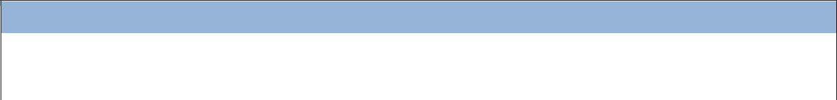

***Criterio de evaluación***

*Intercambia información haciendo uso de* Wh questions *con la estructura y el vocabulario requeridos.*

