Cognitive Research Article Society

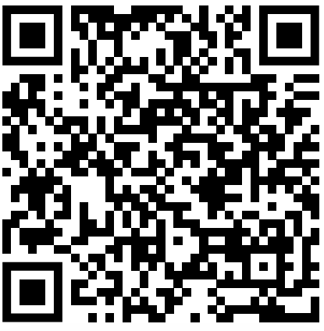
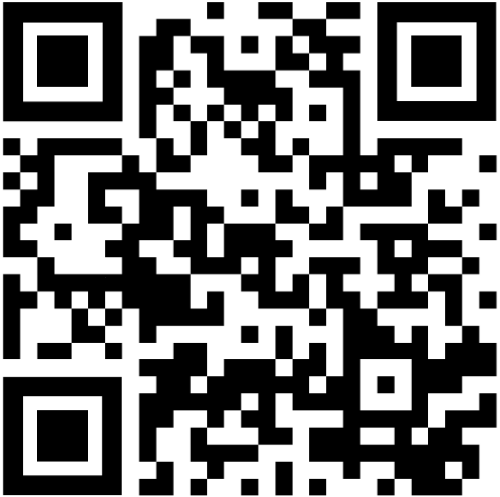
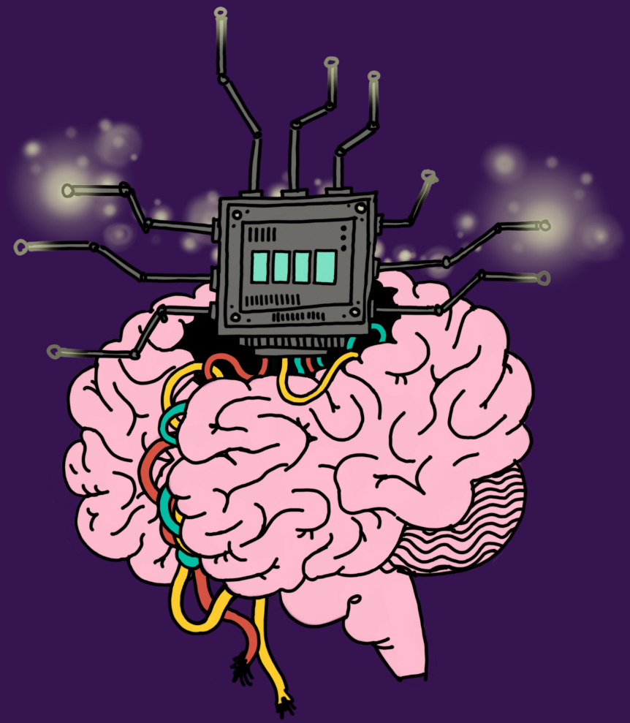
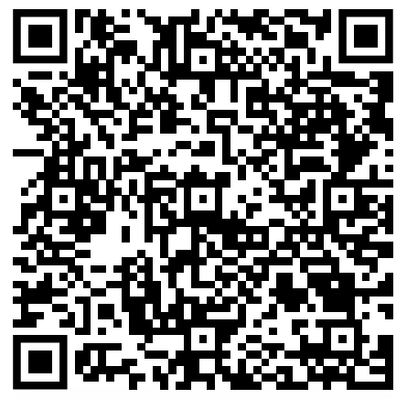
Join our Instagram!
Our amazing logo was made by April, an artist and psychology student from our society!
Join our discord!
GitHub for all resources from journal club meets etc

