FakeArtPhysio Data Collection Guide

- Charge everything
- Muse
- Bitalino
- Turn on thermometer
- Put not disturb sign on outside of door

- Log in (pass: RxxxL2024)

- Open Box (https://sussex.app.box.com/folder/0)
- In FakeArtPhysio folder, open comments
- Fill in participant id, experimenter name, condition (is counterbalanced Interoception or Fiction first, so do the opposite to the previous participant), incentive (credits or money), add temperature during FP1 (when EDA is recordered)

- Run the lsl bridge script
- On the experimenter computer, open VS code.
- Navigate to file->open folder->FakeArtPhysio
  - Ensure you open the repo’s whole folder rather than any folders inside it!
- Press the ‘play’ button in the top right corner
Expected jsPsychMarkers terminal output:
- If everything has been loaded up correctly, you will see a VScode terminal output indicated that the LSL bridge has been synced:
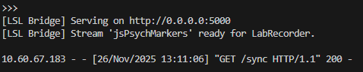
Troubleshooting for jsPsychMarkers:
- "Error 404" on web browser: when trying to open the localhost:8001 port, ensure that the VScode terminal working directory leads to the correct path. The easiest way is to open the FakeArtPhysio repo folder in vs code on the experiment machine. If you still get this error, make the working directory point towards the repo in the relevant html file using cd (e.g., cd "C:\Users\path\index.html") and re-run the local host (python -m http.server 8001).
- Markers not sending to VScode “python” terminal: check whether the correct IPv4 address of the recording machine has been added to the .js file(s) used by the .html file

- Set up Participant’s screen
Go to resting state (http://localhost:8001/experiment/restingstate.html)
- Make sure webcam is in the center ontop of the screen
- Ensure volume is on
- Fit lux: Enter participant ID and fit lux to the center of the black box in the left corner of the screen, then press ‘continue’ in the middle of the screen.
- Leave the screen on the consent form

- Set-up signals
- Open OpenSignals
- Tick ‘lab streaming layer’ under the integration tab
- Click on the rectangle icon with a green circle, then the dark grey rectangle in the center of the screen
- Ensure ports are RESP (A1) ECG (A2) LUX (A3) EDA (A4) and sampling rate is 1000Hz.

- Set-up Lab recorder
- Study root = ‘C:\Users\Reality Bending Lab\Desktop\DATA\FAP_data’
- Participant = S00x (check comments file on box)
- Block task = RS
  - Ensure the ‘block task’ is changed for each recording otherwise the files will over-write. Block task names:
    - Resting state = RS
    - Tapping task = TAP
    - Heartbeat counting task = HCT
    - Fiction phase 1 = FP1
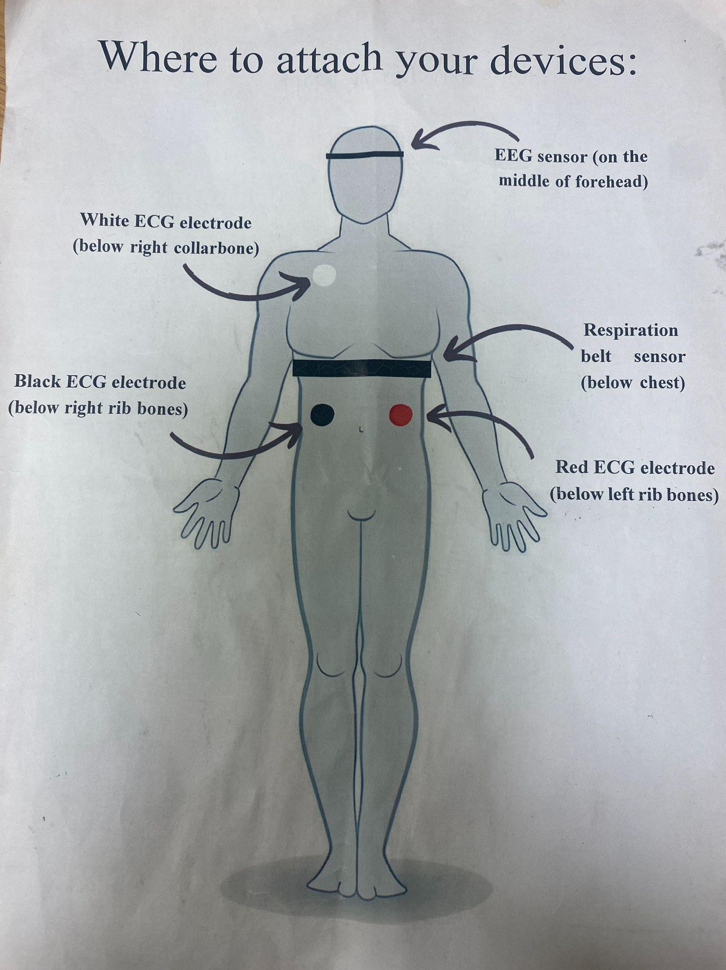

- Participant comes
- Ask them to turn off Bluetooth on all devices and put their phone on silent
- Fit sensors. Ideal output for resp (top) and ECG (bottom):

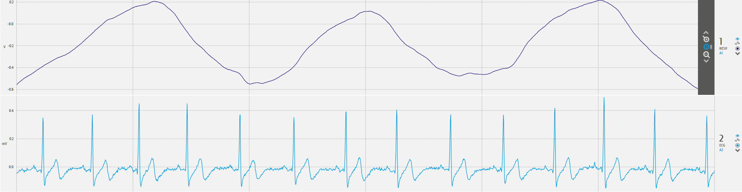
  - RESP
    - Just below chest: snug fit, sensor to the right on the front of their body just below their pectoral muscles
    - Ensure no folded cloth by sensor
    - Troubleshooting tips: Ask participant to take a deep breath. Move the sensor to the place on their body that moved the most
    - Check it’s not so tight that participant can feel their pulse
    - Encourage participant to relax back in seat rather than lean forward, and stay still.
    - Further help: https://support.pluxbiosignals.com/wp-content/uploads/2021/11/pzt-sensor-datasheet-revb.pdf

  - ECG
    - Clip electrode sticker on first
    - White: Just below the right collarbone
    - Black: On the bottom rib bone in the middle of the curvature of the rib. Can suck in the chest to tell where ribs end.
    - Red: parallel to black, in same place on the bottom left rib ribs.
    - Ask participant to draw a line from the white to red to ensure it crosses the heart
    - Troubleshooting tips:
      - Ensure the correct electrode is placed in each position (i.e., white electrode below right collar bone, black electrode below right rib bone, and red electrode below left rib bone)
      - The distance between the white and red electrodes should cross the heart
      - Black and red electrodes should be parallel to each other
      - Show participant the OpenSignals to demonstrate its sensitivity. Ask them to try to remain still during the experiment.
      - Dampen skin under electrodes with a medical wipe.
    - Further help:
      - https://support.pluxbiosignals.com/knowledge-base/where-should-i-place-my-electrocardiocraphy-ecg-electrodes/

- Turn on bitalino and connect cables
- RESP (A1) ECG (A2) LUX (A3)
- Press red circle to view signals
- If bitalino not working - re-plug in bluetooth and reconnect (pass: 1234)
- Press automatic on the right side for each signal
- Drag bar at the bottom towards the left
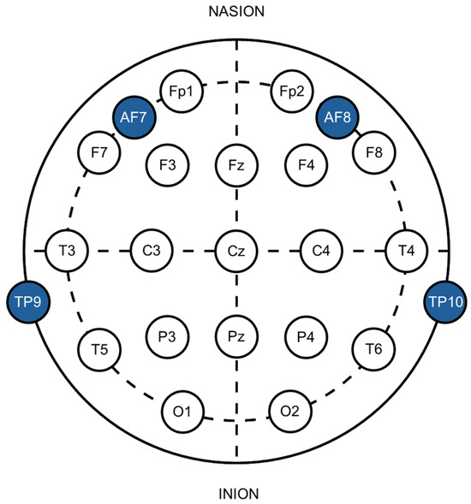
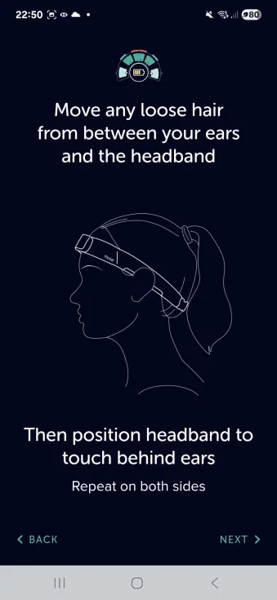
- Fit Muse

- Ask participant to wipe their forehead and above ears with medical wipe
- Remove glasses and tie up hair if applicable
- Clean forehand and above ears with antibacterial wipes
- While loose, clip muse around participant’s neck and lift over the ears.
- Ensure EEG is in the center of the forehead.
- Put hand underneath the Muse athena and pull up hair above the ears on both sides
- Tighten to snug fit

- Connect to Muse on the experimenter’s computer
- Vs Code → New terminal
- install the OpenMuse package (dev branch), uninstalling the previous version first if there’s been an update (pip uninstall OpenMuse): (pip install https://github.com/DominiqueMakowski/OpenMuse/zipball/dev)
- New terminal: (OpenMuse find)
- New terminal: (OpenMuse stream --address 00:55:DA:B9:FA:20
  - Can add ‘–-preset p21’ to test position, then re-steam without any present when ready for the experiment
- New terminal: (OpenMuse view)
- Troubleshooting tips:
  - Ensure Bluetooth connections are disabled on all task-irrelevant devices (e.g., nearby phones, headphones, laptops)
  - Make sure no hair is interfering
  - Make sure electrodes are touching the skin. If the electrode isn’t making contact, adjust position of the muse (and note this in the box folder)
  - Slightly dampen the skin under the electrodes with medical wipes

- Conduct experiment
  - Fit EDA + record temperature before fiction
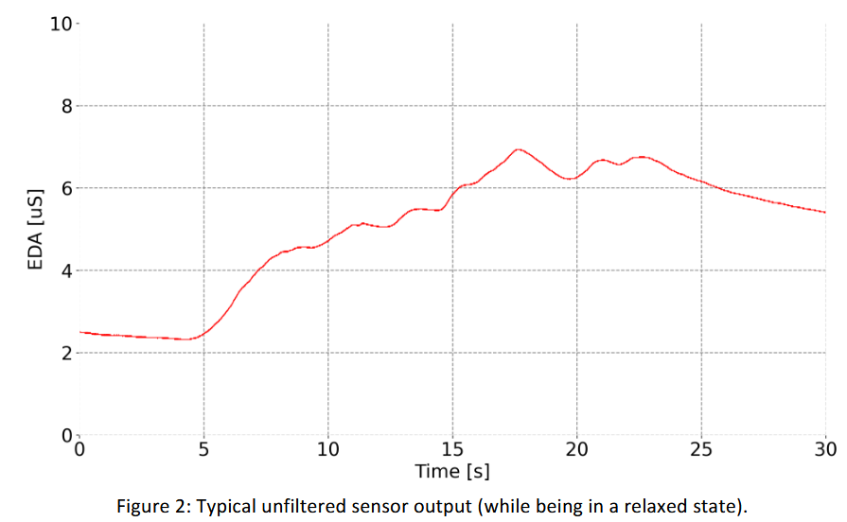
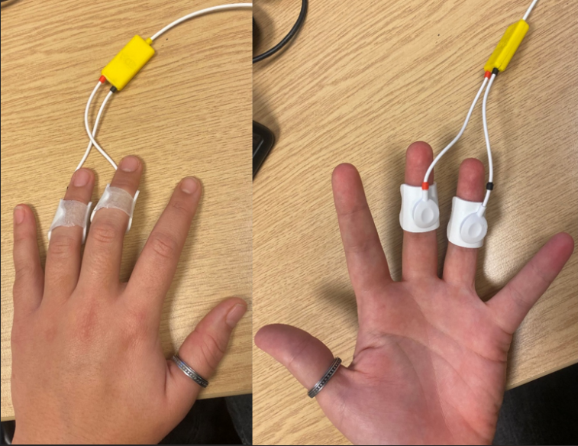

- Turn on thermometer and place by experiment machine. Note temp after it’s calibrated to add to the comments spreadsheet after.
- One-by-one, connect the cable to the electrode and apply a generous drop of isotonic gel to the electrode sponge
- Apply the EDA on the inside of the middle and index finger just below the distal interphalangeal joint.
- Massage in the gel in a circular motion starting from the center then moving out, then connect the back of the sticker with medical tape. Ensure it’s snug but not so tight that the participant can’t feel their heart beat through it (try to gage this without directly asking them if they can feel their heart beat).
- Participant can keep their hand still, palm-down during the experiment, but the eda shouldn’t touch the table.
- If their hand is cold, the blanket can be used.
- Connect EDA to port A4 of bitalino
- Check it’s working: ask participant to take a sharp sniff: this should increase EDA. Can also clap loudly in their ear to see if this increases EDA.
- Troubleshooting tips:
  - Add more gel: can use a syringe to put more gel underneath the sponge without taking it off the participant’s finger
  - Hands can’t be cold: Can warm participant’s hand under warm water
  - Reconnect wire from bitalino
  - Replace electrode stickers
Tips
  - Some people don’t have skin conductance response and may not respond to all stimuli.
  - Baseline can naturally change during the experiment, this is fine just move the arrow up on open signals to keep viewing the wave.
  - EDA responses may decrease through experiment as participant becomes habituated to stimuli.
- Further help: https://support.pluxbiosignals.com/wp-content/uploads/2021/11/electrodermal-activity-eda-user-manual.pdf

- Always verbally communicate instructions as well as asking participant to read them. A ‘ding’ plays when the participant reaches each instruction page.
- Start with resting state, then ask participant to let you know when they’re done, then manually open the next html file (interoception/fiction)
- Keep spare muse pods on charge during experiment and swap them between stages. After you’ve reconnected, lab recorder will need to be reopened to remove the old Muse.
- IMPORTANT TO NOT OVERRIDE FILES: Start new LabRecorder recording for each stage, and change name of lab task on lab recorder accordingly (RS- resting state, TAP- tapping tasks, HCT-heartbeat counting task, FP1 - fiction phase 1
  - When reconnecting to muse (after putting it on charge), make sure to update all streams before recording.

As well asking them to read the instructions, important things to highlight when verbally communicating with participant:
Resting state
- Close your eyes but please don’t fall asleep!
Interoception
- Voluntary external (green): tap the space bar when the circle gets to the arrow as accurately as possible.
- Voluntary internal (blue): Press the space bar whenever you’d like.
- Rhythmic tapping: Tap in synchrony with the beep rhythm and then continue at this pace when the beeps stop.
- Random tapping: Don’t tap consecutively too fast as we won’t be able to pick up the different taps.
- Heart tapping: Without physically feeling your pulse, tap when you sense your heart beating. If you cannot sense year heart, tap when you think it’s beating.
- HCT: After the countdown, start counting your heart beats. When prompted, please then type the number of heart beats you felt.
Fiction
- Eyetracking: beeps after They’ve read instructions. Ask them to click ‘allow’ on camera then follow the instructions. When your face is in the correct position, the box will go green and you can press ‘continue’. Please try to stay in this position for the experiment.
- Gaze calibration: For the first part, click on the dots. In the second part, Just look at the dots.
- FP1: Photos generated by our algorithm are labelled in green as ‘AI-generated’ and real photos are labelled as ‘photograph’ in red. Try to observe all images as if they were real. When you’ve read and understand the description of these questions, unless you’d like any clarification please press start.
- FP2: The labels were mixed up so they were correct for some but incorrect for others. Here, please try to identify the correct category they belong to.

- Debrief
- Open ‘debrief.html’ from the FakeArtPhysio folder and allow participant to go through feedback and debrief.
- Thank participant for their time, answer questions
- All images were real, not really working with a start-up on ethical ai
- Aim: relationship how we feel out body correlates with beliefs about reality

- Add information to Box
- Add comments
- On the experiment machine, add the json files to raw->beh
- On the recording machine, add the participant’s folder to raw-> physio

Notes
- Print / online for checklist
- Print debriefing sheet
- fast charger for muse usb c (amazon - black friday)
- Tissues to clean gel from fingers
- Eye tracking data - check patterns

Experimenters:
- Harry – Exp1
- Tom – Exp2
- Mia – Exp3
- Róisín- Exp4

