**Diagnosis of Brain Tumor based on Moments of Local Binary Patterns and Discrete Wavelet Transform**

**Abstract**

In the field of automatic tumor detection, numerous works have been conducted with varying results. The steps involved in these algorithms can be divided into three categories: pre-processing, feature extraction, and feature classification. In this research, various image processing methods were applied to improve MRI images and prepare them for feature extraction. We used a fuzzy algorithm for tumor area segmentation. Image features were extracted using local binary pattern moments and discrete wavelet transform. In the last stage, the final feature vector is fed into the SVM classifier to determine whether the brain tumor is normal or abnormal (benign or malignant). The experimental results show that the proposed method has an accuracy of over 86% on clinical dataset. This method is fast and effective in classification.

1. Proposed method

HL sub band

Dataset

Abnormal brain

Classification using SVM

Calculate the moment of each sub band

Apply LBP on HH sub band

Apply LBP on LH sub band

Apply BLP on HL sub band

HH sub band

LH sub band

DWT

Tumor segmentation using FCM

Normal brain

Segmented tumor

Figure1. Proposed method

* 1. Pre-processing ( de-noising and resizing to 300×300)
  2. Feature extraction
* Apply DWT on pre-processed image
* Apply LBP on each sub band of DWT
* Apply moment on each sub band of previous step
  1. Feature Classification ( Normal or Abnormal)

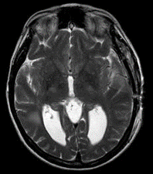

Pre-processed image

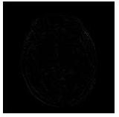 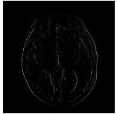 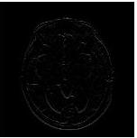

Vertical Detail (HL) Diagonal Detail (HH) Horizontal Detail (LH)

Figure2. Output of DWT

 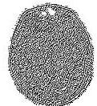 

Figure2. Output of LBP on each sub band of DWT

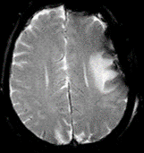 

Figure 3. Tumor segmentation using FCM (Fuzzy c means)

1. Experimental results
   1. Clinical dataset ( 1000 MRI normal images, 1000 MRI abnormal images, 70% for training, 30% for testing)

Table 1. Evaluation metrics of the proposed method

|  |  |  |
| --- | --- | --- |
| Normal brain | Abnormal brain |  |
| FN=133 | TP=867 | Abnormal brain |
| TN=862 | FP=138 | Normal brain |

Table 2. Evaluation metrics of the proposed method

|  |  |  |  |
| --- | --- | --- | --- |
| Accuracy | Specificity | Sensitivity |  |
| 86.45% | 86.20% | 86.70% | 70% Train-30% Test |

Table 3. Evaluation metrics of the proposed method

|  |  |  |  |
| --- | --- | --- | --- |
| Accuracy | Specificity | Sensitivity |  |
| 86.45% | 86.20% | 86.70% | **Proposed method** |
| 86% | %87 | %89 | DWT+PCA+K-NN |
| 81 | 84 | %82 | DWT+PCA+NN |
| %85 | %84 | %89 | PCA+SVM |

**How to run:**

1. Press train dataset button
2. Then click open image for test
3. Click feature extraction button
4. Then click recognition button
5. If tumor image is abnormal (malignant and benign) Click tumor segmentation button

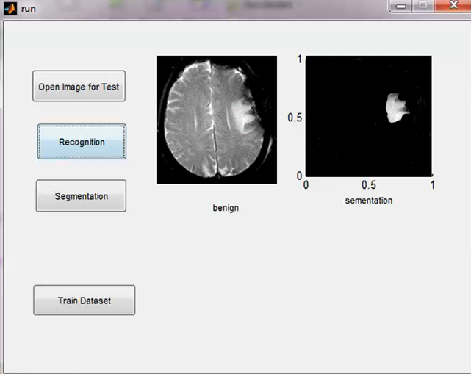

Figure 4. Output of proposed method