1. create an HTML ,CSS and docker file in same folder in VSCODE

2.Open the terminal from the folder in local: DevopsTraining\dockerize a Static Web App

3.check docker version

docker --version

4. Build the docker file

docker build -t staticwebapp .

5. Run the docker file in for 8080:80

docker run -p 8080:80 staticwebapp

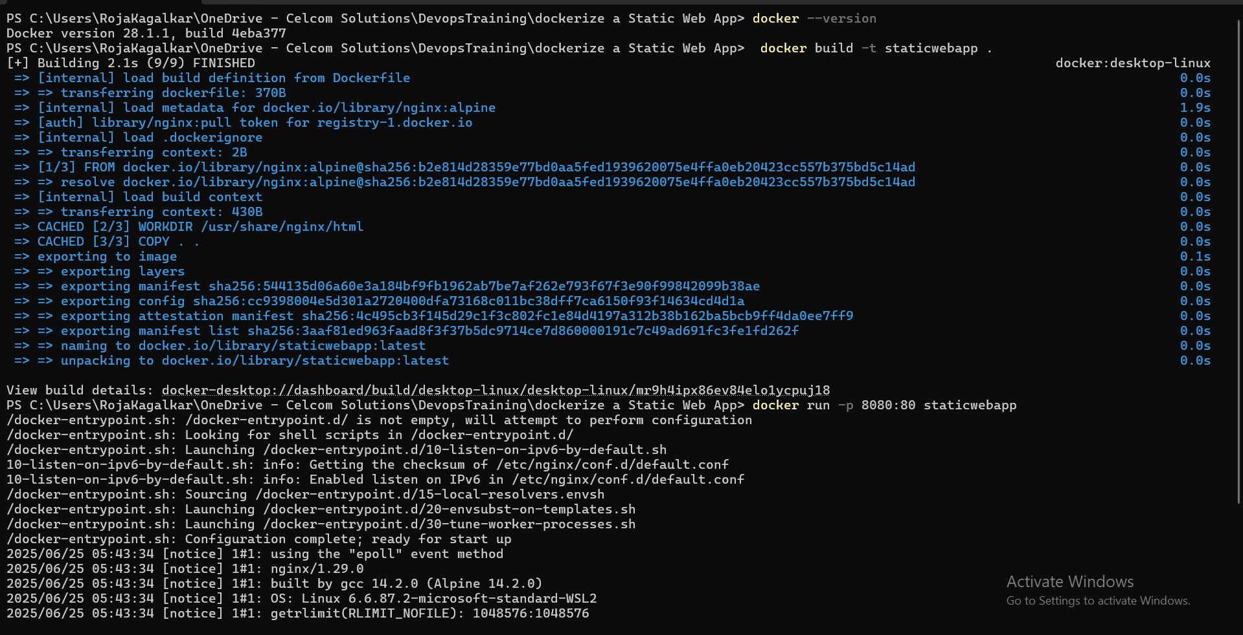

[Hello from XOps!](http://localhost:8080/)

