**Sql query for online food reservation system**

Create database called Hotel that contains following table to store information about daily transactions.

* User
* Staff
* Food
* Order
* Delivery
* View table

To create database following query is used

CREATE DATABASE HOTEL;

To create table inside database following query are used

1. For user table

CREATE TABLE User (

Id int NOT NULL AUTO_INCREMENT PRIMERY KEY,

Username varchar(50),

Email varchar(50),

Address varchar(50),

Password varchar(50)

)

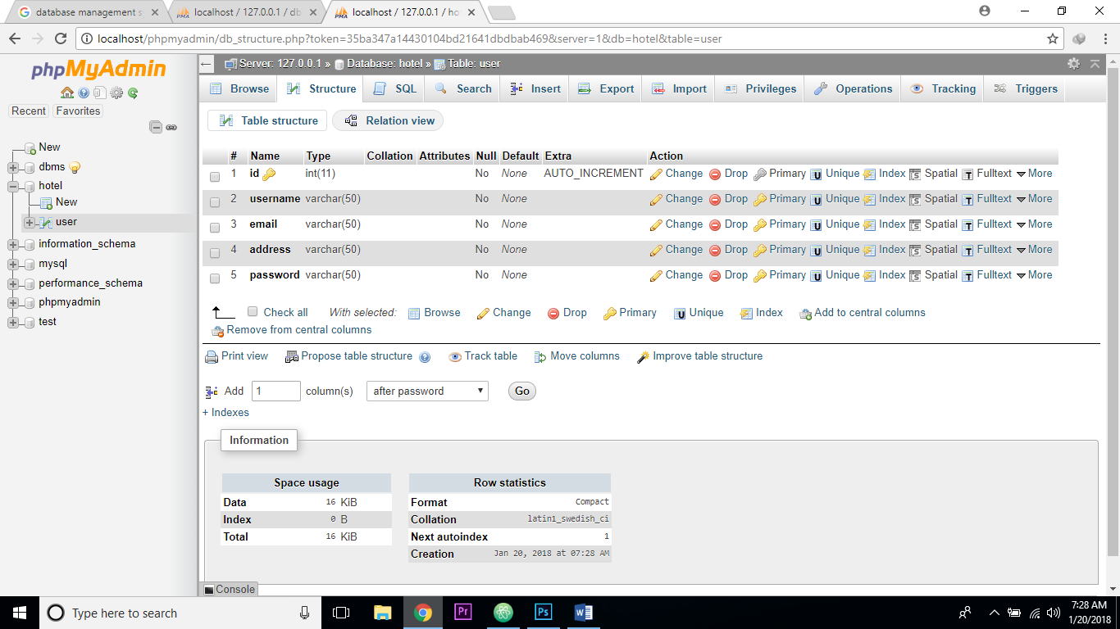

1. To create staff table

CREATE TABLE staff (

S_Id int PRIMERY KEY,

username varchar(50),

password varchar(50),

Post varchar(50),

address varchar(50),

salary int

)

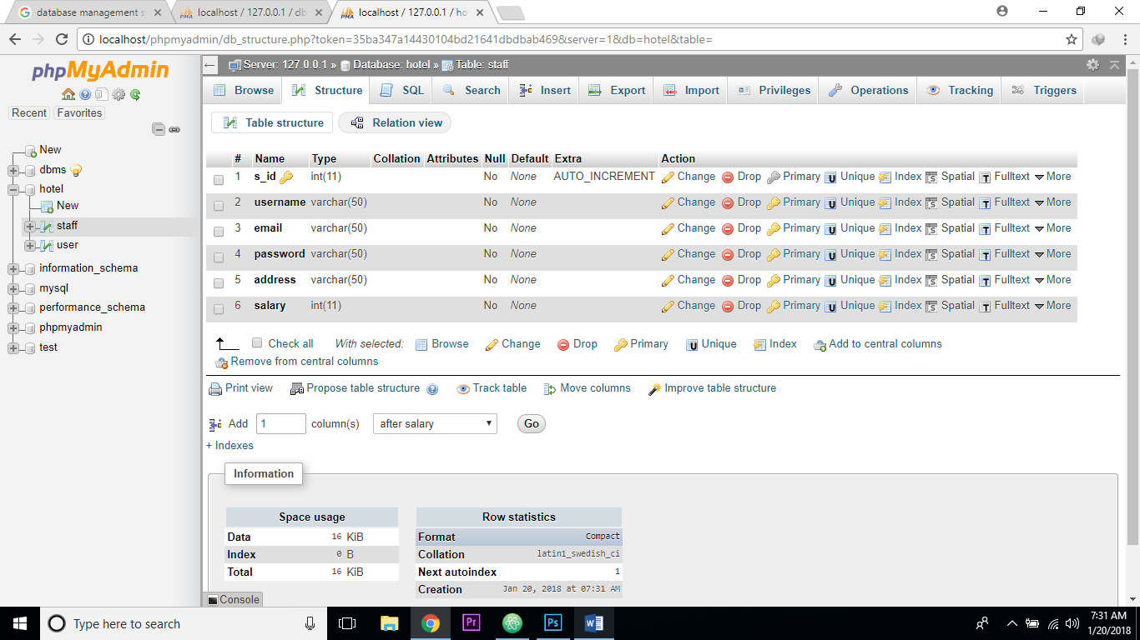

1. To create Food items table

CREATE TABLE Food (

F_Id int PRIMERY KEY,

Food_item varchar(50),

price int

)

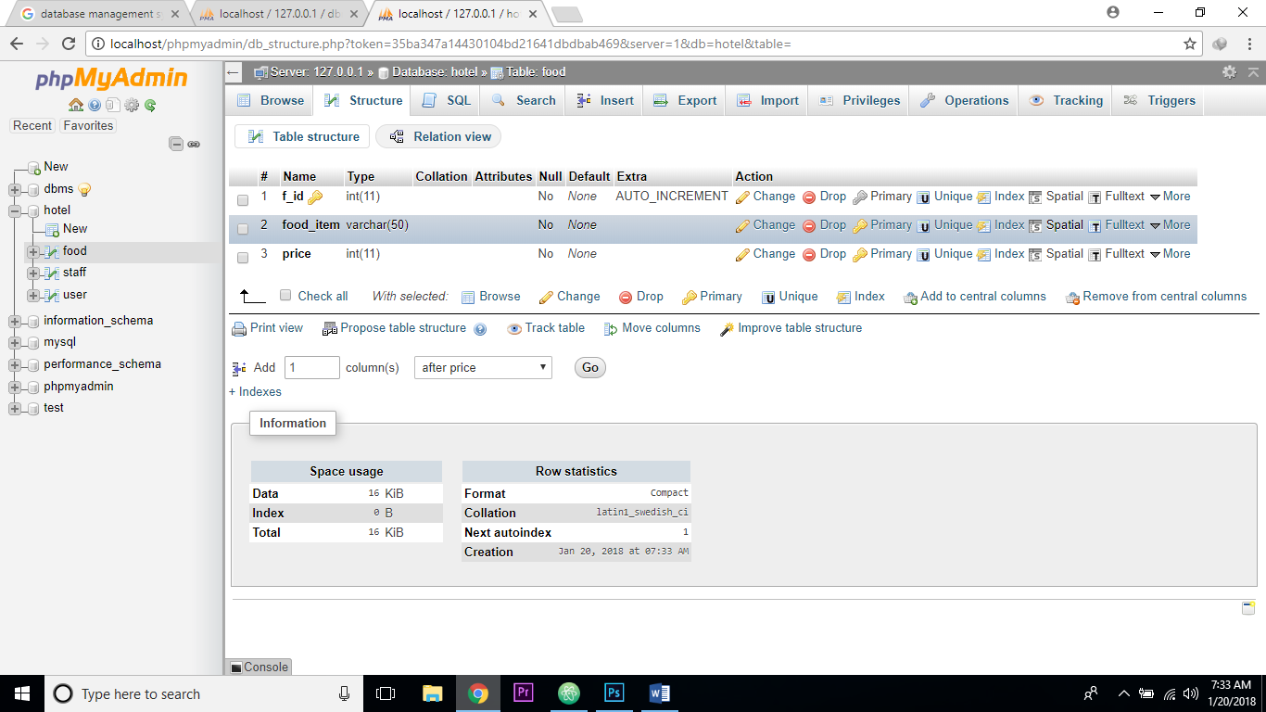

1. To create Order table

CREATE TABLE Order (

O_Id int PRIMERY KEY,

Food_item varchar(50),

number_of_item int

)

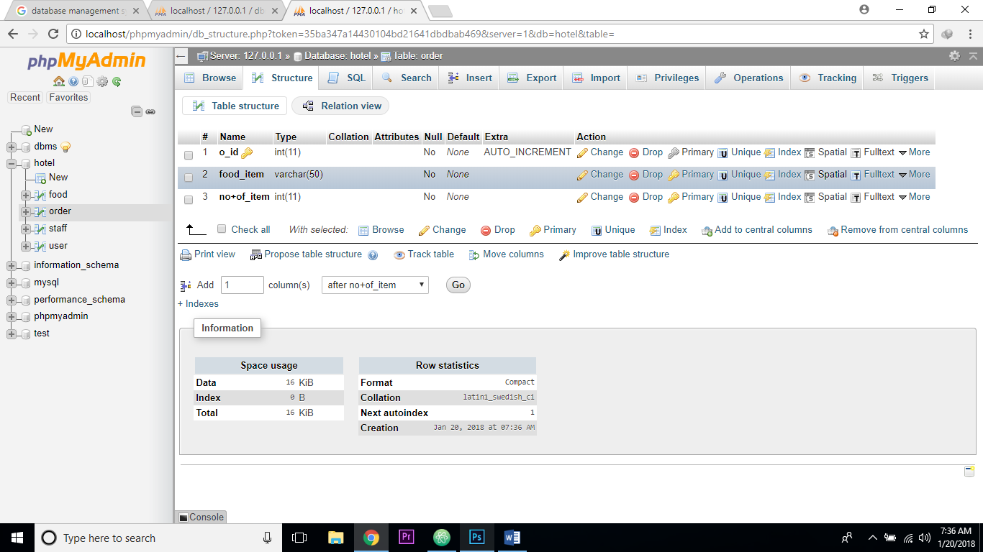

1. To create Delivery Table

CREATE TABLE Delivery (

D_Id int PRIMERY KEY,

S_id int FOREIGN KEY REFERENCE staff(s_id),

F_id int FOREIGN KEY REFERENCE staff(f_id),

Address varchar(50),

number_of_item int

)

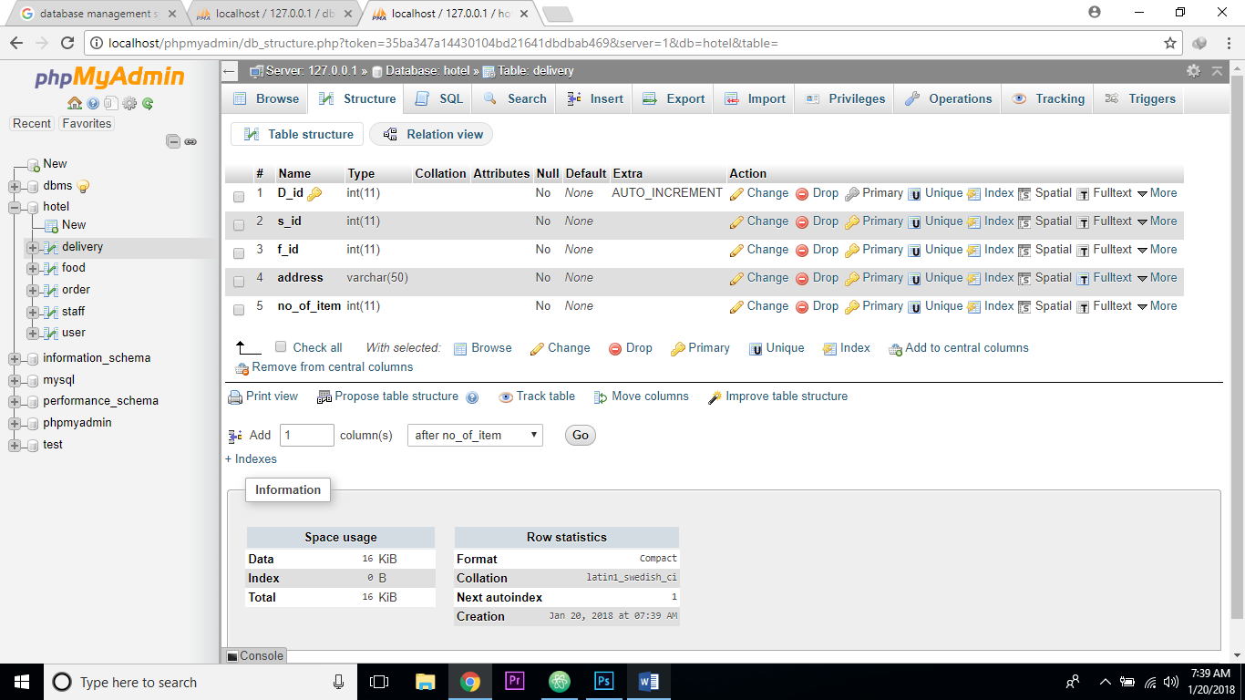

Now to Insert data on table

* To insert food items on table

INSERT INTO FOOD (f_id,food,price)

VALUES (“Food_name”,food_price value)

* To order food items on table

SELECT food_item

FROM Food

* To insert user information

INSERT INTO user (Id, Username, Email, Address, Password)

VALUES (id_value, ”User_name”, ”Email id”, ”Assress”, “Password”)

* To insert Staff information

INSERT INTO Staff (Id, Username, Email, Address, Password, post, salary)

VALUES (id_value, ”User_name”, ”Email id”, ”Assress”, “Password”, ”POST” , Salary)

Create View Information

SELECT username, food_item, number_of_item,price, delvery.address

FROM user, food, order, delivery