Assessment 4
Solving the 8-Puzzle Problem Using A* Search Algorithm

Student Name | Rojan Poudel

Table of Contents
1. Introduction 3
2. Problem Statement 3
3. Selected Search Strategy 3
4. Algorithm Explanation 4
Algorithm Flowchart 4
5. Optimisations and Enhancements 4
6. Visualization of the Search Process 5
7. Complexity Analysis 6
8. Results and Observations 7
9. Relevance to Intelligent Agents and AI Search 7
10. Conclusion 7
References 8

1. Introduction
The 8-puzzle problem provides insight into an important problem in artificial intelligence. It is a tile-based game played on a 3x3 board where each tile has a number from 1 to 8, except for one tile which is blank represented by 0. The goal of the game is to rearrange the tiles on the board to have them arranged in the following way:
1 2 3
4 5 6
7 8 0
The 8-puzzle serves as an example to illustrate the decision-making process of an intelligent agent. It is not based on random selection of moves but rather involves selecting an optimal path among a variety of available options. In addition, the game illustrates several aspects of artificial intelligence including search space, goal condition, path cost, heuristics, and efficiency. In this project, I implemented a python Tkinter GUI program for solving 8-puzzle through A* Search with Manhattan Distance.

2. Problem Statement
The task here is to determine a set of valid moves leading from a starting 8-Puzzle state to its goal configuration. The puzzle involves a static grid with a fixed 3 x 3 grid on which every state indicates a distinct placement of the tiles. The empty tile marked 0 can shift to an adjacent cell either upwards, downwards, towards the left, or towards the right without going outside the grid’s boundaries.
Component | Description
Initial State | The starting board configuration entered or selected by the user
Goal State | 1 2 3 / 4 5 6 / 7 8 0
Actions | Move the blank tile up, down, left, or right
Transition Model | Swapping the blank tile with a neighbouring tile
Path Cost | Each move has a cost of 1
Goal Test | Check whether the current state equals the goal state

The puzzle needs to have all the digits 0-8. However, not all placements lead to a solution. Therefore, the program verifies the possibility of solving the puzzle using inversion count. If the inversion count is even, then the puzzle is solvable; otherwise, it is unsolvable. This is a classic case study of an artificial intelligence algorithm because it illustrates the search process conducted by an intelligent agent toward the goal.

3. Selected Search Strategy
For this project, the A* Search Algorithm has been selected. A* is an informed search algorithm in which the best state is selected based on the formula:
f(n) = g(n) + h(n)
In this equation, g(n) is the cost from the starting state to the current state, whereas h(n) is the estimated cost between the current state and the goal state. In this case, g(n) is defined as the total number of moves made so far. h(n) is calculated through the Manhattan Distance heuristic.
A* was chosen because of its efficiency and suitability for solving the 8-puzzle. It does not expand too many unnecessary states, unlike the BFS algorithm, and is more stable than DFS since there is a possibility of exploring an unproductive path using DFS if not carefully restricted. The choice of Manhattan Distance is well-suited for 8-Puzzle as the tiles can be moved up, down, left, or right positions only.

4. Algorithm Explanation
First, the program creates a graphical interface using the Tkinter library. Then, the user may manually enter the puzzle or select one of the pre-defined puzzles, including Easy, Medium, Hard, or Unsolvable. On clicking the Solve button, the program first validates the input by ensuring there are nine values in the puzzle state and that numbers from 0 to 8 appear once each in the puzzle.
Upon validating the puzzle, the algorithm checks for the solvability of the puzzle. This step utilizes the Inversion Count technique to determine solvability. An inversion occurs when a larger number appears before a smaller number in the puzzle sequence, ignoring the blank tile. A puzzle is solvable if the total number of inversions is an even number.
If the program identifies an unsolvable puzzle, it informs the user and stops searching. Otherwise, the A* Search starts working. The algorithm stores board states in a priority queue based on their f(n) scores and chooses the board state with the lowest f(n) score. It creates valid moves, evaluates path costs, calculates Manhattan Distance, and keeps track of parent nodes.

Algorithm Flowchart
Step | Process
1 | Start and read puzzle state
2 | Validate input values 0 to 8
3 | Check solvability using inversion count
4 | If unsolvable, stop and display message
5 | If solvable, calculate f(n) = g(n) + h(n)
6 | Expand state with the lowest f(n)
7 | Generate legal blank-tile moves
8 | Repeat until goal state is reached
9 | Reconstruct solution path
10 | Display result and animate solution

5. Optimisations and Enhancements
A number of features were added to enhance efficiency, effectiveness, and usability for demonstrating purposes. Firstly, there is a check whether the board is solvable or not before performing the A* search. Thus, unnecessary searches will be avoided in cases where there is no solution to the puzzle. Secondly, priority queues were implemented using the heapq module in Python, allowing finding a board position with minimal expected cost. Thirdly, there is a closed set that stores already visited positions and prevents repeating the same steps over and over again. A dictionary with g-scores is used to store the lowest costs to avoid exploring worse positions than previously visited. Fourthly, the Tkinter-based GUI allows presenting the process visually.

6. Visualization of the Search Process
The application presents the search procedure through the display of the final path leading from the starting state of the puzzle to its goal state. In the GUI application, the board consists of nine squares, each displaying one numbered tile, and the blank square is marked with a distinct color. Once the puzzle is solved, the user can press the button that triggers the animation of each move.
Example solution visualization:
Stage | Board State
Initial State | 1 2 3  4 0 6  7 5 8
Step 1: Blank moves Down | 1 2 3  4 5 6  7 0 8
Step 2: Blank moves Right | 1 2 3  4 5 6  7 8 0
Goal State Reached | 1 2 3  4 5 6  7 8 0

The above illustration helps to comprehend the algorithm's procedure that leads to the solution. Additionally, the program illustrates the present number of steps, as well as the direction of movement, which can be "Up", "Down", "Left", and "Right". Such an approach is beneficial during the evaluation demonstration because it allows for presenting a clear explanation of the solution procedure rather than the final solution itself.
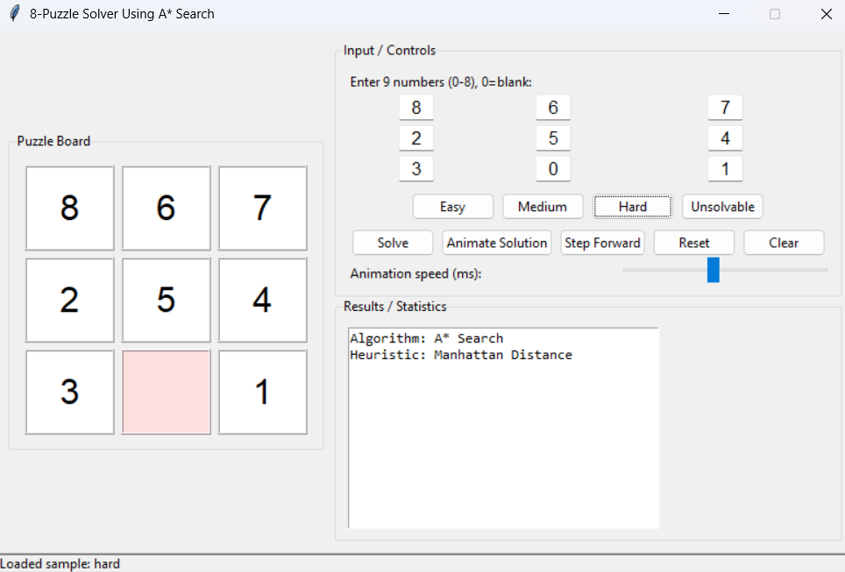
Figure 1: The GUI with the hard puzzle loaded
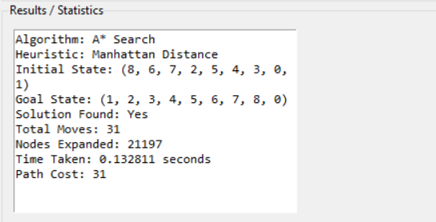
Figure 2: The result panel after solving the puzzle
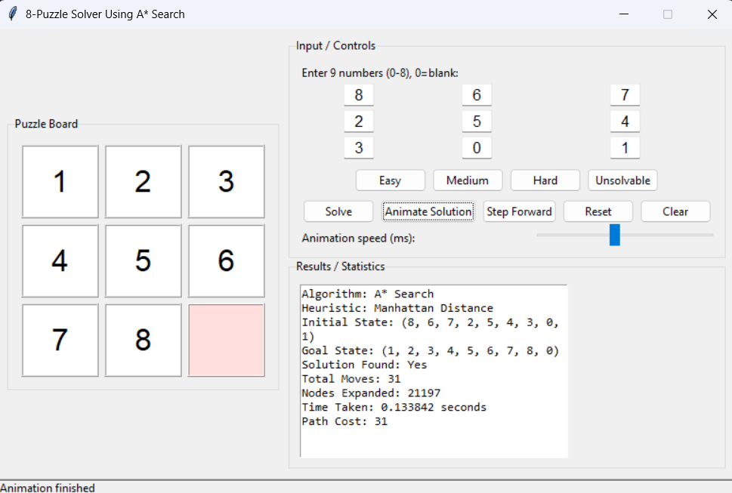
Figure 3: The final solved board

7. Complexity Analysis
Time Complexity of the A* Search is based on branching factor b and solution depth d. Its time complexity in the worst case will be O(b^d). In the 8-Puzzle problem, the blank tile can move in 2 to 4 different directions, so the branching factor is not very large. Nevertheless, hard puzzles may generate many states. Moreover, A* Search outperforms other search strategies because of the guidance by Manhattan Distance, which helps reach states closer to the goal. Space Complexity of A* Search equals O(b^d) as well because A* keeps all generated states in priority queue, closed list, parent dictionary and cost dictionary.

8. Results and Observations
Different puzzle configurations were used for the testing, specifically Easy, Medium, and Unsolvable conditions. As for the first one, the program found a solution very fast with just a small number of movements. On the other hand, more moves were needed to solve the medium puzzle, though it was still done effectively. At last, the unsolvable condition was successfully recognized without performing any A* Search, demonstrating that the inversion count technique functioned well.
Test Case | Initial State | Expected Result
Easy | 1 2 3 / 4 5 6 / 7 0 8 | Solvable
Medium | 1 2 3 / 4 0 6 / 7 5 8 | Solvable
Hard | 8 6 7 / 2 5 4 / 3 0 1 | Solvable
Unsolvable | 1 2 3 / 4 5 6 / 8 7 0 | Not Solvable

Overall, it can be said that the implemented algorithm proved to work well at solving the 8-Puzzle, provided that the latter was solvable. All necessary statistics such as the total number of moves, expanded nodes, used time, and path cost were shown by the program. A distinctive feature of the algorithm is the utilization of Manhattan Distance that ensures an optimization compared with uninformed search techniques. Nonetheless, A* Search uses lots of memory since many states should be stored. Further development may include working with bigger puzzles, comparisons with BFS and DFS, etc.

9. Relevance to Intelligent Agents and AI Search
The 8-Puzzle problem can be considered a task for an intelligent agent. The agent first observes the current board state, then checks the available moves, considers the possible next states, and finally chooses actions that move it closer to the goal. In this way, the 8-Puzzle is a good example of many problems solved in artificial intelligence. This project demonstrates important AI concepts such as state representation, actions, goal testing, path cost, and heuristic evaluation. Therefore, the 8-Puzzle is a useful example of how search algorithms can solve structured AI problems.

10. Conclusion
This project successfully implemented a UI-based 8-Puzzle solver using A* Search with Manhattan Distance as the heuristic. The program can run with different starting states, check whether the puzzle is solvable, solve it when possible, and display the solution through animation. A* Search was chosen because it considers both the actual path cost and the estimated cost to the goal, making it effective for solving the 8-Puzzle problem.

References
Russell, S., & Norvig, P. (2021). Artificial intelligence: A modern approach (4th ed.). Pearson.
Cormen, T. H., Leiserson, C. E., Rivest, R. L., & Stein, C. (2022). Introduction to algorithms (4th ed.). MIT Press.
Python Software Foundation. (2026). tkinter - Python interface to Tcl/Tk. Python Documentation.
Python Software Foundation. (2026). heapq - Heap queue algorithm. Python Documentation.

