Australia Retail Turnover Analytics
(Descriptive & Predictive Analysis using Tableau)
Project Report
Course: Data Analytics
Tool: Tableau Desktop
Rojan Poudel

Executive Summary
The objective of this report is to analyze the retail turnover in Australia using a public data set that contains retail turnover data for each state or territory in Australia and for each retail industry from 1982 to the current year. The business need for this data analysis is for budgeting, inventory management, staffing, and business strategy based on the identification of long-term demand trends for retail businesses in Australia. Five descriptive data analyses were created in Tableau to identify missing data, duplicates, and distribution of the data set. These descriptive data analyses are used for an overview of total retail turnover growth in Australia, retail turnover in each state or territory in Australia, retail turnover in each retail industry in Australia, seasonality of retail data in Australia, and a comparison of retail data in each state or territory in Australia. Two predictive data analyses were completed using Tableau's automated time-series forecasting using exponential smoothing and regression trend analysis to identify the long-term growth rate of the data set. The results of this data analysis show high long-term growth in retail turnover in Australia, high retail turnover in the larger states in Australia (particularly New South Wales and Victoria), a need for food and supermarket retail categories in Australia, and high seasonality in retail data in Australia. The results of this data analysis show high long-term growth in retail turnover in Australia based on the two different forecasting methods used in this data analysis; however, the limitations of each forecasting method are discussed in this report.
Contents
1. Introduction 1
2. Business Demand for Data Collection and Analytics 1
3. Dataset Selection and Justification 1
4. Ethics, Privacy and Security Considerations 2
5. Research Questions and Hypotheses 3
6. Data Readiness and Preparation 3
7. Literature Review: Techniques, Data Mining and Modelling 5
8. Descriptive Analytics Findings 5
8.1 Overall Turnover Trend 5
8.2 Turnover by State and State Trend Comparison 6
8.3 Top Industries by Turnover 7
8.4 Seasonality Heatmap 7
9. Predictive Analytics Findings 8
9.1 Forecasting with Exponential Smoothing 8
9.2 Regression Trend Model 8
10. Model Evaluation and Big Data Context 10
11. Comparison with Published Research / Case Studies 10
12. Limitations 10
13. Recommendations 10
14. Conclusion 11
References 12

Figure 1 : Retail.csv 2
Figure 2 : retail csv in tableau 2
Figure 3 : Data readiness – missing value check 4
Figure 4 : Data Check – turnover 4
Figure 5 : Data Check - Duplicates 5
Figure 6 : Overall turnover trend 6
Figure 7 : Total turnover by state 6
Figure 8 : Trend comparison for top states 7
Figure 9 : Top 10 industries by turnover 7
Figure 10 : Seasonality heatmap 8
Figure 11 : Tableau forecast Turnover 8
Figure 12 : Scatter plot with trend line 9
Figure 13 : Describe Trend Line 9

1. Introduction
It is a commonly used measure of consumer demand and economic activities. For retailers, governments, and investors, it is important to understand the trend of retail turnover. This is crucial for budgeting, workforce management, and strategic business decisions such as expansion and category management. This project aims to use descriptive and predictive analytics techniques based on the Australian retail turnover data and create insights for the stakeholders by using Tableau Desktop.

2. Business Demand for Data Collection and Analytics
Retail turnover data is an essential component of decision-making levels. On a day-to-day basis, retailers rely on current trends in demand to make adjustments, staff stores for the peak periods, and design promotions. On a long-term basis, trends in retail turnover influence goal setting, measuring market saturation, and inter-regional comparisons. Government bodies, especially national statistical agencies, collect this information to measure household expenditure, make economic decisions, and provide sound bases for business and economic analysis. In Australia, the Bureau of Statistics (ABS) releases retail turnover data, which serves as a sound base for economic analysis at both the national and regional levels.

3. Dataset Selection and Justification
I will use "Australia Monthly Retail Turnover Data" available on Kaggle for this project. The dataset contains information on monthly retail turnover across various states and territories in Australia for different industries since 1982. It is relevant for this project because it is time-indexed on a monthly basis, allowing us to analyze trends and seasonal patterns if any; there are categorical dimensions available for comparison; and finally, this dataset is relevant for typical business intelligence questions.
The dataset has five columns: State, Industry, Series ID (unique for each series), Month (date), and Turnover (numerical values). There are no issues of privacy since this is a publicly available data set.
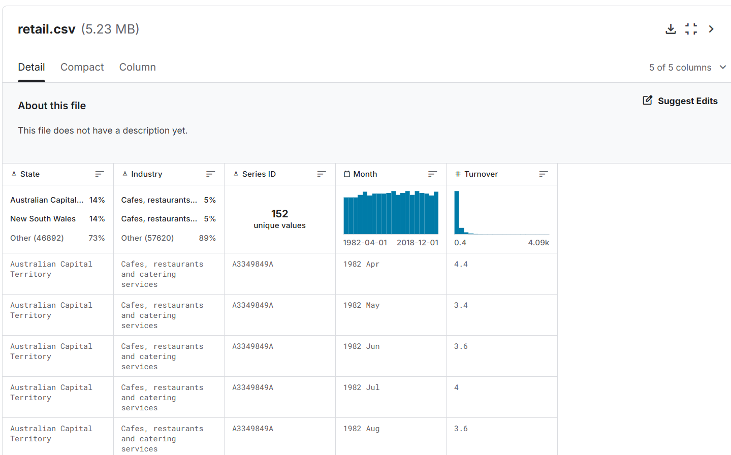
Figure 1 : Retail.csv
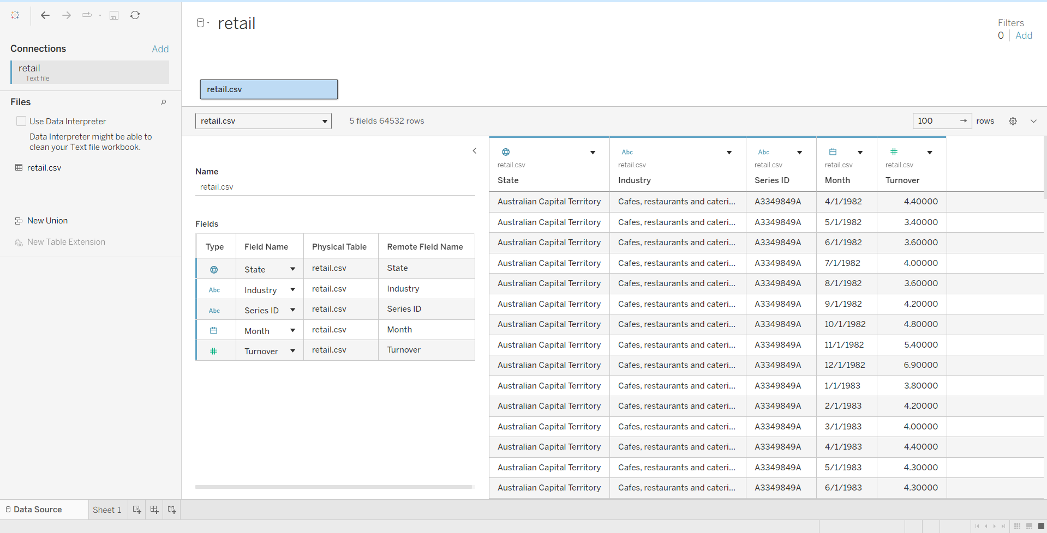
Figure 2 : retail csv in tableau

4. Ethics, Privacy and Security Considerations
However, even with the availability of the data, it is important to consider the ethical issues. Firstly, privacy is ensured by the publication of only aggregated data (by state, industry, and month) and not trying to derive any information about people or small groups of people. Secondly, measures were taken to ensure data protection. The raw data and Tableau workbooks were stored in a secure manner, and files were not shared outside the group members and the tutor. Thirdly, the integrity of the analysis was maintained by documenting the cleaning of data and not trying to selectively report data that could be misleading. Finally, the results are presented in such a way that there is no implication of causation. Turnover is affected by external factors such as population size, inflation, and government policies.

5. Research Questions and Hypotheses
The project addressed the following research questions and testable hypotheses:
- RQ1: How has total Australian retail turnover changed over time?
- RQ2: Which states/territories contribute the most to total retail turnover?
- RQ3: Which retail industries contribute the most to turnover?
- RQ4: Is there evidence of seasonality (month-to-month variation) across years?
- RQ5: Can future turnover be predicted from historical patterns using forecasting and trend models?
Hypotheses (H):
- H1: Retail turnover has a statistically significant upward trend over time.
- H2: Total turnover differs across states/territories, with larger states contributing more.
- H3: Retail turnover exhibits seasonal patterns by month across years.
- H4: Forecasting based on historical data predicts continued growth in turnover in the short-term.

6. Data Readiness and Preparation
Data preparation was performed using Tableau Desktop. The "Month" field was changed from text type to Date type to allow for time-series analysis. Turnover was also checked to be of a numeric type. Data quality checks included: (1) missing values in important fields (State, Industry), (2) duplicates based on a composite key (State, Industry, Month), and (3) Turnover to detect unusual values and ensure it is non-negative.
Turnover_Clean, a clean version of Turnover, has been created to guarantee non-negative values by changing negative values to NULL. Further, date-related fields have been created to allow for more analysis: Year, Month Name, and Year-Month (truncated to month level).Figure placeholders (insert screenshots from Tableau):
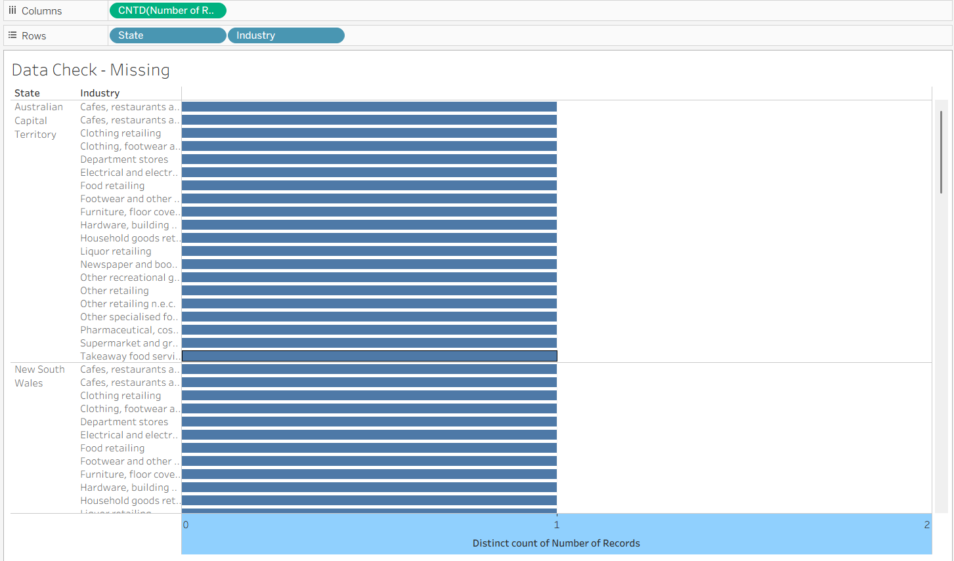
Figure 3 : Data readiness – missing value check
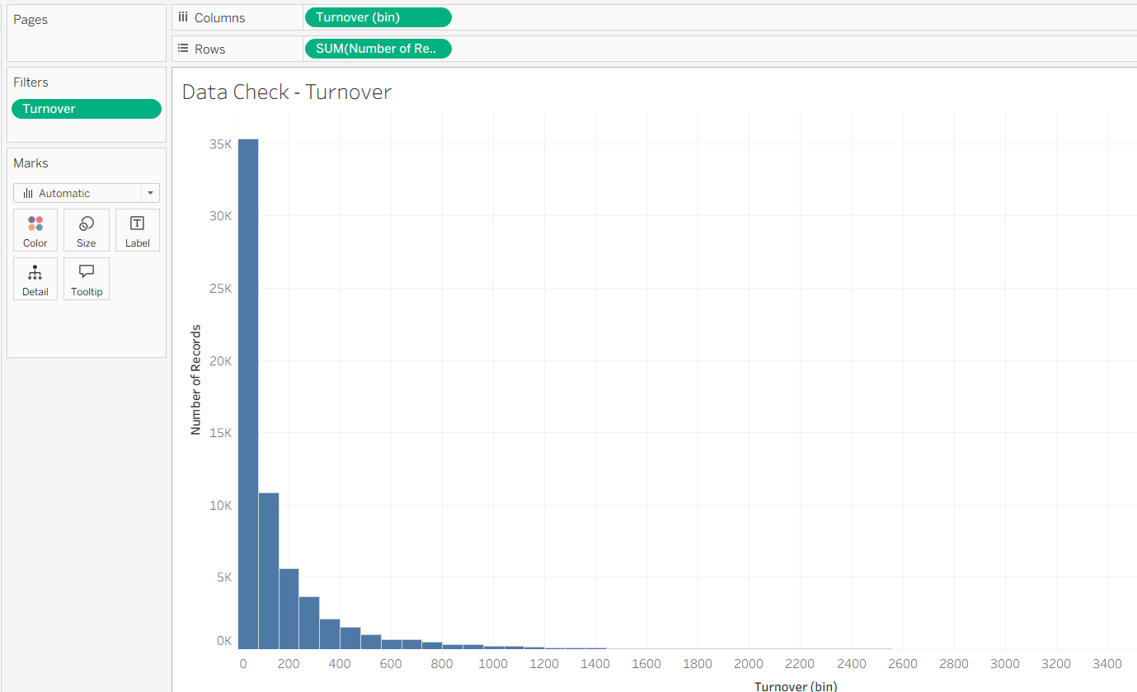
Figure 4 : Data Check – turnover
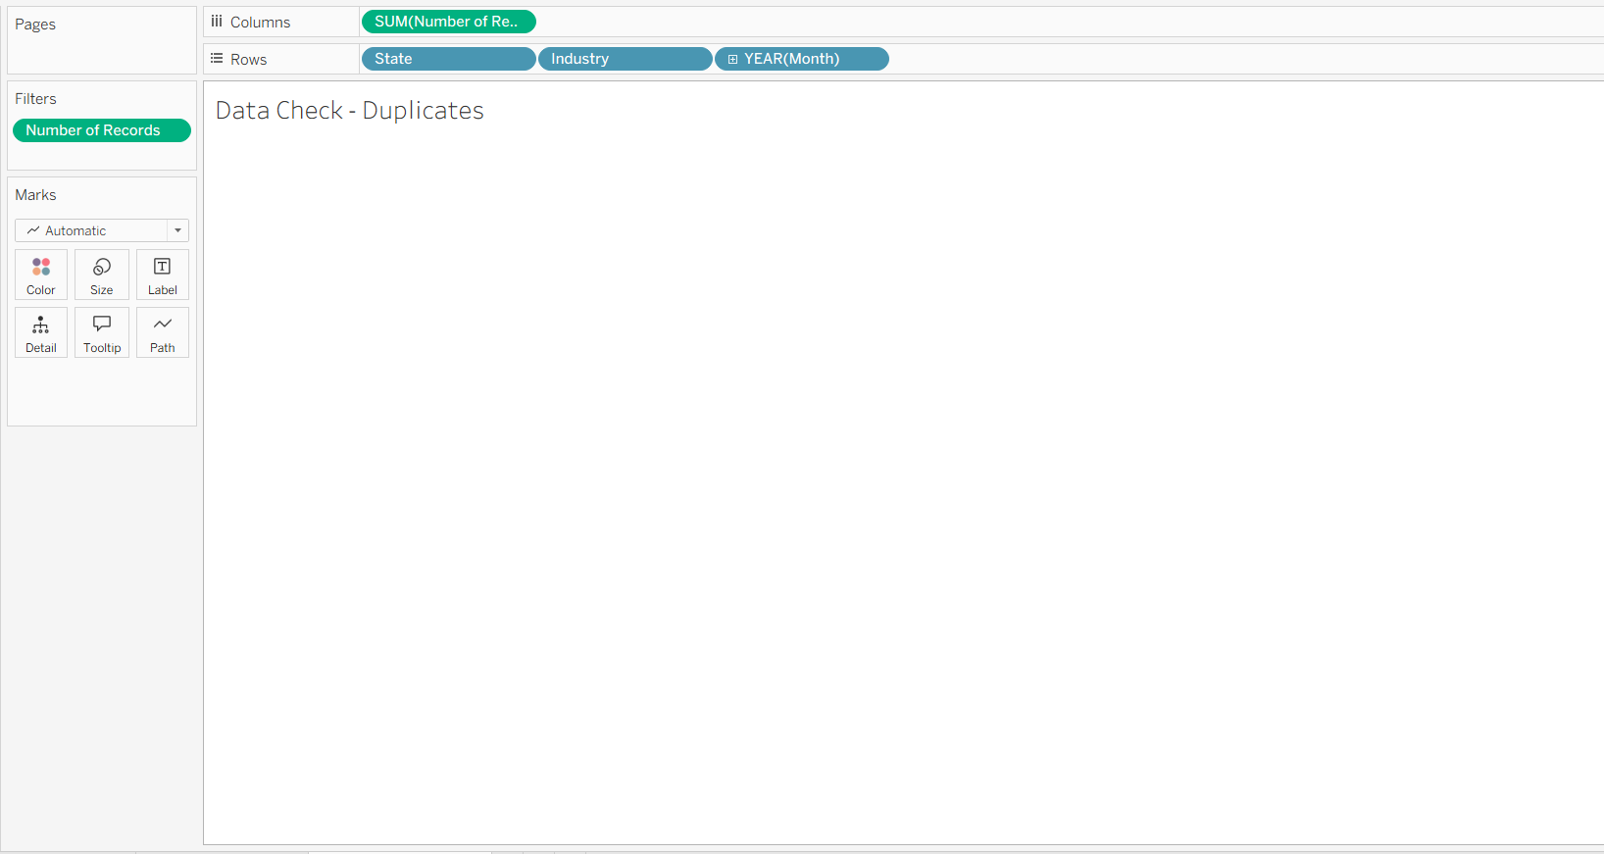
Figure 5 : Data Check - Duplicates

7. Literature Review: Techniques, Data Mining and Modelling
Retail analytics combines exploratory descriptive analytics, forecasting, and regression analysis techniques to inform business decisions. Descriptive analytics involves summarizing the data, making comparisons, and identifying seasonal patterns, and visualizing the results through graphical representations like line charts, bar charts, and heat maps, among others, to communicate results effectively, even to non-technical individuals. For predictive analytics, time series forecasting, particularly techniques like exponential smoothing, including the Holt-Winters' methods, are popular, as they accommodate trends and seasonal patterns and give more weight to recent observations over older observations
Regression Trend models are popular techniques used to understand the relationship between variables. In this assignment, a regression trend model is used to understand the relationship between turnover and time, represented by the year on the x-axis.

8. Descriptive Analytics Findings
Five visualizations were created to answer the research questions. They were carefully selected to meet the needs of various stakeholders: executives need to see big-picture trends, regional managers need to see comparisons by state, category managers need to see industry rankings, and operational planners need to see seasonality patterns.

8.1 Overall Turnover Trend
A line chart showing "Year-Month" on the x-axis and "SUM(Turnover_Clean)" on the y-axis indicates significant growth in retail turnover. The growth in retail turnover increases in speed over the latter years, making it easier to forecast. The line chart answers RQ1.
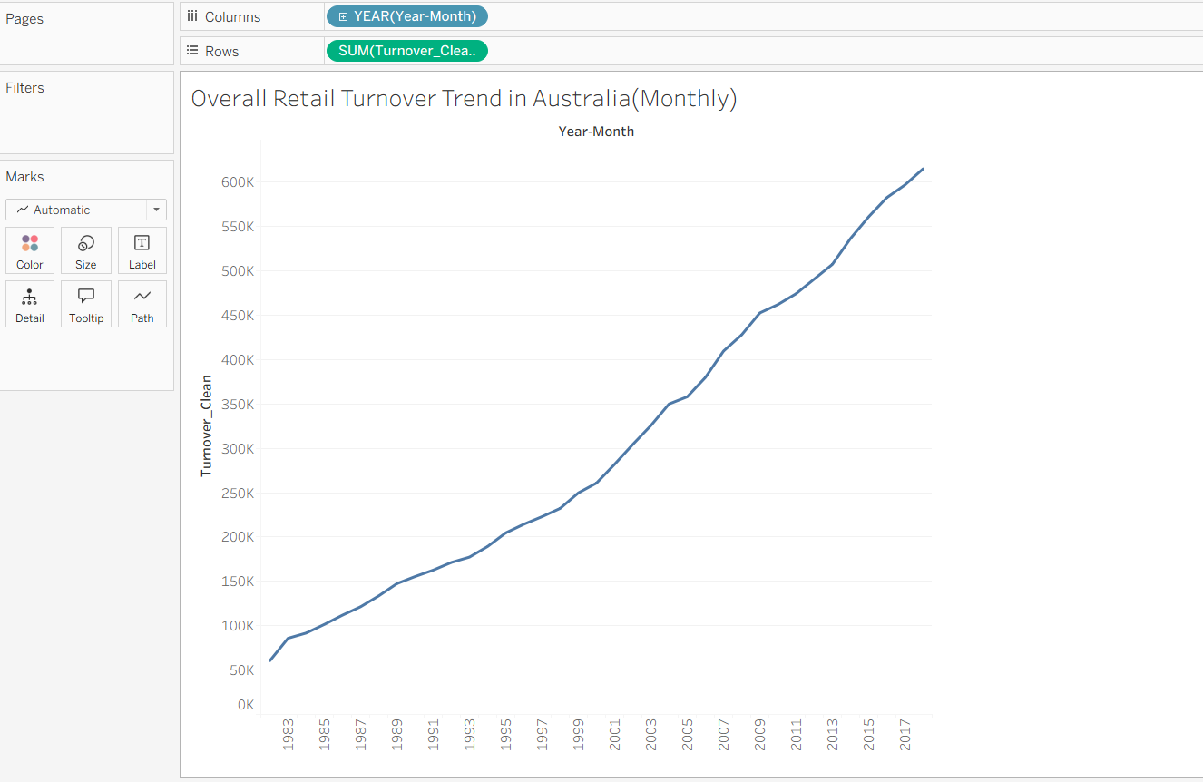
Figure 6 : Overall turnover trend

8.2 Turnover by State and State Trend Comparison
This bar chart plots the states and territories according to their total turnover over the total period. The general trend is dominated by the larger states, with New South Wales and Victoria having the highest turnover, followed by Queensland. The trend chart that accompanies this bar chart for the top five states indicates that all the large states increase over time, although at varying rates (RQ2).
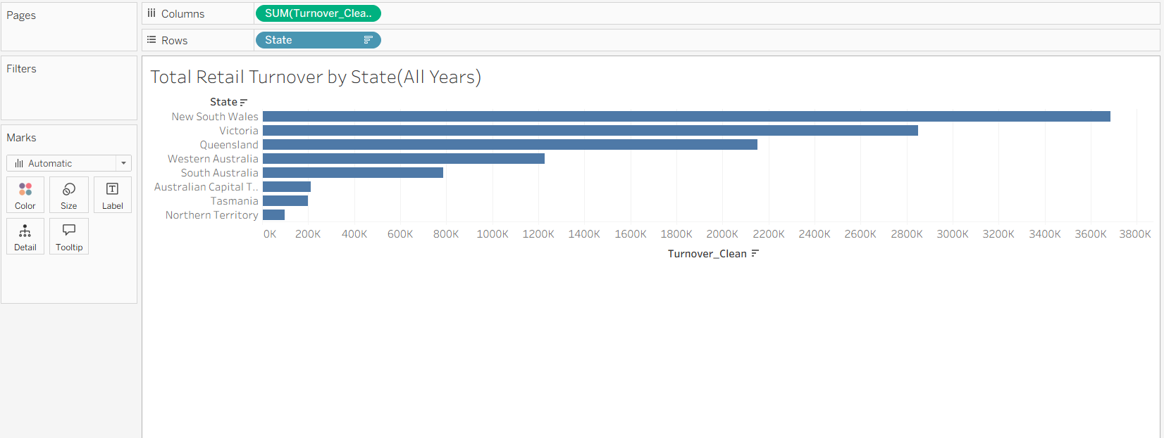
Figure 7 : Total turnover by state
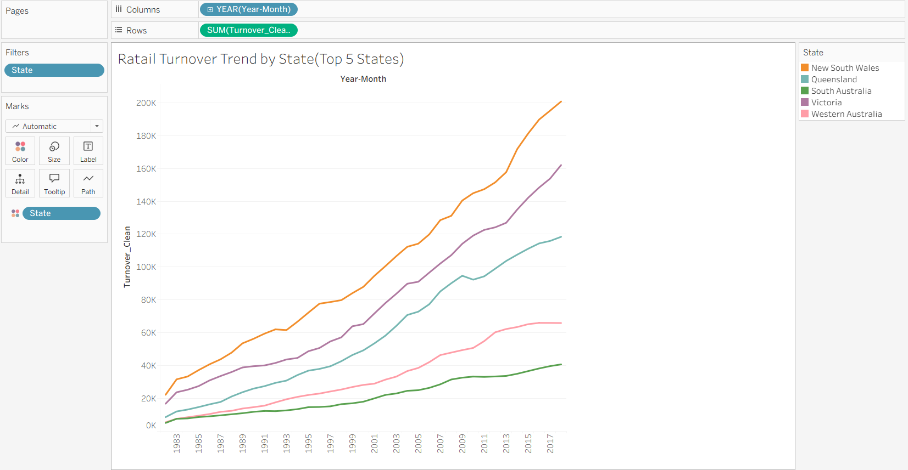
Figure 8 : Trend comparison for top states

8.3 Top Industries by Turnover
A top 10 bar chart for the industry reveals the retail sectors that drive the turnover for the industry (RQ3). The essential retail sectors take the lead, and the retail sectors related to the food business and supermarkets or grocery stores take the top spots. The discretionary retail sectors, such as clothing, department stores, and electronics, contribute less of the overall turnover.
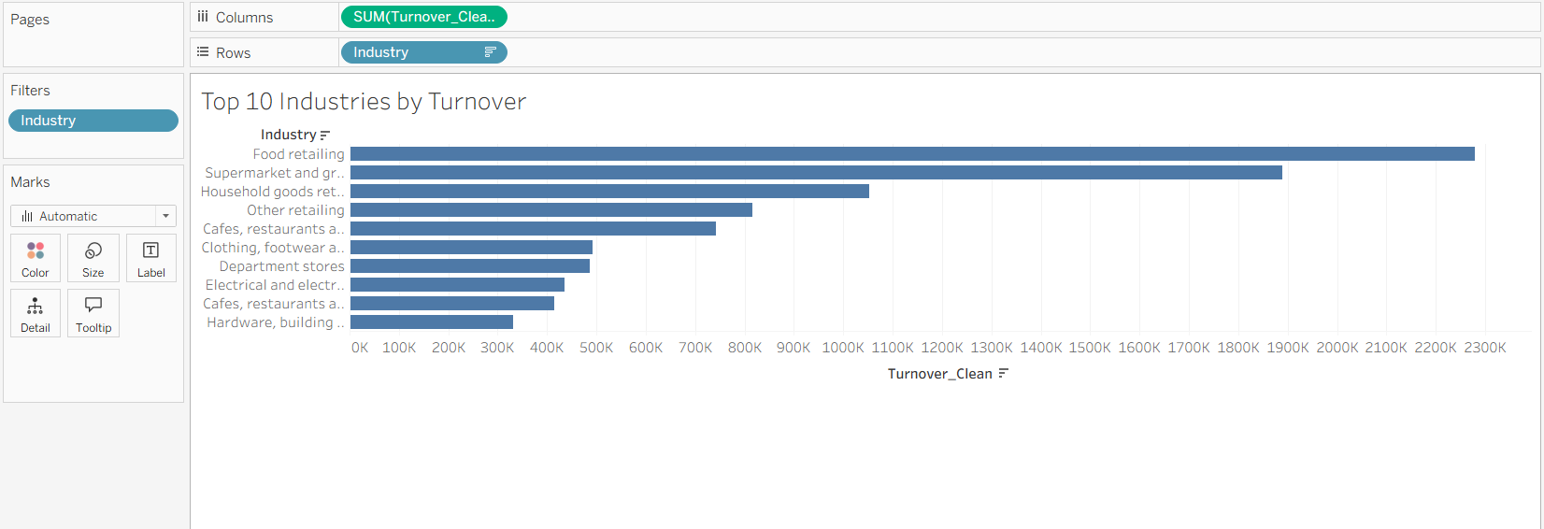
Figure 9 : Top 10 industries by turnover

8.4 Seasonality Heatmap
A heatmap with Month Name as rows and Year as columns, colored by SUM(Turnover_Clean), provides a concise insight into the seasonality and growth (RQ4). The general darkness trend over the years indicates growth, and the variations between months indicate the seasonality that can be used to inform promotions and hiring. While the year-over-year growth may obscure the darkness, you can choose to normalize by year to improve the visualization of the seasonality.
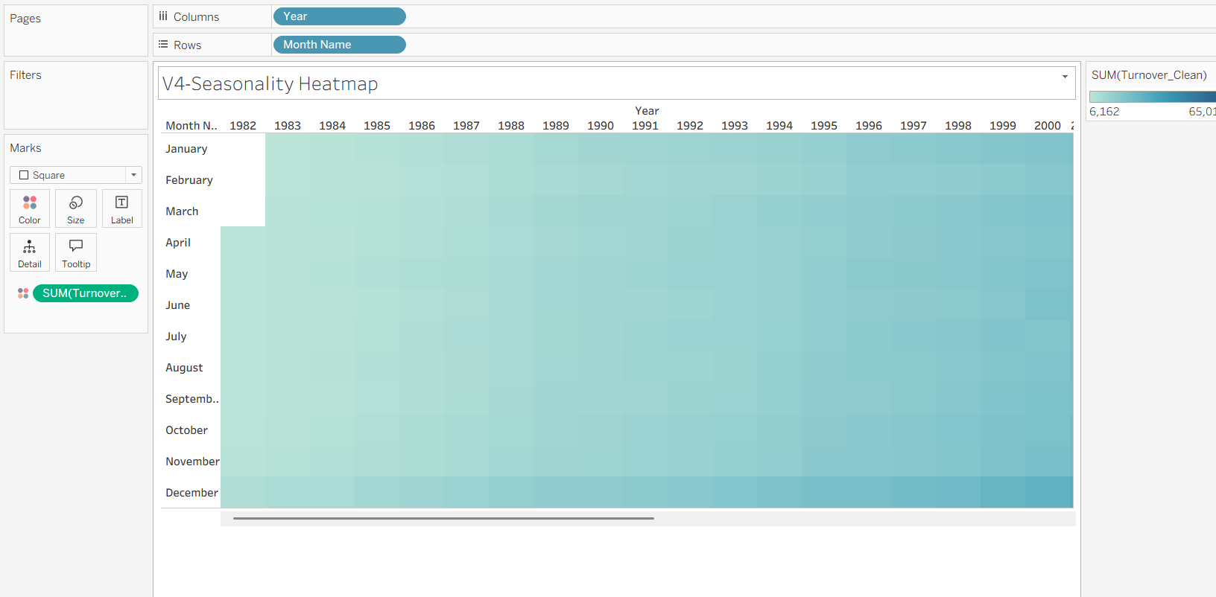
Figure 10 : Seasonality heatmap

9. Predictive Analytics Findings

9.1 Forecasting with Exponential Smoothing
The Tableau forecasting tool has been used to forecast the monthly turnover data. This tool uses an exponential smoothing method to forecast a time series, making estimates of level, trend, and seasonality, with more recent data given greater weight in the forecast. The forecasted path also includes a shaded area indicating a prediction interval. From the forecast, it can be concluded that the turnover will continue to increase in line with past trends.
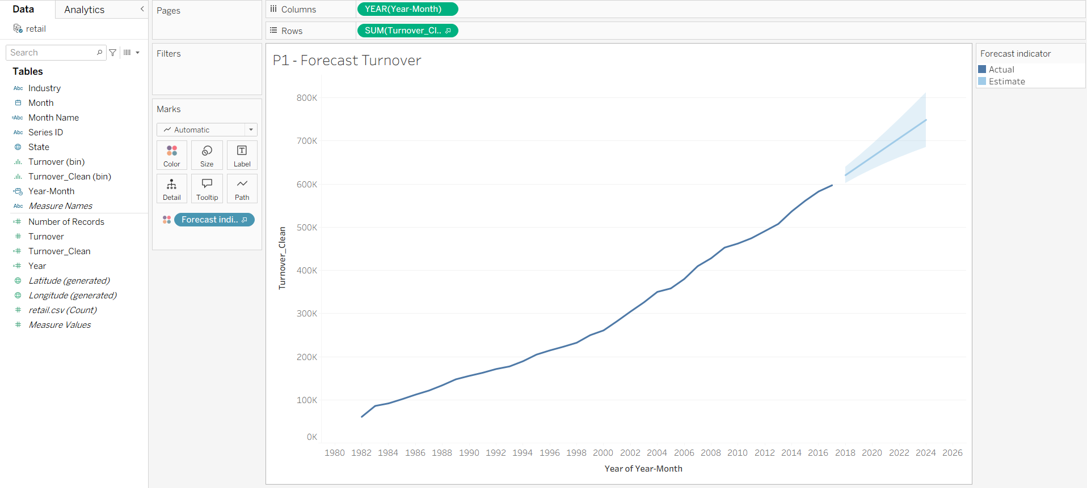
Figure 11 : Tableau forecast Turnover

9.2 Regression Trend Model
A regression line has been added that connects the yearly turnover figures, with the independent variable being YEAR(Month) and the dependent variable being SUM(Turnover_Clean). The line slopes upwards, showing that turnover increases with time. The statistics of the model, such as R-Squared and p-value, have been obtained by using the ‘Describe Trend Model’ dialog in Tableau, showing that it is statistically significant with a p-value < 0.0001. The slope represents the average yearly increase in turnover units.
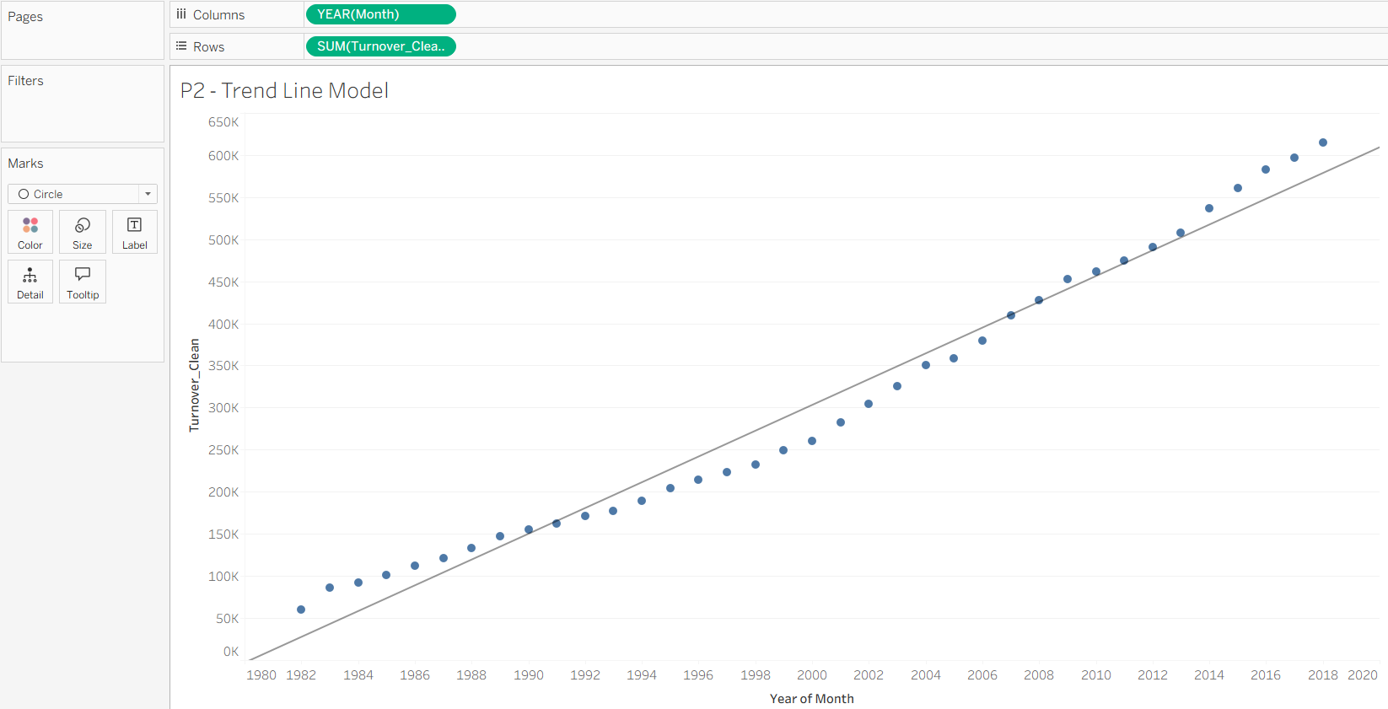
Figure 12 : Scatter plot with trend line
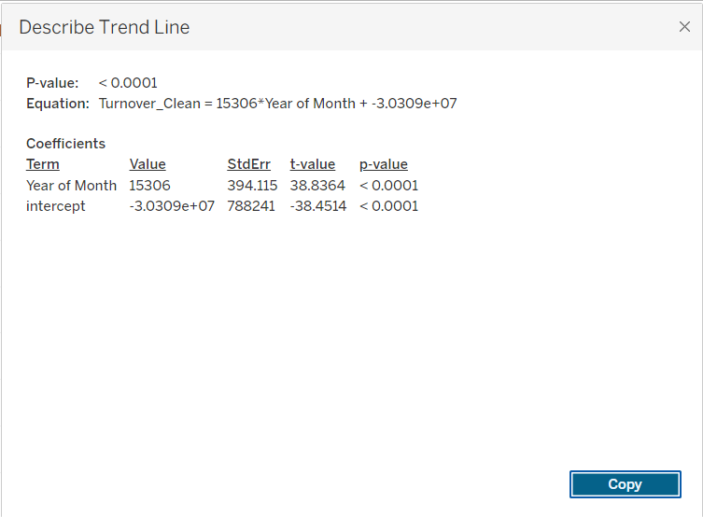
Figure 13 : Describe Trend Line

10. Model Evaluation and Big Data Context
Evaluating the models is a significant step in ensuring that the results of the predictions are used properly. A forecasting model provides a good foundation or baseline for predictions; however, this is based on the assumption that current trends will continue in the same manner in the future. In the event of structural breaks in the data, such as economic or policy-related shocks, the accuracy of the predictions may not be perfect.
A simple linear regression trend line is simple to interpret but lacks the richness of understanding the behavior of retail turnover data. In particular, this approach lacks explicit treatment of seasonality effects.
With the advent of Big Data, there is scope for improvement in the current approach of forecasting retail turnover data by using higher-frequency or higher-dimensional data such as sales data, promotions, prices, weather data, online data, demographics, etc. However, in the current data structure, the chosen models are adequate for business intelligence purposes.

11. Comparison with Published Research / Case Studies
My findings reflect what typically occurs in retail analytics. Forecasting in retail involves monitoring trends and seasonality, and exponential smoothing is a popular method for retail time series because it adjusts to changes in trends and seasonality. Similarly, the Australian retail turnover series demonstrates long-term growth and seasonality, as evidenced in the ABS retail trade datasets used in examples of forecasting and teaching. The dominance of essentials, such as food and supermarkets, reflects what occurs in reality, where essential categories remain relatively stable, while discretionary categories fluctuate.

12. Limitations
- Limited drivers: Although the dataset provides drivers like turnover, time, state, and industry, there is a lack of inflation, population, income, and policy-related drivers. Thus, the analysis can be done but causality can't be determined.
- Model constraints: The analysis can be done using a linear trend line, but this would be an oversimplification of non-linear growth and would not take into account factors like seasons. The analysis would be based on the assumption that the patterns would persist; thus, any unforeseen factors would affect the results.
- Aggregation: Aggregation based on factors like industry, state, and month would not take into account factors like differences within the state (like differences between the city and the region) and store levels.

13. Recommendations
- Utilize the forecast as a basis for planning, budgeting, and inventory, and combine it with scenario planning to address uncertainty.
- Develop promotion and supply allocation strategies based on seasonal peaks in the heatmap, and track month-to-month changes for operational purposes.
- Target high-turnover industries (such as food and grocery products) for strategies related to resilience, and track discretionary industries as indicators of consumer confidence.
- Utilize state-level strategies by targeting expansion and marketing in high-turnover states, while developing strategies for other states with slower growth.
- Enhance analysis by incorporating external drivers (turnover, population, income, interest rates) and updating to the latest ABS releases when available.

14. Conclusion
In this project, an entire analytics process was demonstrated with Tableau Desktop, starting with justification of the data set and verification of the data's readiness, through to descriptive and predictive analytics. The data set on Australian retail turnover shows a steady growth over time, a concentration of activities in the larger states, and a cluster of activities in the essential retail sectors, with noticeable monthly seasonality. The exponential smoothing model and the regression trend model both show growth over time, following the historical trends, but we must be aware of the constraints of such models and their ethical implications.

References
- Australian Bureau of Statistics (ABS). (2025). Retail Trade, Australia methodology (March 2025). https://www.abs.gov.au/methodologies/retail-trade-australia-methodology/mar-2025
- Australian Bureau of Statistics (ABS). (2025). Retail Trade, Australia (latest release). https://www.abs.gov.au/statistics/industry/retail-and-wholesale-trade/retail-trade-australia/latest-release
- Hyndman, R. J., & Athanasopoulos, G. (2021). Forecasting: Principles and Practice (3rd ed.). https://otexts.com/fpp3/
- Fildes, R., Ma, S., & Kolassa, S. (2019). Retail forecasting: research and practice. https://mpra.ub.uni-muenchen.de/89356/
- Tableau. (n.d.). Forecasting in Tableau Desktop. https://help.tableau.com/current/pro/desktop/en-us/forecasting.htm
- Tableau. (n.d.). How forecasting works in Tableau. https://help.tableau.com/current/pro/desktop/en-us/forecast_how_it_works.htm
- Tableau. (n.d.). Describe Forecast dialog box. https://help.tableau.com/current/pro/desktop/en-us/forecast_describe.htm
- Tableau. (n.d.). Add trend lines to a visualization. https://help.tableau.com/current/pro/desktop/en-us/trendlines_add.htm
- Weechomming, K. (n.d.). Australia Monthly Retail Turnover Data [Data set]. Kaggle. https://www.kaggle.com/datasets/kanyaweechomming101/australia-monthly-retail-turnover-data
- Tidyverts / tsibbledata. (n.d.). aus_retail: Australian retail trade turnover (dataset documentation). https://tsibbledata.tidyverts.org/reference/aus_retail.html

