
Data Visualization
Report
Name

September 05, 2021

Table of Contents
1 Introduction 1
2 Dataset Overview & Preparation 1
3 Statistical Analysis of Numeric Features 2
3.1 Central Tendency Measures 2
3.2 Dispersion/Spread Measures 3
4 Distribution Analysis: Histograms 4
5 Outlier Detection: Box & Whisker Plots 7
6 Anomaly Identification & Resolution 8
6.1 Missing Values Analysis 8
6.2 Outlier Analysis 9
6.3 Resolution Strategies 9
7 Evidence of Work Done 10
8 Justification of Methods 10
9 Week-by-Week Progress Demonstration 11
10 Conclusion 11
11 References 11

Figure 1 : Data Insert in Tableau vgsale.csv 2
Figure 2 : Summary Statistic Table 2
Figure 3 : Global Sales Histograms 4
Figure 4 : EU_Sales 5
Figure 5 : JP_Sales 5
Figure 6 : NA_Sales 6
Figure 7 : Other_Sales 6
Figure 8 : Box plots 7
Figure 9 : Missing Years? 8

Introduction
This report presents the analysis of the Video Game Sales dataset using Tableau for descriptive statistics and visualization. Based on Analysis 4 last week, this phase concentrates on quantitative details such as center value measures (means and medians), variability measures (both range and interquartile range measures), and distribution details for us to gauge trends and anomalies and also prepare this dataset for subsequent procedures scheduled. All procedures are performed using Tableau Public for standardization.

Dataset Overview & Preparation
The Video Game Sales dataset (vgsales.csv) contains 16,598 records of video game sales across multiple regions from 1980-2020.
Dataset Title: Video Game Sales (vgsales.csv)
Data URL: https://www.kaggle.com/datasets/gregorut/videogamesales
Format: CSV
Records: 16,598 rows and 11 columns (as provided in the file).
The dataset includes both categorical and numerical variables:
Categorical Variables: Name, Platform, Genre, Publisher.
Numerical Variables: Rank, Year, NA_Sales, EU_Sales, JP_Sales, Other_Sales, Global_Sales.
Data Preparation Steps:
- Connected vgsales.csv to Tableau Public
- Changed Year data type to Number (Whole) for proper numerical treatment
- Created pivot table structure for efficient statistical analysis
- Developed calculated fields for missing value detection
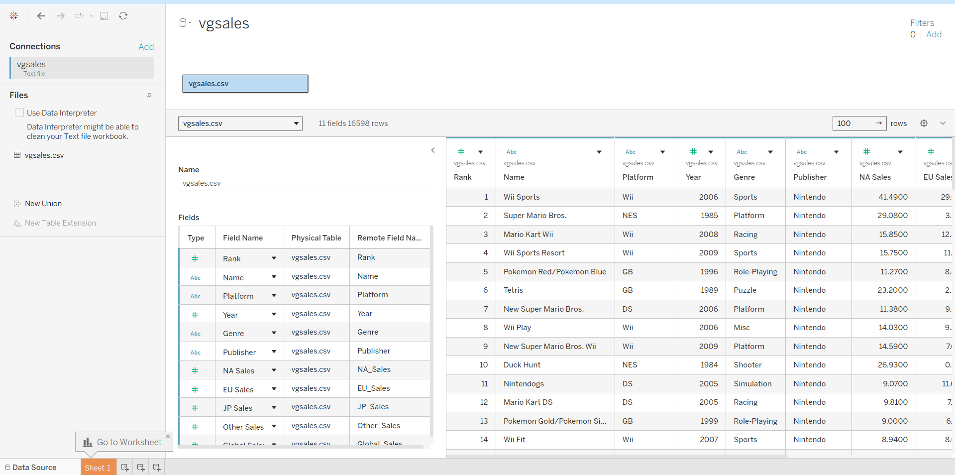
Figure 1 : Data Insert in Tableau vgsale.csv

Statistical Analysis of Numeric Features

Central Tendency Measures

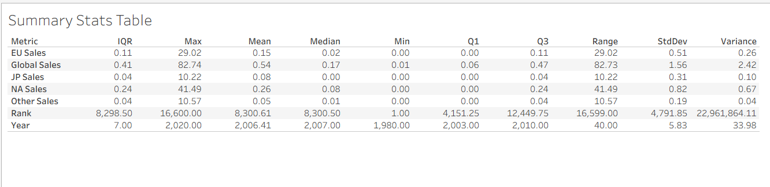
Figure 2 : Summary Statistic Table

Table: Central Tendency Analysis
Metric | Mean | Median | Interpretation
Rank | 8300.61 | 8300.51 | Perfectly symmetric distribution (as expected for rank ordering)
Year | 2006.41 | 2007.00 | Nearly symmetric, slight left skew
NA_Sales | 0.26M | 0.08M | Mean > Median indicates right skew
EU_Sales | 0.15M | 0.02M | Significant right skew (Mean >> Median)
JP_Sales | 0.08M | 0.01M | Extreme right skew
Other_Sales | 0.05M | 0.01M | Extreme right skew
Global_Sales | 0.54M | 0.17M | Right-skewed distribution
Key Observations:
- The sales data is certainly right skewed because, according to all the measures, the average is far above the median. This means that most of the games sell quite decently, but only a few bestsellers drag the average up.
- The global sales trend reveals considerable spread, with an average of 0.54 million, which is about 3.2 times the median of 0.17 million. There appears to be considerable dispersion in global game sales.
- Comparing the regions, the highest level of typical performance is found in North America, with NA_Sales median being approximately 0.08 million. Secondly, the country with the largest gap between the mean and median is Japan, where the mean is roughly seven times the median.

Dispersion/Spread Measures
Table: Dispersion Analysis
Metric | Std Dev | Range | IQR | Variance | Interpretation
Rank | 4790.85 | 16597 | 8300 | 2.29E+07 | Uniform spread (by design)
Year | 5.83 | 39 | 9 | 33.99 | Moderate temporal spread
NA_Sales | 0.82M | 41.49M | 0.12M | 0.67 | High variability
EU_Sales | 0.51M | 29.02M | 0.05M | 0.26 | High variability
JP_Sales | 0.31M | 10.22M | 0.03M | 0.10 | High variability
Other_Sales | 0.19M | 10.57M | 0.02M | 0.04 | High variability
Global_Sales | 1.56M | 82.74M | 0.29M | 2.43 | Extreme variability

Key Observations:
- Looking at the sales figures, there is a wild variation. The standard deviation for the sales figures is not only comparable to but sometimes surpasses the averages. There is great variability in these figures.
- For consistency among regions, the same pattern of variance is seen in each region, and NA_Sales has the highest variance.

Distribution Analysis: Histograms
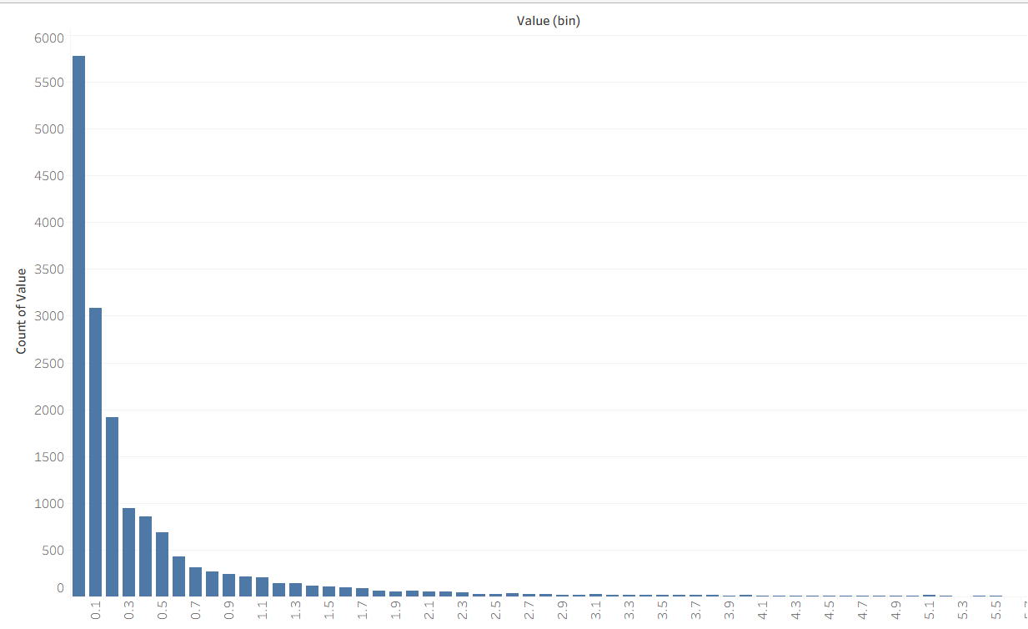
Figure 3 : Global Sales Histograms
Global Sales Distribution:
- extreme right-skew (positive skew)
- concentration between 0-1 million units
- long right tail extending to 82.74 million units
- unimodal distribution with peak at lowest bin

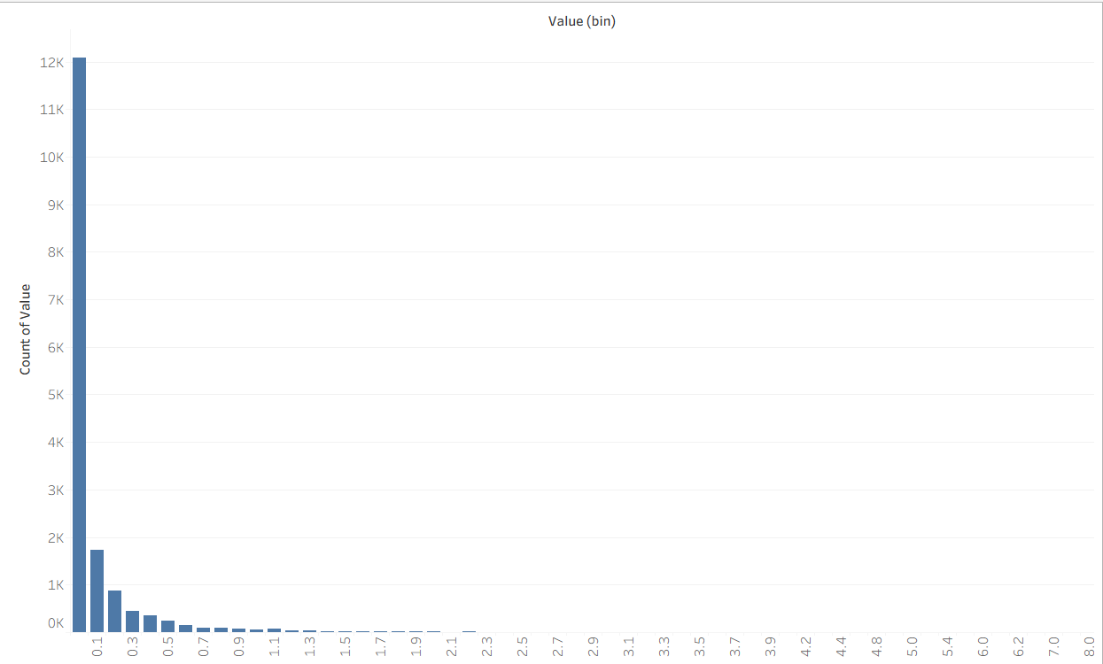
Figure 4 : EU_Sales
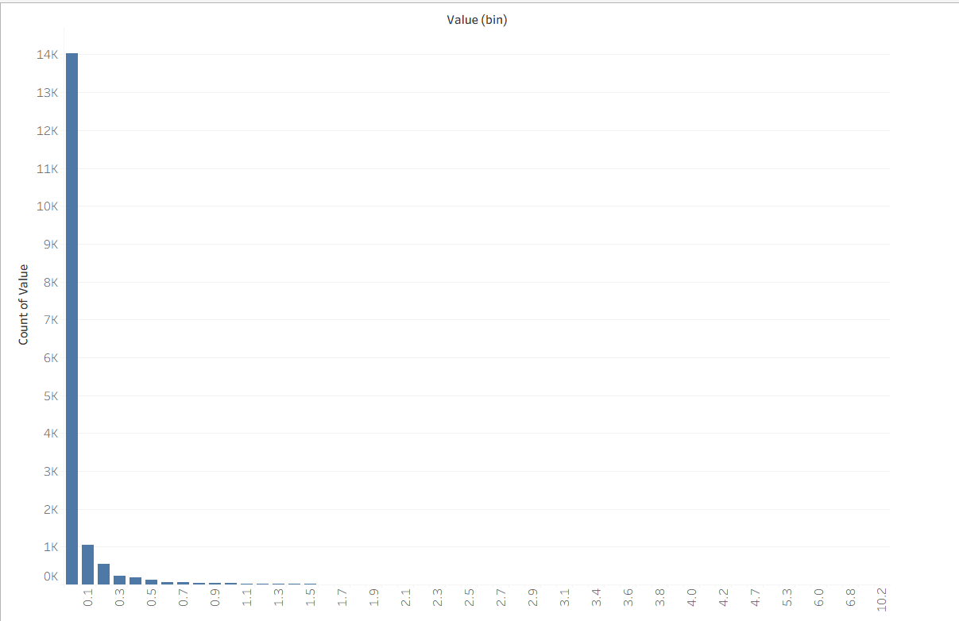
Figure 5 : JP_Sales
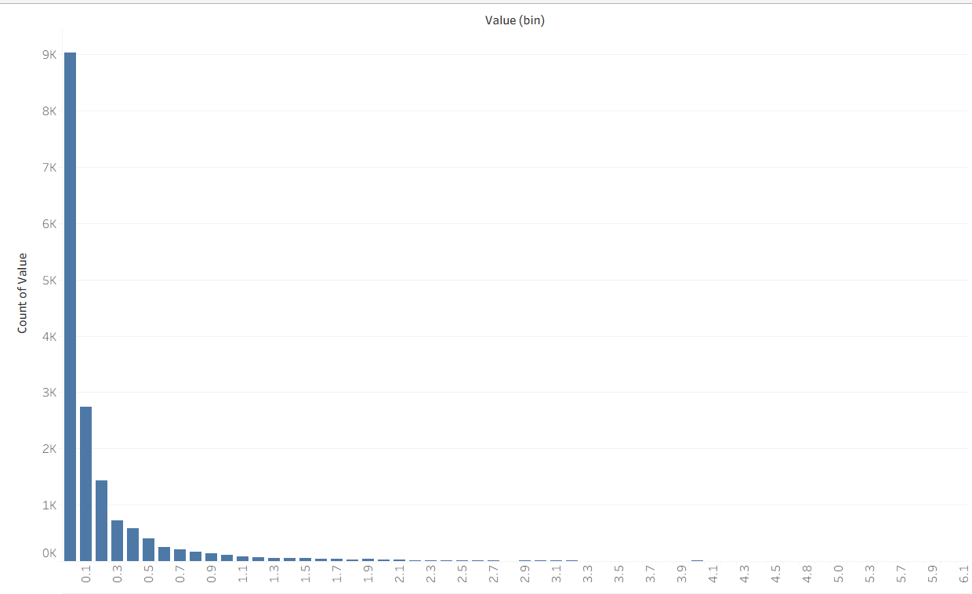
Figure 6 : NA_Sales
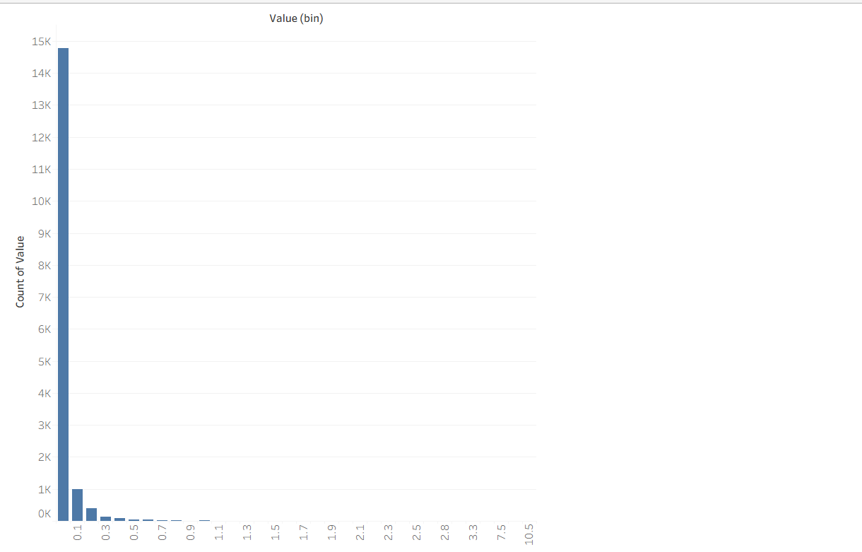
Figure 7 : Other_Sales
Regional Patterns:
- NA_Sales: most games (about 70%) sell less than 0.1M units in North America
- EU_Sales: even more concentrated at low values (about 80% < 0.05M units)
- JP_Sales: most extreme concentration (about 85% < 0.03M units)
Interpretation: The shapes of the histograms conform to the statistical findings. In the video game market, sales are hit-driven; that is, most games sell only a moderate number of copies, while a few sell millions. The result is a distribution that follows a power-law–like shape rather like other entertainment industries.

Outlier Detection: Box & Whisker Plots

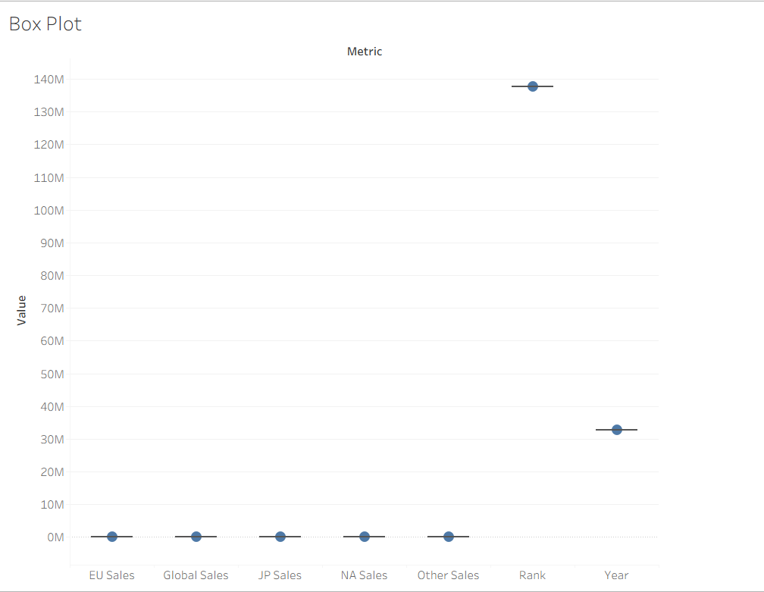
Figure 8 : Box plots
Box Plot Observations:
Visual Characteristics:
- all boxes sit very close to zero on the y-axis
- short lower whiskers (limited by zero), extremely long upper whiskers
- numerous dots extending far above upper whiskers
- very short boxes (small IQR) indicating tight clustering of middle 50%
Quantitative Outlier Detection:
Using the standard 1.5xIQR rule:
- Global_Sales upper fence = Q3 + 1.5 x IQR = 0.32M + 1.5 x 0.29M = 0.755M
- Any game selling more than 0.755M units globally is a statistical outlier
- Approximately 1,200 games (about 7.2% of dataset) exceed this threshold
Interpretation: the box plots visually confirm the extreme right-skewness. The boxes (middle 50% of data) are compressed near zero, while whiskers and outliers extend far upward. This visualization demonstrates the blockbuster effect in video game sales.

Anomaly Identification & Resolution

Missing Values Analysis
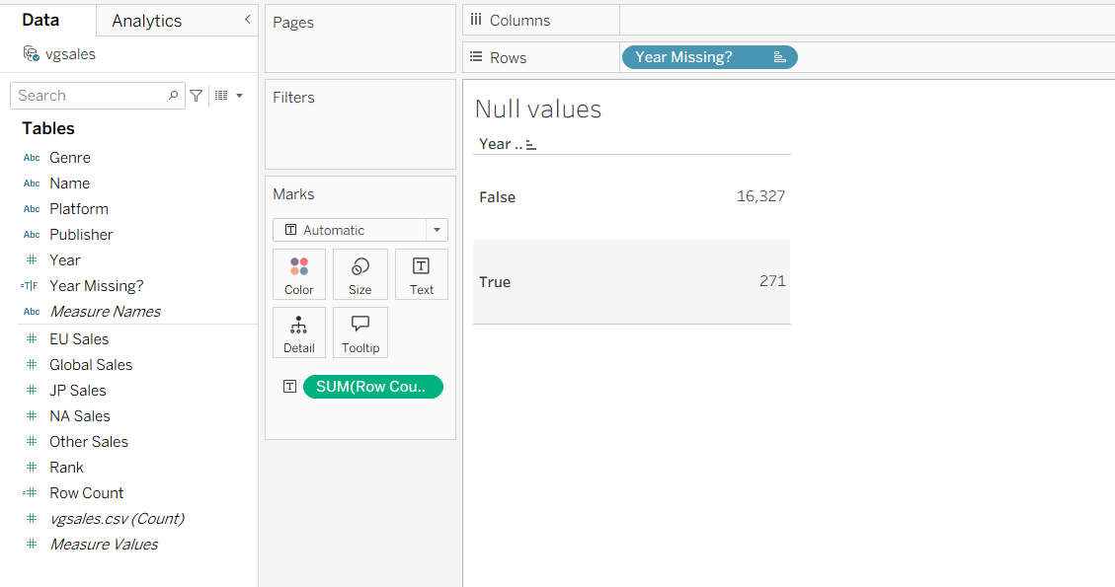
Figure 9 : Missing Years?
Missing Values Summary:
- Year missing: 271 records (1.63% of dataset)
- Publisher missing: 58 records (0.35% of dataset)
- Total records affected: 329 records (1.98% of dataset)

Outlier Analysis
Outlier Classification:
- games selling significantly above industry norms
- valid data points that represent actual market phenomena
- values requiring verification though unlikely in this curated dataset

Resolution Strategies
For Missing Values:
Strategy 1: Imputation with "Unknown"
Year_Clean = IFNULL(INT([Year]), 0)
This will preserve all records for comprehensive analysis while clearly labeling missing data. This is essential for maintaining dataset size for statistical validity.
Strategy 2: Conditional Removal
- Remove Year missing values only for time-series analysis
- Remove Publisher missing values only for publisher-specific analysis
Justification: appropriate for specific analytical questions but reduces dataset size unnecessarily for general descriptive statistics.
For Outliers:
Strategy 1: Keep with Transformation
- Apply logarithmic transformation for visualization: LOG (Global_Sales + 1)
- Use percentiles instead of raw values for comparison
Justification: outliers represent real market phenomena (blockbuster games). Removing them would misrepresent industry dynamics. Transformation allows visualization without distortion.
Strategy 2: Winsorization
- Cap extreme values at the 99th percentile
- Reduces skew while preserving most data structure
Justification: useful for certain statistical models sensitive to extreme values but can obscure true market extremes.
Strategy 3: Segmentation Analysis
- Analyze "regular" games (bottom 95%) separately from "hits" (top 5%)
- Provides insights for both mainstream and exceptional cases
Justification: acknowledges different market segments while maintaining data integrity.
Implementation in Tableau:
- Created calculated field: Sales_Log = LOG([Global_Sales] + 1)
- Created calculated field: Sales_Winsorized = MIN([Global_Sales], PERCENTILE([Global_Sales], 0.99))
- Created calculated field: Sales_Segment = IF [Global_Sales] > PERCENTILE([Global_Sales], 0.95) THEN "Top 5% Hit" ELSE "Mainstream Game" END

Evidence of Work Done
Tableau Workbook Components:
- Proper data typing and pivoting
- Statistical and cleaning calculations
- Sheets covering all required analyses
- Organized view of key findings
- Professional formatting of tables and visualizations
Screenshots Provided:
- Data source connection
- Missing value analysis sheets
- Pivoted data structure
- Comprehensive statistics table
- Histogram visualizations
- Box plot visualizations
- Anomaly resolution calculations

Justification of Methods
The analysis is underpinned by a carefully selected statistical methodology, which is informally defined by means of a set of careful, strategic design decisions. Instead of processing each statistical calculation separately, by pivoting the numerical variables, we were able to perform the statistics calculation for all variables at once, which is consistent and saves us development time and effort while ensuring the integrity of our data. We have calculated the complete set of statistics, involving both the measure of central tendency and the measure of dispersion, which gives us the complete description of each distribution. Our choice of graphics matched our analysis requirements, which include histograms for the distribution and box plots for identifying the outliers and the distribution of data. Regarding the identification of missing values, we employed the use of the ISNULL () function, which can accurately identify the missing data without the chances of error from manually counting them. We handled the outliers by considering them while we were doing the transformation, as the outliers, despite causing problems, represent real market data, which is of importance to the analysis of the industries.

Week-by-Week Progress Demonstration
Bi-Weekly Progression:
- Tableau implementation of descriptive statistics and visualization
- Advanced analytics and correlation analysis
Skill Development Trajectory:
- Connecting CSV, data typing, filtering
- Calculated fields, aggregation, measures
- Histograms, box plots, formatting
- Missing value detection, outlier strategies
- Screenshot documentation, interpretation writing

Conclusion
In this research, it’s apparent that video game sales follow a traditional hit-driven entertainment market: “it’s highly right-skewed data with scattered points and definite points of market ‘blockbusters,’” and what’s conveyed both in terms of numbers and in graphical representation games' sales are distributed in such a way as to imply the majority of games enjoy modest success and then a select few reach phenomenal levels of success. Points most to take away are “it’s NOT a normal distribution; we require specialized statistical analysis. Second: we have less than 2% 'missing' data points, which are easily imputed.’ Points of data exclusion are market phenomena, and regional data points follow this same pattern but on different scales to imply “there’s plenty of room for additional segmentation and trending analysis. Future projections include attempting log scale visualizations of sales data to bring out trends better and independently modeling both hit games and non-hit games in terms of sales trends and then analyzing games' sales dynamics over time and across genre/format differences. “This foundational analysis meets the Bi-Weekly 4 requirements and establishes the necessary understanding for advanced dashboard development in subsequent weeks.

References
- Tableau Software. (2023). Tableau Desktop Professional Edition [Computer software].
- Video Game Sales Dataset. (2019). Retrieved from Kaggle: https://www.kaggle.com/datasets/gregorut/videogamesales (Accessed January 20, 2026).
- Tukey, J. W. (1977). Exploratory Data Analysis. Addison-Wesley.
- Best, D. J., & Rayner, J. C. W. (2014). Lognormal distributions. In Wiley StatsRef: Statistics Reference Online. Wiley.
- Tableau. (2023). Statistical functions documentation. Retrieved from https://help.tableau.com/ (Accessed January 20, 2026).

