
Report
Data visualization

September 05, 2021

Contents
1. Introduction 1
2. Dataset and Preparation 1
3. Predictive Analysis: Clustering in Tableau 2
4. Analysis : Forecasting Total Global Sales 6
5. Comparison with Scholarly Studies 7
5.1 Study 1: Wu (ECAI 2024) – ML Regression for Global Sales Prediction 7
5.2 Study 2: Huang (GEFHR 2023) – XGBoost/LightGBM vs Neural Network 7
5.3 Study 3: Tableau Clustering Documentation (Method Alignment) 7
5.4 Comparison Summary 7
6. Suggestions to Improve the Findings 8
7. Summary: What I Learned Across All Biweekly Exercises 8
8. References 9

Table of Figures
Figure 1 : Tableau Data Source tab showing fields and data types 2
Figure 2 : Week 8 dashboard overview 2
Figure 3 : Plot with clusters 3
Figure 4 : Cluster description/diagnostics window 4
Figure 5 : Bar chart of Avg NA_Sales by Cluster 5
Figure 6 : Cluster heatmap 5
Figure 7 : Global sales by year with forecast and prediction 6

Introduction
This report extends the Video Game Sales data set (vgsales.csv) from Bi-Weekly 4, 6, and 8. In the previous biweekly work, we explored the data by cleaning, exploring, and visualizing it with descriptive statistics and dashboards to get answers for the key business questions related to platforms, genres, publishers, and regional sales patterns. Now, the attention moves from merely describing what has happened to discussing what could happen and how predictive analytics can find the patterns.
Here, at least one predictive model is applied in Tableau to surface patterns that are not obvious by basic charts alone. The predictive analysis is laid out: what model was used, which variables fed it, and why this model fits the dataset. The report emphasizes the most critical new insights that emerge from the predictive outputs and the supporting visuals. To deepen the discussion, review relevant scholarly work that uses similar predictive approaches in video game sales or any relevant market forecast, contrasting those findings against the Week 10 results. Finally, the report gives some suggestions to enhance the accuracy and usefulness of the results and concludes with a one-page reflection summarizing the core concepts and techniques learned across all the biweekly exercises.

Dataset and Preparation
Video Game Sales - The videogamesales dataset by gregorut on Kaggle contains 16,598 entries on how games perform in various regions and overall worldwide. For this prediction problem, the important columns are Year, Platform, Genre, Publisher, NA_Sales, EU_Sales, JP_Sales, Other_Sales, and Global_Sales, through which patterns and trends can be spotted.
Preparation steps completed in Tableau:
- Connected vgsales.csv to Tableau Public/Desktop.
- Converted Year to Number (Whole) and handled Null/Unknown values where needed.
- Created calculated fields used in Week 8 dashboards.
Evidence screenshots:
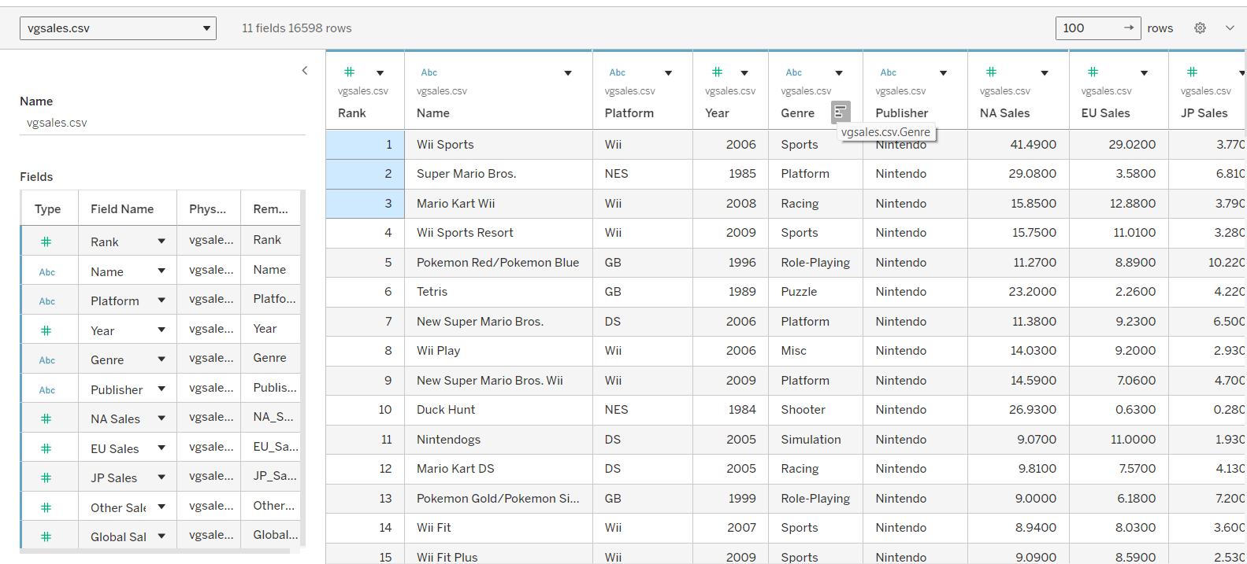
Figure 1 : Tableau Data Source tab showing fields and data types
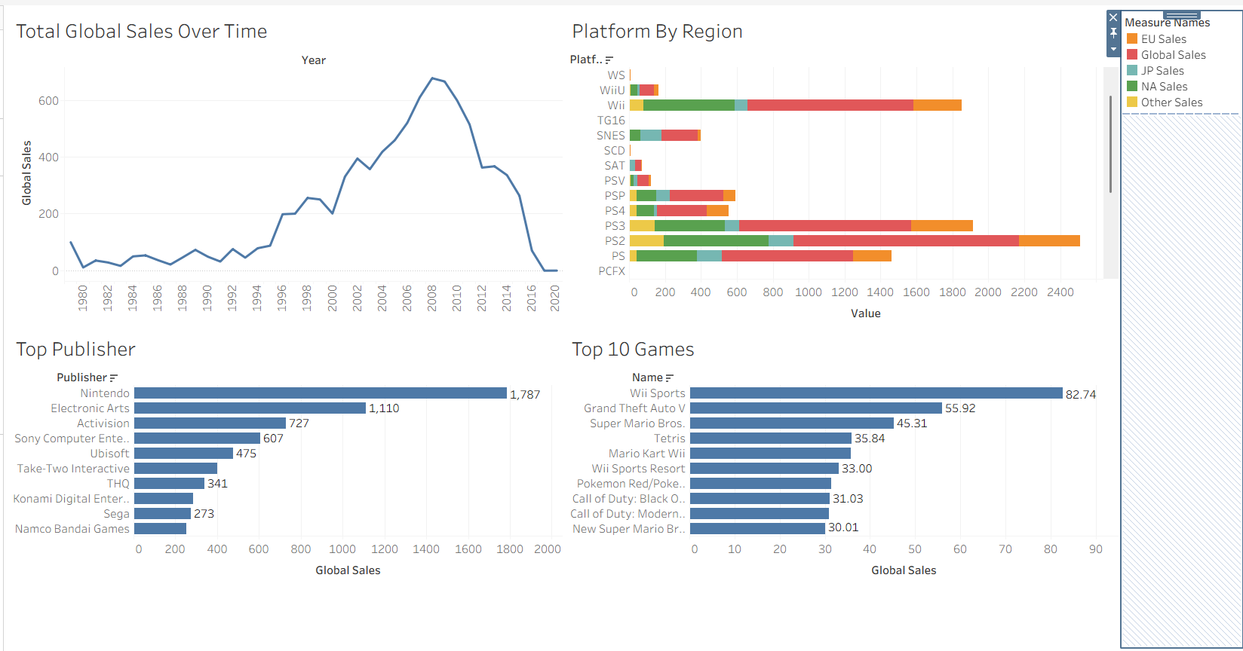
Figure 2 : Week 8 dashboard overview

Predictive Analysis: Clustering in Tableau
To address our research question of splitting the video games data into significant groups depending on the sales patterns in the different regions, and then describing how these groups differ depending on the genre, platform, and performance, we selected the K-means clustering technique and applied it directly within Tableau through the Analytics area. This is a particularly useful unsupervised learning technique in this case, since it identifies significant groups within the data without the need for prior data labeling.
Clusters in Tableau:
In Tableau, I created a k-means clustering model using NA_Sales and EU_Sales as the input variables. This means that the clusters are capturing groups of games that are similar in sales performance in the North American and European markets.
Evidence screenshots to include:
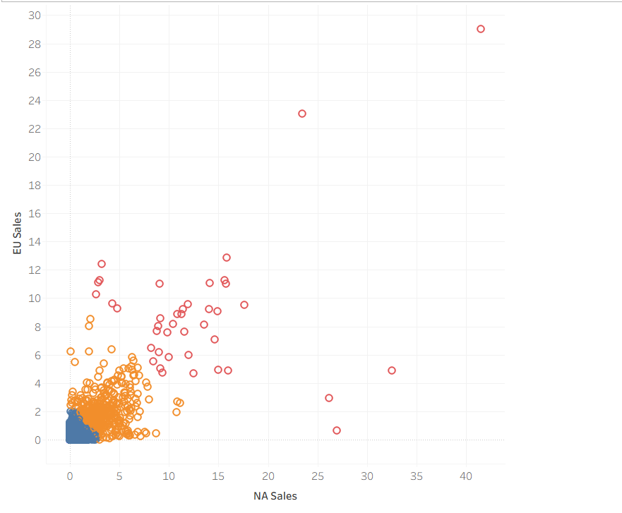
Figure 3 : Plot with clusters
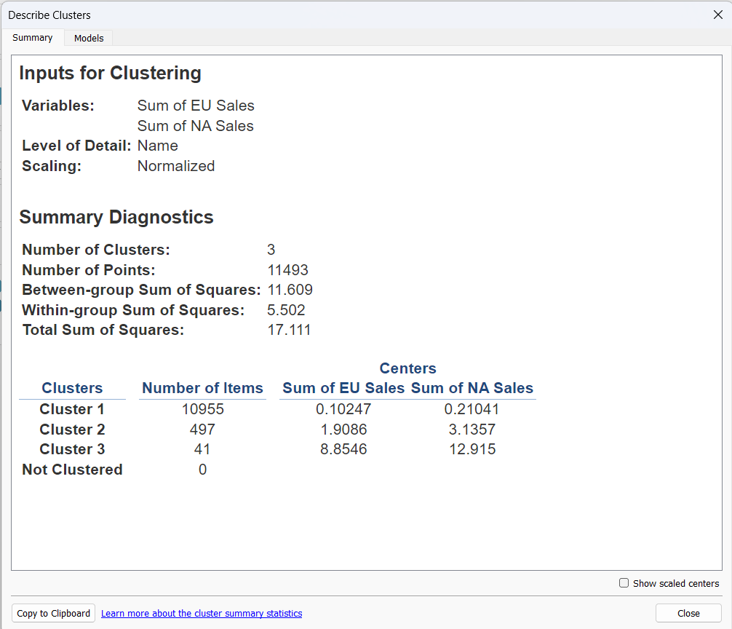
Figure 4 : Cluster description/diagnostics window
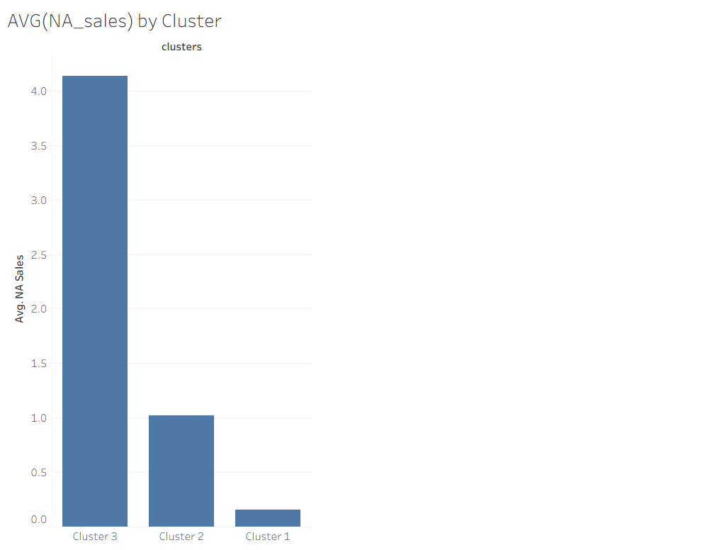
Figure 5 : Bar chart of Avg NA_Sales by Cluster
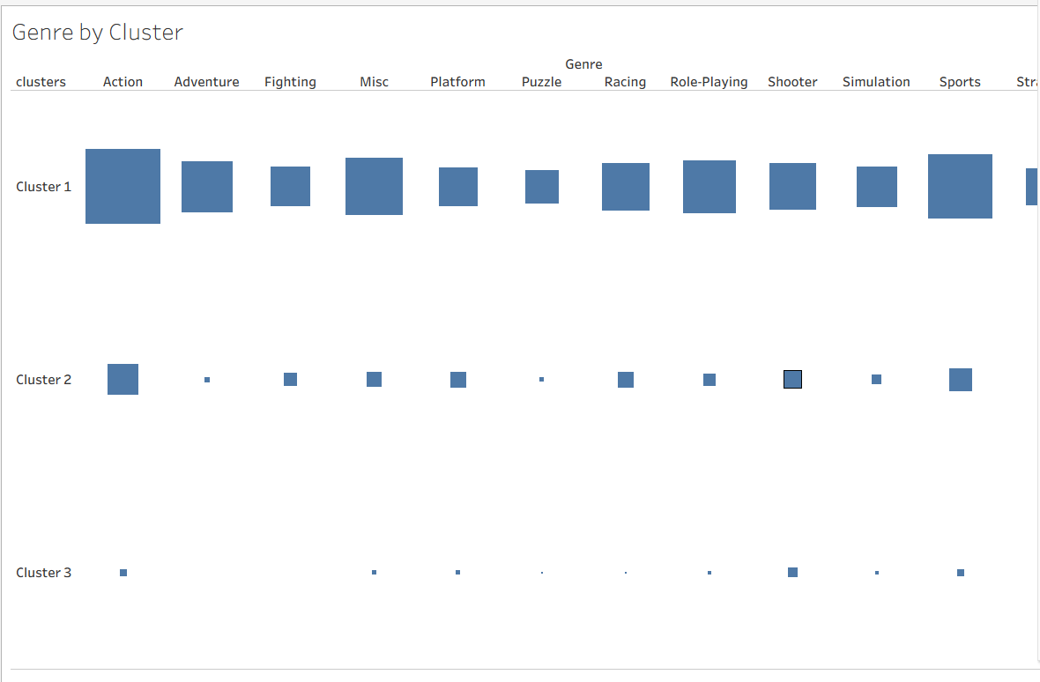
Figure 6 : Cluster heatmap
The application of K-means to video game sales data reveals four important insights regarding how this market is organized. First of all, there is a clear division of market layers if you examine the market in North America and Europe: there are low-selling titles, medium performers, and high-selling titles. It's not a flat market; it's led by titles that are runaway successes compared with everything else. Second, the data shows that the sales in the NA region and the EU region are strongly linked in a positive correlation, which means that success in one region is linked to success in the other. Third, the NA/EU pattern is a strong substitute for the global performance, since the clusters formed around the NA/EU regions have very different average global sales. Fourth, genre distribution is not equal across performance levels, and some genres tend to group with high performance more often than others, indicating that success is not random but genre-dependent. In summary, the study provides a road map through which resources should be invested: focus on the high-performing genre clusters in NA and EU, and success will follow worldwide.

Analysis : Forecasting Total Global Sales
To add a second predictive technique, Tableau’s built-in forecasting can be applied to the time series of total Global_Sales by Year. Tableau forecasting uses exponential smoothing models, which weight recent observations more heavily and can capture trend and seasonality.
Evidence screenshots to include:
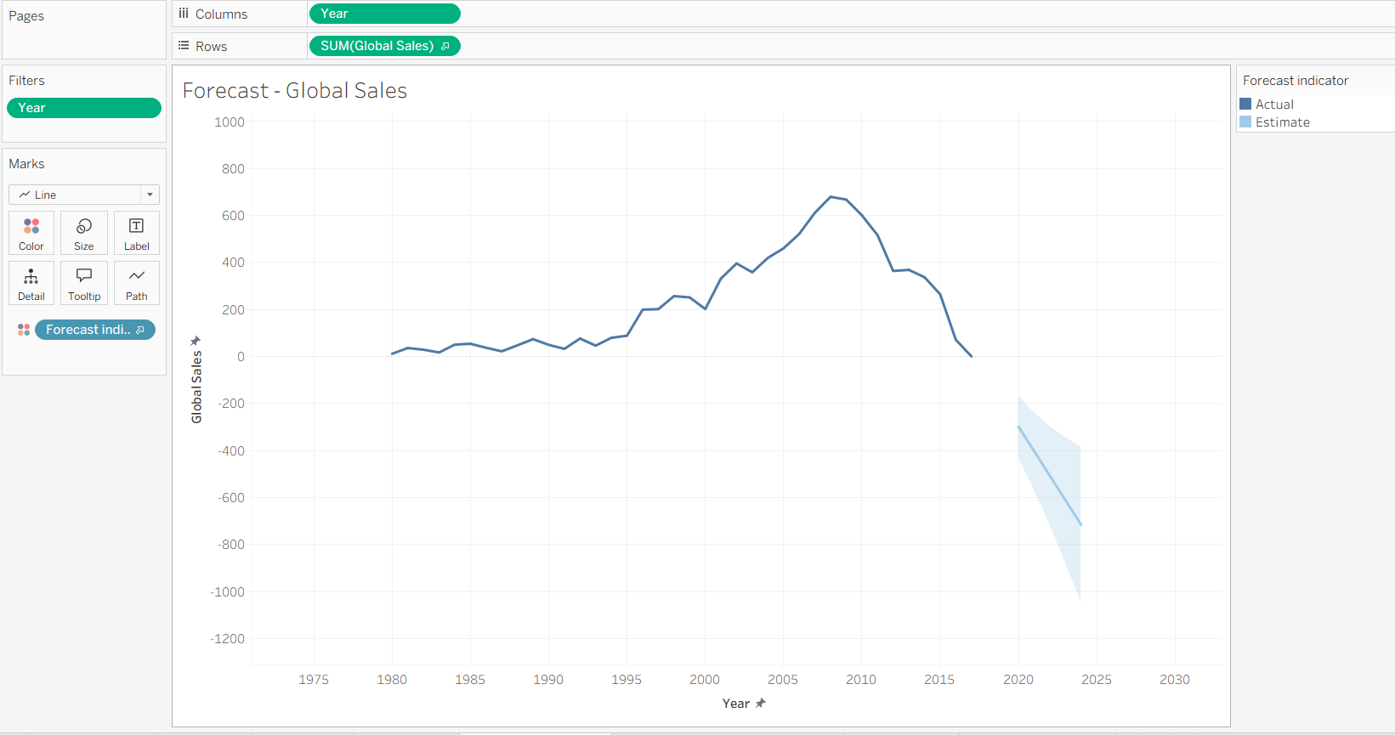
Figure 7 : Global sales by year with forecast and prediction
Tableau Forecasting was applied to predict the SUM(Global_Sales) by year. The historical trend shows steady rise from the 1980s, Strong expansion in the late 1990s - early 2000s, and peaks around 2008-2010, followed by a dramatic drop in sales until the most recent years. The forecasted line follows this decline into the 2020-2024 period. The forecasted line goes below zero, which is not possible since sales cannot be negative; this is taken to mean a drop to near-zero sales rather than actual negative sales. The widening forecast bands indicate increasing uncertainty in the 2020-2024 forecast.

Comparison with Scholarly Studies
To better understand my results from Week 10, I researched academic work that applies predictive analytics to video game sales data. These studies allowed me to compare my approach using Tableau

Study 1: Wu (ECAI 2024) – ML Regression for Global Sales Prediction
In this case, Wu investigated a number of supervised machine learning algorithms for predicting Global_Sales, including linear regression, SVM, KNN, random forest, and gradient boosting on a Kaggle-style dataset for video game sales. The study highlights the importance of preprocessing, selecting meaningful features, and evaluating model performance. Overall, it seems that more complex machine learning methods, particularly boosted/ensemble models, perform better compared to simple baselines methods.

Study 2: Huang (GEFHR 2023) – XGBoost/LightGBM vs Neural Network
Huang examined a number of predictive models, including neural networks, XGBoost, and LightGBM, to predict the sales of video games. The model took a number of inputs, including the year of release, platform, genre, and publisher, as well as other factors related to sales, and evaluated the results using metrics such as RMSE, MAE, and MSE. The findings of the study suggest that gradient boosting models (XGBoost and LightGBM) may be particularly useful in predicting sales because they are able to handle non-linear relationships more effectively than other models.

Study 3: Tableau Clustering Documentation (Method Alignment)
According to Tableau’s official documentation, Tableau’s clustering algorithm utilizes k-means, which can determine the number of clusters based on statistical measures such as the Calinski-Harabasz index. Such a foundation ensures the validity of Tableau’s clustering algorithm in predictive segmentation as well as in discerning sales patterns.

Comparison Summary
My work in week 10 applied unsupervised learning, k-means clustering, to categorize video games according to their performance levels according to regional sales trends. This is unlike the supervised models, such as regression analysis, applied by Wu & Huang et al., where the goal was the prediction of a numerical value, Global_Sales. Although these studies validate the strong relationship between variables such as Platform, Genre, and regional sales, and overall performance, my k-means analysis presented a fresh perspective, identifying a three-way market, consisting of low, mid, and high performers, or blockbusters. One drawback of the unsupervised analysis is its inability to predict a numerical value, such as a sales figure. A natural, justified, and supported progression, therefore, would be the creation of a supervised predictive model, either a regression analysis for the prediction of a specific sales value, or a classification model, such as Hit vs. Non-Hit.

Suggestions to Improve the Findings
To improve what I find, I would consider introducing additional, relevant information that is not present in the existing dataset, such as critic and user ratings , marketing budgets, the month and season of the game's release, if it's a game in a popular series, and the number of people who own the gaming platform. In looking to the future, I would be interested in testing other predictive models besides Tableau, such as Random Forest, XGBoost, or a simple "hit vs non-hit" split.
To validate the quality of the clusters, I would use the silhouette score, among other techniques, to see whether the resulting clusters make sense from a business perspective. Finally, to validate the forecasts, a more robust approach would be to train the model on data from previous years and test it on data from later years, rather than doing a random split by year.

Summary: What I Learned Across All Biweekly Exercises
Through these bi-weekly sessions, I learned how to progress from a raw dataset to dashboards and predictive analysis. During Bi-Weekly 4, I learned how to extract a dataset from Kaggle, interpret what a given column is for, and how a real-life business situation can be articulated as descriptive questions. I also learned basic checks for data quality, which include checking for the number of rows and columns, identifying missing values, and identifying mismatched categories. During Bi-Weekly 6, I learned how to use descriptive statistics (mean, median, standard deviation, range, and IQR) and how to use histograms and box plots to analyze skewness, outliers, and how a long-tail distribution looks like, as commonly found in sales data. During Bi-Weekly 8, I learned how to pick a chart type according to the number of columns (univariate, bivariate, and multivariate), as well as how to articulate findings using business language, not only using visual representations. I also learned basic dashboard concepts, which include keeping titles, legends, filters, and layout consistent so that a viewer can answer a series of questions efficiently. Finally, for Week 10, I learned how predictive analysis is more than simple description. Using clustering, I learned how to distinguish different market patterns for games without a target market, and how forecasting is possible using past trend analysis, estimating future values using Tableau. The overall theme is that analysis is a process: clean and prepare data, explore and describe, visualize and communicate, model and predict, compare with research, make recommendations.

References
- Huang, W. (2023). Research on the prediction on the sales of electronic games. Highlights in Business, Economics and Management (GEFHR 2023), 21, 13–20. https://pdfs.semanticscholar.org/2119/ff50cfb2809e8a4b8577e6a030b8b2121b31.pdf
- Tableau. (n.d.). Find clusters in data (k-means clustering). Tableau Help. https://help.tableau.com/current/pro/desktop/en-us/clustering.htm
- Tableau. (n.d.). How forecasting works in Tableau. Tableau Help. https://help.tableau.com/current/pro/desktop/en-us/forecast_how_it_works.htm
- Wu, K. (2025). Machine learning models-based video game sales prediction. In Proceedings of the 1st International Conference on E-commerce and Artificial Intelligence (ECAI 2024) (pp. 45–50). https://www.scitepress.org/Papers/2024/132058/132058.pdf

