Database Project Report
Library Management System

Group Members:
Rojan Poudel
Nikesh Adhikari
Course: DBMS
Instructor/Tutor: Abhinash Jha
Submission Date: feb,2022

Contents
1. Executive Summary 1
2. Introduction 1
3. Task 1 – Enhanced Entity-Relationship Diagram (EERD) 2
4. Task 2 – Relational Data Structures and Normalisation 2
Table Name: Users 2
Table Name: Member 3
Table Name: Staff 3
Table Name: Liberian 3
Table Name: Book 3
Table Name: Publisher 3
Table Name: Category 4
Table Name: Loan 4
Table Name: Reservation 4
First Normal Form (1NF) 4
Second Normal Form (2NF) 4
Third Normal Form (3NF) 5
Summary of Final Tables 5
5. Task 3 – SQL DDL and DML Scripts 6
6. Task 4 – Sample SQL Queries 16
Query 1: JOIN (Multiple Tables) 16
Query 2: LIKE 17
Query 3: ORDER BY 17
Query 4: Aggregate Function 18
Query 5: UPDATE 18
7. Task 5 – NoSQL Queries (MongoDB) 20
8. Task 6 – Concurrency Control and Transaction Processing 25
9. Conclusion 26
10. References 26

Figure 1 : EERD 2
Figure 2 : Database created 6
Figure 3 : Table Created 8
Figure 4 : Database table names 9
Figure 5 : user table data 10
Figure 6 : Member table data 10
Figure 7 : AdminTable values 11
Figure 8 : Staff table values 12
Figure 9 : Librarian values 12
Figure 10 : Publisher values 13
Figure 11 : Category values 13
Figure 12 : Book table values 14
Figure 13 : Loan table values 15
Figure 14 : Reservation table values 15
Figure 15 : Selecting all the value from all tables 16
Figure 16 : Output of fig 15 16
Figure 17 : Example of JOIN 17
Figure 18 : Example of LIKE 17
Figure 19 : Example of ORDER BY 18
Figure 20 : Example of COUNT and Group BY 18
Figure 21 : Example of UPDATE 19
Figure 22 : Values after UPDATE 19
Figure 23 : Created DataBase 20
Figure 24 : Insert Values in Assignment 21
Figure 25 : Insert Values in Assignment 22
Figure 26 : Insert Values in Assignment 23
Figure 27 : Insert Values in Assignment 24
Figure 28 : Aggregation 25

1. Executive Summary
This project is about designing and implementing a database system for a Library Management System which can help the library manage, organize, and access their resources easily. The database is a formal system of storing information about books, members, staff, borrowings and it is designed to ensure data accuracy, privacy, and consistency. An Enhanced Entity, Relationship Diagram (EERD) was created to determine the main entities, their attributes, and relationships, including advanced concepts such as specialization and generalization, and resolving many, too, many relationships. From the conceptual model, relational data structures were obtained, and normalization was used to eliminate duplication and ensure consistency throughout the database. The database was realized with the help of the SQL Server, where DDL and DML scripts were used to create tables, set constraints, and insert sample records. Besides that, MongoDB was utilized to illustrate NoSQL database operations. The project also looked at transaction management, concurrency control, and access permission features to allow smooth and secure multi, user environment. In general, this report is a testimony of the joint effort to develop a sturdy, efficient, and scalable Library Management System that satisfies both functional and business needs.

2. Introduction
Effective information management is key to running a modern library successfully, where accurate records of books, members, and transactions are needed for the everyday working of the library. This project is about designing a Library Management System database which will efficiently handle the storage, retrieval, and management of library data. The system will be able to track book loans, manage member records and keep staff information, thus providing a dependable library management framework. The project started with determining the main entities, characteristics, and relationships, which were mapped out in an Enhanced Entity, Relationship Diagram (EERD). This conceptual model then served as a basis for defining relational data structures. Normalization was performed to remove redundancy and preserve data integrity. The group utilized SQL Server to build the database and MongoDB to display NoSQL operations, thus evidencing their knowledge of various database technologies. The database scheme further included features such as concurrency control, transaction management, and authorization to facilitate secure and efficient multi, user operations. This project demonstrates how database design concepts have been practically implemented in a Library Management System that is dependable, flexible, and tailored to the needs of the organization.

3. Task 1 – Enhanced Entity-Relationship Diagram (EERD)
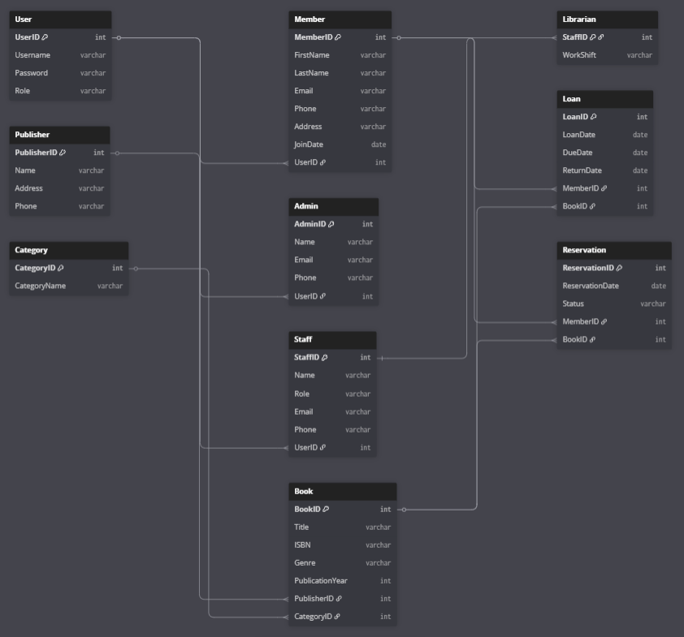
Figure 1 : EERD

4. Task 2 – Relational Data Structures and Normalisation
From the library management system Enhanced Entity Relationship Diagram (EERD), the conceptual entities are converted into relational tables. Each entity as a table, attributes as columns, and relationships with primary keys (PK) and foreign keys (FK) have been implemented. We used specialisation and generalisation to represent various user roles effectively and to eliminate repetition in the data.

Table Name: Users
Attribute | Description
User ID (PK) | Unique identifier for system users
Username | Login username
Password | Encrypted user password
Role | User role (Member, Admin, Staff)

Table Name: Member
Attribute | Description
Member ID (PK) | Unique member identifier
FirstName | Member first name
Last Name | Member last name
Email | Member email address
Phone | Contact number
Address | Residential address
Join Date | Membership start date
User ID (FK) | References User (User ID)

Table Name: Staff
Attribute | Description
Staff ID (PK) | Unique staff identifier
Name | Staff name
Role | Staff role
Email | Staff email
Phone | Staff contact number
User ID (FK) | References User (User ID)

Table Name: Liberian
Attribute | Description
Staff ID (PK/FK) | References Staff (Staff ID)
Work Shift | Assigned working shift

Table Name: Book
Attribute | Description
Book ID (PK) | Unique book identifier
Title | Book title
ISBN | International Standard Book Number
Genre | Book genre
Publication Year | Year of publication
Publisher ID (FK) | References Publisher (Publisher ID)
Category ID (FK) | References Category (Category ID)

Table Name: Publisher
Attribute | Description
Publisher ID (PK) | Unique publisher identifier
Name | Publisher name
Address | Publisher address
Phone | Contact number

Table Name: Category
Attribute | Description
Category ID (PK) | Unique category identifier
Category Name | Category name (e.g., Fiction, Science)

Table Name: Loan
Attribute | Description
Loan ID (PK) | Unique loan identifier
Loan Date | Date of issue
Due Date | Due return date
Return Date | Actual return date
Member ID (FK) | References Member (Member ID)
Book ID (FK) | References Book (Book ID)

Table Name: Reservation
Attribute | Description
Reservation ID (PK) | Unique reservation identifier
Reservation Date | Date of reservation
Status | Reservation status
Member ID (FK) | References Member (Member ID)
Book ID (FK) | References Book (Book ID)

First Normal Form (1NF)
The database was brought to 1NF by making sure all attributes had atomic values and removing the repeating groups. Initially, all library information was saved in one unnormalised table with all attributes such as users, members, admins, staff, librarians, books, publishers, categories, loans, and reservations. It had repeating groups, multiple roles in a single table, and redundancy, which might have caused data inconsistencies.

Second Normal Form (2NF)
To eliminate partial dependencies, the database was split into primary key based tables. Users' data was gathered on the User table. Information which pertains only to members was taken to the Member table. Admin and Staff were split as separate tables. Since Librarian is a kind of Staff, it was given its own table. Details about books were taken to the Book table while Publisher and Category became separate tables. Loan and Reservation tables were introduced to maintain the records of transactions. thus, Members and Books were linked.

Third Normal Form (3NF)
All tables were cleaned up to remove transitive dependencies. Now every attribute is only a direct fact of the primary key of its table. Specialisation was used to separate different user roles thus reducing redundancy. The last normal form tables are:
- User: Keeps all users of the system with attributes User ID, Username, Password, and Role. User ID is the primary key.
- Member: Holds the details of a member like Member ID, FirstName, Last Name, Email, Phone, Address, Join Date, and User ID as a foreign key Pulled from User (User ID). Member ID is the primary key.
- Admin: Has admin details such as Admin ID, Name, Email, Phone, and User ID as a foreign key Pulled from User (User ID). Admin ID is the primary key.
- Staff: Contains information of staff such as Staff ID, Name, Role, Email, Phone, and User ID as a foreign key Pulled from User (User ID). Staff ID is the primary key.
- Librarian: Holds details concerning the librarian, Staff ID being both the primary and foreign key referencing Staff (Staff ID), and the Work Shift attribute.
- Book: Keeps the details of a book such as Book ID, Title, ISBN, Genre, Publication Year, Publisher ID, and Category ID. Publisher ID and Category ID are foreign keys refereeing Publisher (Publisher ID) and Category (Category ID) respectively. Book ID is the primary key.
- Publisher: Keeps the publisher's data such as Publisher ID, Name, Address, and Phone. Publisher ID is the primary key.
- Category: Defines book categories with Category ID and Category Name. Category ID is the primary key.
- Loan: Keeps records of loan transactions with Loan ID, Loan Date, Due Date, Return Date, Member ID, and Book ID as attributes. Member ID and Book ID are foreign keys that refer to Member (Member ID) and Book (Book ID) respectively. Loan ID is the primary key.
- Reservation: Maintains the details of reservations with attributes Reservation ID, Reservation Date, Status, Member ID, and Book ID. Member ID and Book ID are foreign keys that refer to Member (Member ID) and Book (Book ID) respectively. Reservation ID is the primary key.
The database is now normalized to the third normal form, which means it is free from redundancy, maintains data integrity, and allows efficient querying and scalability. This design is capable of meeting all the operational requirements of the Library Management System while keeping referential integrity and data organization clarity.

Summary of Final Tables
Table | Attributes | PK | FK / Notes
User | User ID, Username, Password, Role | User ID | All system users
Member | Member ID, FirstName, Last Name, Email, Phone, Address, Join Date, User ID | Member ID | User ID → User (User ID)
Admin | Admin ID, Name, Email, Phone, User ID | Admin ID | User ID → User (User ID)
Staff | Staff ID, Name, Role, Email, Phone, User ID | Staff ID | User ID → User (User ID)
Librarian | Staff ID, Work Shift | Staff ID | Staff ID → Staff (Staff ID)
Book | Book ID, Title, ISBN, Genre, Publication Year, Publisher ID, Category ID | Book ID | Publisher ID → Publisher; Category ID → Category
Publisher | Publisher ID, Name, Address, Phone | Publisher ID | Book publishers
Category | Category ID, Category Name | Category ID | Book categories
Loan | Loan ID, Loan Date, Due Date, Return Date, Member ID, Book ID | Loan ID | Member ID → Member; Book ID → Book
Reservation | Reservation ID, Reservation Date, Status, Member ID, Book ID | Reservation ID | Member ID → Member; Book ID → Book

5. Task 3 – SQL DDL and DML Scripts
Step 1: Create Database
CREATE DATABASE LibraryDBs;
GO
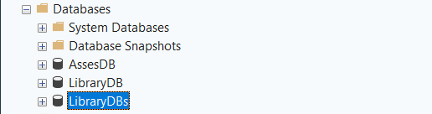
Figure 2 : Database created

USE LibraryDBs;
GO

Step 2: Create Tables
CREATE TABLE UserTable (
UserID INT IDENTITY(1,1) PRIMARY KEY,
Username VARCHAR(50) NOT NULL,
Password VARCHAR(50) NOT NULL,
Role VARCHAR(20) NOT NULL
);

CREATE TABLE Member (
MemberID INT IDENTITY(1,1) PRIMARY KEY,
FirstName VARCHAR(50) NOT NULL,
LastName VARCHAR(50) NOT NULL,
Email VARCHAR(100),
Phone VARCHAR(20),
Address VARCHAR(200),
JoinDate DATE,
UserID INT NOT NULL,
FOREIGN KEY (UserID) REFERENCES UserTable(UserID)
);

CREATE TABLE AdminTable (
AdminID INT IDENTITY(1,1) PRIMARY KEY,
Name VARCHAR(100) NOT NULL,
Email VARCHAR(100),
Phone VARCHAR(20),
UserID INT NOT NULL,
FOREIGN KEY (UserID) REFERENCES UserTable(UserID)
);

CREATE TABLE Staff (
StaffID INT IDENTITY(1,1) PRIMARY KEY,
Name VARCHAR(100) NOT NULL,
Role VARCHAR(50),
Email VARCHAR(100),
Phone VARCHAR(20),
UserID INT NOT NULL,
FOREIGN KEY (UserID) REFERENCES UserTable(UserID)
);

CREATE TABLE Librarian (
StaffID INT PRIMARY KEY,
WorkShift VARCHAR(50),
FOREIGN KEY (StaffID) REFERENCES Staff(StaffID)
);

CREATE TABLE Publisher (
PublisherID INT IDENTITY(1,1) PRIMARY KEY,
Name VARCHAR(100) NOT NULL,
Address VARCHAR(200),
Phone VARCHAR(20)
);

CREATE TABLE Category (
CategoryID INT IDENTITY(1,1) PRIMARY KEY,
CategoryName VARCHAR(50) NOT NULL
);

CREATE TABLE Book (
BookID INT IDENTITY(1,1) PRIMARY KEY,
Title VARCHAR(200) NOT NULL,
ISBN VARCHAR(20),
Genre VARCHAR(50),
PublicationYear INT,
PublisherID INT,
CategoryID INT,
FOREIGN KEY (PublisherID) REFERENCES Publisher(PublisherID),
FOREIGN KEY (CategoryID) REFERENCES Category(CategoryID)
);

CREATE TABLE Loan (
LoanID INT IDENTITY(1,1) PRIMARY KEY,
LoanDate DATE NOT NULL,
DueDate DATE NOT NULL,
ReturnDate DATE,
MemberID INT NOT NULL,
BookID INT NOT NULL,
FOREIGN KEY (MemberID) REFERENCES Member(MemberID),
FOREIGN KEY (BookID) REFERENCES Book(BookID)
);

CREATE TABLE Reservation (
ReservationID INT IDENTITY(1,1) PRIMARY KEY,
ReservationDate DATE NOT NULL,
Status VARCHAR(20) NOT NULL,
MemberID INT NOT NULL,
BookID INT NOT NULL,
FOREIGN KEY (MemberID) REFERENCES Member(MemberID),
FOREIGN KEY (BookID) REFERENCES Book(BookID)
);

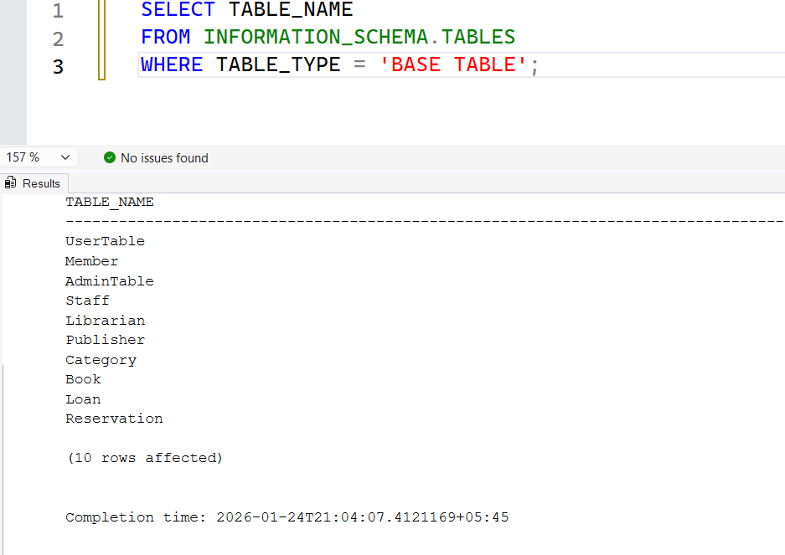
Figure 3 : Table Created

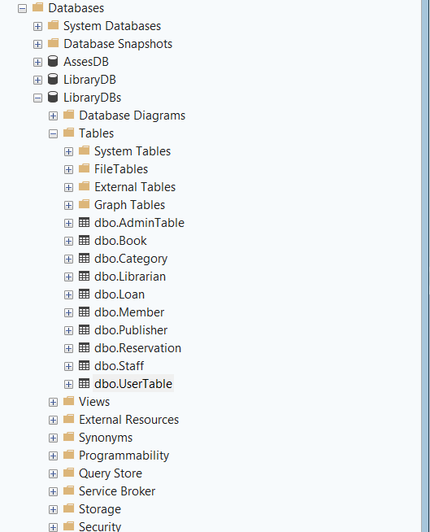
Figure 4 : Database table names
Step 3: Insert Data
INSERTINSERT INTO UserTable (Username, Password, Role) VALUES
('FahimS','pass123','Member'),
('MollickS','pass456','Member'),
('KushalT','admin123','Admin'),
('DenishB','lib123','Staff'),
('AliceM','pass789','Member'),
('BobC','pass321','Staff');
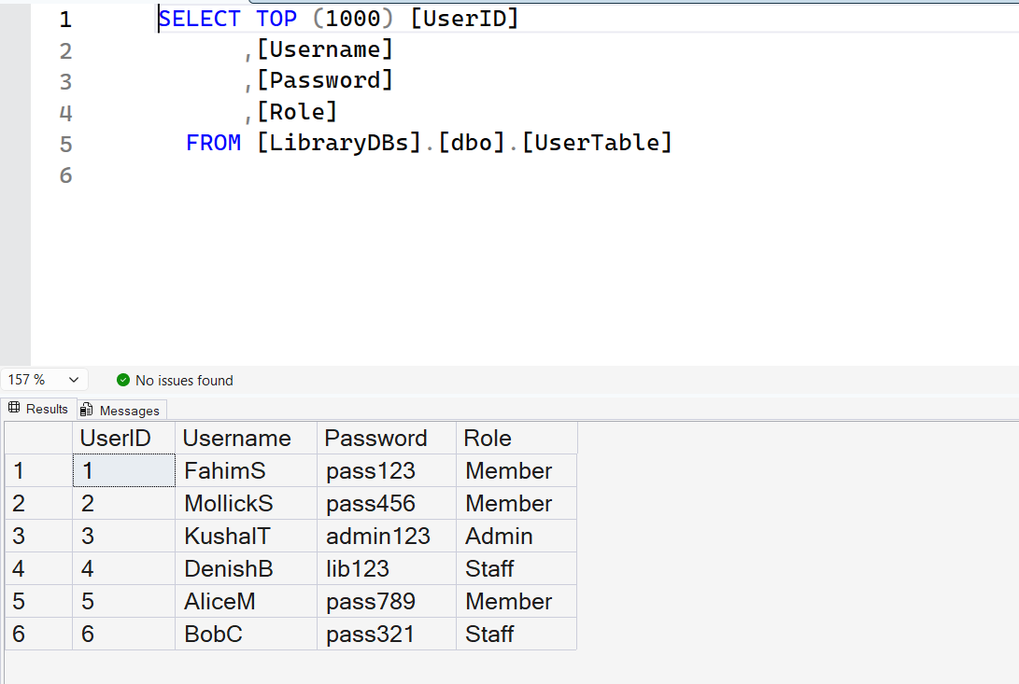
Figure 5 : user table data

INSERT INTO Member VALUES
('Fahim','Ahmed Sarker','20029294@students.koi.edu.au','0412345678','12 Main St','2026-01-01',1),
('Mollick','Ifaj SAJID','20034382@students.koi.edu.au','0412345679','34 Oak St','2026-01-03',2),
('Alice','Miller','alice@example.com','0412345680','56 Pine St','2026-01-05',5),
('John','Smith','john@example.com','0412345684','78 King St','2026-01-06',1),
('Emma','Brown','emma@example.com','0412345685','90 Queen St','2026-01-07',2);

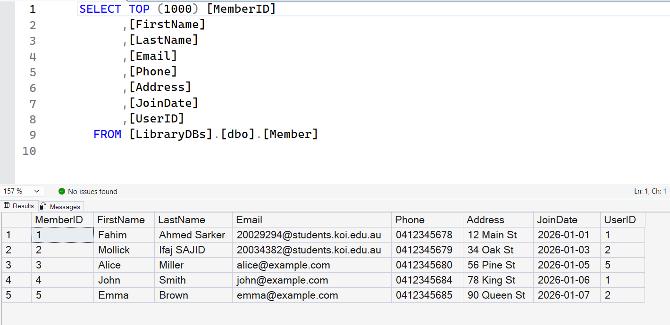
Figure 6 : Member table data

INSERT INTO AdminTable VALUES
('KUSHAL THAPALIYA','20030717@students.koi.edu.au','0412345681',3),
('Admin Two','admin2@example.com','0412345686',3),
('Admin Three','admin3@example.com','0412345687',3),
('Admin Four','admin4@example.com','0412345688',3),
('Admin Five','admin5@example.com','0412345689',3);

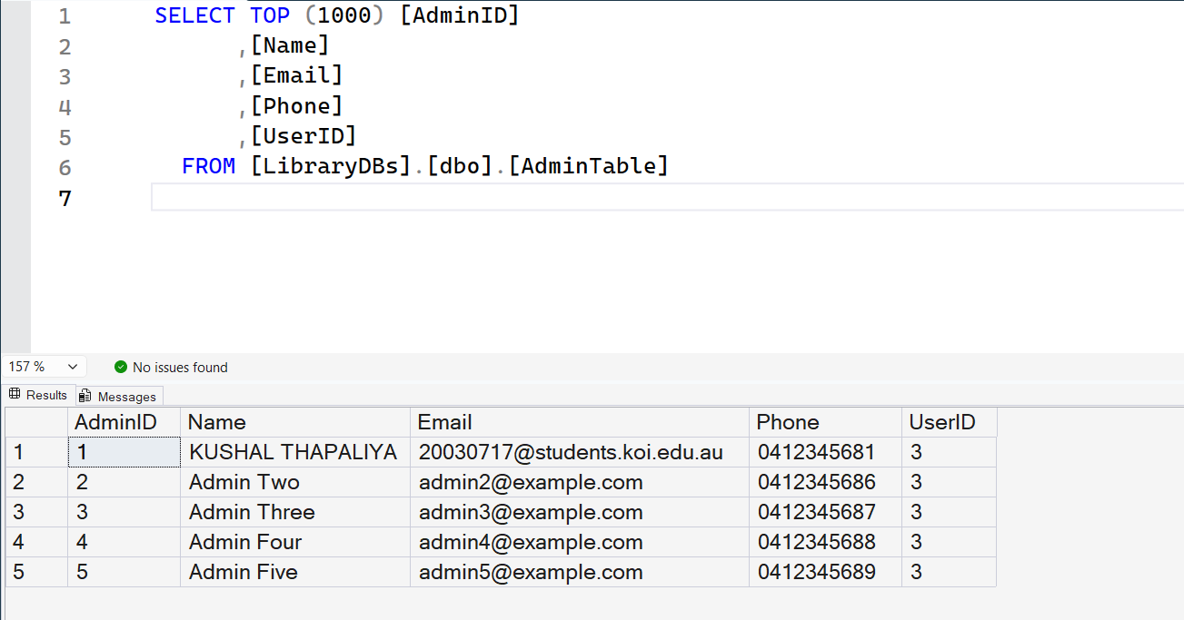
Figure 7 : AdminTable values

INSERT INTO Staff VALUES
('Denish Jung BOGATI','Librarian','20030161@students.koi.edu.au','0412345682',4),
('Bob Carter','Staff','bob@example.com','0412345683',6),
('Sarah Lee','Assistant','sarah@example.com','0412345690',6),
('Michael Wong','Technician','michael@example.com','0412345691',6),
('David Clark','Support','david@example.com','0412345692',6);

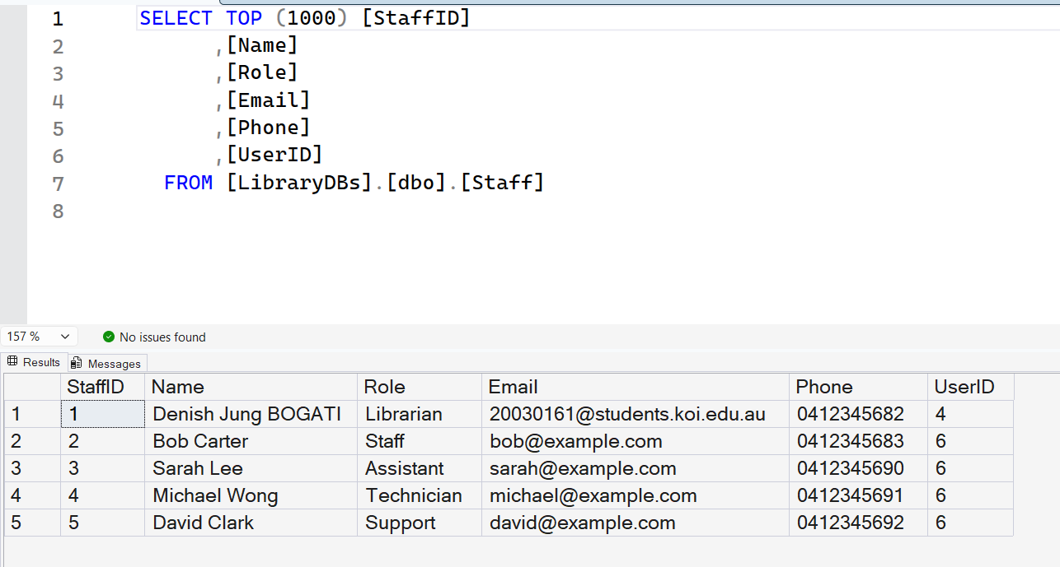
Figure 8 : Staff table values

INSERT INTO Librarian VALUES
(1,'Morning'), (2,'Evening'), (3,'Night'), (4,'Morning'), (5,'Evening');

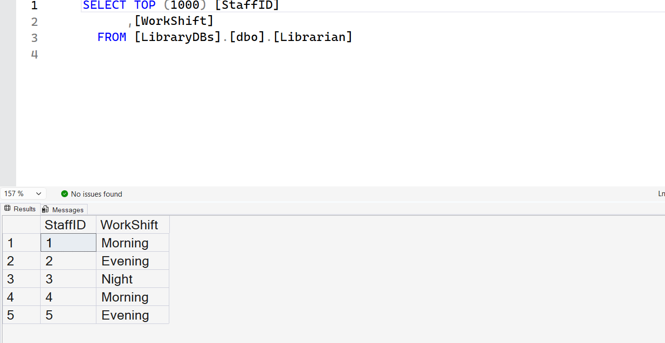
Figure 9 : Librarian values

INSERT INTO Publisher VALUES
('Penguin Books','1 Book St','0412345600'),
('HarperCollins','2 Story Rd','0412345601'),
('Oxford Press','3 Knowledge Ave','0412345693'),
('Cambridge Press','4 Academic Rd','0412345694'),
('Pearson','5 Education St','0412345695');

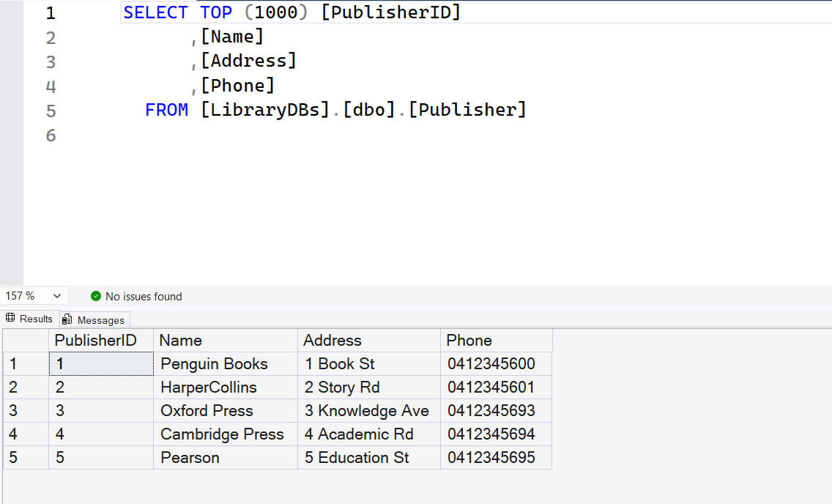
Figure 10 : Publisher values

INSERT INTO Category VALUES
('Fiction'), ('Science'), ('History'), ('Technology'), ('Literature');

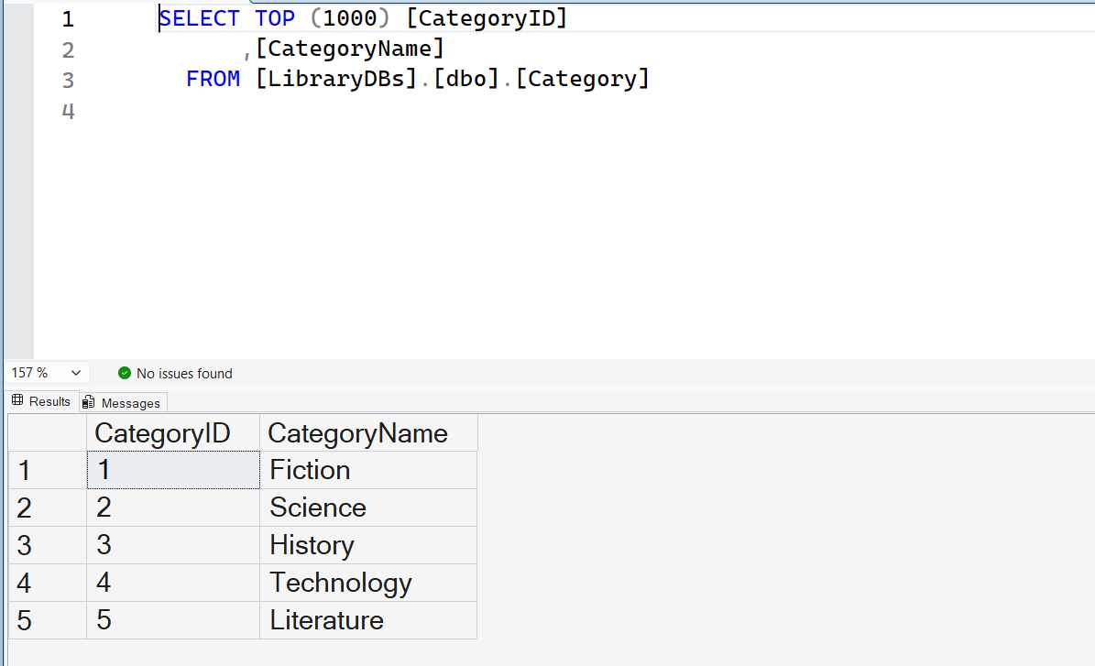
Figure 11 : Category values

INSERT INTO Book VALUES
('The Great Gatsby','978-1234567890','Fiction',1925,1,1),
('Brief History of Time','978-0987654321','Science',1988,2,2),
('World War II','978-1122334455','History',2000,1,3),
('Database Systems','978-6677889900','Technology',2015,3,4),
('English Literature','978-5566778899','Literature',2010,4,5);

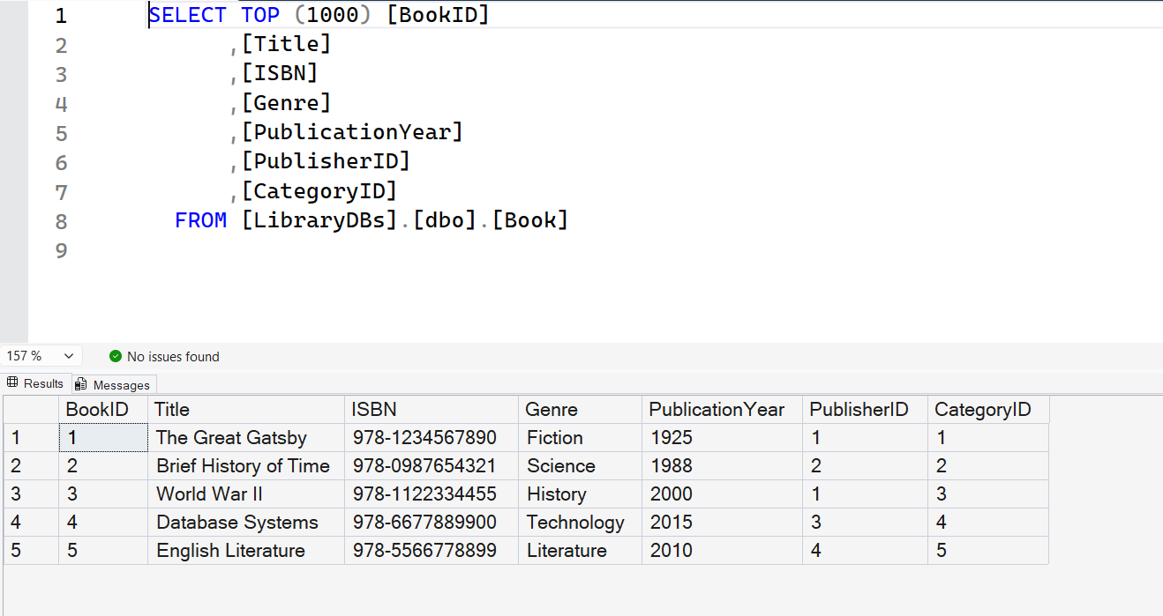
Figure 12 : Book table values

INSERT INTO Loan VALUES
('2026-01-01','2026-01-07',NULL,1,1),
('2026-01-02','2026-01-08',NULL,2,2),
('2026-01-03','2026-01-09',NULL,3,3),
('2026-01-04','2026-01-10',NULL,4,4),
('2026-01-05','2026-01-11',NULL,5,5);

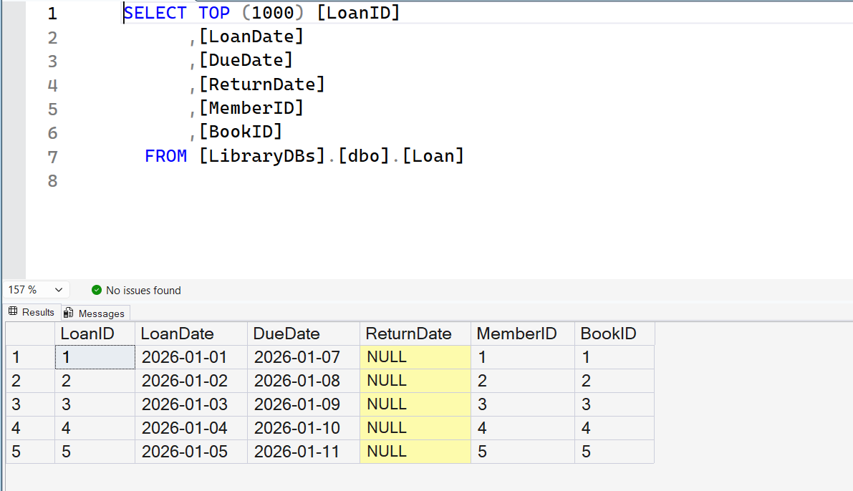
Figure 13 : Loan table values

INSERT INTO Reservation VALUES
('2026-01-01','Pending',1,3),
('2026-01-03','Confirmed',2,1),
('2026-01-04','Pending',3,2),
('2026-01-05','Confirmed',4,4),
('2026-01-06','Pending',5,5);

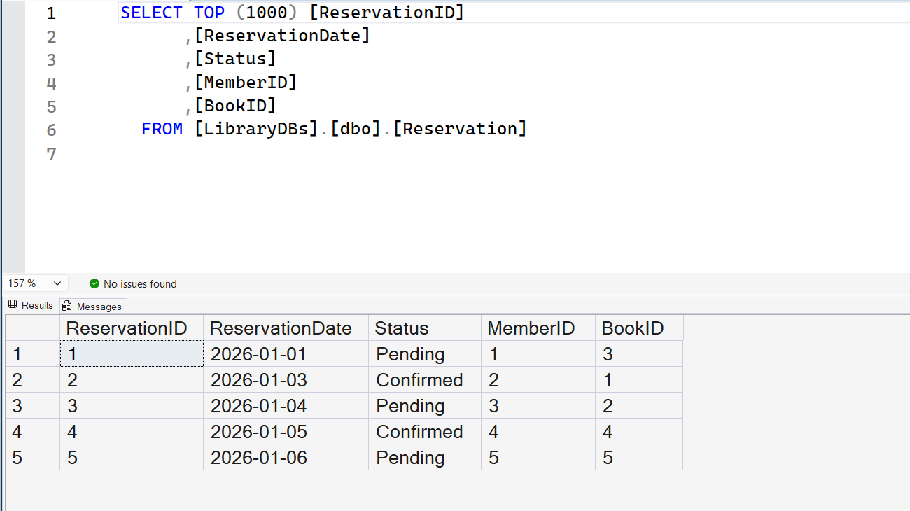
Figure 14 : Reservation table values

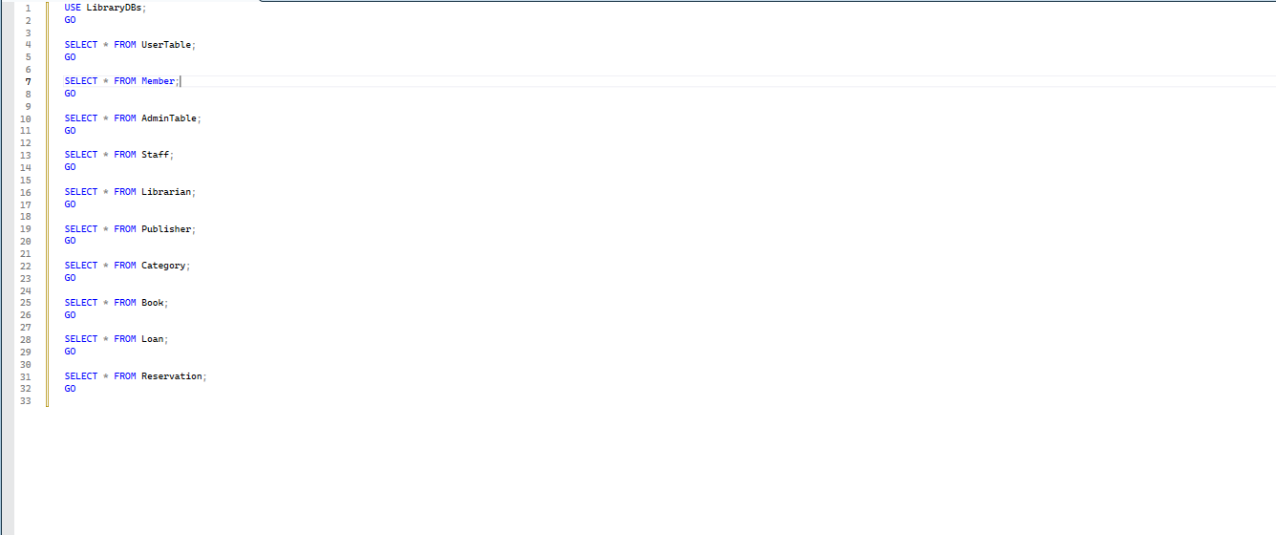
Figure 15 : Selecting all the value from all tables

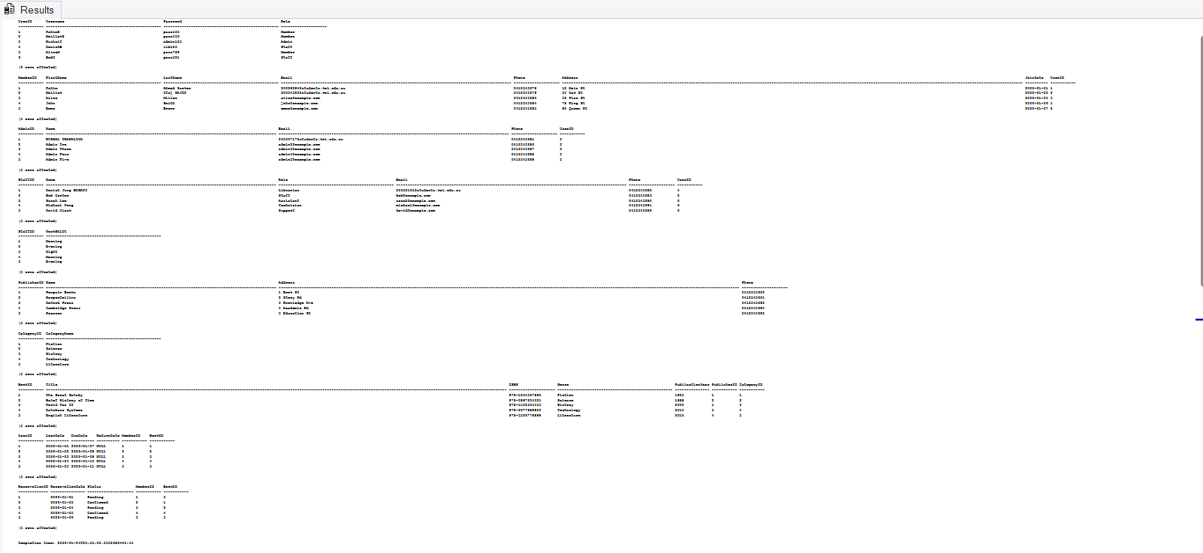
Figure 16 : Output of fig 15

6. Task 4 – Sample SQL Queries

Query 1: JOIN (Multiple Tables)
Purpose: Display which member has borrowed which book
Concepts used: JOIN
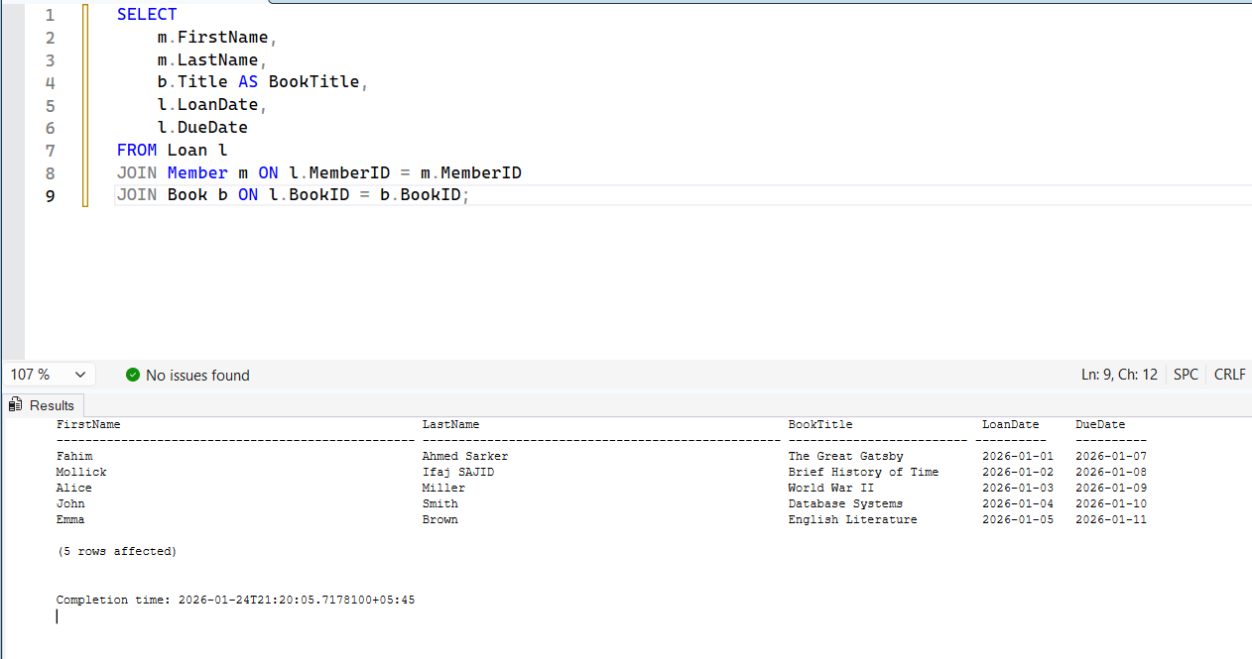
Figure 17 : Example of JOIN

Query 2: LIKE
Purpose: Find books with the word History in the title
Concepts used: LIKE
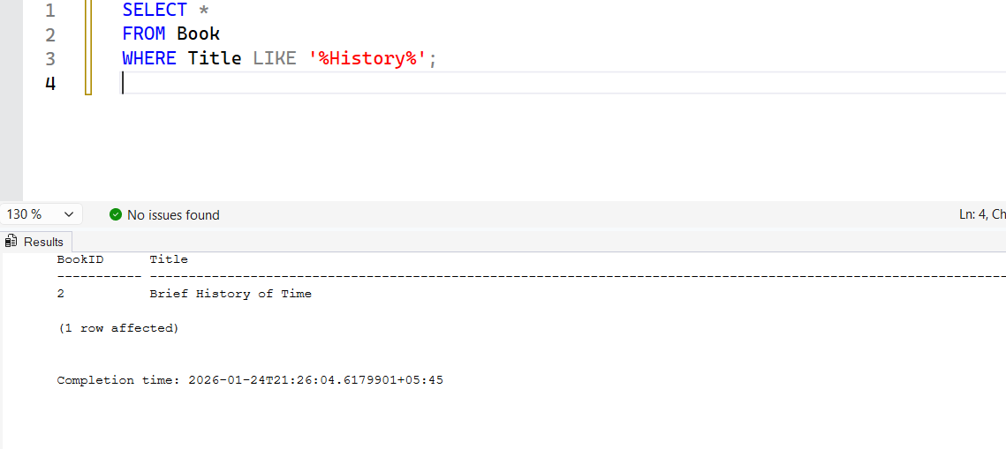
Figure 18 : Example of LIKE

Query 3: ORDER BY
Purpose: List all members ordered by join date
Concepts used: ORDER BY
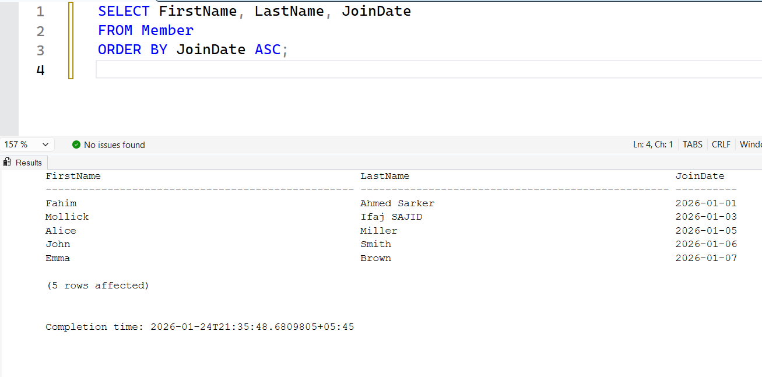
Figure 19 : Example of ORDER BY

Query 4: Aggregate Function
Purpose: Count how many books are available in each category
Concepts used: COUNT, GROUP BY
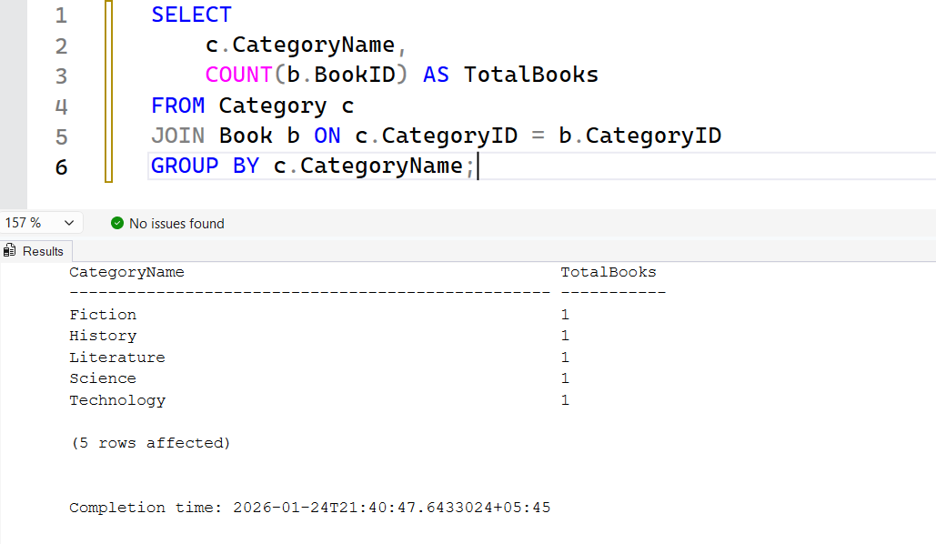
Figure 20 : Example of COUNT and Group BY

Query 5: UPDATE
Purpose: Update reservation status
Concepts used: UPDATE
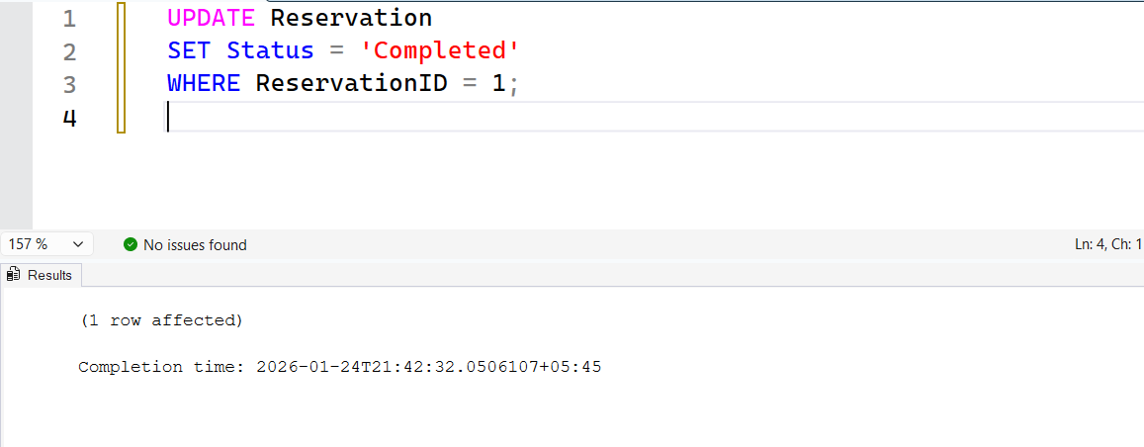
Figure 21 : Example of UPDATE
Check after update:
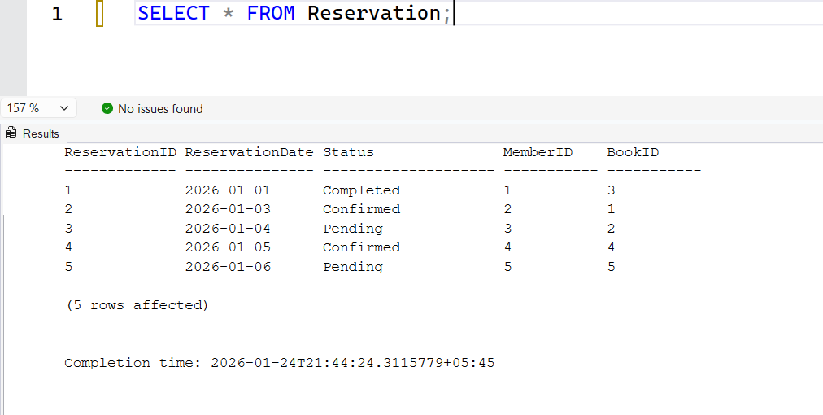
Figure 22 : Values after UPDATE

7. Task 5 – NoSQL Queries (MongoDB)

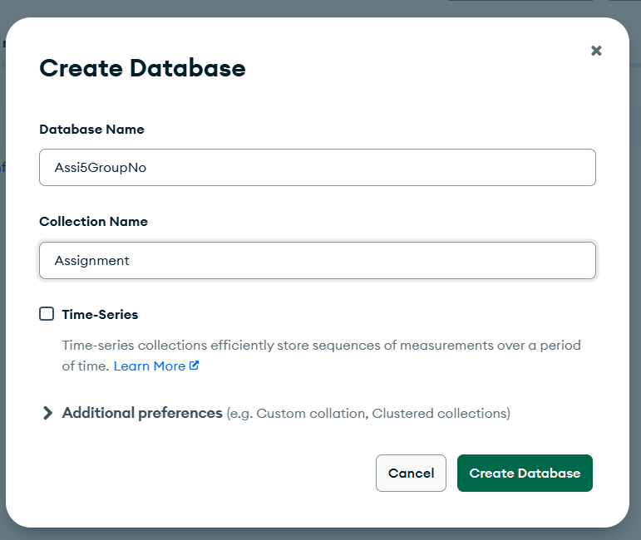
Figure 23 : Created DataBase
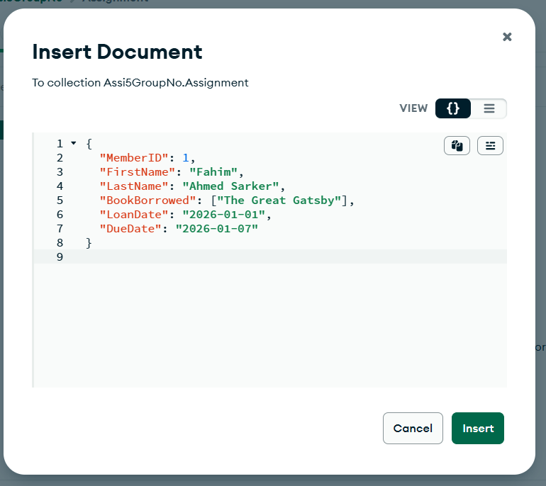
Figure 24 : Insert Values in Assignment
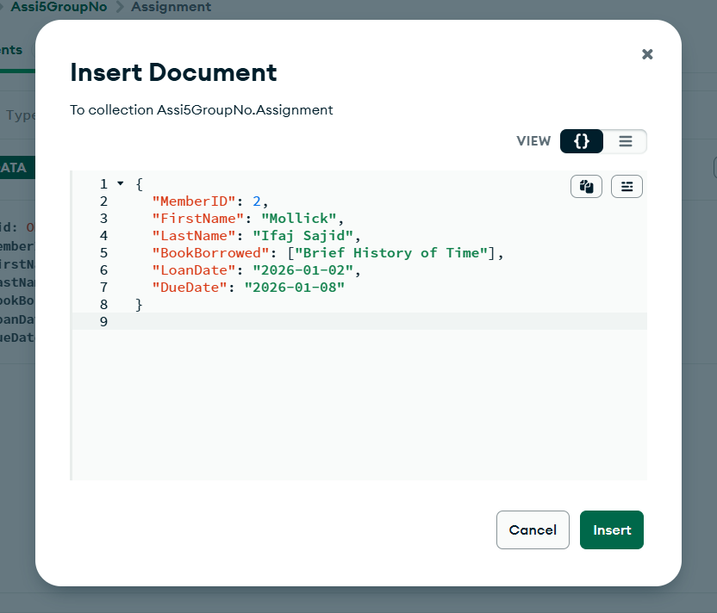
Figure 25 : Insert Values in Assignment
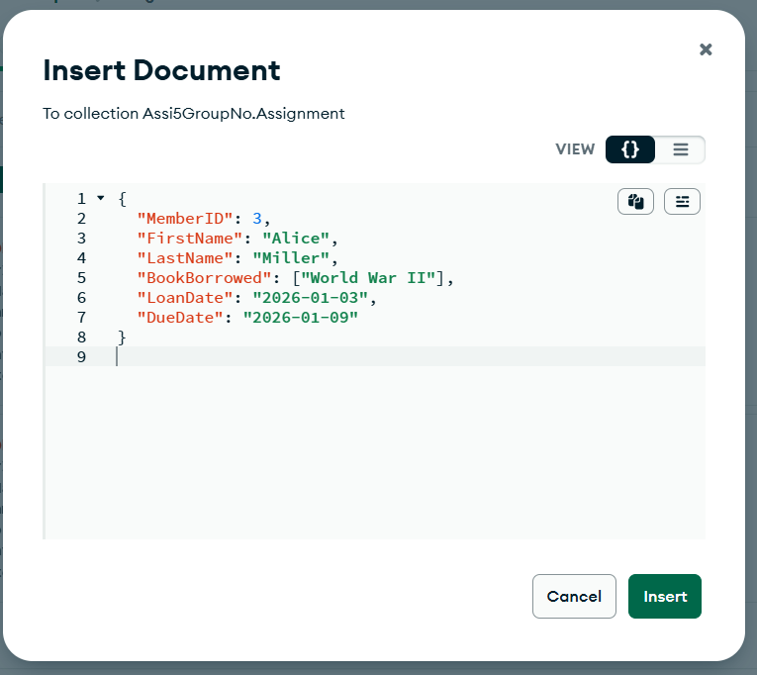
Figure 26 : Insert Values in Assignment
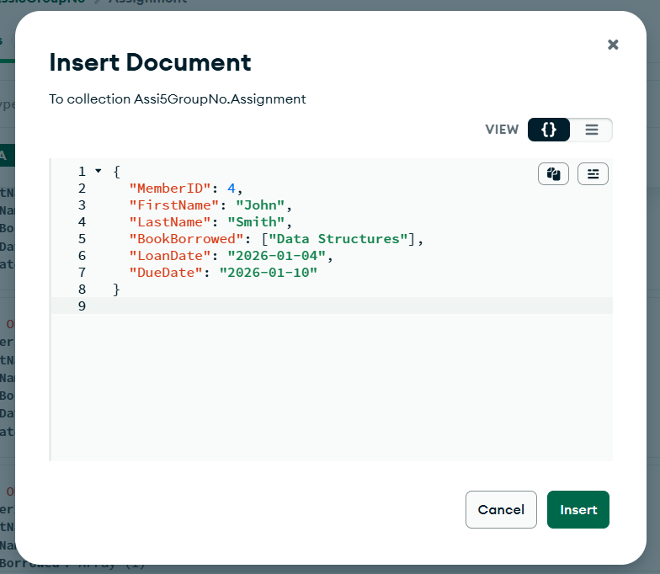
Figure 27 : Insert Values in Assignment

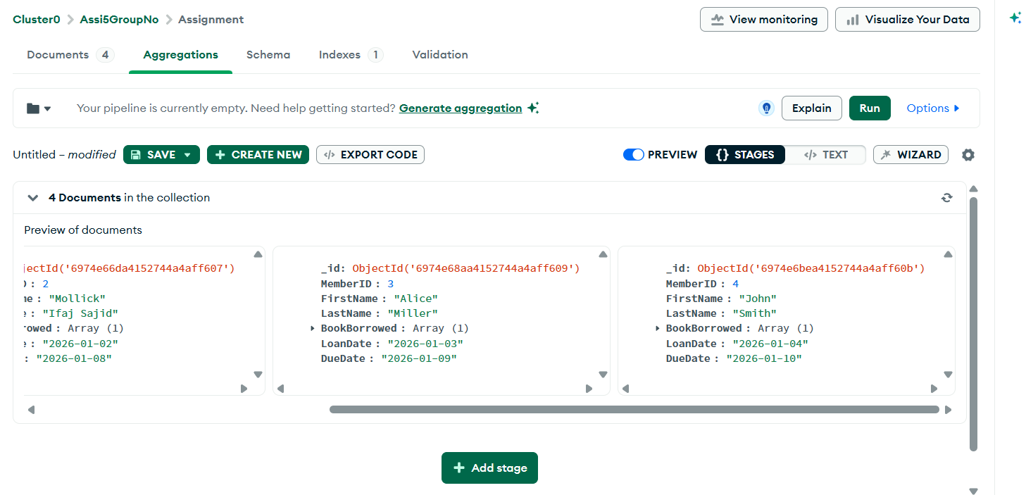
Figure 28 : Aggregation

8. Task 6 – Concurrency Control and Transaction Processing
It is very important for a library management system to maintain the integrity of data and provide uninterrupted service, especially in cases of simultaneous interaction by multiple users with the database. In fact, concurrency control methods are vital in avoiding conflicts of record access and updates happening together between staff or members. A good example will be two casual staff members changing the status of a book for sale; clean transaction management can do just this, the situation where one update stands before the next, thus no improper data. Besides, to keep things consistent and reliable, what is more, will transaction processing, which groups several interdependent operations into one atomic unit, normally changing equally the member's borrowing history and the book's availability when a book is issued. One rollback could be a news within the piece if any of the operations of a book issuance fail. Basically, control mechanisms of access are also a big help to database security because they segregate roles and authorize rights that only the right people can make changes like in sensitive member information or fines. The intrigue of backup and recovery along with the single step is that both scenarios will be in favour of the library by way of quick resumption of activities without a hint of data integrity being compromised. Still, a multi, user environment needs to have efficient query support for fast information retrieval which is characterized by timely indexing and proper relational structuring. Hence, all these features of a database co, operatively provide for a robust, secure, and efficient system that supports reliable day-to-day library operations.

9. Conclusion
Working on the database of the Library Management System gave me an in, depth understanding of database design principles as well as hands, on skills. Making the Enhanced Entity, Relationship Diagram (EERD) helped the team define the main entities, relationships, and attributes that would make the system for the library quite efficient. Converting the conceptual model into normalized relational data structures helped to lower redundancy, keep data integrity, and make data retrieving and updating easier. Implementation with SQL Server made it possible to write robust DDL and DML scripts, whereas MongoDB showcased the use of NoSQL tech in dealing with flexible data structures. The project also managed to touch on transaction processing, concurrency control, access control, and other important aspects of database management, which altogether led to secure, dependable, and scalable multi, user operations. Besides fulfilling the functional aspects required of a Library Management System like maintaining records of books, members, staff, and borrowing transactions, the project has also focused on data privacy, security, and system performance issues. Problem, solving skills were greatly improved by working together as a group and one got a glimpse of the practical challenges of the database development field. To sum up, this work is a great example of how planning, designing, and creating a database system carefully help one develop a useful and efficient tool. The Library Management System that has evolved out of this work acts as a dependable platform for the library team and clearly shows the use of database principles in meeting the needs of the organization.

10. References
- Microsoft. (n.d.). SQL Server documentation. Microsoft Learn.
- MongoDB. (n.d.). MongoDB Manual. MongoDB Documentation.
- Studio 3T. (n.d.). Studio 3T documentation. Studio 3T Knowledge Base.
- Elmasri, R., & Navathe, S. B. (2016). Fundamentals of Database Systems (7th ed.). Pearson.
- Date, C. J. (2003). An Introduction to Database Systems (8th ed.). Addison-Wesley.

