CareLink Healthcare Management System
(HMS) Implementation Project
A PMBOK-Based Project Plan for CareLink Health Services Pty Ltd

PROJECT DETAILS
Name | Rojan Chandra Poudel

Table of Contents
1. Introduction 4
2. Project Charter 4
2.1 Project Purpose and Justification: 4
2.2 Goal and Objectives: 5
2.3 Business Benefits: 5
2.4 Project Scope Overview: 5
2.5 Key Deliverables: 5
2.6 Assumptions: 6
2.7 Constraints: 6
2.8 High-Level Risks: 6
2.9 Key Stakeholders: 6
2.10 Milestone Schedule: 7
2.11 Project Manager Authority: 7
2.12 Authorization: 7
3. Scope Statement 8
3.1 Project Summary and Justification: 8
3.2 Product Characteristics and Requirements: 8
3.3 Summary of Project Deliverables: 8
3.4 Inclusions and Exclusions: 9
3.5 Assumptions and Constraints 9
3.6 Project Boundaries 9
3.7 Acceptance Criteria and Project Success Criteria 9
4. Stakeholder Register & Engagement Strategy 10
4.1 Stakeholder Register: 10
4.2 Engagement Strategy Summary: 12
5. Risk Register & Treatment Plan 12
6. Work Breakdown Structure 13
7. Project Schedule (Gantt chart) 15
8. Project Budget 16
9. Weekly Status Reports & Group Contribution Log 20
Status Report 1 - Week 3 20
Status Report 2 - Week 5 21
Status Report 3 - Week 7 22
Group Contribution Log 22
10. Conclusion 23
References 23

Figure 1: HMS Implementation Project 16
Figure 2 : HMS implementation project - Budget 18
Figure 3 : Budget summary by category 19
Figure 4 : Budget share by category 19
Figure 5 : Budget by category(AUD) 20

1. Introduction
CareLink Health Services Pty Ltd provides health care services to clients in the states of New South Wales and Victoria. As a result of rapid growth, the company has become heavily dependent on various isolated systems for managing client records, staffing, billing, and compliance reports, leading to data duplication, inefficiencies and reporting errors. The current paper offers an HMS implementation project plan developed according to the PMBOK principles, within a fixed budget of AUD 1,800,000 and 10 months project duration. The predictive (waterfall) PMBOK approach was chosen instead of an adaptive approach because the project has fixed scope, budget and time constraints as well as compliance requirement, which favors the predictability of the up-front planning of the predictive process groups. “Predictive approaches are generally favored for projects with well-defined scope, fixed budgets and firm deadlines, whereas adaptive approaches suit projects where requirements are expected to evolve (Schwalbe 2018).”
This report is intended to demonstrate how the various PMBOK planning documents interrelate with each other. It starts off with the Project Charter (which outlines goals and objectives), followed by a Scope Statement that clearly defines what is included and excluded from the project. Next, we identify those who are most affected by the project known as stakeholders. Their interests, motivations and degree of influence over us will also need consideration at this stage. After this, the Risk Register highlights some of the key issues that might affect the success of the project, helping to justify the time buffers and budget contingency included later in the plan. The Work Breakdown Structure (WBS) breaks the project into smaller, manageable work packages when providing foundation for developing the project schedule and budget.

2. Project Charter
“A project charter formally authorizes the project and give the project manager authority to apply organization resources to project activities (PMI 2013)”. This project was approved by Senior Management to replace CareLink’s disparate client records, rostering, billing and compliance-reporting systems with a single integrated HMS, resulting in improved efficiency, data accuracy and regulatory compliance.

2.1 Project Purpose and Justification:
CareLink Health Services, a leading provider of Home Care services, needed an integrated Healthcare Management System that eliminates disconnected systems and minimises duplication and delays while enhancing data accuracy & operational efficiency and ensuring compliance with healthcare data privacy standards.

2.2 Goal and Objectives:
An integrated HMS, comprised of core functions and training processes approved in the previous release including an enhanced approach to improving efficiency and compliance with Australian healthcare privacy requirements, will be implemented within 10 months at a cost of AUD 1.8 million.

2.3 Business Benefits:
These enable such wins as eliminating data re-entry, reducing reporting errors, enhancing operational efficiency, establishing a single source of truth for product records across all functions within the organization including R&D and Clinical, improving service deliverables, audit-readiness and enhanced regulatory compliance.

2.4 Project Scope Overview:
This project encompasses
- HMS software
- Configuration
- Data migration
- Training
- Documentation
- Testing
- Deployment.
Out of scope for the project
- Mobile application development
- Hardware upgrades.

2.5 Key Deliverables:
Key deliverables include:
- Project Charter
- Stakeholder Register
- Scope Statement and WBS
- Project Schedule
- Risk Register and Treatment Plan
- Project Budget
- Weekly Status Reports
Such deliverables include project objectives, stakeholders, scope of the project, timelines for each phase, risks and issues to monitor along with their costs as well as progress demonstrating governance, monitoring of progress accountability and successful delivery.

2.6 Assumptions:
The project Assumes sufficient infrastructure, staff resources, vendor capacity and capabilities, legacy data quality & completeness, timeliness in the management decision to move forward with implementing the HMS migration training and go-live within ten months from agreeing to proceed.

2.7 Constraints:
The project has a budget of AUD 1,800,000 and duration of ten (10) months. Data privacy compliance is mandatory throughout implementation process however significant hardware upgrades are out of scope so the HMS must run on available infrastructure and technical capabilities.

2.8 High-Level Risks:
Potential hazards involve data transfer mistakes, employee opposition, vendor stagnation, privacy violations and surpassing budget. These risks could have a great impact on project timelines, pricing, adoption, data integrity and compliance.

2.9 Key Stakeholders:
Key stakeholders include the
- CEO
- Steering Committee
- IT team
- clinical and administrative staff
- Compliance Officer
- HMS vendor support
- Clients.

2.10 Milestone Schedule:
Month 1: Chartering Phase: Getting Charters Approved, Launching the Project and Planning the Deliverables. By Month 2, the HMS Vendor will be selected and contracted. Configuration to close-out by Month-4 and data migration in Month-5 Training for staff will end in Month 7, UAT in Month 8, and the system will go live during Month 9. In Month 10 we will conduct a post-implementation review and close the project.

2.11 Project Manager Authority:
The Project Manager has full authority to plan, initiate, manage, oversee and conclude the Project in its defined scope of work, budget and schedule, and to escalate any deviations exceeding agreed thresholds to the Project Sponsor and Steering Committee for further action and decision making.

2.12 Authorization:
By signing below, the undersigned approve this Project Charter and authorize the Project Manager to proceed with project planning and execution.
Role | Name | Signature | Date
Project Sponsor
Project Manager
Client / Steering Committee Representative

3. Scope Statement
The scope statement provides a detailed description of the project’s deliverables and the work required to create them, establishing a common understanding of scope among stakeholders (PMI 2013).

3.1 Project Summary and Justification:
The CareLink system currently has disconnected client records, staff roster, and billing and compliance reporting systems. The project will implement an integrated HMS replacing these current disparate systems. It will aim to minimize errors, delays and administrative burden and duplication, while enhancing compliance for health data privacy in both NSW and Victoria. It is a fixed budget $1,800,000 10-month project.

3.2 Product Characteristics and Requirements:
The HMS will provide:
- A combined client management, rostering, and billing.
- Role-base access control restricting data access by staff role and location (NSW/VIC).
- Automated compliance and audit reporting.
- Secure migration of current client, scheduling, and billing data.
- Systems training and user guides.
- Robust system reliability within set maintenance timeframes.

3.3 Summary of Project Deliverables:
Below are the project management-focused and product-focused deliverables:
- Business Case & Project Charter
- Scope Statement & WBS
- Stakeholder Register & Engagement Strategy
- Risk Register & Treatment plan
- Project Schedule (Gantt chart)
- Project Budget & Cost baseline
- Configured and tested HMS platform
- Migrated client, rostering and billing data
- User training materials and training sessions
- System test plan and UAT sign-off
- Deployed and live HMS with ongoing support handshake
- Final Project Report and Lesson-learned report

3.4 Inclusions and Exclusions:
In Scope:
- HMS software and licenses
- System configuration
- Data migration
- User training and documentation
- System testing and deployment
Out of Scope:
- Mobile application development
- Hardware upgrades

3.5 Assumptions and Constraints
Assumptions:
- Existing hardware and network infrastructure is sufficient for the new HMS.
- Staff will be available for workshops, testing and training within schedule.
Constraints:
- Fixed budget AUD 1,800,000 and duration 10 months.
- Compliance with healthcare data privacy requirements.

3.6 Project Boundaries
The authority of the project includes the following: Design, Configuration, Migration, Testing, Training, and Deployment of the HMS software. The project does not include any purchase or upgrade of hardware, network infrastructure and nor any development of mobile application; any such need appear during the project will be handled as a change request or referred to a future project.

3.7 Acceptance Criteria and Project Success Criteria
HMS will be accepted if (1) all in-scope functional areas (i.e. Client Management, Rostering, and Billing) are accepted via UAT, (2) all legacy data has been successfully migrated and proven to be accurate, (3) training of all staff has been completed, and (4) the HMS has been confirmed compliant with relevant data protection privacy requirements. The Project will be declared a success when these conditions have been met, the HMS is within the allocated AUD 1,800,000 budget and 10-month program and sign-off on the final deliverables has been received from the Project Sponsor.

4. Stakeholder Register & Engagement Strategy
Six groups of stakeholders fall into governance, delivery and end user categories. The Sponsor and Compliance officer receive close engagement since they are highly influential and interested. The IT and Vendor groups are the subject of joined management. And the end-user group are to be supported for change management. Clients get separated and customized communication. Resources are utilized around the efforts which impact budget, schedule and the project goals and the compliance.

4.1 Stakeholder Register:

Stakeholder | Int/Ext | Interest | Influence | Key Expectations | Communication Needs
CEO / Project Sponsor | Internal | High | High | Delivered on time/budget, demonstrable process improvements. | Group briefings, exceptional reporting of budget/schedule risk
Compliance / Privacy Officer | Internal | High | High | No data leakage, verifiable auditable records of compliance | Sign off of design and testing, privacy impact assessment before going live
IT Department / System Admin | Internal | High | Medium | Clear technical specs can support adequately after going live. | Weekly technical sessions; early access to vendor documentation
Clinical & Admin Staff | Internal | Medium | Medium | Usability, minimal disruption, proper training | User-friendly training, FAQs and help-desk, pre-go-live presentations
HMS Vendor | External | High | Medium | Defined objectives, realistic time schedule, in time payment and decision | Regular vendor status meetings, a single point of contact (PM)

4.2 Engagement Strategy Summary:
High-Interest/High-Influence stakeholders receive engaged via Steering Meetings and early risk visibility. IT and Vendor collaborate via sessions. End users engaged via training, demonstrations and communications to support adoption. Clients get basic information when impact service interruption occurs, also ensuring efficient communication while protecting schedule, budget, compliance and product delivery.

5. Risk Register & Treatment Plan
Six significant risks that span all major risk areas including technical, people, schedule, compliance, cost and quality, reflecting the project core constraints of fixed budget and fixed time duration which is 10 - month, and mandatory healthcare data privacy compliance. Two major high risks - Data migration errors (high), vendor delivery delay (high) have high ratings due to possible direct impact on schedule and data integrity respectively. Though there’s lower probability, the risk of privacy breaches has a high impact and thus high-risk rating. Risks will be actively mitigated to align with this project’s low level of tolerance for client data and regulatory compliance related risks. Risk ratings and treatment actions will be reviewed at each Project Status Meeting and updated accordingly based on emerging risks.

No. | Risk | Category | Root Cause | Response Strategy | Owner | Prob. | Impact | Rating
R1 | Data migration errors | Technical | Bad data Quality/ standardization in legacy system | Conduct trial migrations, have a data cleansing phase, check against source data prior to cut over | IT Lead | Medium | High | High
R2 | Staff resistance to new system | People | Change fatigue, not enough staff involvement at the initial stage. | involve staff in design phase, clearly communicate benefits, hands-on, training and post go-live support | Project Manager | Medium | Medium | Medium
R3 | Vendor delivery delay | Schedule | Vendor resourcing limitations, effort underestimated | Contract milestones/penalties, weekly monitoring, critical path scheduling. | Project Manager | Medium | High | High
R4 | Healthcare data privacy breach | Compliance | Privacy controls are not put in place properly during migration stage. | Privacy Impact Assessment, restricted test access, review sign-off from Compliance Officer. | Compliance Officer | Low | High | High
R5 | Budget overrun on customization | Cost | Underestimated configuration scope at budgeting stage | Review requirements prior to contract, include 10% contingency fund, ensure formal change control. | Project Manager | Medium | Medium | Medium
R6 | Insufficient user acceptance testing coverage | Quality | Schedule compression late in the project | Priorities test cases by risk and importance, extend testing resources during the UAT phase, establish clear minimum exit criteria for go-live | QA/ IT Lead | Medium | Medium | Medium

6. Work Breakdown Structure
The format of the WBS is to be deliverable based, coinciding with the Scope Statement of the project while assuring clear responsibilities and cost estimations. The WBS has six main deliverable streams with 19 work packages belonging to Level 2 that are ready for assignment, estimation, and scheduling.
WBS ID | Work Package / Component
1.0 | CareLink HMS Implementation Project
1.1 | Project Management
1.1.1 | Initiation (business case, charter, kick-off)
1.1.2 | Planning (scope, WBS, schedule, risk, budget)
1.1.3 | Monitoring & controlling (status reports, change control)
1.1.4 | Project closure (final report, lessons learned)
1.2 | Vendor & Procurement
1.2.1 | Requirements definition
1.2.2 | Vendor selection & contract signing
1.3 | System Configuration
1.3.1 | Client management module configuration
1.3.2 | Staff rostering module configuration
1.3.3 | Billing module configuration, security & access control setup
1.4 | Data Migration
1.4.1 | Data cleansing & mapping
1.4.2 | Migration development & trial run
1.4.3 | Final data migration & validation
1.5 | Training & Documentation
1.5.1 | Training materials development
1.5.2 | Staff training delivery
1.5.3 | User documentation
1.6 | Testing & Deployment
1.6.1 | System integration testing (SIT)
1.6.2 | User acceptance testing (UAT)
1.6.3 | Go-live / deployment
1.6.4 | Post-implementation support handover

7. Project Schedule (Gantt chart)
The project schedule will show how each of the 19 WBS work packages fit into this baseline period of 10 months. Seven key milestone are used to mark the completion of the main stages of the project: Charter & Planning Approval (MS1), Vendor Contract Signature (MS2), System Configuration Complete (MS3), Data Migration Complete (MS4), Training Complete (MS5), UAT Signoff (MS6), and Project Closure (MS7). These milestones help establish some key points to review progress made and ensure sufficient resources have been committed to deliver what’s required prior to commencing subsequent, time-sensitive activities.
The critical path leading from initiation right through to closure. This includes Initiation (1.1.1), Planning (1.1.2), Requirements Definition (1.2.1), Vendor Selection & Contract Signing (1.2.2), Billing Configuration & Security and Access (1.3.3), it then move through either Training Materials Development (1.5.1) or System Integration Test (1.6.1), then continues through UAT Signoff (1.6.2), Deployment/Go-live (1.6.3), Post Implementation Support Handover (1.6.4), finally Project Closure (1.1.4). Any delay would cause the overall timeline to extend beyond the allocated period of ten months.
Other work streams may proceed in parallel and don’t contribute to this critical path. For instance, the Client Management and Staff Rostering modules configuration (1.3.1 & 1.3.2) may run concurrent with Billing Configuration (1.3.3) during Months 4-6. Likewise, data cleansing, migration development and final data migration (1.4.1-1.4.3) can happen concurrently over Months 3-7, supplying the necessary test data without directly extending the critical chain.
Monitoring and controlling (1.1.3) continues from month 1-9. This process will continue to be implemented during this period as one of the ongoing management activities rather than as a discrete deliverable. This allows the team to keep track of risks, stakeholder concerns, progress, and emerging issues and take corrective action when needed to keep the implementation on schedule.
.
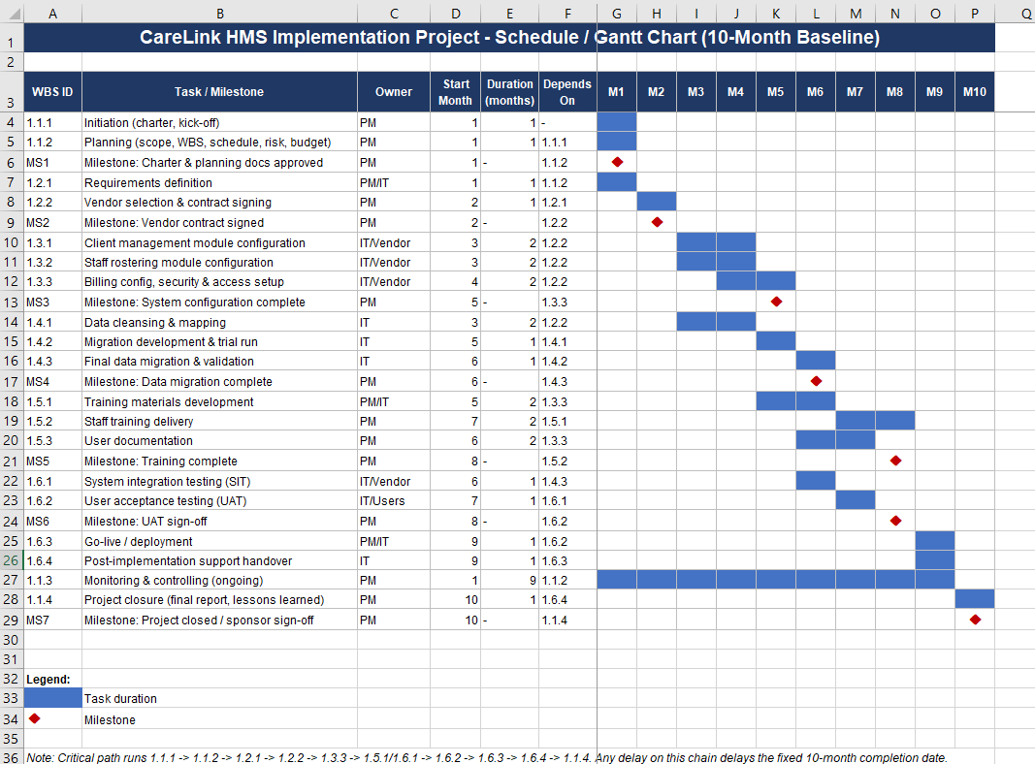
Figure 1: HMS Implementation Project

8. Project Budget
The total project cost is AUD 1,786,840, well under the maximum available project budget of AUD 1,800,000, giving us approx. AUD 13,160 in headroom. The largest single cost expense was the Year 1 HMS license (AUD 850,000), as HMS software & licensing needs were clearly articulated as key deliverables in our project’s Scope Statement. Further expenses include execution phase labor (AUD 300,000) -project manager, business analyst & configuration specialists tasked with system configuration & data migration tasks, vendor testing support (AUD 120,000), covering system integration & user acceptance testing. Training costs total AUD 54,000, which covers trainer delivery across all NSW & VIC sites.
All above figures have been accounted for in relation to work packages in our WBS relating to system configuration, data migration, testing & deployment. In addition, a 20% overhead on labour costs and a 10% contingency reserve have also been included to help manage unexpected expenses, like customization cost increases and testing delays, which were highlighted in our Risk Register. The overall idea here is to provide the project with some financial headroom for anything crop up during implementation. In particular, the contingency help manage certain risks including vendor delivery delays and data quality issues uncovered during migration. By doing this, there is less chance that the project will have an unexpected need for funds supplied by the sponsor during its execution.
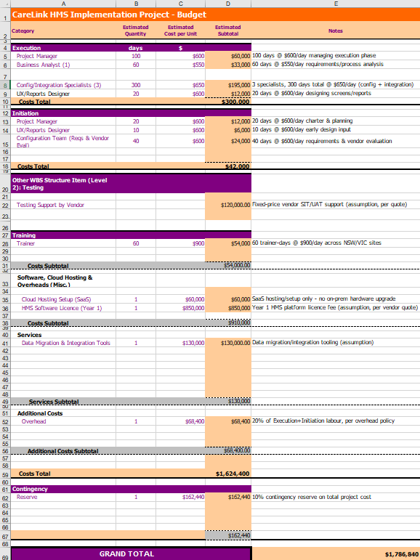
Figure 2 : HMS implementation project - Budget
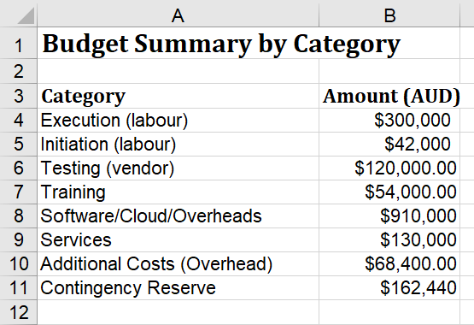
Figure 3 : Budget summary by category
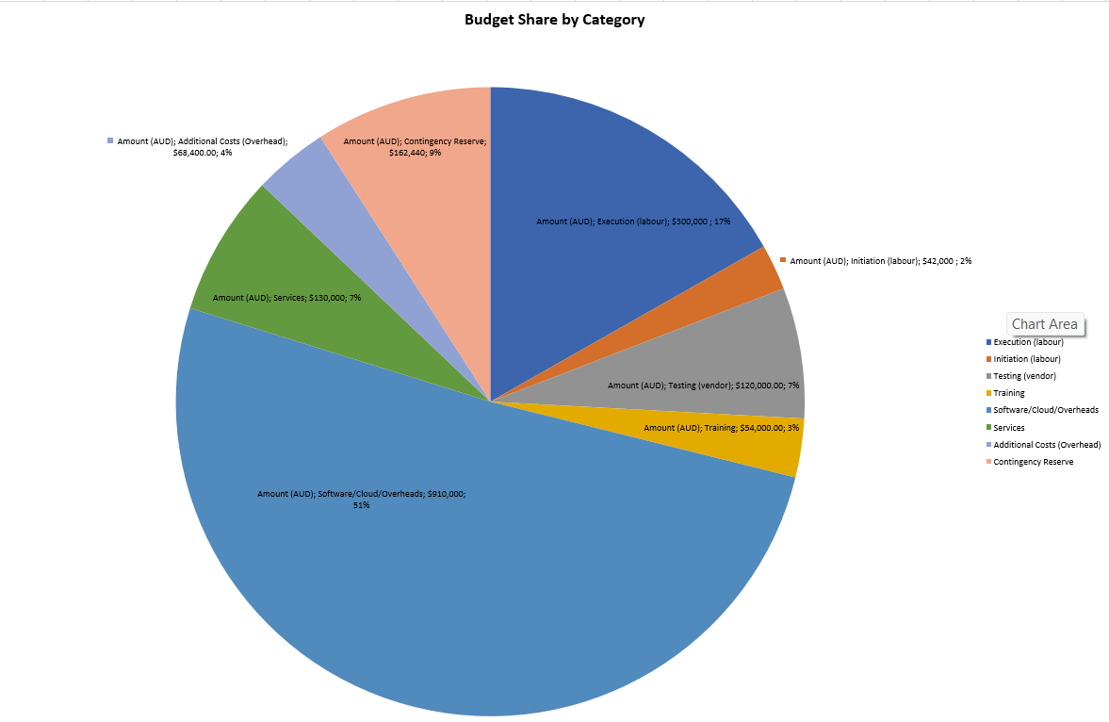
Figure 4 : Budget share by category

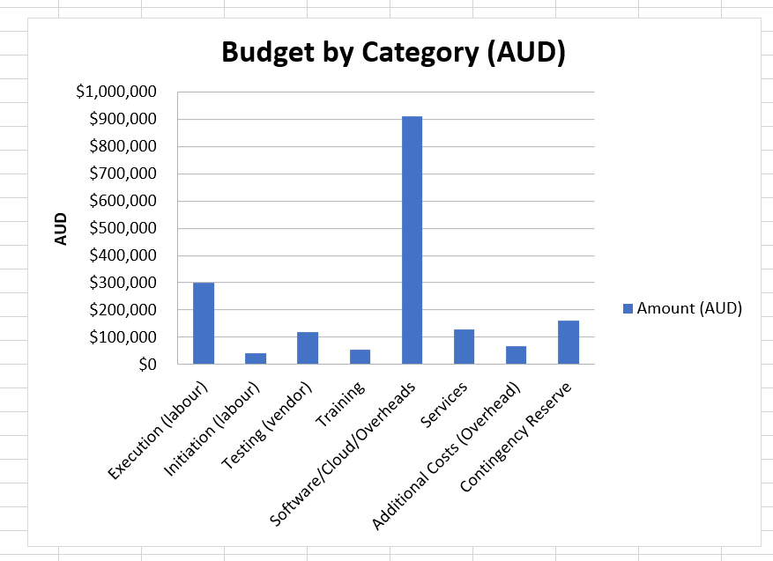
Figure 5 : Budget by category(AUD)

9. Conclusion
This report has created an efficient, PMBOK-aligned project plan for CareLink's HMS implementation. Each component has been connected with the appropriate sections (goals, objectives, stakeholders, WBS, risk management strategies) to ensure the availability of a clear project baseline, which will improve the team’s project management capacity, contribute to timely and informed decision-making throughout the process, and promote the success of the CareLink HMS implementation. Attention should be paid to the potential vendor delivery delays, data migration quality issues, staff adoption resistance, and data privacy issues, as these factors may prevent the successful achievement of project objectives. By implementing a proper monitoring system and risk mitigation mechanisms, CareLink will be able to implement an HMS on time and within the allotted budget.

References
Project Management Institute 2013, A Guide to the Project Management Body of Knowledge (PMBOK Guide), 5th edn, Project Management Institute, Newtown Square, PA.
Schwalbe, K 2018, Information Technology Project Management, 8th edn, Cengage Learning, Boston, MA.
Office of the Australian Information Commissioner (OAIC) 2023, Australian Privacy Principles guidelines, OAIC, Canberra, viewed [insert access date], <https://www.oaic.gov.au/>.
Privacy Act 1988 (Cth).

