Health Services Pty Ltd
Individual Agile Project Activity Report
Prepared by: Rojan Chandra Poudel

Table of Contents
1. Agile Charter and Approach 1
Project Vision 1
Mission 1
Success Criteria 1
Why Agile Scrum Is Suitable 1
Limitations and Risks of Using Agile 2
2. Product Backlog and User Stories 2
3. Sprint Plan and Software 4
Definition of Done 5
Software Evidence 5
4. Agile Team Communication and Collaboration Plan 6
Roles 6
Ceremonies 7
Communication Tools 7
Motivation, Communication and Team Culture 7
Managing Conflict or Poor Participation 7
5. Agile Project Issues and Improvements 7
6. Application of ACS Code of Professional Conduct 8
Primacy of the Public Interest 8
Honesty and Integrity 9
Competence 9
7. PMBOK vs Agile Reflection 9
References 10

1. Agile Charter and Approach

Project Vision
For the delivery of Reliable Healthcare Management System (HMS) minimum viable product (MVP) that will offer CareLink employees fast and accurate access to their client records files, staff scheduling, billing and compliance data, improving coordination for clients across New South Wales and Victoria.

Mission
Working in intensive bi-weekly sprints, the Agile team will iteratively design, develop, test, and release the most valuable HMS features first, with feedback from stakeholders incorporated following each sprint, to ensure that the output meets the needs of the clinical staff, administration, and the Compliance Officer.

Success Criteria
- An MVP containing customer records, scheduling of staff members, simple billing, compliance reports, and role-based access will be released in eight week timeframe.
- All delivered user stories met all their acceptance criteria and went through a privacy and security check before release.
- Feedback from stakeholders will be sought in at least two out of the four sprint reviews.
- There were no major bugs that needed to be fixed on go-live and the MVP worked within the resources allocated to the agile component.

Why Agile Scrum Is Suitable
Unlike the fixed-scope, fixed-budget predictive (PMBOK/waterfall) approach used for the wider HMS project, this component is faced with changing demands and a pressing deadline for deployment. Scrum’s short, with its fixed duration and a built-in Sprint Review, provides the Product Owner with the ability to continuously re-prioritize the backlog as clinical, administration, and needs become clearer. Thus, CareLink provides usable functionality every two weeks rather than waiting for one long release at the end of a rigid plan (Schwaber & Sutherland 2020; Schwalbe 2018).

Limitations and Risks of Using Agile
- Budget and cost control are harder to manage/fix in advance than under PMBOK, because scope is allowed to change sprint by sprint , and thus cost overruns are controlled by fixed capacity sprints rather than by a fixed scope baseline.
- The 8 week timeframe will provide limited slack for the privacy and security testing that healthcare data normally needs, so the risk management must be done rather than assumption.

2. Product Backlog and User Stories
The above product backlog is made up of eight user stories that have been drawn from the five focus areas of CareLink based on the agile approach. These are the Client Records, Staff Scheduling, Basic Billing, Compliance Reporting Dashboard, and User Access/Role-based Permissions. Each of the user stories has been allocated a level of priority (High/Medium) and also estimated in terms of story points based on the team effort relative to other work items. The total number of story points in the backlog is 47.
ID | User Role | User Story | Priority | Points | Acceptance Criteria
US01 | Clinical Staff | As a clinical staff member, I want to be able to quickly locate and view client records, in order to offer prompt and informed treatment. | High | 5 | Search results reveal the matching client within a maximum of three seconds; full record access is only available to authorized roles; record reveals current care plan.
US02 | Administrator / Scheduler | As an administrator/scheduler, I want to create and modify staff rosters, so that scheduling conflicts are avoided. | High | 8 | Roster management avoids double booking; changes are visible to concerned personnel within 24 hours; the roster can be exported and printed.
US03 | Billing Officer | As a billing officer, I would like to have the ability to produce invoices for clients. | High | 8 | Invoices are generated based on entered services; invoices is reviewable before sending; error rate during UAT is less than 1%.
US04 | System Administrator | As a system administrator, I want to set up role-based access to be sure that only those who are authorized can see client health information. | High | 8 | At least four roles can be defined in the system; attempts to access without proper authorization are logged and stopped; permissions are tested against APP 11.
US05 | Compliance Officer | As a compliance officer, I would like to have a compliance dashboard to allow quick identification of any records or reports in danger of becoming non-compliant | High | 5 | Dashboard marks overdue items; data refreshes on a minimum daily basis; the summary report can be exported.
US06 | IT / Security Administrator | As an IT security administrator, I would like to have enforced login and auditing in place to be sure that anyone accessing client records does so in a secure manner. | High | 5 | Strong authentication is applied; logging of all accesses with timestamp and user id is done; logs are accessible to the Compliance Officer.
US07 | New Staff Member | As a new staff member, I would like to have a simple guide within the system to help me learn the HMS without assistance. | Medium | 3 | Guide can be accessed from the main menu; the guide explains essential activities of each module; positive feedback was received from at least two test users.
US08 | Team Lead | As a team lead, I would like to be able to set up alerts to remind me when compliance deadlines are approaching. | Medium | 5 | Alerts sent 7 and 2 days before deadline; alert recipients can be configured; alert delivery is confirmed in the test log.
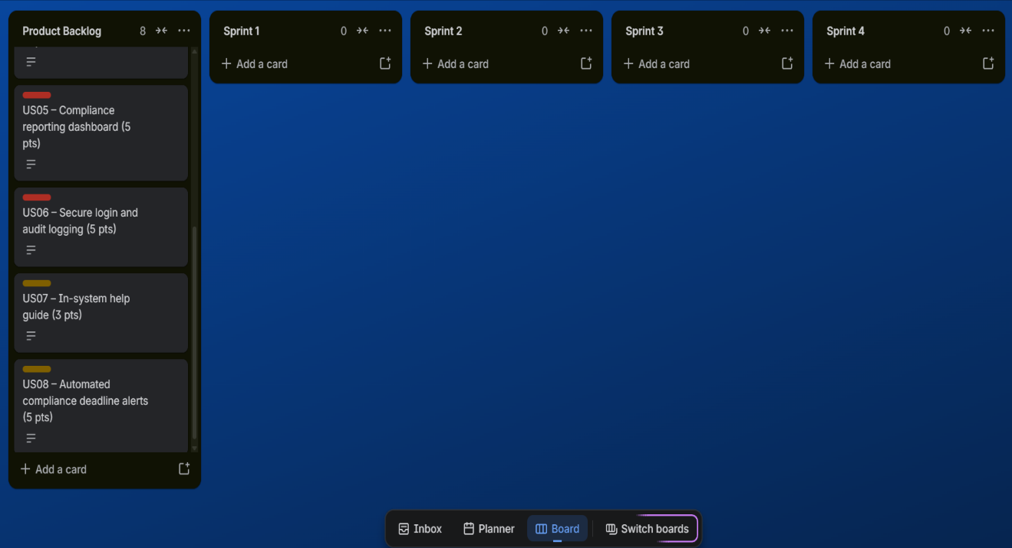

3. Sprint Plan and Software
The 8 week agile delivery is broken down into four sprints of 2 weeks each. The sprint plan, product backlog and task boards were created and monitored using Trello, with a Status of To Do, In Progress and Done columns for each sprint so that progress is visible to the whole team and to the Product Owner at any point in time.
Sprint | Weeks | Sprint Goal | Stories | Points | Deliverables | Order Justification
Sprint 1 | Weeks 1–2 | Ensure a safe and secure platform that has access controls in place before developing functionalities. | US04, US06 | 13 | Role-based permission model and a secure login and audit logging operational. | Privacy/security is the highest impact risk if left late, all of the subsequently developed features can all be built and tested using live permission rules.
Sprint 2 | Weeks 3–4 | Develop the basic functionalities required for use on a daily basis within the organization | US01, US02 | 13 | Client record search / client record view modules and staff roster module. | These are highest value/most used features and were graded High priority in backlog grooming.
Sprint 3 | Weeks 5–6 | Create an MVP scope that will include functionalities such as billing and compliance | US03, US05 | 13 | Basic billing/invoicing module and compliance reporting dashboard. | Billing and compliance reporting depend on client and roster data existing first (Sprint 2), and both are High priority.
Sprint 4 | Weeks 7–8 | Improve on the MVP through feedback from stakeholders ahead of go-live. | US07, US08 + feedback fixes | 8 + buffer | In-system help guide, compliance deadline alerts and a final MVP release incorporating Sprint 3 feedback. | Lower-risk items are scheduled last, so that space will be available to address issues found during early Sprint reviews without endangering the 8-week time to complete goal.

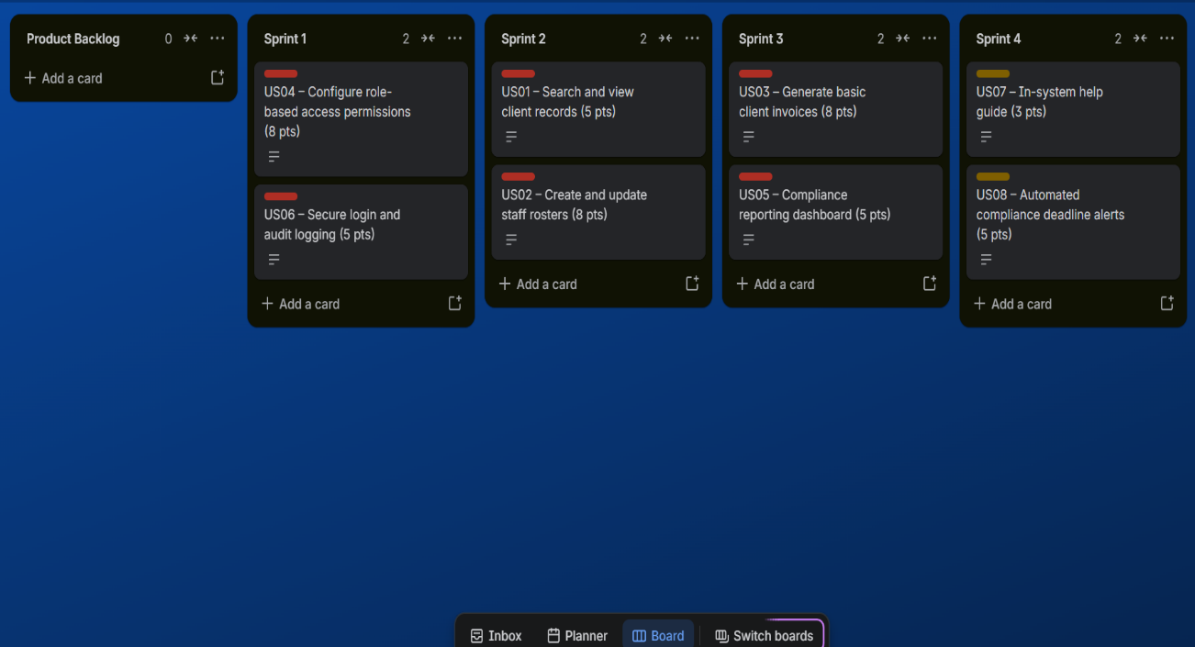

Definition of Done
The status of "Done" for user stories applies if the code development is finished and has gone through a peer review; unit and integration tests passed; all acceptance criteria for the stories apply; all the stories affecting client data have passed the privacy/security review and finally-all work has been reviewed and signed-off by the Product Owner at the Sprint Review and the story deployed to the test/staging environment without any outstanding high severity bugs.

Software Evidence
The screenshots below provide evidence of the backlog and sprint boards described above, captured directly from the project management tool.
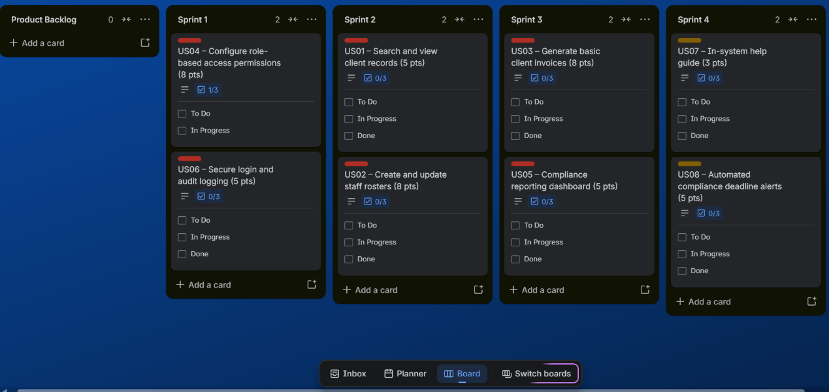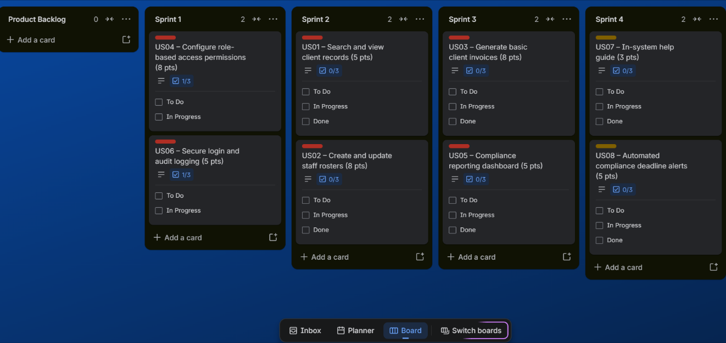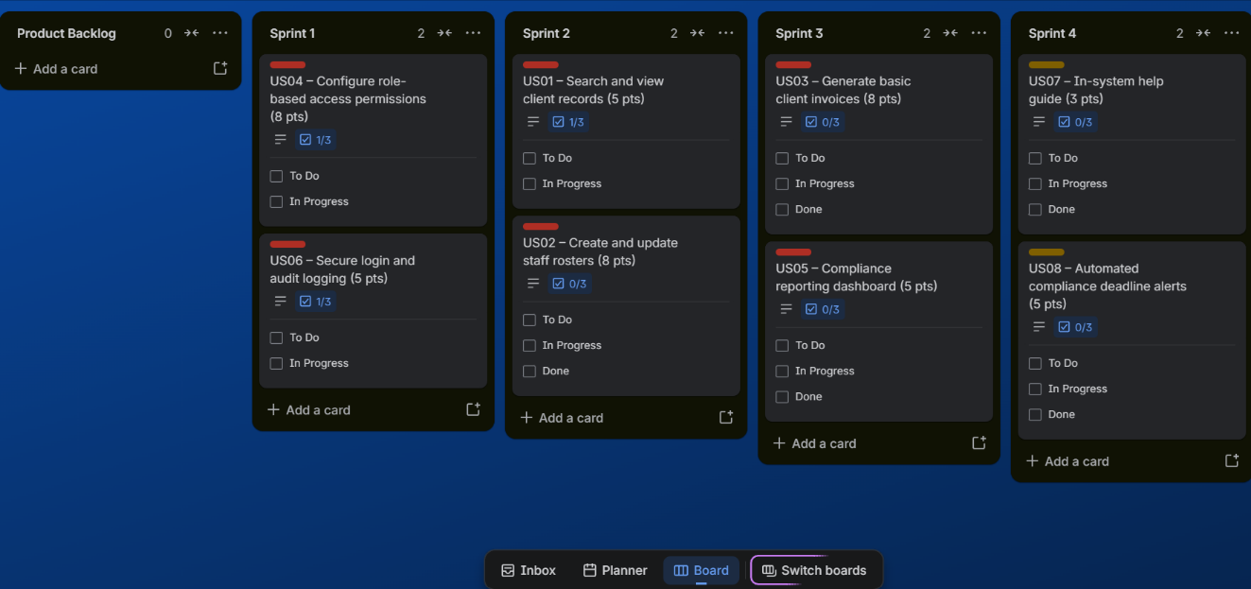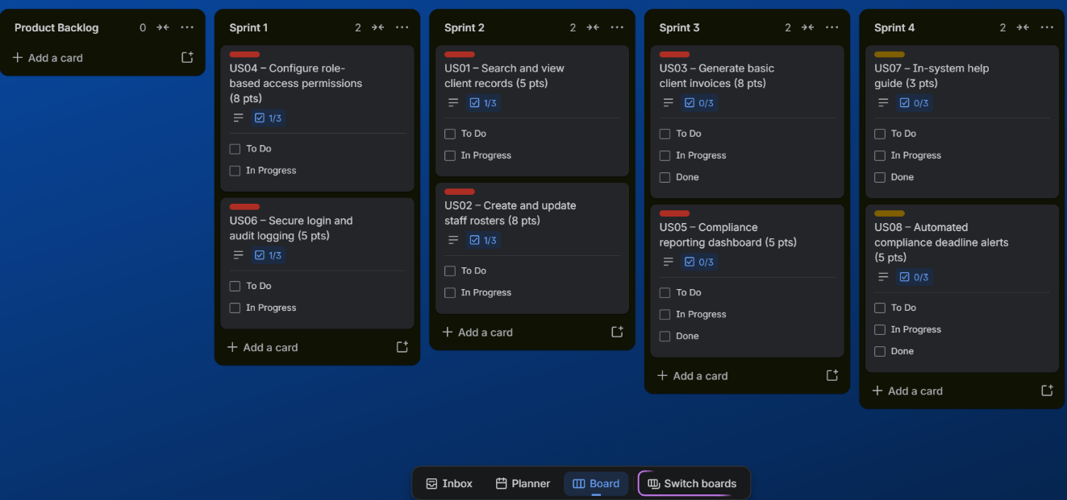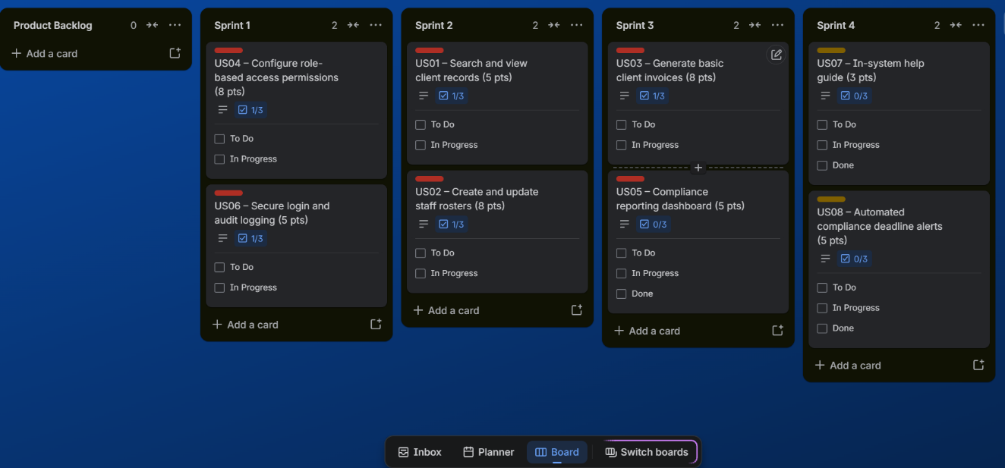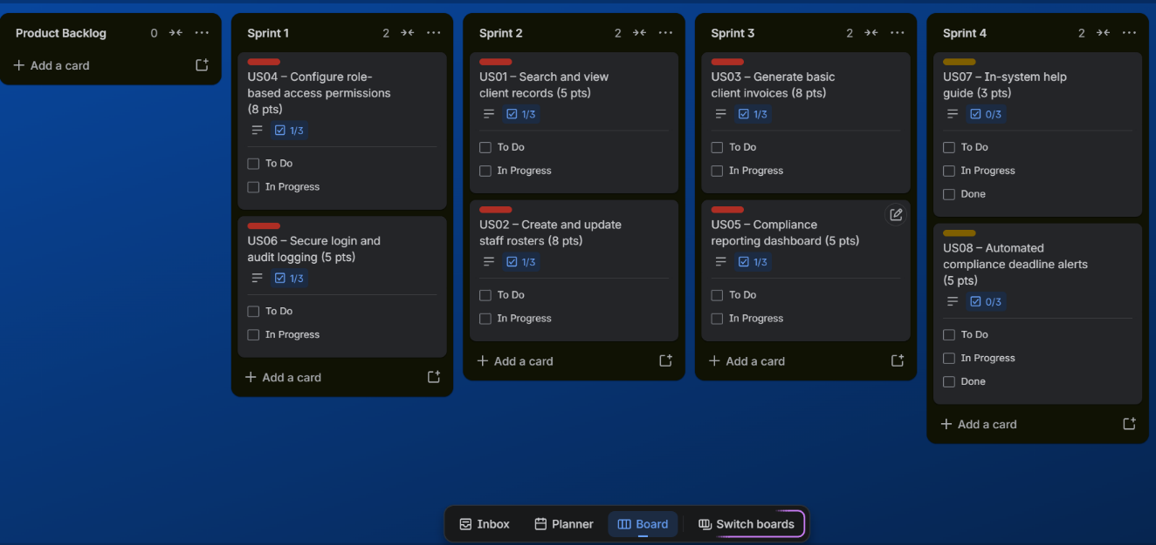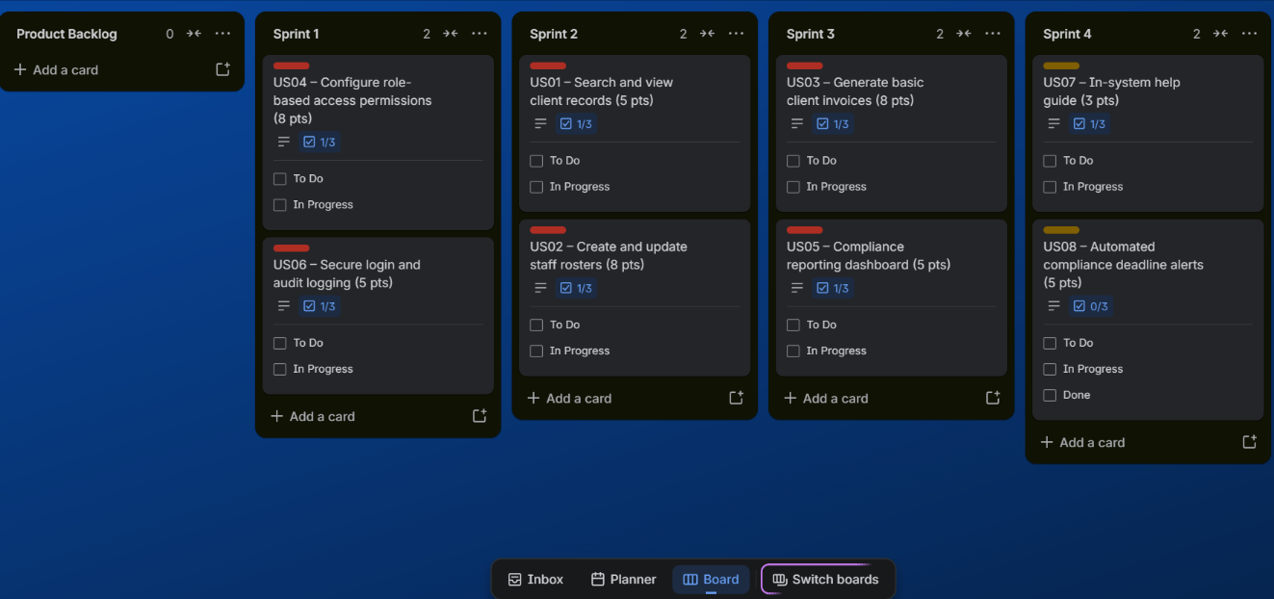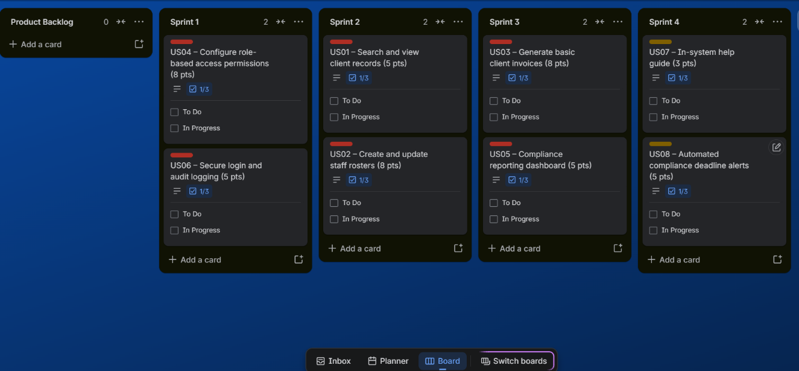

4. Agile Team Communication and Collaboration Plan

Roles
- Product Owner - represents CareLink's stakeholders, including the Compliance Officer and clinical/admin leads. Responsible for owning the product backlog, ordering and re-priorities it.
- Scrum Master - facilitates all Scrum ceremonies, works with the Product Owner and Development team to remove impediments and protect the team against mid-sprint changes, and coaches the team in the agile process.
- Development Team - a small, cross-functional, self-organizing group of individuals, who design, build and test each sprint's increment.

Ceremonies
- Daily stand-up - 15 minutes, same time and place each day. Each member quickly goes over their previous day's progress, next day's goals and any blockers.
- Sprint Review - held at the end of each sprint; during the team demonstrates to the Product Owner and any other relevant stakeholders such as a clinician or administrative team member and gathers feedback that feeds the next sprint.
- Sprint Retrospective - a team-only session after the review; covers what worked, what did not, and one or two concrete changes to try in the next sprint.

Communication Tools
Trello is used to manage the backlog and sprint boards, while Microsoft Teams (or Slack) is used for daily communication, file sharing, and posting stand-up updates when someone cannot attend the meeting. This also keeps a written record of updates and blockers, making it easier for the Scrum Master to track and follow up on them.

Motivation, Communication and Team Culture
The Scrum Master keeps stand-ups short and focused on blockers, publicly recognizes completed work during each Sprint Review to keep everyone motivated, checks in with quieter team members privately to find issues early and shields the team from mid sprint changes by routing new request to the Product Owner for backlog prioritization instead of letting them interrupt the team’s ongoing work.

Managing Conflict or Poor Participation
Recurring absence or not actively involved is addressed privately by the Scrum Master first. The blocked or falling behind tasks are quickly re-scoped or reassigned within the sprint and a conflict that cannot be solved informally is escalated to the Product Owner or the individual's line manager, while maintaining a respectful and collaborative team environment.

5. Agile Project Issues and Improvements
Three realistic issues that could occur during the CareLink Agile project are discussed below. These can be delays or unfinished work, team communication issues, privacy and security concerns. For every problem, a simple and practical solution is proposed.
Project Issue | Why It Matters | Suggested Improvement Action
Staff roster story (US02) is not completed within Sprint 2 | The delay may impact the Sprint 3 billing testing, and could make it more difficult to get to the fixed 8-week MVP deadline. | Divide tasks into smaller ones, re-prioritize the Sprint 3 backlog with the Product Owner, and reducing its scope as needed.
Uneven participation in daily stand-ups | Delays may go unnoticed until the sprint review, thereby lowering trust and team cohesion. | The Scrum Master maintains the format of the stand-up, allows everyone to speak, and checks with them individually if they are having trouble speaking or reporting on any impediments.
Role-based access permissions are misconfigured | Failure to adhere to access policies may result in confidential client health information being accessed by staff who are not authorized, breaching the Australian Privacy Principles and Privacy Act 1988 (Cth), and also create legal and reputational risks for CareLink. | Add a mandatory security/privacy check to the Definition of Done, only use anonymized data for testing, and have the Compliance Officer review and approve the system before each Sprint Review.

6. Application of ACS Code of Professional Conduct
As the Agile Project Manager/Scrum Master, at least three values from the ACS Code of Professional Conduct (ACS, 2014) are applied throughout the CareLink Agile project.

Primacy of the Public Interest
This value is enforced by scheduling US04 (role based access permissions) and US06 (secure login and audit logging) in Sprint 1, even before concentrating on visible clinical or billing features. This puts the privacy & security of the CareLink users first, rather than focusing only on the visible quick feature progress. It reflects the ACS Code to put public interest before personal, commercial or sectional interests.

Honesty and Integrity
This value is applied by having the Scrum Master and Product Owner openly report the Sprint 2 roster delay (Section 5) to stakeholders during the Sprint Review, instead of hiding the issue or removing acceptance criteria without discussion, and by refusing to commit the team to unrealistic story points under schedule pressure.

Competence
This value is applied by assigning stories to team members based on their skills and experience. For example, access-control and audit-logging tasks are given to developers with security experience. Peer reviews and testing are also included in the Definition of Done to make sure each completed increment meets the required professional standard before release.

7. PMBOK vs Agile Reflection
The table below compares the predictive PMBOK approach used for the wider CareLink HMS project with the Agile Scrum approach used for this MVP component.
Dimension | PMBOK (Predictive) | Agile Scrum (Adaptive)
Planning | Involves detailed planning before the project starts, covering areas such as scope, schedule, cost, and risk. This is shown in the Assessment 2 Charter, Scope Statement, WBS, and Budget. | Planning is done continuously and in short cycles. The group schedules the next sprint with precision while slowly improving the broader product backlog (Schwaber & Sutherland, 2020).
Scope Management | The scope is defined and formally baselined in the Scope Statement. Any changes are handled through a formal change-request process. | The scope remains flexible.The Product Owner may shift backlog priority prior to every sprint according to fresh needs, user responses, or altered focus areas.
Risk Management | Risks are identified early and recorded in a Risk Register, as shown in Assessment 2, Section 5. They are then reviewed periodically during project status meetings. | Risks are handled continuously by delivering small working increments early. For instance, security features are addressed in Sprint 1, allowing problem to be surfaced and resolved through stand-ups and Sprint Reviews.
Change Management | Changes are generally discouraged after the baseline is approved and must go through a formal change-control process | Change is expected and may be introduced in a controlled manner at the end of each sprint without unnecessarily disrupting of the current sprint.
Stakeholder Involvement | Stakeholder communication mainly happens at formal governance points, such as steering meetings, briefings, and sign-offs, based on each stakeholder’s level of interest and influence. | Communication is continuous and practical. The Product Owner communicates closely with the team, while stakeholders will be able to see working software at the end of each two week sprint.

References
Australian Computer Society (ACS) 2014, ACS Code of Professional Conduct, ACS, Sydney.
Office of the Australian Information Commissioner (OAIC) 2023, Australian Privacy Principles guidelines, OAIC, Canberra, viewed 2 September 2026, <https://www.oaic.gov.au/>.
Privacy Act 1988 (Cth).
Project Management Institute 2013, A Guide to the Project Management Body of Knowledge (PMBOK Guide), 5th edn, Project Management Institute, Newtown Square, PA.
Schwaber, K & Sutherland, J 2020, The Scrum Guide, viewed 3 September 2026, <https://scrumguides.org/>.
Schwalbe, K 2018, Information Technology Project Management, 8th edn, Cengage Learning, Boston, MA.

