
Data VISUALIZATION
Report
Name

September 05, 2021

Table of Contents
1 Executive Summary 1
2 Introduction and Dataset Recap 1
3 Evidence of Work Done 1
4 Analysis, Visualisation and Justification 3
4.1 Business Question 1: 3
4.2 Business Question 2: 4
4.3 Business Question 3: 4
4.4 Business Question 4: Bi-variate Analysis 5
5 Dashboard Design and Integration 6
6 Week-by-Week Progress Demonstration 6
7 Conclusion 6
8 References 7

Table of Figures
Figure 1 : Tableau Workspace showing dataset of video game sales 2
Figure 2 : Dashboard - Video Game Sales Analysis 2
Figure 3 : Platform Sales by Region Chart 3
Figure 4 : Global Sales Trend Line Chart 4
Figure 5 : Top 10 Games Bar Chart 5
Figure 6 : Top Publishers Bar Chart 5

Executive Summary
This report presents the descriptive analysis and visualisation performed for the Video Game Sales dataset. The analysis addresses four pre-defined business questions using Tableau, incorporating uni-variate, bi-variate, and multi-variate techniques as mandated. The visualisations, comprising a trend analysis, a regional platform breakdown, a publisher ranking, and a top games list, have been synthesised into a single, interactive dashboard. This report documents the process, justifies the analytical choices, demonstrates progressive work across the weeks, and presents the key insights derived, providing a comprehensive view of the global video game market landscape.

Introduction and Dataset Recap
The purpose of this project is to examine the "Video Game Sales" dataset, which comprises the global sales of video games with attributes like Game Name, Platform, Year of Release, Genre, Publisher, and corresponding global sales for each region (NA_Sales, EU_Sales, JP_Sales, Other_Sales, and Global_Sales), to derive market patterns from the past and understand market leaders and preferences for different regions. The main purpose of this report is to perform and display the descriptive analysis for the chosen business queries using the Tableau tool within the scope of certain visualization types (uni-variate, bi-variate, and multi-variate visualization), and the secondary purpose is to prepare an integrated dashboard to display the findings.

Evidence of Work Done
For analysis, Tableau Desktop has been utilized, wherein all steps for data preparation, analysis, visualizations, and construction of dashboards have been performed in Tableau itself, following an organized approach: the data source is connected, data types have been checked, worksheets have been created for specific business questions with aggregations (SUM), filters (Top N), and sorting, and then all worksheets have been combined into a dashboard with filters (Year, Platform, Genre) for better usability.
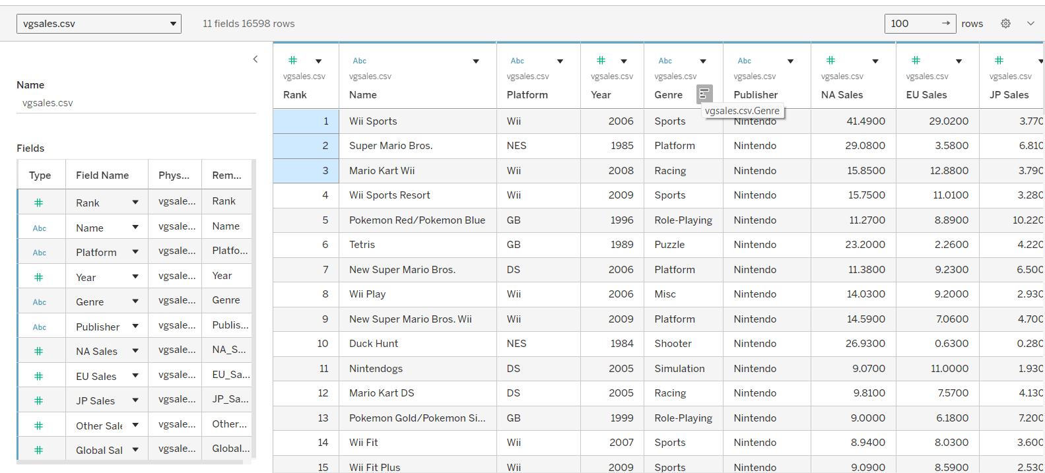
Figure 1 : Tableau Workspace showing dataset of video game sales
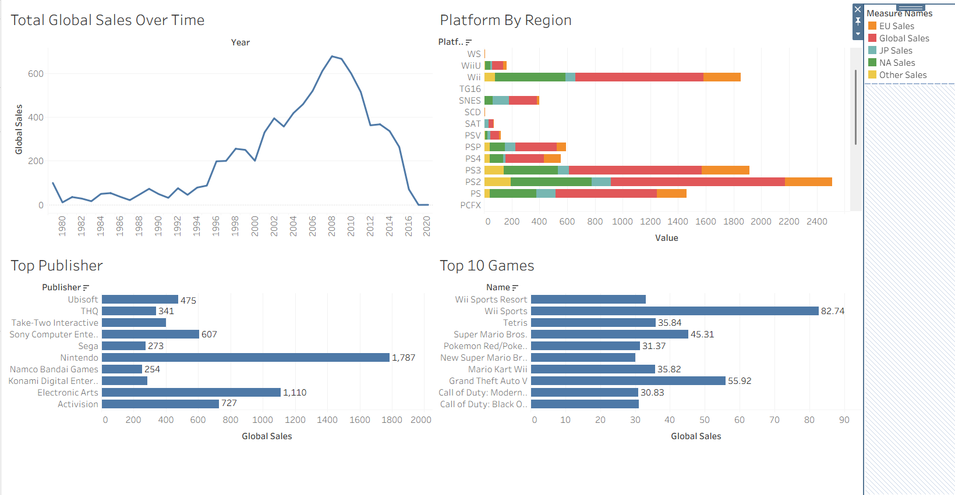
Figure 2 : Dashboard - Video Game Sales Analysis
There are four major analyses in this dashboard: (Top-Left) Global Sales Over Time; (Top-Right) Sales by Regions & Platforms; (Bottom-Left) Top Publishers; (Bottom-Right) Top Games, with filters on the right side of the dashboard.

Analysis, Visualisation and Justification

Business Question 1:
- Question: Which gaming platforms generated the highest total Global_Sales, and how does this differ across regions (NA vs EU vs JP)?
- Category: Multi-variate Analysis (Platform, Region, Sales).
- Visualisation: Stacked Bar Chart.

To analyze which gaming platforms led to the most total Global_Sales, and how this differs across regions (NA vs EU vs JP), a stacked bar chart was design as shown in Figure 3.
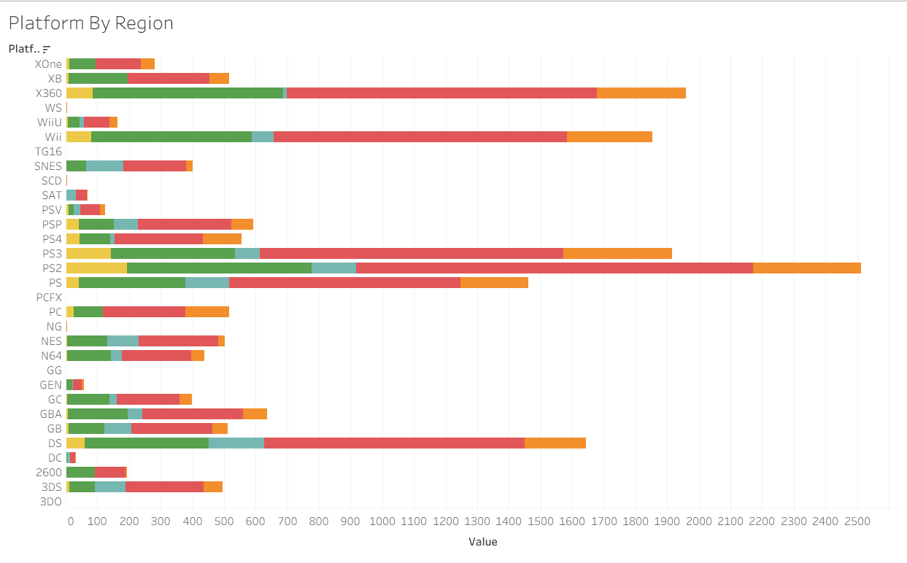
Figure 3 : Platform Sales by Region Chart

The visualization shows the cumulative sales for each platform, and the sectors for each are colored according to regions, where blue signifies the Japan market, orange signifies the European market, green signifies the market in North American, yellow signifies the other sales, and red signifies the market in Global. It also effectively identifies the PS2 and the Xbox 360 as the most successful platforms in the industry. One thing that can be easily noted in regards to the regional dynamics is that the NA and EU markets are the driving forces for the Xbox 360 and the Wii, but the market for Japan skews towards the handheld market, along with the Sony brands, particularly the DS and PS3. The bar chart was preferred for the visualization, as it most effectively shows part-to-whole information for multiple entities, allowing one to quickly evaluate the cumulative sales for the platforms, side by side, simultaneously providing a breakdown for the composition in each platform.

Business Question 2:
- Question: How have total global video game sales changed over time (by release year), and which years show peak sales?
- Category: Uni-variate Analysis (Global_Sales over Year).
- Visualisation: Line Chart.

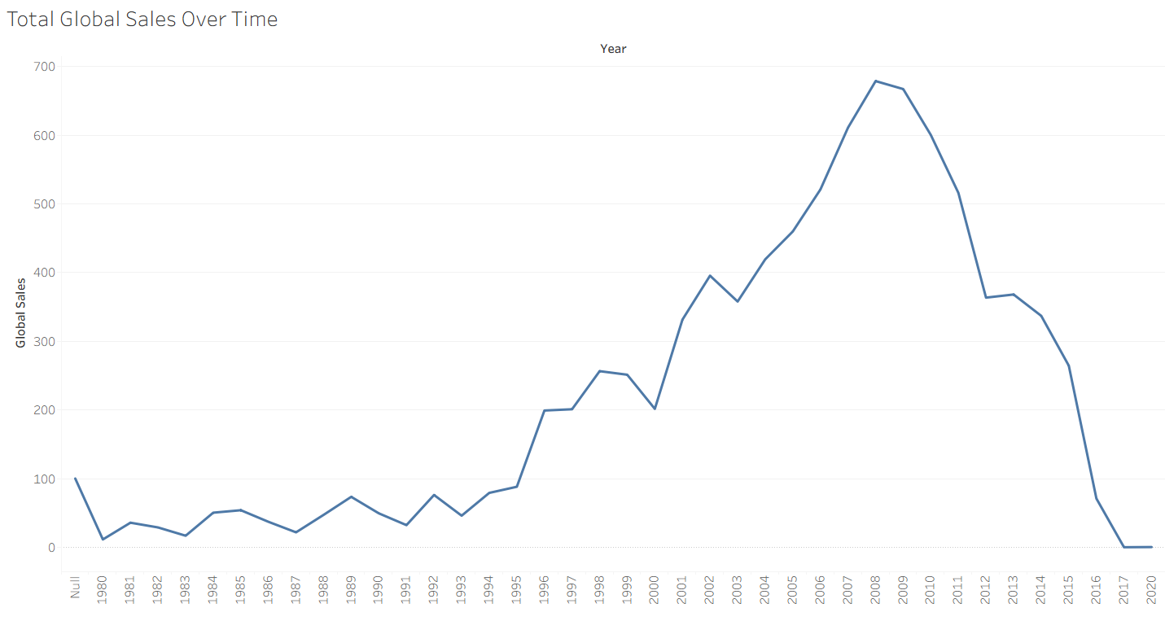
Figure 4 : Global Sales Trend Line Chart
This line chart plots the total Global_Sales by release year, starting from the early 1980s and moving forward. It shows a strong upswing in the market beginning in the early 2000s, hitting a high around 2008–2009 roughly the peak era for the Wii, PS3, and Xbox 360. After 2010, sales slope downward, which could reflect market saturation, the rise of mobile gaming, or gaps in how later-year data was captured. The chart clearly marks a boom period from 2005–2010 and the subsequent market correction. A line chart was chosen because it’s the standard, most effective way to visualize trends over time, making increases, decreases, peaks, and overall direction easy to see and helping pinpoint the exact peak sales years the business question asks about.

Business Question 3:
- Question: What are the top 10 games by Global_Sales?
- Category: Uni-variate Analysis (Ranking of Game by Global_Sales).
- Visualisation: Horizontal Bar Chart.
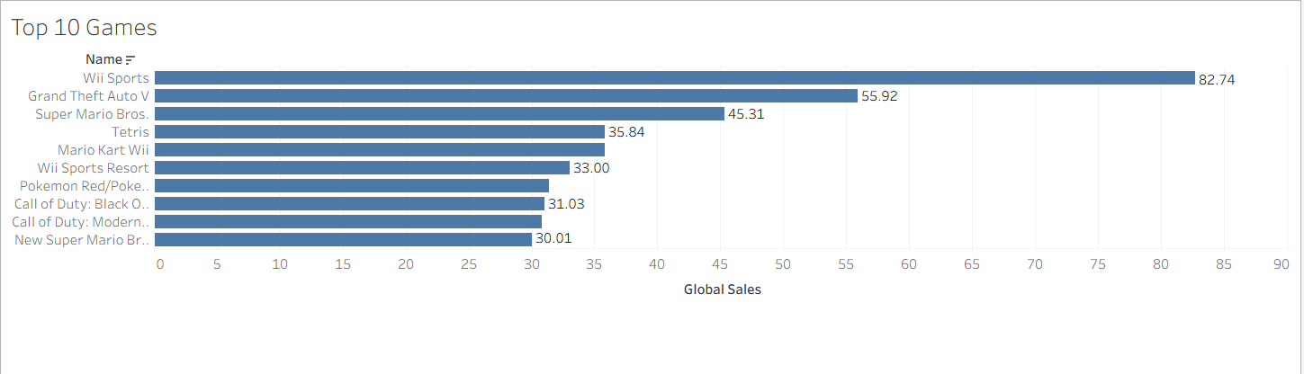
Figure 5 : Top 10 Games Bar Chart
This bar chart is organized horizontally, representing the ten most successful games according to total Global_Sales, with bar length equivalent to sales volume. This bar chart clearly indicates that Wii Sports is a long way ahead in terms of sales, but other titles in the most successful group include those available for Wii, NES, Xbox 360 consoles. A bar chart has been selected for this analysis because a horizontal bar chart works particularly well for ranking or comparison purposes, for categorical data such as game names, and is easy to compare by ordering them in descending order.

Business Question 4: Bi-variate Analysis
- Question: Which publishers have the highest cumulative Global_Sales, and what is their market share compared with others?
- Category: Bi-variate Analysis (Publisher vs. Global_Sales).
- Visualisation: Horizontal Bar Chart.

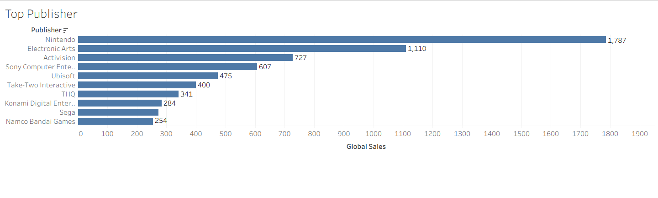
Figure 6 : Top Publishers Bar Chart
This graph presents the top ten publishers with the largest cumulative Global_Sales, making it clear that Nintendo is well in the lead, with Electronic Arts and Activision following close behind. The leading publishers together contribute to the majority of the market share, reflecting the long-tail effect characteristic of media industries, where the majority of the sales are accumulated in the hands of the leading players, while the remaining small players contribute marginal value to the industry. The use of the horizontal bar chart is effective in comparing the total sales of the various publishers, making it clear at first sight whose market influence is stronger. The inclusion of the Top 10 is useful in simplifying the graphic.

Dashboard Design and Integration
A 2x2 Template for Time Series + Multi-Variable Analysis is an extremely useful kit for people interested in doing data storytelling. The kit comes with a simple 2x2 grid-based dashboard design. It keeps the time-series analysis of sales over time in the top-left corner, which is obviously the first thing that needs to be analyzed. Then comes the analysis of different variables for a specific platform in the top-right corner. The analysis for ranking Publisher and Games comes next. The design is all about clarity, comparison, self-guided analysis, with a simple, neutral palette like basic Tableau’s classic.

Week-by-Week Progress Demonstration
The process was carried out over weeks in a logical, step-by-step manner. We started off with the finalization of the dataset, choosing four key business questions (Q1, Q2, Q4, Q5), identifying the requirements of uni, bi, multivar analysis, while also conceptualizing the suitable types of visualizations for each. Moving forward, the linking of the data was done using Tableau, creating the first two worksheets, Global Sales Trend (uni-var analysis, Q2), and the Top Publishers chart (bi-var analysis, Q4). The calculations were verified for correctness, proper ordering, while assigning the proper role to each piece of data. We then moved towards the more involved process of creating the Platform by Region chart (Multivar chart, Q1), utilizing the feature of Measure Names/Measure Values, while using the concept of the top-N filter appropriately in the chart. Finally, the culmination of all the created worksheets came together in the form of the dashboard. We worked towards improving the aesthetics in the dashboard, deployment of the filter functionality, while labeling the titles, legends, capturing the complete flow of the process in the report.

Conclusion
From the descriptive analysis perspective, there are four key findings that can be identified. Firstly, the peak in the global video games market takes place around the years 2008-2009.Secondly, the success in each region and across different platforms differs greatly, and this indicates that in Japan, there's a preference for DS and PS3, but in North America and Europe, there's more affinity for the Xbox 360 and Wii. Thirdly, Nintendo becomes the leading publisher in video games, and Wii Sports leads the list as the best-selling item in this dataset. Fourthly, the video games market follows a long tail in both the publisher and games distributions.
For the developer or publisher, the above considerations with regard to platforms could point towards the importance of region-specific strategies, the awareness of the influence of the life span of consoles on major points of sale, and the realization of the impact of key participants in the market of competition. However, there is no question that there are limitations as well. The set of data is descriptive and is historical, as it shows what has happened and not why it happened. The downward trend after 2010 may be a result of something in the coverage of the data, and it does not include inflation-adjusted sales numbers.
Thus, the next few logical steps involve transitioning from description to prediction and inference. This involves using predictive analytics techniques, including sales prediction, as well as using inferential techniques, including regression, in order to extract the drivers of the commercial success of games.

References
1. Kaggle. (n.d.). Video Game Sales dataset (vgsales.csv). Retrieved from https://www.kaggle.com/datasets/gregorut/videogamesales
2. Tableau Software. (2023). Tableau Desktop Help Guide. Retrieved from https://help.tableau.com/current/guides/get-started-tutorial/en-us/get-started-tutorial-home.htm

