
Data Visualization
Report
Name

September 05, 2021

Contents
1. Introduction 1
2. Dataset Overview 1
2.1 Title and Source 1
2.2 Dataset Description 1
2.3 Column Descriptions 1
3. Business Questions for Analytical Insights 2
4. Data Quality Assessment 2
4.1 Completeness of Data 2
4.2 Sufficiency for Research Questions 3
4.3 Additional Information Needs 3
4.4 Categorical Groups 4
4.5 Data Cleaning Requirements 4
5. Evidence of Work Done 4
6. Justification of Work 6
7. Week-by-Week Progress 7
8. Conclusion 7
9. References 7

Table of figure
Figure 1 : Data preview 3
Figure 2 : Missing values 3
Figure 3 : Login in kaggle 4
Figure 4 : Video game sales data 5
Figure 5 : Netflix Dataset 5
Figure 6 : Search History 6
Figure 7 : Missing values in vgsales.csv 6

Introduction
This report documents the initial phase of data exploration for the Business Analytics course. The primary objective of this is to select a data sets, analysis of the data set structure, creation of meaningful questions, and analysis of data set quality for further analysis tasks. For the purpose of data analysis, three sets of data were considered, namely Video Game Sales, Netflix Data, and COVID-19 Data, according to the project requirements, which include the need for the data set to exceed 1,000 rows, well-structured variables, and the ability to be analyzed from a descriptive, business prospective. The selected data set is "Video Game Sales," which has many observations and variables of different data types, amiable to market analysis.

Dataset Overview

Title and Source
Selected dataset title: Video Game Sales
Source: Kaggle data set page (Gregorut, n.d.).
Data URL: https://www.kaggle.com/datasets/gregorut/videogamesales
Other datasets visited but not selected: Netflix Dataset (Paramvir_705, n.d.) and COVID-19 Dataset (Sanaaafrine, n.d.).
Data URLs:
- https://www.kaggle.com/datasets/paramvir705/netflix-dataset
- https://www.kaggle.com/datasets/sanaaafrine/covid-19-dataset

Dataset Description
The Video Game Sales dataset records the sales of video games. This dataset includes 16,598 observations of the sales of video games on various platforms, categories, and publishers. This dataset records the sales performance of the games in four major regions (North America, Europe, Japan, and Other Regions) and the total sales in the world. This dataset is of immense importance to analyze the market, the preference of the platforms, categories, and the performance of the publishers in the ever-growing market of video games.

Column Descriptions
Table 1 summarizes the meaning of each column in the dataset.
Column | Data type | Description
Rank | Numeric (integer) | Ranking of the game based on total worldwide sales (1 = highest sales).
Name | Text | Video game title name.
Platform | Categorical (text) | Gaming platform on which the game was released (e.g., Wii, PS2, X360).
Year | Numeric (year) | Release year of the game.
Genre | Categorical (text) | Game genre category (e.g., Action, Sports, Role-Playing).
Publisher | Categorical (text) | Company that published the game.
NA_Sales | Numeric (float) | Sales in North America.
EU_Sales | Numeric (float) | Sales in Europe.
JP_Sales | Numeric (float) | Sales in Japan.
Other_Sales | Numeric (float) | Sales in other regions.
Global_Sales | Numeric (float) | Total worldwide sales.

Business Questions for Analytical Insights
The following descriptive business questions can be answered using the selected dataset. Each question is designed to generate insights (trends, comparisons, and summaries) rather than predictions.
- Which gaming platforms generated the highest total Global_Sales, and how does this differ across regions (NA vs EU vs JP)?
- How have total global video game sales changed over time (by release year), and which years show peak sales?
- What are the top-selling genres globally, and do genre preferences differ by region?
- Which publishers have the highest cumulative Global_Sales, and what is their market share compared with other publishers?
- What are the top 10 games by Global_Sales, and do the top titles change when looking at NA_Sales, EU_Sales, and JP_Sales separately?

Data Quality Assessment

Completeness of Data
A missing-value check was performed on the downloaded CSV file (vgsales.csv). Most columns are complete, but two columns contain missing values. The Year column has 271 missing values and Publisher has 58 missing values (based on the dataset file used for this report).
Figure 1 shows a sample of the dataset and Figure 2 summarises missing values by column.
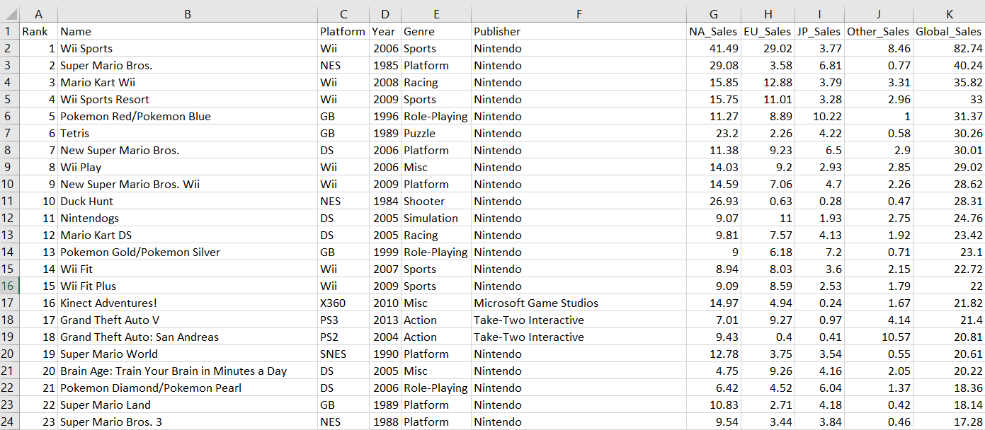
Figure 1 : Data preview
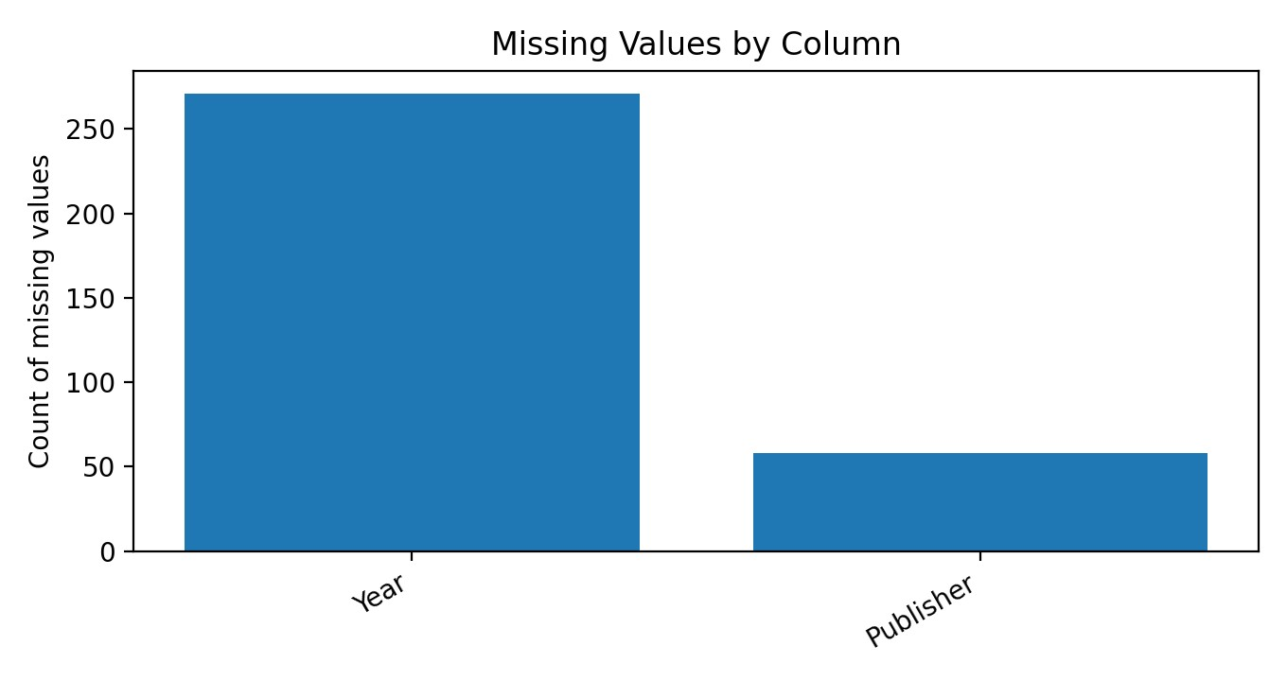
Figure 2 : Missing values

Sufficiency for Research Questions
The data set has the basic information that would be asked by the proposed descriptive questions: platform, year, genre, publisher, and regional and worldwide sales. It is thus sufficient for descriptive purposes. It only lacks information regarding the cost of the products and the spending on their promotion, an aspect which would inform on the reasons that led to the variation on the number of sales, only stating what actually occurred.

Additional Information Needs
To strengthen business conclusions, the following additional information would be useful:
- Production Costs: Development and marketing budgets would enable profitability analysis.
- Review Scores: Metacritic or user ratings could correlate sales with quality.
- Game Features: Multiplayer capability, downloadable content, or franchise affiliation.
- Demographic Data: Age ratings and target audience information.
- Release Month: Seasonal sales patterns cannot be analyzed with only year data.
- Sales Types: Digital vs physical sales split (the dataset is often interpreted as mainly retail-based).

Categorical Groups
The dataset contains several categorical variables with distinct groups:
- Platform: 31 distinct platforms (e.g., Wii, PS2, DS).
- Genre: 12 genre categories.
- Publisher: 578 different publishing companies.
- Region: sales are separated into NA, EU, JP, and Other, enabling regional comparison.

Data Cleaning Requirements
Before analysis, the following data cleaning and transformation steps are recommended:
- Handle 271 missing Year and 58 missing publisher values require imputation or exclusion strategy.
- Ensure all sales columns are numeric and Year is integer.
- Examine extreme sales values for potential data entry errors.
- Verify publisher names for spelling variations.
- May need to calculate percentages, ratios, or decade classifications
- Consider grouping publishers with very small counts into an "Other publishers" category for cleaner visualisations.

Evidence of Work Done
The following actions were completed to meet the Week 4 task requirements:

Figure 3 : Login in kaggle

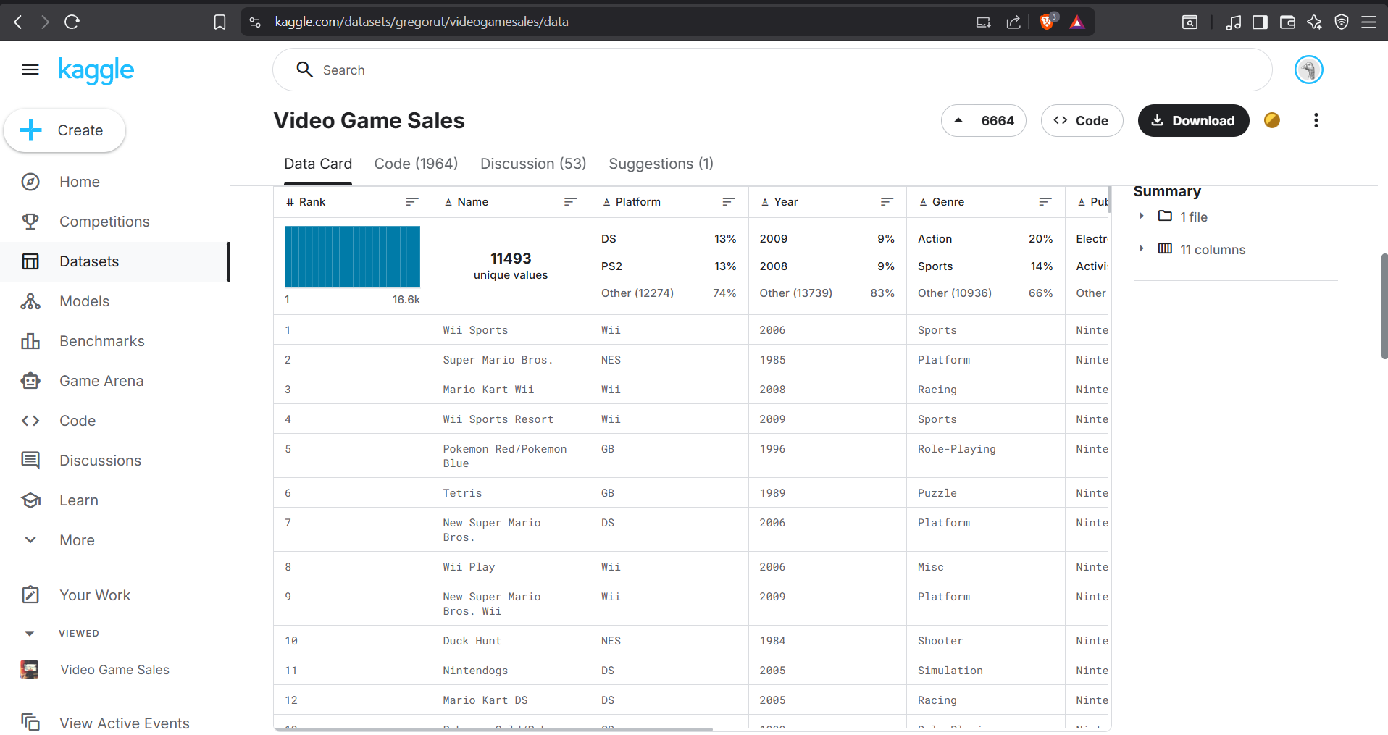
Figure 4 : Video game sales data
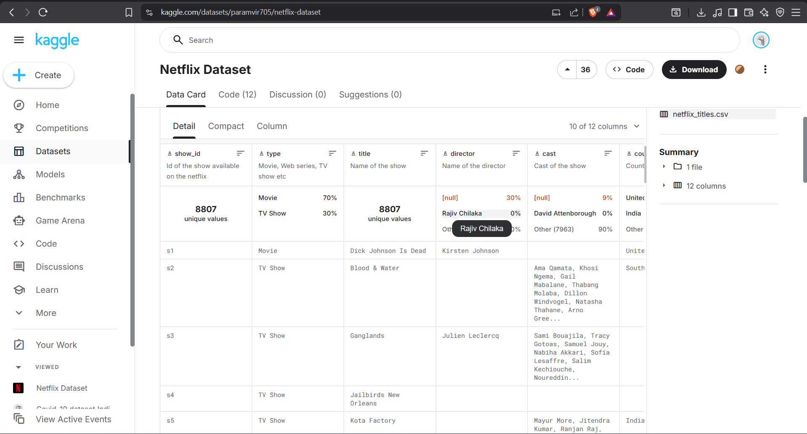
Figure 5 : Netflix Dataset
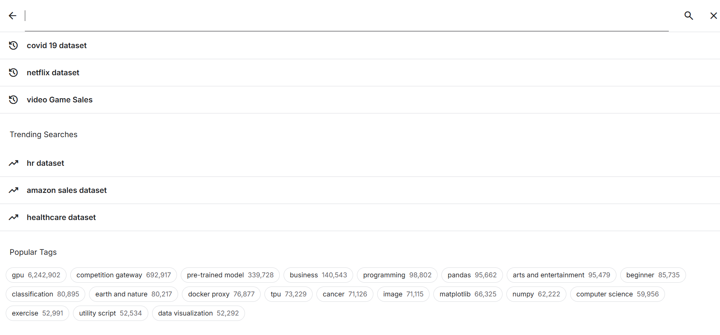
Figure 6 : Search History
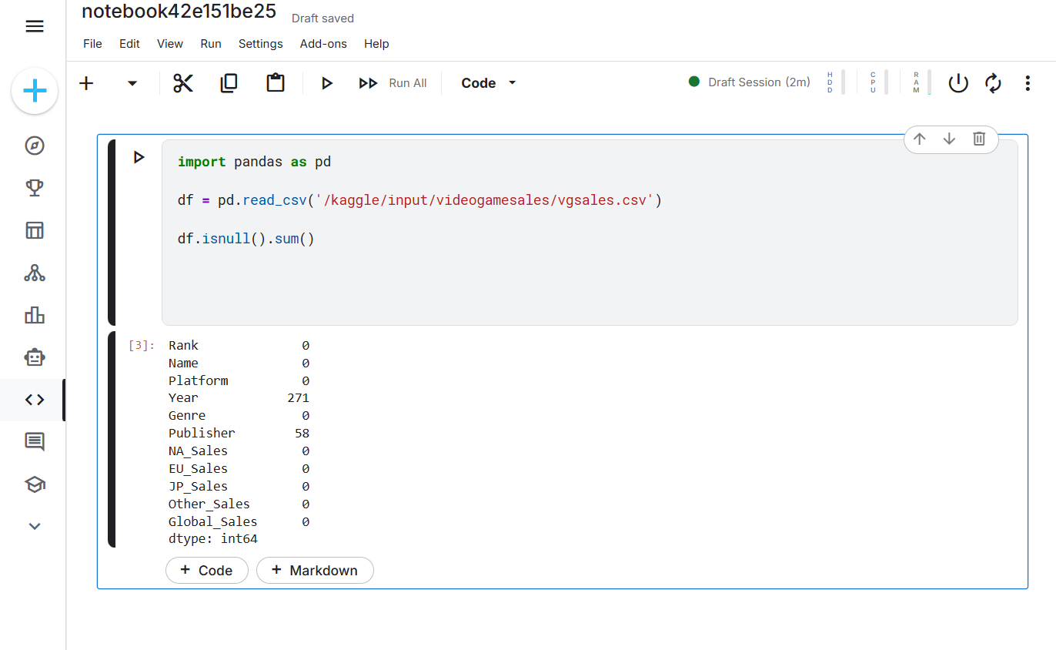
Figure 7 : Missing values in vgsales.csv

Justification of Work
This dataset on Video Game Sales is selected because it contains sales values in a numerical form while also having descriptive variables such as genre and platform. This allows it to be modeled using a variety of analytical tools. The industry pertaining to the video game sector is a massive global industry that exceeds $180 billion. The analyses gained using such a dataset are practical. The dataset is also clean. The dataset does not contain many missing values. This is an important factor since it allows greater time for the analytical work rather than spending a considerable amount of time on data cleaning. The dataset contains sales values alongside other variables such as categories. This is important because it allows a diversity of graph constructions.

Week-by-Week Progress
Week 4 Accomplishments:
- Successfully created Kaggle account using KOI credentials.
- Researched and selected appropriate dataset meeting all criteria (>1000 rows, mixed data types).
- Conducted preliminary data exploration and quality assessment.
- Formulated five business-aligned analytical questions.
- Documented findings in structured report format.
Planned Progress for Week 6:
- Import dataset into Tableau for statistical analysis.
- Calculate central tendency and dispersion measures for all numeric columns.
- Create histograms and box plots to understand data distributions.
- Develop strategies for handling missing Year values and potential outliers

Conclusion
This Week 4 report demonstrates completion of the dataset discovery and evaluation tasks on Kaggle. The selected Video Game Sales dataset meets the row-count requirement and provides relevant variables for descriptive business analysis across time, platform, genre, publisher, and region. While the dataset has some missing values (Year and Publisher), the issues are manageable with basic cleaning, and the dataset is suitable for the next stages of analysis.

References
Gregorut. (n.d.). Video Game Sales [Data set]. Kaggle. Retrieved 20 January 2026, from https://www.kaggle.com/datasets/gregorut/videogamesales
Paramvir_705. (n.d.). Netflix Dataset [Data set]. Kaggle. Retrieved 20 January 2026, from https://www.kaggle.com/datasets/paramvir705/netflix-dataset
Sanaaafrine. (n.d.). Covid 19 Dataset [Data set]. Kaggle. Retrieved 20 January 2026, from https://www.kaggle.com/datasets/sanaaafrine/covid-19-dataset
VGChartz. (n.d.). Video game sales and charts. https://www.vgchartz.com

