

Doctors Appointment Booking Service
Developer (Tech lead)

Student Id: 2408474
Student Name: Rojan Shrestha
Section: L5CG18
Group: 18 – 4RS
Module Leader: Yogesh Bigram Shah
Tutor: Mr Sulav

Table of Content

Acknowledgement
I would like to thank our tutor Sulav budhatoki for guiding me to create and operate Jira. He also taught me about Scrum methodology and how I can implement in my project. I would also like to thank my team members especially the development team for finishing their assigned task on time.

Self-apprasial Form

Student Number | 2408474 | Name | Rojan Shrestha
Project | Doctor Appointment System | Date | 2025/15/4
Role | Developer(Tech lead) | Team | Group-4RS
Sprint (1 or 2) | 1

Personal Objective – Performance Management
Objective | Evidence Provided  (E.g., appendix A, file name etc.) | Evaluation  Student | Tutor
Choosing for the relevant technologies | After some group discussion our team concluded that HTML, CSS, JavaScript would be used for Front-End and Php for back-end and MySQl for database.  While your team was already familiar with these languages
Tutor Feedback:
Functional Requirement’s  Implementation | As a developer I worked on mainly frontend. I worked on overall designs for our website. And added javascript functionality for login signup and other operations.
Tutor Feedback:
Tutor Feedback:
Choosing for the relevant technologies
Tutor Feedback:

Collaboration Development

Evidence of good collaboration
Good Communication and File Sharing Our team collectively decided to use various collaboration tools for communication and file sharing amongst the team. We used Jira to track backlog and assign tasks. We also used GitHub as Version Control System to synchronize code between the developers. Google Drive was used to distribute technical documents, developer documents, and UML diagrams. And google meet was used to communicate between each other.

Continuing Personal Development (CDP)
As a beginner in github I was able to learn valuable lesson from this project I got lot of experience.
During this I learned how to work on multiple branches, restrict branch merging and review code in Github.
As a developer, I worked on front-end which was using Html, css and javascript.

Appendix A

Evidence of choosing for the relevant technologies
Below lists all the technologies used for designing, developing, managing, hosting, and testing applications. Based on the client’s requirements, the following tech stack seemed perfectly functional to develop Doctor Appointment System

Programming Language
- JavaScript
- Php
- Html
- Css
Server
- XAmpp control Panel
- Apache
- MySql
Design Tool
- Figma
Version Control System
- Github

Frontend
Language HTML and CSS were used as the markup and styling language to develop Raise Rally. HTML’s primary function in this project was to create backbone of the web page creating elements such as title, heading, paragraph, image, div, links.CSS was used to manipulate the color, font, style, layout of multiple web pages at the same time. Using both of same, we can develop webpages without much effort
Backend
The PHP that was used to develop backend was old but it was mostly used in your project because it had better compatibility with our project. It was also easier for us to work since all of your team member did this before.

Database
MySQL is an open-source Relational Database Management System which provides us with scalability, performance, and reliability. Using SQL commands users can save, extract, delete, and retrieve data. It is widely used for developing database driven web applications.
Risks/Limitations
While the tech stack we chose provided us with many advantages, it however came with some risks associated with it:
• XAMPP crashing was a major issue during development. Multiple crashes during a week led to production halt.
• Php problem with cors and session management was one of the thing we needed to handle the most.

Evidence of Funtional Requirement’s Implementation
Codes and its explanation

Use of Version Control System
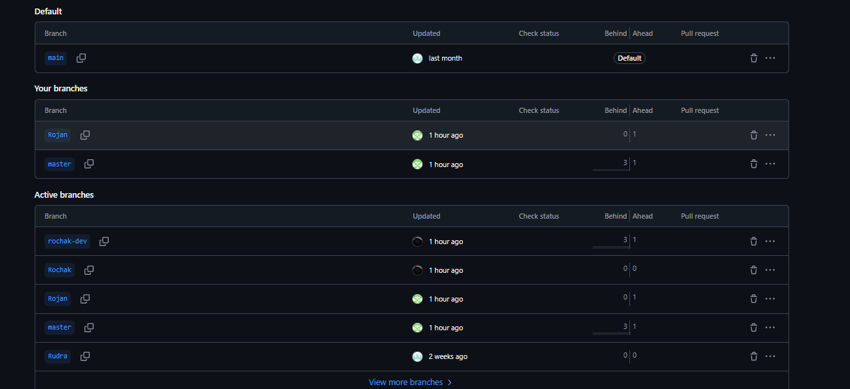

Use of Jira for

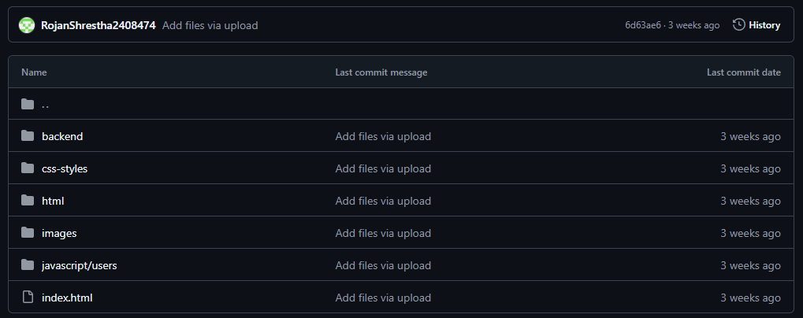
Our Homepage

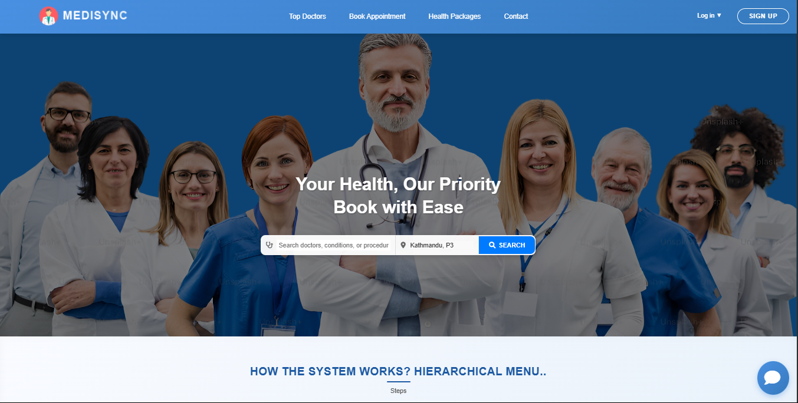

This is my GIthub repo
