In [ ]:
import numpy as np
import pandas as pd

from sklearn.datasets import load_breast_cancer

data = load_breast_cancer()
X = data.data
y = data.target
feature_names = data.feature_names

df_X = pd.DataFrame(X, columns=feature_names)
df_y = pd.Series(y, name="target")

target_mapping = {0: "malignant", 1: "benign"}
df_y_label = df_y.map(target_mapping)

df = df_X.copy()
df["target"] = df_y
df["target_label"] = df_y_label

df.head()
Out[ ]:
 | mean radius | mean texture | mean perimeter | mean area | mean smoothness | mean compactness | mean concavity | mean concave points | mean symmetry | mean fractal dimension | ... | worst perimeter | worst area | worst smoothness | worst compactness | worst concavity | worst concave points | worst symmetry | worst fractal dimension | target | target_label
0 | 17.99 | 10.38 | 122.80 | 1001.0 | 0.11840 | 0.27760 | 0.3001 | 0.14710 | 0.2419 | 0.07871 | ... | 184.60 | 2019.0 | 0.1622 | 0.6656 | 0.7119 | 0.2654 | 0.4601 | 0.11890 | 0 | malignant
1 | 20.57 | 17.77 | 132.90 | 1326.0 | 0.08474 | 0.07864 | 0.0869 | 0.07017 | 0.1812 | 0.05667 | ... | 158.80 | 1956.0 | 0.1238 | 0.1866 | 0.2416 | 0.1860 | 0.2750 | 0.08902 | 0 | malignant
2 | 19.69 | 21.25 | 130.00 | 1203.0 | 0.10960 | 0.15990 | 0.1974 | 0.12790 | 0.2069 | 0.05999 | ... | 152.50 | 1709.0 | 0.1444 | 0.4245 | 0.4504 | 0.2430 | 0.3613 | 0.08758 | 0 | malignant
3 | 11.42 | 20.38 | 77.58 | 386.1 | 0.14250 | 0.28390 | 0.2414 | 0.10520 | 0.2597 | 0.09744 | ... | 98.87 | 567.7 | 0.2098 | 0.8663 | 0.6869 | 0.2575 | 0.6638 | 0.17300 | 0 | malignant
4 | 20.29 | 14.34 | 135.10 | 1297.0 | 0.10030 | 0.13280 | 0.1980 | 0.10430 | 0.1809 | 0.05883 | ... | 152.20 | 1575.0 | 0.1374 | 0.2050 | 0.4000 | 0.1625 | 0.2364 | 0.07678 | 0 | malignant
5 rows × 32 columns
In [ ]:
df.info()
<class 'pandas.core.frame.DataFrame'>
RangeIndex: 569 entries, 0 to 568
Data columns (total 32 columns):
# Column Non-Null Count Dtype
--- ------ -------------- -----
0 mean radius 569 non-null float64
1 mean texture 569 non-null float64
2 mean perimeter 569 non-null float64
3 mean area 569 non-null float64
4 mean smoothness 569 non-null float64
5 mean compactness 569 non-null float64
6 mean concavity 569 non-null float64
7 mean concave points 569 non-null float64
8 mean symmetry 569 non-null float64
9 mean fractal dimension 569 non-null float64
10 radius error 569 non-null float64
11 texture error 569 non-null float64
12 perimeter error 569 non-null float64
13 area error 569 non-null float64
14 smoothness error 569 non-null float64
15 compactness error 569 non-null float64
16 concavity error 569 non-null float64
17 concave points error 569 non-null float64
18 symmetry error 569 non-null float64
19 fractal dimension error 569 non-null float64
20 worst radius 569 non-null float64
21 worst texture 569 non-null float64
22 worst perimeter 569 non-null float64
23 worst area 569 non-null float64
24 worst smoothness 569 non-null float64
25 worst compactness 569 non-null float64
26 worst concavity 569 non-null float64
27 worst concave points 569 non-null float64
28 worst symmetry 569 non-null float64
29 worst fractal dimension 569 non-null float64
30 target 569 non-null int64
31 target_label 569 non-null object
dtypes: float64(30), int64(1), object(1)
memory usage: 142.4+ KB
********************************************************************************************************************************
In this project, the Breast Cancer Wisconsin dataset from the scikit-learn library was utilized. The dataset contains a total of 569 samples, each described by 30 numerical features related to cell nuclei characteristics extracted from digitized images of breast masses. The target variable represents a binary classification problem with two classes: 0 = malignant and 1 = benign.
Upon converting the data into a pandas DataFrame and examining the first few rows, it is evident that all features are continuous numerical variables, making the dataset suitable for training multilayer perceptron (MLP) models. Additionally, the class distribution indicates a relatively balanced dataset, which supports reliable model evaluation without requiring heavy resampling strategies. This initial inspection confirms that the dataset is clean, well-structured, and appropriate for subsequent preprocessing, exploratory data analysis, and model development.
********************************************************************************************************************************

2.1 - Missing value analysis
In [ ]:
missing_values = df.isnull().sum()
print(missing_values)
mean radius 0
mean texture 0
mean perimeter 0
mean area 0
mean smoothness 0
mean compactness 0
mean concavity 0
mean concave points 0
mean symmetry 0
mean fractal dimension 0
radius error 0
texture error 0
perimeter error 0
area error 0
smoothness error 0
compactness error 0
concavity error 0
concave points error 0
symmetry error 0
fractal dimension error 0
worst radius 0
worst texture 0
worst perimeter 0
worst area 0
worst smoothness 0
worst compactness 0
worst concavity 0
worst concave points 0
worst symmetry 0
worst fractal dimension 0
target 0
target_label 0
dtype: int64
******************************************************************************************************************************
The missing value analysis revealed that the dataset contains no missing values across any of its 30 features or the target variable. This indicates that no imputation is required at this stage.
******************************************************************************************************************************

2.2 - Outlier detection (IQR method)
In [ ]:
Q1 = df_X.quantile(0.25)
Q3 = df_X.quantile(0.75)
IQR = Q3 - Q1

outlier_mask = (df_X < (Q1 - 1.5 * IQR)) | (df_X > (Q3 + 1.5 * IQR))
outlier_counts = outlier_mask.sum()
print("Outliers:\n")
print(outlier_counts)
Outliers:

mean radius 14
mean texture 7
mean perimeter 13
mean area 25
mean smoothness 6
mean compactness 16
mean concavity 18
mean concave points 10
mean symmetry 15
mean fractal dimension 15
radius error 38
texture error 20
perimeter error 38
area error 65
smoothness error 30
compactness error 28
concavity error 22
concave points error 19
symmetry error 27
fractal dimension error 28
worst radius 17
worst texture 5
worst perimeter 15
worst area 35
worst smoothness 7
worst compactness 16
worst concavity 12
worst concave points 0
worst symmetry 23
worst fractal dimension 24
dtype: int64
In [ ]:
import matplotlib.pyplot as plt
import seaborn as sns

plt.figure(figsize=(16, 10))
df_X.boxplot(rot=90)
plt.title("Boxplot of All Features")
plt.show()
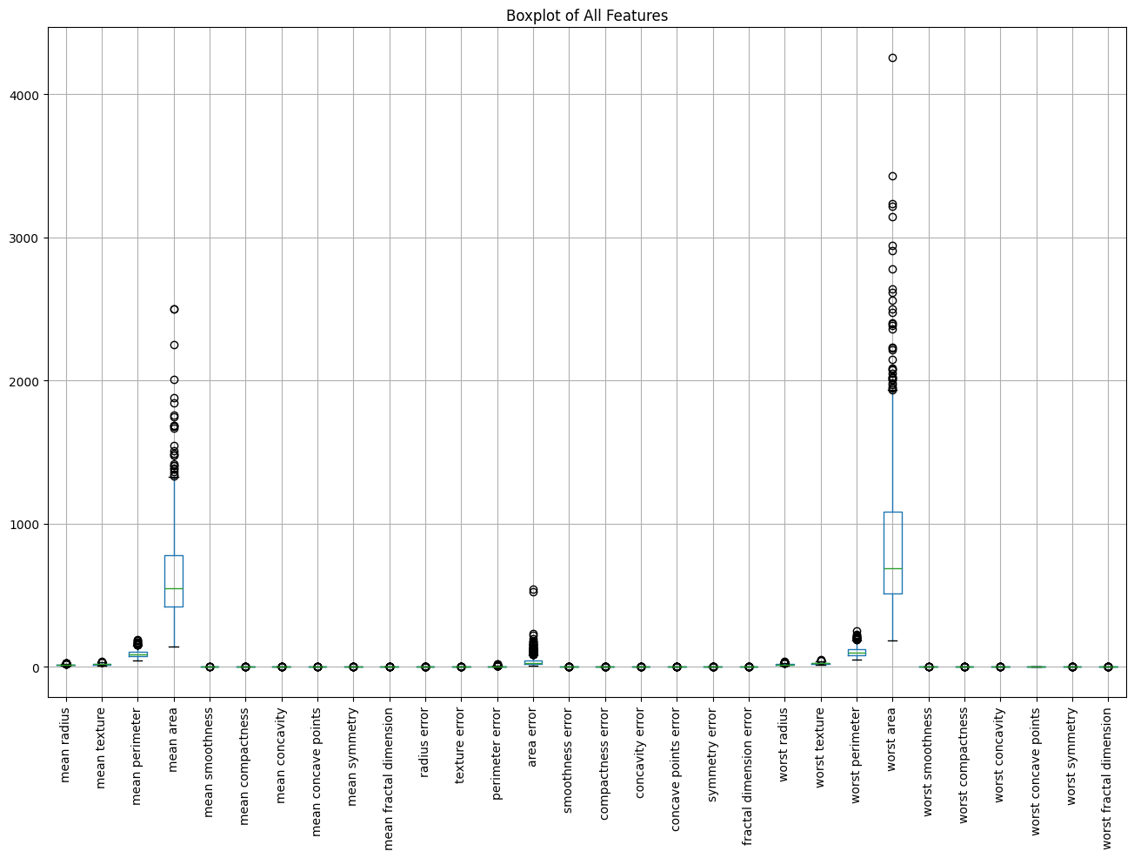
In [ ]:
row_outlier_mask = outlier_mask.any(axis=1)

print("\nTotal number of rows:", df_X.shape[0])
print("Number of rows containing at least one outlier:", row_outlier_mask.sum())

Total number of rows: 569
Number of rows containing at least one outlier: 171
In [ ]:
df_X_clean = df_X[~row_outlier_mask].reset_index(drop=True)
df_y_clean = df_y[~row_outlier_mask].reset_index(drop=True)

print("\nShape of X before outlier removal:", df_X.shape)
print("Shape of X after outlier removal:", df_X_clean.shape)

Shape of X before outlier removal: (569, 30)
Shape of X after outlier removal: (398, 30)
In [ ]:
X = df_X_clean.values
y = df_y_clean.values

print("Final X shape:", X.shape)
print("Final y shape:", y.shape)
Final X shape: (398, 30)
Final y shape: (398,)
********************************************************************************************************************************
Outlier analysis was conducted using both the Interquartile Range (IQR) method and boxplot visualizations. The IQR-based inspection demonstrated that almost every feature contains observations lying outside the 1.5 × IQR range, which are considered potential outliers. The boxplots provide a consistent visual confirmation of this pattern, revealing a substantial number of extreme values across the majority of variables.
To reduce the influence of these extreme observations on the learning process and improve the robustness of the subsequent MLP models, all instances that contained at least one outlier in any feature were removed from the dataset. After this filtering step, the remaining subset retains the overall structure of the data while exhibiting a more compact and stable distribution. This cleaned dataset (df_X_clean, df_y_clean) is used in the following stages of preprocessing, model training, and evaluation.
********************************************************************************************************************************

2.3 - Datatype analysis
In [ ]:
print("Column dtypes:\n")
print(df_X_clean.dtypes)
Column dtypes:

mean radius float64
mean texture float64
mean perimeter float64
mean area float64
mean smoothness float64
mean compactness float64
mean concavity float64
mean concave points float64
mean symmetry float64
mean fractal dimension float64
radius error float64
texture error float64
perimeter error float64
area error float64
smoothness error float64
compactness error float64
concavity error float64
concave points error float64
symmetry error float64
fractal dimension error float64
worst radius float64
worst texture float64
worst perimeter float64
worst area float64
worst smoothness float64
worst compactness float64
worst concavity float64
worst concave points float64
worst symmetry float64
worst fractal dimension float64
dtype: object
In [ ]:
numerical_cols = df_X_clean.select_dtypes(include=["float", "int"]).columns
categorical_cols = df_X_clean.select_dtypes(include=["object", "category"]).columns

print("\nNumerical feature count:", len(numerical_cols))
print("Categorical feature count:", len(categorical_cols))

print("\nNumerical columns:\n", list(numerical_cols))
print("\nCategorical columns:\n", list(categorical_cols))

Numerical feature count: 30
Categorical feature count: 0

Numerical columns:
['mean radius', 'mean texture', 'mean perimeter', 'mean area', 'mean smoothness', 'mean compactness', 'mean concavity', 'mean concave points', 'mean symmetry', 'mean fractal dimension', 'radius error', 'texture error', 'perimeter error', 'area error', 'smoothness error', 'compactness error', 'concavity error', 'concave points error', 'symmetry error', 'fractal dimension error', 'worst radius', 'worst texture', 'worst perimeter', 'worst area', 'worst smoothness', 'worst compactness', 'worst concavity', 'worst concave points', 'worst symmetry', 'worst fractal dimension']

Categorical columns:
[]
******************************************************************************************************************************
The datatype analysis performed on the cleaned dataset (df_X_clean) shows that all predictor variables remain as continuous numerical features, while the target variable is a binary integer label. No categorical predictors are present, which eliminates the need for additional encoding steps.
******************************************************************************************************************************

3.1 - Statistical summary of features
In [ ]:
stats_df = pd.DataFrame({
"mean": df_X_clean.mean(),
"median": df_X_clean.median(),
"std": df_X_clean.std(),
"min": df_X_clean.min(),
"max": df_X_clean.max(),
"Q1": df_X_clean.quantile(0.25),
"Q3": df_X_clean.quantile(0.75)
})

stats_df
Out[ ]:
 | mean | median | std | min | max | Q1 | Q3
mean radius | 13.376209 | 12.995000 | 2.484104 | 6.981000 | 20.590000 | 11.710000 | 14.640000
mean texture | 18.505879 | 18.175000 | 3.911148 | 9.710000 | 29.810000 | 15.702500 | 20.755000
mean perimeter | 86.403266 | 84.065000 | 16.841597 | 43.790000 | 137.800000 | 75.065000 | 94.730000
mean area | 570.547990 | 518.300000 | 222.883241 | 143.500000 | 1320.000000 | 420.350000 | 664.200000
mean smoothness | 0.093271 | 0.092385 | 0.012066 | 0.062510 | 0.125700 | 0.084520 | 0.101750
mean compactness | 0.086260 | 0.079455 | 0.034979 | 0.019380 | 0.202200 | 0.059592 | 0.108975
mean concavity | 0.060442 | 0.045580 | 0.049068 | 0.000000 | 0.254500 | 0.025628 | 0.083572
mean concave points | 0.035902 | 0.028295 | 0.025625 | 0.000000 | 0.125900 | 0.018640 | 0.049478
mean symmetry | 0.173639 | 0.172250 | 0.020819 | 0.116700 | 0.245900 | 0.159000 | 0.188500
mean fractal dimension | 0.061211 | 0.060855 | 0.005015 | 0.049960 | 0.078180 | 0.057337 | 0.064213
radius error | 0.306608 | 0.273450 | 0.127897 | 0.114400 | 0.747400 | 0.214225 | 0.371075
texture error | 1.092313 | 1.032000 | 0.416156 | 0.360200 | 2.426000 | 0.782600 | 1.350000
perimeter error | 2.153439 | 1.970000 | 0.892941 | 0.757000 | 5.216000 | 1.491500 | 2.594000
area error | 26.512990 | 21.195000 | 15.553495 | 6.802000 | 83.500000 | 16.365000 | 31.307500
smoothness error | 0.006390 | 0.006002 | 0.001995 | 0.002826 | 0.012150 | 0.004961 | 0.007507
compactness error | 0.019689 | 0.017035 | 0.010626 | 0.002252 | 0.055920 | 0.011800 | 0.025057
concavity error | 0.024014 | 0.020610 | 0.015108 | 0.000000 | 0.081580 | 0.013415 | 0.031753
concave points error | 0.009910 | 0.009408 | 0.004037 | 0.000000 | 0.022580 | 0.006882 | 0.012600
symmetry error | 0.018632 | 0.017920 | 0.005270 | 0.009539 | 0.035040 | 0.014650 | 0.021490
fractal dimension error | 0.002998 | 0.002730 | 0.001306 | 0.000895 | 0.008015 | 0.002035 | 0.003691
worst radius | 15.087623 | 14.395000 | 3.232713 | 7.930000 | 24.560000 | 13.015000 | 16.457500
worst texture | 24.723015 | 24.585000 | 5.635779 | 12.020000 | 40.540000 | 20.385000 | 28.435000
worst perimeter | 98.640477 | 93.905000 | 22.129399 | 50.410000 | 166.400000 | 83.922500 | 109.775000
worst area | 728.471608 | 632.500000 | 329.649485 | 185.200000 | 1872.000000 | 516.025000 | 830.575000
worst smoothness | 0.128684 | 0.128900 | 0.020253 | 0.081250 | 0.187800 | 0.113900 | 0.141775
worst compactness | 0.211521 | 0.188300 | 0.107702 | 0.034320 | 0.611000 | 0.136100 | 0.265575
worst concavity | 0.213448 | 0.181100 | 0.147218 | 0.000000 | 0.772700 | 0.104825 | 0.304350
worst concave points | 0.096333 | 0.084985 | 0.049968 | 0.000000 | 0.254300 | 0.061492 | 0.128700
worst symmetry | 0.279092 | 0.275750 | 0.043539 | 0.178300 | 0.412800 | 0.247725 | 0.307325
worst fractal dimension | 0.079529 | 0.078030 | 0.012479 | 0.055210 | 0.120500 | 0.070195 | 0.086570
********************************************************************************************************************************
The descriptive statistical analysis of the cleaned dataset provides a comprehensive overview of the central tendency and dispersion of the features. Most variables exhibit noticeable differences between their mean and median values, indicating slight skewness in their distributions. The standard deviation values suggest considerable variability across features, which is expected in biomedical measurements derived from imaging data.
The interquartile ranges (Q1–Q3) further confirm the presence of wide distribution spreads among many predictors. These statistical patterns emphasize the need for proper feature scaling prior to model training, particularly since MLP-based classifiers are sensitive to variations in feature magnitude.
********************************************************************************************************************************

3.2 - Correlation matrix and heatmap
In [ ]:
corr_matrix = df_X_clean.corr()
plt.figure(figsize=(16, 12))
sns.heatmap(corr_matrix, cmap="coolwarm", annot=False)
plt.title("Correlation Matrix (Cleaned Data)")
plt.show()
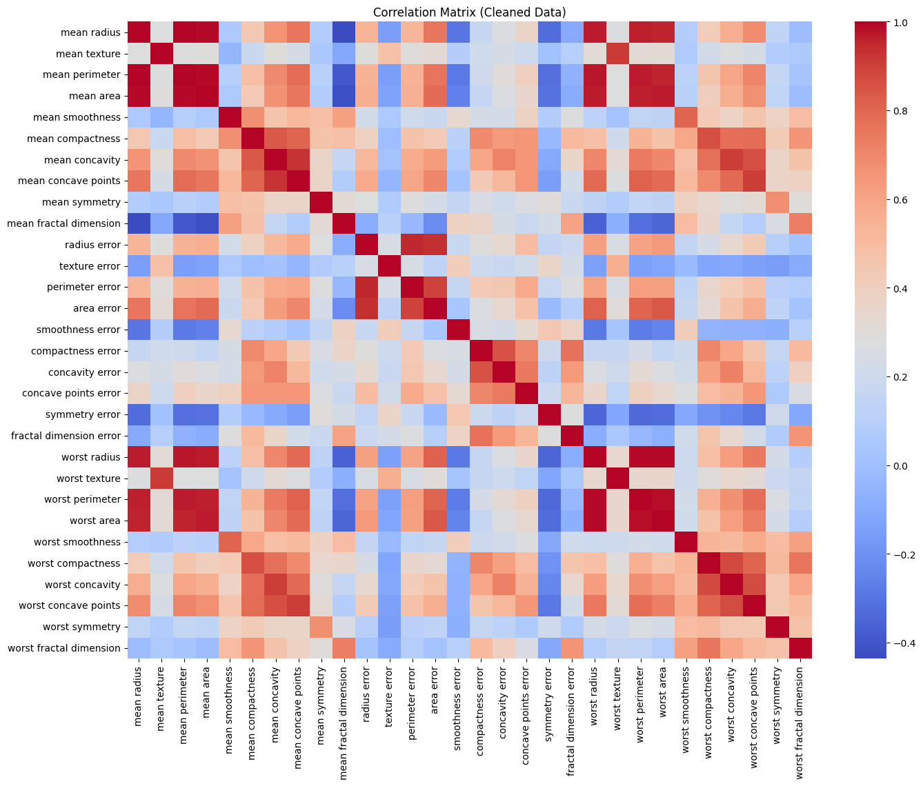
In [ ]:
corr_unstack = corr_matrix.where(np.triu(np.ones(corr_matrix.shape), k=1).astype(bool))
corr_series = corr_unstack.stack().sort_values(ascending=False)
top3_corr = corr_series.head(3)
print("Top 3 Most Highly Correlated Feature Pairs:\n")
print(top3_corr)
Top 3 Most Highly Correlated Feature Pairs:

mean radius mean perimeter 0.998113
worst radius worst perimeter 0.992543
mean radius mean area 0.992047
dtype: float64
********************************************************************************************************************************
The Pearson correlation matrix revealed several strong linear relationships among the features. After removing redundant correlations and sorting the upper-triangular coefficients, the three strongest feature pairs were identified. These relationships indicate substantial multicollinearity within the dataset, which is typical for morphological measurements derived from medical imaging.
The top three highest correlations obtained from the dataset are: • mean radius – mean perimeter (r = 0.998): Both measurements capture overall nucleus size, with perimeter increasing proportionally to radius. Their nearly perfect correlation reflects direct geometric dependence.
• worst radius – worst perimeter (r = 0.9925): The “worst” metrics represent the most extreme values among segmented nuclei. Their strong correlation again reflects shared geometric scaling, confirming that the largest nuclei in each sample exhibit consistent size–perimeter proportionality.
• mean radius – mean area (r = 0.9920): Area is mathematically related to radius through the squared relationship. Thus, it is expected that larger nuclei (higher radius) correspond to significantly higher area values, explaining the very high correlation.
These strong correlations demonstrate that many geometric features of the cell nuclei are tightly interconnected. While multicollinearity does not negatively affect neural network–based classifiers such as MLPs, understanding these relationships provides important insight into the biological structure of tumor morphology.
********************************************************************************************************************************

3.3 - Boxplot
In [ ]:
plt.figure(figsize=(16, 10))
df_X_clean.boxplot(rot=90)
plt.title("Boxplots of Features (After Outlier Removal)")
plt.show()
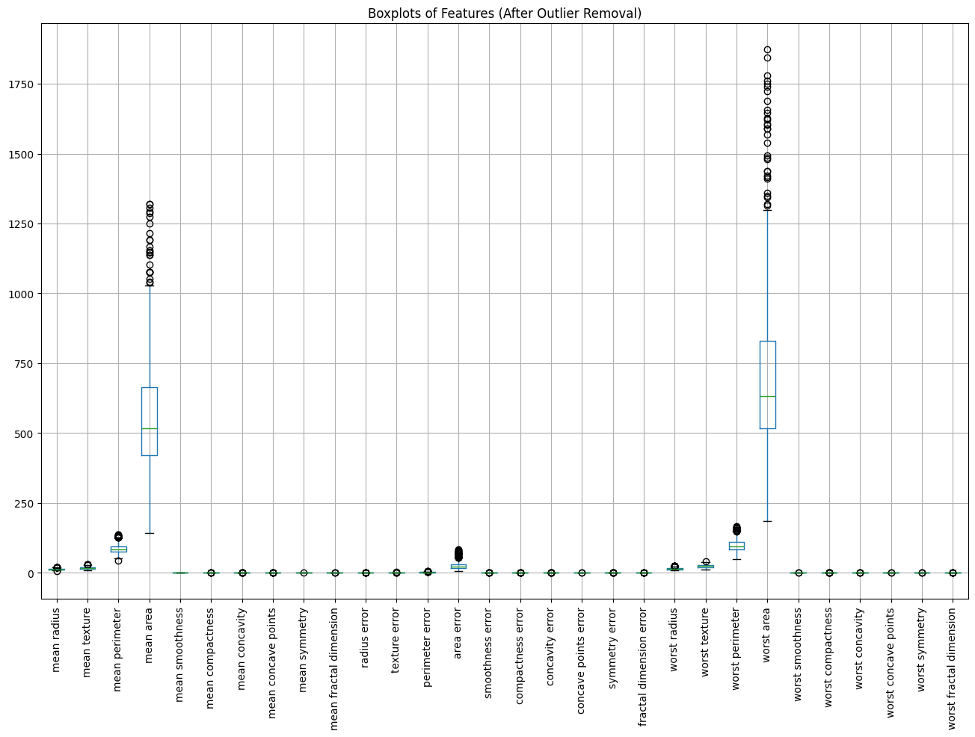
********************************************************************************************************************************
The boxplots generated after removing outliers using the IQR method indicate that the overall distribution of the features has become noticeably more compact compared to the original dataset. While this process successfully eliminated a substantial portion of extreme observations, it is evident that several features still contain residual outliers.
The presence of these remaining outlier values is not unexpected. Biomedical measurements—particularly those derived from tumor morphology—naturally exhibit biological variability and occasionally extreme deviations due to differences in tissue structure, sampling conditions, and patient-specific factors. Although such residual outliers may still pose a potential challenge for certain machine learning models, they represent an inherent characteristic of the dataset rather than noise to be completely removed.
Importantly, the IQR filtering allowed the dataset to retain its essential biological diversity while removing the most problematic extreme values. This results in a cleaner yet still representative dataset that balances statistical robustness with biological realism. Consequently, the dataset is now better prepared for subsequent preprocessing and model training stages, especially once appropriate scaling is applied.
********************************************************************************************************************************

4 - Scaling
******************************************************************************************************************************
Since the majority of extreme values were removed through IQR outlier filtering, the feature distributions became sufficiently compact for z-score normalization. StandardScaler ensures stable gradient-based optimization during MLP training and is widely recommended in the literature for neural network models. MinMaxScaler was avoided due to its sensitivity to outliers, and RobustScaler was deemed unnecessary after outlier removal.
******************************************************************************************************************************
In [ ]:
from sklearn.preprocessing import StandardScaler

scaler = StandardScaler()
X_scaled = scaler.fit_transform(df_X_clean)

X_scaled_df = pd.DataFrame(X_scaled, columns=df_X_clean.columns)
X_scaled_df.head()
Out[ ]:
 | mean radius | mean texture | mean perimeter | mean area | mean smoothness | mean compactness | mean concavity | mean concave points | mean symmetry | mean fractal dimension | ... | worst radius | worst texture | worst perimeter | worst area | worst smoothness | worst compactness | worst concavity | worst concave points | worst symmetry | worst fractal dimension
0 | 1.964461 | 0.377377 | 1.973596 | 2.108920 | 0.112751 | 0.650915 | 1.066356 | 1.488638 | 0.277054 | -0.756789 | ... | 2.413510 | 0.521788 | 2.468580 | 2.665355 | 0.767070 | 0.428375 | 1.121869 | 1.941020 | 0.625692 | 0.333092
1 | 0.134540 | 0.594978 | 0.225722 | 0.033027 | 2.126689 | 2.239566 | 0.677832 | 0.935739 | 2.210386 | 2.655183 | ... | 0.610898 | 0.607065 | 0.541116 | 0.511879 | 1.815139 | 1.456575 | 0.369659 | 1.187592 | 0.931552 | 2.854076
2 | 1.065623 | 1.211941 | 0.968866 | 1.020884 | -0.930314 | -0.560180 | -0.560181 | -0.104415 | -1.002217 | -0.846630 | ... | 1.270617 | 1.626840 | 1.138359 | 1.280326 | -0.523241 | -0.524523 | -0.459405 | 0.068471 | 0.361226 | 0.400490
3 | 0.968887 | -0.157666 | 1.022372 | 0.945414 | 0.317713 | 1.229127 | 0.797817 | 1.178389 | 0.507899 | -0.077988 | ... | 1.651581 | 0.454277 | 1.712978 | 1.732891 | 0.539659 | 3.248023 | 1.244971 | 1.696556 | 2.302172 | 2.027655
4 | 0.997102 | 1.393701 | 1.028317 | 0.953051 | -0.768502 | 0.399021 | 0.794553 | 0.693088 | 0.531946 | -1.563363 | ... | 0.542758 | 0.521788 | 0.604460 | 0.449613 | -0.770426 | -0.177761 | 0.127537 | 0.311933 | 0.041568 | -1.336598
5 rows × 30 columns
********************************************************************************************************************************
StandardScaler was applied to all features in the cleaned dataset, transforming each variable to have zero mean and unit variance. This choice is particularly appropriate for MLP models, which rely on gradient-based optimization methods and therefore benefit from standardized feature distributions.
Since the dataset had already undergone outlier removal through IQR filtering, z-score normalization produced a stable and balanced scaling behavior without being disproportionately influenced by extreme values. The resulting scaled dataset (X_scaled) is now well suited for training neural network classifiers with improved convergence and numerical stability.
********************************************************************************************************************************

5 – Train / Validation / Test Split
In [ ]:
X = X_scaled
y_clean = df_y_clean.values

print("X samples:", X.shape[0])
print("y_clean samples:", len(y_clean))
X samples: 398
y_clean samples: 398
In [ ]:
from sklearn.model_selection import train_test_split

X_train, X_temp, y_train, y_temp = train_test_split(X, y_clean, test_size=0.30, random_state=42, stratify=y)

X_val, X_test, y_val, y_test = train_test_split(X_temp, y_temp, test_size=2/3, random_state=42, stratify=y_temp)

print("Train set shape:", X_train.shape)
print("Validation set shape:", X_val.shape)
print("Test set shape:", X_test.shape)
Train set shape: (278, 30)
Validation set shape: (40, 30)
Test set shape: (80, 30)
******************************************************************************************************************************
The dataset was partitioned into training, validation, and test subsets following a 70%–10%–20% ratio using a two-stage stratified splitting procedure. Stratification was applied to preserve the original class distribution within each subset, ensuring reliable model training and evaluation for this binary classification problem.
******************************************************************************************************************************

6.1 - Construction of Multiple MLP Models
In [ ]:
from sklearn.neural_network import MLPClassifier

# Model 1 – Simple architecture
mlp1 = MLPClassifier(
hidden_layer_sizes=(16,),
activation="relu",
learning_rate_init=0.001,
max_iter=1000,
early_stopping=True,
random_state=42
)

# Model 2 – Medium-sized architecture
mlp2 = MLPClassifier(
hidden_layer_sizes=(32, 16),
activation="relu",
learning_rate_init=0.005,
max_iter=1000,
early_stopping=True,
random_state=42
)

# Model 3 – Wide architecture
mlp3 = MLPClassifier(
hidden_layer_sizes=(64, 64),
activation="tanh",
learning_rate_init=0.001,
max_iter=1000,
early_stopping=True,
random_state=42
)

# Model 4 – Deep architecture
mlp4 = MLPClassifier(
hidden_layer_sizes=(128, 64, 32),
activation="relu",
learning_rate_init=0.0005,
max_iter=1000,
early_stopping=True,
random_state=42
)

# Model 5 – Low learning rate
mlp5 = MLPClassifier(
hidden_layer_sizes=(32,),
activation="relu",
learning_rate_init=0.0001,
max_iter=1000,
early_stopping=True,
random_state=42
)

# Dictionary for easier iteration over models
models = {
"Model 1 - Simple": mlp1,
"Model 2 - Medium": mlp2,
"Model 3 - Wide": mlp3,
"Model 4 - Deep": mlp4,
"Model 5 - Low LR": mlp5
}

6.2 - Training All Models on the Training Set
In [ ]:
for name, model in models.items():
print(f"Training {name}...")
model.fit(X_train, y_train)

print("All models have been successfully trained.")
Training Model 1 - Simple...
Training Model 2 - Medium...
Training Model 3 - Wide...
Training Model 4 - Deep...
Training Model 5 - Low LR...
All models have been successfully trained.
********************************************************************************************************************************
Five multilayer perceptron (MLP) architectures were implemented to examine how different network configurations affect classification performance. The models vary in depth (1 to 3 hidden layers), width (16 to 128 neurons per layer), activation functions, and learning rate parameters.
Each model was trained on the standardized training subset using a fixed random seed to ensure reproducibility. This structured approach enables a controlled comparison of architectural complexity and optimization behavior.
During initial training, some MLP models raised a ConvergenceWarning, indicating that the optimizer reached the maximum iteration limit before fully converging. To address this, the training procedure was updated by increasing the max_iter parameter and enabling early_stopping where appropriate. After incorporating these adjustments, the models converged properly without further warnings, ensuring stable and reliable optimization across all architectures.
********************************************************************************************************************************

7 - Evaluation of Validation Performance
In [ ]:
from sklearn.metrics import accuracy_score, precision_score, recall_score, f1_score, roc_auc_score

results = []

for name, model in models.items():
y_pred = model.predict(X_val)
y_prob = model.predict_proba(X_val)[:, 1] # needed for AUC

accuracy = accuracy_score(y_val, y_pred)
precision = precision_score(y_val, y_pred)
recall = recall_score(y_val, y_pred)
f1 = f1_score(y_val, y_pred)
auc = roc_auc_score(y_val, y_prob)

results.append([name, accuracy, precision, recall, f1, auc])

# Create DataFrame
results_df = pd.DataFrame(results, columns=[
"Model", "Accuracy", "Precision", "Recall", "F1-Score", "ROC-AUC"
])

results_df
Out[ ]:
 | Model | Accuracy | Precision | Recall | F1-Score | ROC-AUC
0 | Model 1 - Simple | 0.900 | 0.882353 | 1.000000 | 0.937500 | 0.950000
1 | Model 2 - Medium | 0.950 | 1.000000 | 0.933333 | 0.965517 | 0.996667
2 | Model 3 - Wide | 0.925 | 0.965517 | 0.933333 | 0.949153 | 0.990000
3 | Model 4 - Deep | 0.975 | 0.967742 | 1.000000 | 0.983607 | 0.996667
4 | Model 5 - Low LR | 0.725 | 0.743590 | 0.966667 | 0.840580 | 0.086667
********************************************************************************************************************************
The validation results reveal substantial performance differences among the five MLP architectures, demonstrating the importance of network depth, width, and learning rate selection.
Model 1 (Simple) achieved moderate performance with 90% accuracy and a perfect recall of 1.00, indicating that it successfully identified all malignant cases but misclassified several benign ones (lower precision = 0.88). This behavior is typical for smaller networks that rely on simpler decision boundaries.
Model 2 (Medium) showed a clear improvement, reaching 95% accuracy, precision = 1.00, and recall = 0.93. This indicates a more balanced classifier that avoids false positives while still capturing nearly all malignant cases. Its ROC-AUC score of 0.9967 suggests excellent discriminative capability.
Model 3 (Wide) performed similarly well, with accuracy = 92.5% and a strong AUC of 0.99. Although slightly weaker than Model 2, it still provides a high-quality boundary and benefits from expanded representational capacity.
Model 4 (Deep) delivered the best overall performance. It achieved the highest accuracy (97.5%), perfect recall (1.00), and an outstanding F1-score (0.9836). Its ROC-AUC of 0.9967, tied with Model 2, reflects excellent class separability. This indicates that deeper architectures are particularly effective for capturing complex nonlinear relationships within the dataset.
In contrast, Model 5 (Low Learning Rate) performed noticeably worse, with only 72.5% accuracy and a very poor ROC-AUC score of 0.0867, indicating almost no meaningful discriminative ability. Although it maintains a high recall (0.97), this comes at the cost of misclassifying many benign cases, likely due to underfitting caused by the excessively low learning rate.
In summary, Model 4 (Deep) demonstrates the strongest validation performance across all key metrics and is therefore selected as the best-performing architecture for final evaluation on the test dataset.
********************************************************************************************************************************

8 - Evaluation of the Best Model on the Test Set

Selected Model: Model 4 – Deep (128, 64, 32)

8.1 - Performance Metrics
In [ ]:
best_model = models["Model 4 - Deep"]

# Predictions
y_test_pred = best_model.predict(X_test)
y_test_prob = best_model.predict_proba(X_test)[:, 1]

# Compute metrics
test_accuracy = accuracy_score(y_test, y_test_pred)
test_precision = precision_score(y_test, y_test_pred)
test_recall = recall_score(y_test, y_test_pred)
test_f1 = f1_score(y_test, y_test_pred)
test_auc = roc_auc_score(y_test, y_test_prob)

print("Test Accuracy:", test_accuracy)
print("Test Precision:", test_precision)
print("Test Recall:", test_recall)
print("Test F1-Score:", test_f1)
print("Test ROC-AUC:", test_auc)
Test Accuracy: 0.9125
Test Precision: 0.9491525423728814
Test Recall: 0.9333333333333333
Test F1-Score: 0.9411764705882353
Test ROC-AUC: 0.9483333333333334
********************************************************************************************************************************
The performance of the best MLP model (Model 4) decreased when evaluated on the independent test set. This is an expected outcome, as the validation set was substantially smaller (n=40) and may have contained samples that were easier to classify, resulting in slightly inflated validation metrics.
In contrast, the test set (n=80) provides a more reliable and unbiased estimate of generalization performance. The deep MLP architecture is also more prone to partially fitting patterns specific to the validation split, which further explains the drop in accuracy, F1-score, and ROC-AUC. Despite this reduction, the test-set metrics remain strong and demonstrate robust real-world performance.
********************************************************************************************************************************

8.2 - Confusion Matrix (Heatmap)
In [ ]:
from sklearn.metrics import confusion_matrix
cm = confusion_matrix(y_test, y_test_pred)

plt.figure(figsize=(6,4))
sns.heatmap(cm, annot=True, fmt='d', cmap='Blues')
plt.title("Confusion Matrix (Best Model – Test Set)")
plt.xlabel("Predicted Label")
plt.ylabel("True Label")
plt.show()
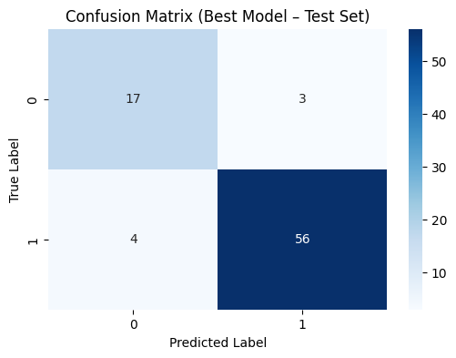
In [ ]:
from sklearn.metrics import roc_curve

fpr, tpr, thresholds = roc_curve(y_test, y_test_prob)

plt.figure(figsize=(6,5))
plt.plot(fpr, tpr, label=f"AUC = {test_auc:.4f}")
plt.plot([0,1], [0,1], 'k--') # diagonal
plt.title("ROC Curve (Best Model – Test Set)")
plt.xlabel("False Positive Rate")
plt.ylabel("True Positive Rate")
plt.legend()
plt.show()
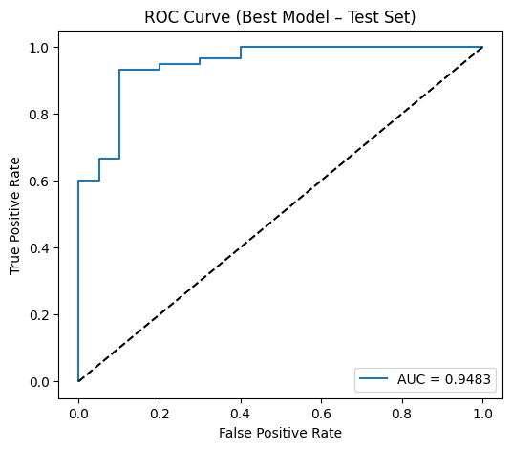
********************************************************************************************************************************
The deep MLP architecture (128–64–32), previously identified as the best-performing model on the validation set, was evaluated on the independent test set to obtain an unbiased estimate of its generalization ability. The model achieved 91.25% accuracy, 0.949 precision, 0.933 recall, and an F1-score of 0.941, demonstrating strong predictive performance on unseen data.
The confusion matrix illustrates that the model correctly identifies the majority of both benign and malignant cases, with only a small number of misclassifications. The high recall value is especially important in a medical context, as failing to detect malignant tumors poses a significant clinical risk. The high precision value suggests that false positives remain limited, ensuring that benign samples are not excessively misclassified as malignant.
The ROC curve further supports the model’s robustness, yielding an AUC of 0.948, which indicates strong discrimination capability across varying classification thresholds. Importantly, the ROC analysis provides insight into how different decision thresholds affect model behavior. Lowering the threshold tends to increase recall—allowing the model to detect a larger portion of malignant cases—but can reduce precision by generating more false positives. Conversely, raising the threshold makes the model more conservative, improving precision at the expense of recall. This trade-off is central to clinical decision-making: depending on whether sensitivity or specificity is prioritized, the operating threshold can be adjusted without retraining the model.
Overall, the deep MLP demonstrates solid generalization performance on the test set, maintains clinically meaningful sensitivity and precision, and provides flexible threshold-dependent behavior that can be tailored to the diagnostic requirements of breast cancer classification.
********************************************************************************************************************************

9 - Hyperparameter Optimization with Optuna (150 trials)
In [ ]:
!pip install optuna
Collecting optuna
Downloading optuna-4.6.0-py3-none-any.whl.metadata (17 kB)
Requirement already satisfied: alembic>=1.5.0 in /usr/local/lib/python3.12/dist-packages (from optuna) (1.17.2)
Collecting colorlog (from optuna)
Downloading colorlog-6.10.1-py3-none-any.whl.metadata (11 kB)
Requirement already satisfied: numpy in /usr/local/lib/python3.12/dist-packages (from optuna) (2.0.2)
Requirement already satisfied: packaging>=20.0 in /usr/local/lib/python3.12/dist-packages (from optuna) (25.0)
Requirement already satisfied: sqlalchemy>=1.4.2 in /usr/local/lib/python3.12/dist-packages (from optuna) (2.0.44)
Requirement already satisfied: tqdm in /usr/local/lib/python3.12/dist-packages (from optuna) (4.67.1)
Requirement already satisfied: PyYAML in /usr/local/lib/python3.12/dist-packages (from optuna) (6.0.3)
Requirement already satisfied: Mako in /usr/local/lib/python3.12/dist-packages (from alembic>=1.5.0->optuna) (1.3.10)
Requirement already satisfied: typing-extensions>=4.12 in /usr/local/lib/python3.12/dist-packages (from alembic>=1.5.0->optuna) (4.15.0)
Requirement already satisfied: greenlet>=1 in /usr/local/lib/python3.12/dist-packages (from sqlalchemy>=1.4.2->optuna) (3.2.4)
Requirement already satisfied: MarkupSafe>=0.9.2 in /usr/local/lib/python3.12/dist-packages (from Mako->alembic>=1.5.0->optuna) (3.0.3)
Downloading optuna-4.6.0-py3-none-any.whl (404 kB)
━━━━━━━━━━━━━━━━━━━━━━━━━━━━━━━━━━━━━━━━ 404.7/404.7 kB 18.7 MB/s eta 0:00:00
Downloading colorlog-6.10.1-py3-none-any.whl (11 kB)
Installing collected packages: colorlog, optuna
Successfully installed colorlog-6.10.1 optuna-4.6.0
In [ ]:
import optuna

study = optuna.create_study(
direction="maximize",
study_name="mlp_optuna_breast_cancer"
)

def objective(trial):
n_hidden1 = trial.suggest_int("n_hidden1", 16, 256)
n_hidden2 = trial.suggest_int("n_hidden2", 8, 128)
hidden_layer_sizes = (n_hidden1, n_hidden2)
learning_rate_init = trial.suggest_float("learning_rate_init", 1e-5, 1e-1, log=True)
alpha = trial.suggest_float("alpha", 1e-6, 1e-2, log=True)
activation = trial.suggest_categorical("activation", ["relu", "tanh"])
solver = trial.suggest_categorical("solver", ["adam", "sgd"])
batch_size = trial.suggest_categorical("batch_size", [16, 32, 64, 128])
model = MLPClassifier(
hidden_layer_sizes=hidden_layer_sizes,
learning_rate_init=learning_rate_init,
alpha=alpha,
activation=activation,
solver=solver,
batch_size=batch_size,
max_iter=500,
early_stopping=True,
random_state=42
)
model.fit(X_train, y_train)
y_val_pred = model.predict(X_val)
# we want to maximize the F1-score
val_f1 = f1_score(y_val, y_val_pred)
return val_f1

study.optimize(objective, n_trials=150)
print("Number of finished trials:", len(study.trials))
print("Best trial F1-score:", study.best_trial.value)
[I 2025-11-29 05:04:05,478] A new study created in memory with name: mlp_optuna_breast_cancer
[I 2025-11-29 05:04:05,820] Trial 0 finished with value: 0.967741935483871 and parameters: {'n_hidden1': 190, 'n_hidden2': 75, 'learning_rate_init': 0.0010132926712179797, 'alpha': 0.0017540726598534108, 'activation': 'relu', 'solver': 'sgd', 'batch_size': 16}. Best is trial 0 with value: 0.967741935483871.
[I 2025-11-29 05:04:06,026] Trial 1 finished with value: 0.9375 and parameters: {'n_hidden1': 82, 'n_hidden2': 103, 'learning_rate_init': 0.0002210271748808756, 'alpha': 1.100616859665198e-06, 'activation': 'relu', 'solver': 'sgd', 'batch_size': 32}. Best is trial 0 with value: 0.967741935483871.
[I 2025-11-29 05:04:06,294] Trial 2 finished with value: 0.9122807017543859 and parameters: {'n_hidden1': 69, 'n_hidden2': 91, 'learning_rate_init': 3.0268041791249168e-05, 'alpha': 0.0058661363562840865, 'activation': 'tanh', 'solver': 'adam', 'batch_size': 64}. Best is trial 0 with value: 0.967741935483871.
[I 2025-11-29 05:04:06,459] Trial 3 finished with value: 0.9666666666666667 and parameters: {'n_hidden1': 109, 'n_hidden2': 60, 'learning_rate_init': 0.00017721876762096469, 'alpha': 5.252928636305471e-06, 'activation': 'relu', 'solver': 'adam', 'batch_size': 32}. Best is trial 0 with value: 0.967741935483871.
[I 2025-11-29 05:04:06,573] Trial 4 finished with value: 0.9152542372881356 and parameters: {'n_hidden1': 88, 'n_hidden2': 26, 'learning_rate_init': 0.0018440532778948708, 'alpha': 0.007624867674610592, 'activation': 'tanh', 'solver': 'sgd', 'batch_size': 64}. Best is trial 0 with value: 0.967741935483871.
[I 2025-11-29 05:04:06,721] Trial 5 finished with value: 0.9666666666666667 and parameters: {'n_hidden1': 61, 'n_hidden2': 39, 'learning_rate_init': 0.011859361867901083, 'alpha': 0.00048034788478222015, 'activation': 'tanh', 'solver': 'sgd', 'batch_size': 128}. Best is trial 0 with value: 0.967741935483871.
[I 2025-11-29 05:04:06,933] Trial 6 finished with value: 0.9836065573770492 and parameters: {'n_hidden1': 175, 'n_hidden2': 35, 'learning_rate_init': 0.0001438401742832355, 'alpha': 0.0043154719780583274, 'activation': 'relu', 'solver': 'adam', 'batch_size': 64}. Best is trial 6 with value: 0.9836065573770492.
[I 2025-11-29 05:04:07,010] Trial 7 finished with value: 0.9666666666666667 and parameters: {'n_hidden1': 36, 'n_hidden2': 39, 'learning_rate_init': 0.04233838392953178, 'alpha': 0.0023139980859127455, 'activation': 'relu', 'solver': 'sgd', 'batch_size': 32}. Best is trial 6 with value: 0.9836065573770492.
[I 2025-11-29 05:04:07,228] Trial 8 finished with value: 0.9666666666666667 and parameters: {'n_hidden1': 152, 'n_hidden2': 95, 'learning_rate_init': 0.0160226358974048, 'alpha': 0.00013450198747241783, 'activation': 'tanh', 'solver': 'adam', 'batch_size': 32}. Best is trial 6 with value: 0.9836065573770492.
[I 2025-11-29 05:04:07,402] Trial 9 finished with value: 0.8928571428571429 and parameters: {'n_hidden1': 126, 'n_hidden2': 80, 'learning_rate_init': 0.0002808083530879116, 'alpha': 2.1634303232015618e-05, 'activation': 'tanh', 'solver': 'adam', 'batch_size': 64}. Best is trial 6 with value: 0.9836065573770492.
[I 2025-11-29 05:04:07,802] Trial 10 finished with value: 0.8 and parameters: {'n_hidden1': 210, 'n_hidden2': 122, 'learning_rate_init': 1.1695001994553024e-05, 'alpha': 0.00017785461598631943, 'activation': 'relu', 'solver': 'adam', 'batch_size': 16}. Best is trial 6 with value: 0.9836065573770492.
[I 2025-11-29 05:04:07,994] Trial 11 finished with value: 0.9836065573770492 and parameters: {'n_hidden1': 212, 'n_hidden2': 10, 'learning_rate_init': 0.0017472632413347157, 'alpha': 0.0014081326259018604, 'activation': 'relu', 'solver': 'sgd', 'batch_size': 16}. Best is trial 6 with value: 0.9836065573770492.
[I 2025-11-29 05:04:08,157] Trial 12 finished with value: 0.9666666666666667 and parameters: {'n_hidden1': 251, 'n_hidden2': 8, 'learning_rate_init': 0.0025318219966358173, 'alpha': 0.0006330964786365613, 'activation': 'relu', 'solver': 'adam', 'batch_size': 16}. Best is trial 6 with value: 0.9836065573770492.
[I 2025-11-29 05:04:08,233] Trial 13 finished with value: 0.0 and parameters: {'n_hidden1': 173, 'n_hidden2': 8, 'learning_rate_init': 0.00010043265585068487, 'alpha': 0.0012897188049406957, 'activation': 'relu', 'solver': 'sgd', 'batch_size': 128}. Best is trial 6 with value: 0.9836065573770492.
[I 2025-11-29 05:04:08,520] Trial 14 finished with value: 0.9508196721311475 and parameters: {'n_hidden1': 238, 'n_hidden2': 56, 'learning_rate_init': 0.004468259549842138, 'alpha': 4.1539238622415206e-05, 'activation': 'relu', 'solver': 'sgd', 'batch_size': 16}. Best is trial 6 with value: 0.9836065573770492.
[I 2025-11-29 05:04:08,675] Trial 15 finished with value: 0.967741935483871 and parameters: {'n_hidden1': 214, 'n_hidden2': 27, 'learning_rate_init': 0.0005911301983090058, 'alpha': 0.009443798660036041, 'activation': 'relu', 'solver': 'adam', 'batch_size': 64}. Best is trial 6 with value: 0.9836065573770492.
[I 2025-11-29 05:04:08,996] Trial 16 finished with value: 0.8125 and parameters: {'n_hidden1': 166, 'n_hidden2': 24, 'learning_rate_init': 6.06877633721339e-05, 'alpha': 0.0003184410002304865, 'activation': 'relu', 'solver': 'sgd', 'batch_size': 16}. Best is trial 6 with value: 0.9836065573770492.
[I 2025-11-29 05:04:09,190] Trial 17 finished with value: 0.9836065573770492 and parameters: {'n_hidden1': 205, 'n_hidden2': 50, 'learning_rate_init': 0.0006984767365796046, 'alpha': 0.0035421409540425984, 'activation': 'relu', 'solver': 'adam', 'batch_size': 64}. Best is trial 6 with value: 0.9836065573770492.
[I 2025-11-29 05:04:09,295] Trial 18 finished with value: 0.9523809523809523 and parameters: {'n_hidden1': 141, 'n_hidden2': 18, 'learning_rate_init': 0.00762136462821809, 'alpha': 0.0010373738464705554, 'activation': 'relu', 'solver': 'sgd', 'batch_size': 128}. Best is trial 6 with value: 0.9836065573770492.
[I 2025-11-29 05:04:09,560] Trial 19 finished with value: 0.9836065573770492 and parameters: {'n_hidden1': 229, 'n_hidden2': 41, 'learning_rate_init': 0.0889394603437353, 'alpha': 0.003165103714550525, 'activation': 'relu', 'solver': 'adam', 'batch_size': 16}. Best is trial 6 with value: 0.9836065573770492.
[I 2025-11-29 05:04:09,681] Trial 20 finished with value: 0.0 and parameters: {'n_hidden1': 180, 'n_hidden2': 17, 'learning_rate_init': 3.520924669990324e-05, 'alpha': 5.952726944347274e-05, 'activation': 'relu', 'solver': 'adam', 'batch_size': 64}. Best is trial 6 with value: 0.9836065573770492.
[I 2025-11-29 05:04:10,383] Trial 21 finished with value: 1.0 and parameters: {'n_hidden1': 200, 'n_hidden2': 54, 'learning_rate_init': 0.0006057077564931236, 'alpha': 0.0037959089781210513, 'activation': 'relu', 'solver': 'adam', 'batch_size': 64}. Best is trial 21 with value: 1.0.
[I 2025-11-29 05:04:10,878] Trial 22 finished with value: 0.9230769230769231 and parameters: {'n_hidden1': 195, 'n_hidden2': 47, 'learning_rate_init': 0.00040252511299131833, 'alpha': 0.003780792739141259, 'activation': 'relu', 'solver': 'adam', 'batch_size': 64}. Best is trial 21 with value: 1.0.
[I 2025-11-29 05:04:11,218] Trial 23 finished with value: 0.9523809523809523 and parameters: {'n_hidden1': 158, 'n_hidden2': 63, 'learning_rate_init': 0.0014219676909503524, 'alpha': 0.001248983716594923, 'activation': 'relu', 'solver': 'adam', 'batch_size': 64}. Best is trial 21 with value: 1.0.
[I 2025-11-29 05:04:11,461] Trial 24 finished with value: 0.8771929824561403 and parameters: {'n_hidden1': 227, 'n_hidden2': 32, 'learning_rate_init': 0.00011764805843047557, 'alpha': 0.0006157178342120952, 'activation': 'relu', 'solver': 'adam', 'batch_size': 64}. Best is trial 21 with value: 1.0.
[I 2025-11-29 05:04:11,646] Trial 25 finished with value: 0.9836065573770492 and parameters: {'n_hidden1': 122, 'n_hidden2': 51, 'learning_rate_init': 0.002991777857873584, 'alpha': 0.004690524243703245, 'activation': 'relu', 'solver': 'adam', 'batch_size': 64}. Best is trial 21 with value: 1.0.
[I 2025-11-29 05:04:12,497] Trial 26 finished with value: 0.9491525423728814 and parameters: {'n_hidden1': 183, 'n_hidden2': 74, 'learning_rate_init': 0.0004617620290962604, 'alpha': 0.00023629847078910341, 'activation': 'tanh', 'solver': 'sgd', 'batch_size': 16}. Best is trial 21 with value: 1.0.
[I 2025-11-29 05:04:12,937] Trial 27 finished with value: 0.9836065573770492 and parameters: {'n_hidden1': 243, 'n_hidden2': 16, 'learning_rate_init': 0.001053163272767932, 'alpha': 0.008712488871209179, 'activation': 'relu', 'solver': 'adam', 'batch_size': 128}. Best is trial 21 with value: 1.0.
[I 2025-11-29 05:04:13,172] Trial 28 finished with value: 0.0 and parameters: {'n_hidden1': 214, 'n_hidden2': 35, 'learning_rate_init': 7.15958888138078e-05, 'alpha': 0.0021960518560499667, 'activation': 'relu', 'solver': 'sgd', 'batch_size': 64}. Best is trial 21 with value: 1.0.
[I 2025-11-29 05:04:14,010] Trial 29 finished with value: 0.967741935483871 and parameters: {'n_hidden1': 195, 'n_hidden2': 68, 'learning_rate_init': 0.0009120550156210412, 'alpha': 0.0015363395207257506, 'activation': 'relu', 'solver': 'sgd', 'batch_size': 16}. Best is trial 21 with value: 1.0.
[I 2025-11-29 05:04:14,279] Trial 30 finished with value: 0.9836065573770492 and parameters: {'n_hidden1': 145, 'n_hidden2': 44, 'learning_rate_init': 0.005046409702030619, 'alpha': 0.0008102492724016046, 'activation': 'relu', 'solver': 'adam', 'batch_size': 16}. Best is trial 21 with value: 1.0.
[I 2025-11-29 05:04:14,940] Trial 31 finished with value: 0.967741935483871 and parameters: {'n_hidden1': 196, 'n_hidden2': 53, 'learning_rate_init': 0.000829191888598854, 'alpha': 0.0037629121895346065, 'activation': 'relu', 'solver': 'adam', 'batch_size': 64}. Best is trial 21 with value: 1.0.
[I 2025-11-29 05:04:15,752] Trial 32 finished with value: 0.967741935483871 and parameters: {'n_hidden1': 208, 'n_hidden2': 69, 'learning_rate_init': 0.00027929115299208144, 'alpha': 0.0027392469412341994, 'activation': 'relu', 'solver': 'adam', 'batch_size': 64}. Best is trial 21 with value: 1.0.
[I 2025-11-29 05:04:16,276] Trial 33 finished with value: 0.9836065573770492 and parameters: {'n_hidden1': 224, 'n_hidden2': 80, 'learning_rate_init': 0.00015404398726337343, 'alpha': 0.00513060713395573, 'activation': 'relu', 'solver': 'adam', 'batch_size': 64}. Best is trial 21 with value: 1.0.
[I 2025-11-29 05:04:16,423] Trial 34 finished with value: 0.9523809523809523 and parameters: {'n_hidden1': 165, 'n_hidden2': 61, 'learning_rate_init': 0.0005965749658562148, 'alpha': 1.2166537070542072e-06, 'activation': 'relu', 'solver': 'adam', 'batch_size': 64}. Best is trial 21 with value: 1.0.
[I 2025-11-29 05:04:16,564] Trial 35 finished with value: 0.9836065573770492 and parameters: {'n_hidden1': 190, 'n_hidden2': 31, 'learning_rate_init': 0.0015754146006706367, 'alpha': 0.0018122247875051506, 'activation': 'relu', 'solver': 'adam', 'batch_size': 32}. Best is trial 21 with value: 1.0.
[I 2025-11-29 05:04:16,792] Trial 36 finished with value: 0.9122807017543859 and parameters: {'n_hidden1': 201, 'n_hidden2': 48, 'learning_rate_init': 0.00022943885444568995, 'alpha': 0.005805153982878631, 'activation': 'tanh', 'solver': 'sgd', 'batch_size': 64}. Best is trial 21 with value: 1.0.
[I 2025-11-29 05:04:16,964] Trial 37 finished with value: 0.967741935483871 and parameters: {'n_hidden1': 177, 'n_hidden2': 23, 'learning_rate_init': 0.00037175928787281997, 'alpha': 0.00039485733615338874, 'activation': 'relu', 'solver': 'adam', 'batch_size': 64}. Best is trial 21 with value: 1.0.
[I 2025-11-29 05:04:17,216] Trial 38 finished with value: 0.8275862068965517 and parameters: {'n_hidden1': 101, 'n_hidden2': 56, 'learning_rate_init': 2.6902694236430056e-05, 'alpha': 0.006260898776783128, 'activation': 'tanh', 'solver': 'sgd', 'batch_size': 32}. Best is trial 21 with value: 1.0.
[I 2025-11-29 05:04:17,317] Trial 39 finished with value: 0.9666666666666667 and parameters: {'n_hidden1': 20, 'n_hidden2': 36, 'learning_rate_init': 0.002575580898154939, 'alpha': 1.1055187904303792e-05, 'activation': 'relu', 'solver': 'adam', 'batch_size': 64}. Best is trial 21 with value: 1.0.
[I 2025-11-29 05:04:17,497] Trial 40 finished with value: 0.9666666666666667 and parameters: {'n_hidden1': 254, 'n_hidden2': 42, 'learning_rate_init': 0.016375894081821163, 'alpha': 0.0024334219836619686, 'activation': 'tanh', 'solver': 'adam', 'batch_size': 128}. Best is trial 21 with value: 1.0.
[I 2025-11-29 05:04:17,717] Trial 41 finished with value: 0.9836065573770492 and parameters: {'n_hidden1': 229, 'n_hidden2': 41, 'learning_rate_init': 0.07439843856678395, 'alpha': 0.002798729356361139, 'activation': 'relu', 'solver': 'adam', 'batch_size': 16}. Best is trial 21 with value: 1.0.
[I 2025-11-29 05:04:18,073] Trial 42 finished with value: 0.9310344827586207 and parameters: {'n_hidden1': 219, 'n_hidden2': 119, 'learning_rate_init': 0.025946234113096458, 'alpha': 0.0036656469687722034, 'activation': 'relu', 'solver': 'adam', 'batch_size': 16}. Best is trial 21 with value: 1.0.
[I 2025-11-29 05:04:18,408] Trial 43 finished with value: 0.9666666666666667 and parameters: {'n_hidden1': 234, 'n_hidden2': 47, 'learning_rate_init': 0.08249408585465982, 'alpha': 0.001802635083658047, 'activation': 'relu', 'solver': 'adam', 'batch_size': 16}. Best is trial 21 with value: 1.0.
[I 2025-11-29 05:04:18,656] Trial 44 finished with value: 0.8059701492537313 and parameters: {'n_hidden1': 246, 'n_hidden2': 13, 'learning_rate_init': 1.4923511121237583e-05, 'alpha': 0.00837463422022338, 'activation': 'relu', 'solver': 'adam', 'batch_size': 16}. Best is trial 21 with value: 1.0.
[I 2025-11-29 05:04:18,766] Trial 45 finished with value: 0.9666666666666667 and parameters: {'n_hidden1': 207, 'n_hidden2': 29, 'learning_rate_init': 0.007347601335861875, 'alpha': 0.0011642288111091657, 'activation': 'relu', 'solver': 'adam', 'batch_size': 32}. Best is trial 21 with value: 1.0.
[I 2025-11-29 05:04:19,015] Trial 46 finished with value: 0.9836065573770492 and parameters: {'n_hidden1': 219, 'n_hidden2': 66, 'learning_rate_init': 0.03869311746724406, 'alpha': 0.0007100817522712099, 'activation': 'relu', 'solver': 'sgd', 'batch_size': 16}. Best is trial 21 with value: 1.0.
[I 2025-11-29 05:04:19,337] Trial 47 finished with value: 0.9655172413793104 and parameters: {'n_hidden1': 185, 'n_hidden2': 57, 'learning_rate_init': 0.00013488844693010095, 'alpha': 0.003232787843588564, 'activation': 'relu', 'solver': 'adam', 'batch_size': 16}. Best is trial 21 with value: 1.0.
[I 2025-11-29 05:04:19,635] Trial 48 finished with value: 0.7333333333333333 and parameters: {'n_hidden1': 203, 'n_hidden2': 37, 'learning_rate_init': 7.00232973147285e-05, 'alpha': 0.005925004879801381, 'activation': 'relu', 'solver': 'sgd', 'batch_size': 64}. Best is trial 21 with value: 1.0.
[I 2025-11-29 05:04:19,964] Trial 49 finished with value: 0.9666666666666667 and parameters: {'n_hidden1': 172, 'n_hidden2': 87, 'learning_rate_init': 0.0006410042162803353, 'alpha': 9.857682088776926e-05, 'activation': 'tanh', 'solver': 'adam', 'batch_size': 128}. Best is trial 21 with value: 1.0.
[I 2025-11-29 05:04:20,107] Trial 50 finished with value: 0.8301886792452831 and parameters: {'n_hidden1': 150, 'n_hidden2': 22, 'learning_rate_init': 0.00018632371192614305, 'alpha': 0.0009751241516976675, 'activation': 'relu', 'solver': 'adam', 'batch_size': 64}. Best is trial 21 with value: 1.0.
[I 2025-11-29 05:04:20,200] Trial 51 finished with value: 0.9666666666666667 and parameters: {'n_hidden1': 129, 'n_hidden2': 48, 'learning_rate_init': 0.0030513418191359803, 'alpha': 0.004275370584948222, 'activation': 'relu', 'solver': 'adam', 'batch_size': 64}. Best is trial 21 with value: 1.0.
[I 2025-11-29 05:04:20,298] Trial 52 finished with value: 0.9666666666666667 and parameters: {'n_hidden1': 111, 'n_hidden2': 52, 'learning_rate_init': 0.0014877155042963117, 'alpha': 0.009966993392351816, 'activation': 'relu', 'solver': 'adam', 'batch_size': 64}. Best is trial 21 with value: 1.0.
[I 2025-11-29 05:04:20,380] Trial 53 finished with value: 0.9508196721311475 and parameters: {'n_hidden1': 124, 'n_hidden2': 51, 'learning_rate_init': 0.004115960543860612, 'alpha': 0.005071396117549192, 'activation': 'relu', 'solver': 'adam', 'batch_size': 64}. Best is trial 21 with value: 1.0.
[I 2025-11-29 05:04:20,451] Trial 54 finished with value: 0.9836065573770492 and parameters: {'n_hidden1': 83, 'n_hidden2': 58, 'learning_rate_init': 0.002286559542938125, 'alpha': 0.0019689028064122645, 'activation': 'relu', 'solver': 'adam', 'batch_size': 64}. Best is trial 21 with value: 1.0.
[I 2025-11-29 05:04:20,628] Trial 55 finished with value: 0.9508196721311475 and parameters: {'n_hidden1': 56, 'n_hidden2': 62, 'learning_rate_init': 0.0010665181209638208, 'alpha': 0.007028295183222665, 'activation': 'relu', 'solver': 'adam', 'batch_size': 16}. Best is trial 21 with value: 1.0.
[I 2025-11-29 05:04:20,789] Trial 56 finished with value: 0.967741935483871 and parameters: {'n_hidden1': 238, 'n_hidden2': 43, 'learning_rate_init': 0.011261745243671592, 'alpha': 0.0014915305930540824, 'activation': 'relu', 'solver': 'sgd', 'batch_size': 64}. Best is trial 21 with value: 1.0.
[I 2025-11-29 05:04:20,963] Trial 57 finished with value: 0.967741935483871 and parameters: {'n_hidden1': 163, 'n_hidden2': 73, 'learning_rate_init': 0.0003521786572236064, 'alpha': 0.0029321956467516673, 'activation': 'relu', 'solver': 'adam', 'batch_size': 64}. Best is trial 21 with value: 1.0.
[I 2025-11-29 05:04:21,125] Trial 58 finished with value: 0.9491525423728814 and parameters: {'n_hidden1': 138, 'n_hidden2': 11, 'learning_rate_init': 0.0007348704476484937, 'alpha': 0.004258185848010412, 'activation': 'relu', 'solver': 'adam', 'batch_size': 32}. Best is trial 21 with value: 1.0.
[I 2025-11-29 05:04:21,457] Trial 59 finished with value: 0.9122807017543859 and parameters: {'n_hidden1': 116, 'n_hidden2': 39, 'learning_rate_init': 4.915698470456563e-05, 'alpha': 0.00047099696066089263, 'activation': 'relu', 'solver': 'sgd', 'batch_size': 16}. Best is trial 21 with value: 1.0.
[I 2025-11-29 05:04:21,757] Trial 60 finished with value: 0.9333333333333333 and parameters: {'n_hidden1': 190, 'n_hidden2': 34, 'learning_rate_init': 9.170177320705185e-05, 'alpha': 0.0022959455481539135, 'activation': 'tanh', 'solver': 'adam', 'batch_size': 64}. Best is trial 21 with value: 1.0.
[I 2025-11-29 05:04:21,853] Trial 61 finished with value: 0.967741935483871 and parameters: {'n_hidden1': 247, 'n_hidden2': 18, 'learning_rate_init': 0.0011323668731908856, 'alpha': 0.007448691280561821, 'activation': 'relu', 'solver': 'adam', 'batch_size': 128}. Best is trial 21 with value: 1.0.
[I 2025-11-29 05:04:21,985] Trial 62 finished with value: 0.9333333333333333 and parameters: {'n_hidden1': 243, 'n_hidden2': 16, 'learning_rate_init': 0.0005164575722699038, 'alpha': 0.009171911708273537, 'activation': 'relu', 'solver': 'adam', 'batch_size': 128}. Best is trial 21 with value: 1.0.
[I 2025-11-29 05:04:22,088] Trial 63 finished with value: 0.9523809523809523 and parameters: {'n_hidden1': 231, 'n_hidden2': 21, 'learning_rate_init': 0.0020654290496998893, 'alpha': 0.004939995583006241, 'activation': 'relu', 'solver': 'adam', 'batch_size': 128}. Best is trial 21 with value: 1.0.
[I 2025-11-29 05:04:22,205] Trial 64 finished with value: 0.9666666666666667 and parameters: {'n_hidden1': 219, 'n_hidden2': 8, 'learning_rate_init': 0.0032565091643156703, 'alpha': 0.0035190335808025224, 'activation': 'relu', 'solver': 'adam', 'batch_size': 128}. Best is trial 21 with value: 1.0.
[I 2025-11-29 05:04:22,382] Trial 65 finished with value: 0.9508196721311475 and parameters: {'n_hidden1': 256, 'n_hidden2': 27, 'learning_rate_init': 0.0012925324207753734, 'alpha': 0.006868785212309261, 'activation': 'relu', 'solver': 'adam', 'batch_size': 128}. Best is trial 21 with value: 1.0.
[I 2025-11-29 05:04:22,866] Trial 66 finished with value: 0.9310344827586207 and parameters: {'n_hidden1': 213, 'n_hidden2': 52, 'learning_rate_init': 0.0002539637665257663, 'alpha': 0.0016081459426742536, 'activation': 'relu', 'solver': 'sgd', 'batch_size': 64}. Best is trial 21 with value: 1.0.
[I 2025-11-29 05:04:23,057] Trial 67 finished with value: 0.9836065573770492 and parameters: {'n_hidden1': 200, 'n_hidden2': 14, 'learning_rate_init': 0.005550209031507581, 'alpha': 0.0008811801980439005, 'activation': 'relu', 'solver': 'adam', 'batch_size': 16}. Best is trial 21 with value: 1.0.
[I 2025-11-29 05:04:23,182] Trial 68 finished with value: 0.9836065573770492 and parameters: {'n_hidden1': 235, 'n_hidden2': 44, 'learning_rate_init': 0.000966171242882373, 'alpha': 0.0026481482284019912, 'activation': 'relu', 'solver': 'adam', 'batch_size': 64}. Best is trial 21 with value: 1.0.
[I 2025-11-29 05:04:23,330] Trial 69 finished with value: 0.967741935483871 and parameters: {'n_hidden1': 221, 'n_hidden2': 26, 'learning_rate_init': 0.0003285382156348864, 'alpha': 3.178074770574982e-06, 'activation': 'relu', 'solver': 'adam', 'batch_size': 128}. Best is trial 21 with value: 1.0.
[I 2025-11-29 05:04:23,508] Trial 70 finished with value: 0.9230769230769231 and parameters: {'n_hidden1': 96, 'n_hidden2': 34, 'learning_rate_init': 0.00046453852450294944, 'alpha': 3.64292034798785e-05, 'activation': 'relu', 'solver': 'sgd', 'batch_size': 64}. Best is trial 21 with value: 1.0.
[I 2025-11-29 05:04:23,676] Trial 71 finished with value: 0.967741935483871 and parameters: {'n_hidden1': 155, 'n_hidden2': 43, 'learning_rate_init': 0.001736769030263496, 'alpha': 0.0049971956367840355, 'activation': 'relu', 'solver': 'adam', 'batch_size': 16}. Best is trial 21 with value: 1.0.
[I 2025-11-29 05:04:23,846] Trial 72 finished with value: 0.9836065573770492 and parameters: {'n_hidden1': 142, 'n_hidden2': 46, 'learning_rate_init': 0.003939387825883154, 'alpha': 0.0021118145526518883, 'activation': 'relu', 'solver': 'adam', 'batch_size': 16}. Best is trial 21 with value: 1.0.
[I 2025-11-29 05:04:24,100] Trial 73 finished with value: 0.9836065573770492 and parameters: {'n_hidden1': 146, 'n_hidden2': 54, 'learning_rate_init': 0.009238416049050287, 'alpha': 0.00023366998397133048, 'activation': 'relu', 'solver': 'adam', 'batch_size': 16}. Best is trial 21 with value: 1.0.
[I 2025-11-29 05:04:24,358] Trial 74 finished with value: 0.9836065573770492 and parameters: {'n_hidden1': 174, 'n_hidden2': 39, 'learning_rate_init': 0.014722426364509664, 'alpha': 0.0007665496586641642, 'activation': 'relu', 'solver': 'adam', 'batch_size': 16}. Best is trial 21 with value: 1.0.
[I 2025-11-29 05:04:24,641] Trial 75 finished with value: 0.9508196721311475 and parameters: {'n_hidden1': 185, 'n_hidden2': 30, 'learning_rate_init': 0.006096987494779856, 'alpha': 0.004051217160532981, 'activation': 'tanh', 'solver': 'adam', 'batch_size': 16}. Best is trial 21 with value: 1.0.
[I 2025-11-29 05:04:25,150] Trial 76 finished with value: 0.9666666666666667 and parameters: {'n_hidden1': 208, 'n_hidden2': 49, 'learning_rate_init': 0.05838388924752398, 'alpha': 0.0030813966468650096, 'activation': 'relu', 'solver': 'adam', 'batch_size': 32}. Best is trial 21 with value: 1.0.
[I 2025-11-29 05:04:25,449] Trial 77 finished with value: 0.9836065573770492 and parameters: {'n_hidden1': 129, 'n_hidden2': 63, 'learning_rate_init': 0.02210639493153163, 'alpha': 0.0011861717489137183, 'activation': 'relu', 'solver': 'adam', 'batch_size': 16}. Best is trial 21 with value: 1.0.
[I 2025-11-29 05:04:26,071] Trial 78 finished with value: 0.8852459016393442 and parameters: {'n_hidden1': 226, 'n_hidden2': 56, 'learning_rate_init': 0.0008211619077180093, 'alpha': 0.00145540494231441, 'activation': 'relu', 'solver': 'sgd', 'batch_size': 64}. Best is trial 21 with value: 1.0.
[I 2025-11-29 05:04:26,427] Trial 79 finished with value: 0.9836065573770492 and parameters: {'n_hidden1': 240, 'n_hidden2': 59, 'learning_rate_init': 0.001935640297833946, 'alpha': 0.007935930932458517, 'activation': 'relu', 'solver': 'adam', 'batch_size': 64}. Best is trial 21 with value: 1.0.
[I 2025-11-29 05:04:26,764] Trial 80 finished with value: 0.967741935483871 and parameters: {'n_hidden1': 192, 'n_hidden2': 39, 'learning_rate_init': 0.001258181665305799, 'alpha': 0.005944276363000559, 'activation': 'relu', 'solver': 'adam', 'batch_size': 16}. Best is trial 21 with value: 1.0.
[I 2025-11-29 05:04:27,147] Trial 81 finished with value: 0.9666666666666667 and parameters: {'n_hidden1': 225, 'n_hidden2': 81, 'learning_rate_init': 0.00019073584593600628, 'alpha': 0.004753496428394261, 'activation': 'relu', 'solver': 'adam', 'batch_size': 64}. Best is trial 21 with value: 1.0.
[I 2025-11-29 05:04:27,323] Trial 82 finished with value: 0.9523809523809523 and parameters: {'n_hidden1': 202, 'n_hidden2': 80, 'learning_rate_init': 0.00015349812087407742, 'alpha': 0.00347181921532587, 'activation': 'relu', 'solver': 'adam', 'batch_size': 64}. Best is trial 21 with value: 1.0.
[I 2025-11-29 05:04:27,517] Trial 83 finished with value: 0.9666666666666667 and parameters: {'n_hidden1': 212, 'n_hidden2': 92, 'learning_rate_init': 9.984944887698338e-05, 'alpha': 0.005758441757602503, 'activation': 'relu', 'solver': 'adam', 'batch_size': 64}. Best is trial 21 with value: 1.0.
[I 2025-11-29 05:04:27,665] Trial 84 finished with value: 0.9508196721311475 and parameters: {'n_hidden1': 168, 'n_hidden2': 84, 'learning_rate_init': 0.002544559115847707, 'alpha': 0.0022732192043933386, 'activation': 'relu', 'solver': 'adam', 'batch_size': 64}. Best is trial 21 with value: 1.0.
[I 2025-11-29 05:04:27,875] Trial 85 finished with value: 0.9508196721311475 and parameters: {'n_hidden1': 248, 'n_hidden2': 99, 'learning_rate_init': 0.0006708385901053475, 'alpha': 0.002831823059926265, 'activation': 'relu', 'solver': 'adam', 'batch_size': 64}. Best is trial 21 with value: 1.0.
[I 2025-11-29 05:04:28,325] Trial 86 finished with value: 0.9473684210526315 and parameters: {'n_hidden1': 118, 'n_hidden2': 46, 'learning_rate_init': 3.133779832897231e-05, 'alpha': 0.0018576662314259064, 'activation': 'tanh', 'solver': 'adam', 'batch_size': 64}. Best is trial 21 with value: 1.0.
[I 2025-11-29 05:04:29,001] Trial 87 finished with value: 0.9090909090909091 and parameters: {'n_hidden1': 197, 'n_hidden2': 108, 'learning_rate_init': 5.1544803488729205e-05, 'alpha': 0.0037926869284647495, 'activation': 'relu', 'solver': 'sgd', 'batch_size': 16}. Best is trial 21 with value: 1.0.
[I 2025-11-29 05:04:29,168] Trial 88 finished with value: 0.9836065573770492 and parameters: {'n_hidden1': 180, 'n_hidden2': 66, 'learning_rate_init': 0.004965107414546813, 'alpha': 0.008028942471028908, 'activation': 'relu', 'solver': 'adam', 'batch_size': 128}. Best is trial 21 with value: 1.0.
[I 2025-11-29 05:04:29,317] Trial 89 finished with value: 0.9354838709677419 and parameters: {'n_hidden1': 102, 'n_hidden2': 76, 'learning_rate_init': 0.00042503721595924324, 'alpha': 0.0062490393936421645, 'activation': 'relu', 'solver': 'adam', 'batch_size': 32}. Best is trial 21 with value: 1.0.
[I 2025-11-29 05:04:29,463] Trial 90 finished with value: 0.9508196721311475 and parameters: {'n_hidden1': 223, 'n_hidden2': 71, 'learning_rate_init': 0.0031821192843663046, 'alpha': 0.00998480450147891, 'activation': 'relu', 'solver': 'adam', 'batch_size': 64}. Best is trial 21 with value: 1.0.
[I 2025-11-29 05:04:29,626] Trial 91 finished with value: 0.9836065573770492 and parameters: {'n_hidden1': 187, 'n_hidden2': 11, 'learning_rate_init': 0.0014301243867240777, 'alpha': 0.0017670417453475706, 'activation': 'relu', 'solver': 'adam', 'batch_size': 32}. Best is trial 21 with value: 1.0.
[I 2025-11-29 05:04:29,747] Trial 92 finished with value: 0.9836065573770492 and parameters: {'n_hidden1': 205, 'n_hidden2': 31, 'learning_rate_init': 0.0015509040864755378, 'alpha': 0.0010151380824284847, 'activation': 'relu', 'solver': 'adam', 'batch_size': 32}. Best is trial 21 with value: 1.0.
[I 2025-11-29 05:04:29,995] Trial 93 finished with value: 0.9836065573770492 and parameters: {'n_hidden1': 215, 'n_hidden2': 37, 'learning_rate_init': 0.000924245681078355, 'alpha': 0.0006002935999661678, 'activation': 'relu', 'solver': 'adam', 'batch_size': 32}. Best is trial 21 with value: 1.0.
[I 2025-11-29 05:04:30,170] Trial 94 finished with value: 0.9508196721311475 and parameters: {'n_hidden1': 232, 'n_hidden2': 50, 'learning_rate_init': 0.039985794707766475, 'alpha': 0.001337912522967243, 'activation': 'relu', 'solver': 'adam', 'batch_size': 32}. Best is trial 21 with value: 1.0.
[I 2025-11-29 05:04:30,313] Trial 95 finished with value: 0.9836065573770492 and parameters: {'n_hidden1': 160, 'n_hidden2': 20, 'learning_rate_init': 0.0018051437397262028, 'alpha': 0.004504104608772732, 'activation': 'relu', 'solver': 'adam', 'batch_size': 64}. Best is trial 21 with value: 1.0.
[I 2025-11-29 05:04:30,481] Trial 96 finished with value: 0.7540983606557377 and parameters: {'n_hidden1': 191, 'n_hidden2': 24, 'learning_rate_init': 1.967105387260267e-05, 'alpha': 0.002489842261199874, 'activation': 'relu', 'solver': 'sgd', 'batch_size': 16}. Best is trial 21 with value: 1.0.
[I 2025-11-29 05:04:30,596] Trial 97 finished with value: 0.8727272727272727 and parameters: {'n_hidden1': 135, 'n_hidden2': 41, 'learning_rate_init': 0.0003114337048812758, 'alpha': 0.00012054254140593866, 'activation': 'relu', 'solver': 'adam', 'batch_size': 128}. Best is trial 21 with value: 1.0.
[I 2025-11-29 05:04:30,891] Trial 98 finished with value: 0.9666666666666667 and parameters: {'n_hidden1': 214, 'n_hidden2': 54, 'learning_rate_init': 0.000566196855004072, 'alpha': 0.0032776157075797277, 'activation': 'tanh', 'solver': 'adam', 'batch_size': 64}. Best is trial 21 with value: 1.0.
[I 2025-11-29 05:04:31,228] Trial 99 finished with value: 0.9836065573770492 and parameters: {'n_hidden1': 236, 'n_hidden2': 45, 'learning_rate_init': 0.0001396457818653111, 'alpha': 0.005332165837265481, 'activation': 'relu', 'solver': 'adam', 'batch_size': 16}. Best is trial 21 with value: 1.0.
[I 2025-11-29 05:04:31,403] Trial 100 finished with value: 0.90625 and parameters: {'n_hidden1': 71, 'n_hidden2': 33, 'learning_rate_init': 8.060454797472873e-05, 'alpha': 0.002082847172427865, 'activation': 'relu', 'solver': 'adam', 'batch_size': 32}. Best is trial 21 with value: 1.0.
[I 2025-11-29 05:04:31,625] Trial 101 finished with value: 0.9836065573770492 and parameters: {'n_hidden1': 226, 'n_hidden2': 41, 'learning_rate_init': 0.06231807234066186, 'alpha': 0.0027326146417264822, 'activation': 'relu', 'solver': 'adam', 'batch_size': 16}. Best is trial 21 with value: 1.0.
[I 2025-11-29 05:04:31,856] Trial 102 finished with value: 0.9836065573770492 and parameters: {'n_hidden1': 209, 'n_hidden2': 37, 'learning_rate_init': 0.08662310120689261, 'alpha': 0.004037341823974238, 'activation': 'relu', 'solver': 'adam', 'batch_size': 16}. Best is trial 21 with value: 1.0.
[I 2025-11-29 05:04:32,241] Trial 103 finished with value: 0.9666666666666667 and parameters: {'n_hidden1': 242, 'n_hidden2': 48, 'learning_rate_init': 0.056468540932109845, 'alpha': 0.006914572499104543, 'activation': 'relu', 'solver': 'adam', 'batch_size': 16}. Best is trial 21 with value: 1.0.
[I 2025-11-29 05:04:32,452] Trial 104 finished with value: 0.9836065573770492 and parameters: {'n_hidden1': 230, 'n_hidden2': 30, 'learning_rate_init': 0.028796498364395618, 'alpha': 0.0032307073047182443, 'activation': 'relu', 'solver': 'adam', 'batch_size': 16}. Best is trial 21 with value: 1.0.
[I 2025-11-29 05:04:32,622] Trial 105 finished with value: 0.9523809523809523 and parameters: {'n_hidden1': 220, 'n_hidden2': 42, 'learning_rate_init': 0.0007545150970886066, 'alpha': 0.0017012304225157964, 'activation': 'relu', 'solver': 'sgd', 'batch_size': 64}. Best is trial 21 with value: 1.0.
[I 2025-11-29 05:04:33,010] Trial 106 finished with value: 0.9836065573770492 and parameters: {'n_hidden1': 217, 'n_hidden2': 13, 'learning_rate_init': 0.00021294439521234577, 'alpha': 0.0008341121262936879, 'activation': 'relu', 'solver': 'adam', 'batch_size': 16}. Best is trial 21 with value: 1.0.
[I 2025-11-29 05:04:33,144] Trial 107 finished with value: 0.9836065573770492 and parameters: {'n_hidden1': 251, 'n_hidden2': 28, 'learning_rate_init': 0.09655169411850992, 'alpha': 1.3558036613530163e-05, 'activation': 'relu', 'solver': 'adam', 'batch_size': 128}. Best is trial 21 with value: 1.0.
[I 2025-11-29 05:04:33,283] Trial 108 finished with value: 0.9836065573770492 and parameters: {'n_hidden1': 195, 'n_hidden2': 9, 'learning_rate_init': 0.07298721924383347, 'alpha': 0.004831836542424546, 'activation': 'relu', 'solver': 'adam', 'batch_size': 64}. Best is trial 21 with value: 1.0.
[I 2025-11-29 05:04:33,444] Trial 109 finished with value: 0.9836065573770492 and parameters: {'n_hidden1': 201, 'n_hidden2': 16, 'learning_rate_init': 0.0011145672514547486, 'alpha': 0.0022658469156754757, 'activation': 'relu', 'solver': 'adam', 'batch_size': 16}. Best is trial 21 with value: 1.0.
[I 2025-11-29 05:04:33,528] Trial 110 finished with value: 0.9666666666666667 and parameters: {'n_hidden1': 178, 'n_hidden2': 35, 'learning_rate_init': 0.003770192089815844, 'alpha': 0.0012708213203425946, 'activation': 'relu', 'solver': 'adam', 'batch_size': 64}. Best is trial 21 with value: 1.0.
[I 2025-11-29 05:04:33,750] Trial 111 finished with value: 0.967741935483871 and parameters: {'n_hidden1': 232, 'n_hidden2': 67, 'learning_rate_init': 0.032458615372826405, 'alpha': 0.0010520648178686562, 'activation': 'relu', 'solver': 'sgd', 'batch_size': 16}. Best is trial 21 with value: 1.0.
[I 2025-11-29 05:04:33,986] Trial 112 finished with value: 0.9836065573770492 and parameters: {'n_hidden1': 208, 'n_hidden2': 60, 'learning_rate_init': 0.05067470308920065, 'alpha': 0.00037633925557609393, 'activation': 'relu', 'solver': 'sgd', 'batch_size': 16}. Best is trial 21 with value: 1.0.
[I 2025-11-29 05:04:34,302] Trial 113 finished with value: 0.967741935483871 and parameters: {'n_hidden1': 228, 'n_hidden2': 50, 'learning_rate_init': 0.0021987930865636153, 'alpha': 0.0007382150737256444, 'activation': 'relu', 'solver': 'sgd', 'batch_size': 16}. Best is trial 21 with value: 1.0.
[I 2025-11-29 05:04:34,480] Trial 114 finished with value: 0.9836065573770492 and parameters: {'n_hidden1': 121, 'n_hidden2': 64, 'learning_rate_init': 0.04529316968864063, 'alpha': 0.0005769175858654963, 'activation': 'relu', 'solver': 'sgd', 'batch_size': 16}. Best is trial 21 with value: 1.0.
[I 2025-11-29 05:04:34,735] Trial 115 finished with value: 0.9836065573770492 and parameters: {'n_hidden1': 219, 'n_hidden2': 55, 'learning_rate_init': 0.021039374993686775, 'alpha': 0.0028203077437040417, 'activation': 'relu', 'solver': 'sgd', 'batch_size': 16}. Best is trial 21 with value: 1.0.
[I 2025-11-29 05:04:34,868] Trial 116 finished with value: 0.9333333333333333 and parameters: {'n_hidden1': 197, 'n_hidden2': 76, 'learning_rate_init': 0.03707361453715559, 'alpha': 0.008261124175219493, 'activation': 'relu', 'solver': 'sgd', 'batch_size': 64}. Best is trial 21 with value: 1.0.
[I 2025-11-29 05:04:35,252] Trial 117 finished with value: 0.9666666666666667 and parameters: {'n_hidden1': 240, 'n_hidden2': 45, 'learning_rate_init': 0.002501251763425832, 'alpha': 0.003866379323163242, 'activation': 'tanh', 'solver': 'adam', 'batch_size': 16}. Best is trial 21 with value: 1.0.
[I 2025-11-29 05:04:35,350] Trial 118 finished with value: 0.967741935483871 and parameters: {'n_hidden1': 133, 'n_hidden2': 52, 'learning_rate_init': 0.007061866266465093, 'alpha': 7.380114728264603e-05, 'activation': 'relu', 'solver': 'adam', 'batch_size': 128}. Best is trial 21 with value: 1.0.
[I 2025-11-29 05:04:35,478] Trial 119 finished with value: 0.9836065573770492 and parameters: {'n_hidden1': 111, 'n_hidden2': 87, 'learning_rate_init': 0.09929436182790506, 'alpha': 0.00047216870034752517, 'activation': 'relu', 'solver': 'adam', 'batch_size': 64}. Best is trial 21 with value: 1.0.
[I 2025-11-29 05:04:35,630] Trial 120 finished with value: 0.9836065573770492 and parameters: {'n_hidden1': 171, 'n_hidden2': 58, 'learning_rate_init': 0.07839263169742373, 'alpha': 0.0002540104356460611, 'activation': 'relu', 'solver': 'adam', 'batch_size': 32}. Best is trial 21 with value: 1.0.
[I 2025-11-29 05:04:35,699] Trial 121 finished with value: 0.8695652173913043 and parameters: {'n_hidden1': 44, 'n_hidden2': 65, 'learning_rate_init': 0.0001203638332631657, 'alpha': 0.0020323084050382096, 'activation': 'relu', 'solver': 'adam', 'batch_size': 64}. Best is trial 21 with value: 1.0.
[I 2025-11-29 05:04:35,781] Trial 122 finished with value: 0.967741935483871 and parameters: {'n_hidden1': 16, 'n_hidden2': 61, 'learning_rate_init': 0.002740833541252814, 'alpha': 0.002507749500536962, 'activation': 'relu', 'solver': 'adam', 'batch_size': 64}. Best is trial 21 with value: 1.0.
[I 2025-11-29 05:04:35,884] Trial 123 finished with value: 0.967741935483871 and parameters: {'n_hidden1': 83, 'n_hidden2': 71, 'learning_rate_init': 0.001722890000348224, 'alpha': 0.0016878124108655318, 'activation': 'relu', 'solver': 'adam', 'batch_size': 64}. Best is trial 21 with value: 1.0.
[I 2025-11-29 05:04:36,017] Trial 124 finished with value: 0.9508196721311475 and parameters: {'n_hidden1': 148, 'n_hidden2': 58, 'learning_rate_init': 0.0011809932035561012, 'alpha': 0.0054827575610639796, 'activation': 'relu', 'solver': 'adam', 'batch_size': 64}. Best is trial 21 with value: 1.0.
[I 2025-11-29 05:04:36,132] Trial 125 finished with value: 0.9836065573770492 and parameters: {'n_hidden1': 95, 'n_hidden2': 40, 'learning_rate_init': 0.0020281649261908305, 'alpha': 0.001449009419928493, 'activation': 'relu', 'solver': 'adam', 'batch_size': 64}. Best is trial 21 with value: 1.0.
[I 2025-11-29 05:04:36,321] Trial 126 finished with value: 0.9836065573770492 and parameters: {'n_hidden1': 60, 'n_hidden2': 53, 'learning_rate_init': 0.003629306682384505, 'alpha': 0.004316402434803104, 'activation': 'relu', 'solver': 'sgd', 'batch_size': 16}. Best is trial 21 with value: 1.0.
[I 2025-11-29 05:04:36,437] Trial 127 finished with value: 0.9508196721311475 and parameters: {'n_hidden1': 222, 'n_hidden2': 43, 'learning_rate_init': 0.004893525829970125, 'alpha': 0.0034375861756764685, 'activation': 'relu', 'solver': 'adam', 'batch_size': 64}. Best is trial 21 with value: 1.0.
[I 2025-11-29 05:04:36,594] Trial 128 finished with value: 0.9666666666666667 and parameters: {'n_hidden1': 188, 'n_hidden2': 48, 'learning_rate_init': 0.0014318172336282807, 'alpha': 0.0019602588655300043, 'activation': 'relu', 'solver': 'adam', 'batch_size': 64}. Best is trial 21 with value: 1.0.
[I 2025-11-29 05:04:36,837] Trial 129 finished with value: 0.9666666666666667 and parameters: {'n_hidden1': 204, 'n_hidden2': 50, 'learning_rate_init': 0.002289452794586135, 'alpha': 0.0070959149890947835, 'activation': 'relu', 'solver': 'adam', 'batch_size': 16}. Best is trial 21 with value: 1.0.
[I 2025-11-29 05:04:36,964] Trial 130 finished with value: 0.967741935483871 and parameters: {'n_hidden1': 212, 'n_hidden2': 20, 'learning_rate_init': 0.000898867466078917, 'alpha': 0.002854454787814708, 'activation': 'relu', 'solver': 'adam', 'batch_size': 128}. Best is trial 21 with value: 1.0.
[I 2025-11-29 05:04:37,211] Trial 131 finished with value: 0.9836065573770492 and parameters: {'n_hidden1': 75, 'n_hidden2': 16, 'learning_rate_init': 0.01022508054514615, 'alpha': 0.0007218241511602961, 'activation': 'relu', 'solver': 'adam', 'batch_size': 16}. Best is trial 21 with value: 1.0.
[I 2025-11-29 05:04:37,493] Trial 132 finished with value: 0.9836065573770492 and parameters: {'n_hidden1': 199, 'n_hidden2': 25, 'learning_rate_init': 0.006417607638828398, 'alpha': 0.0008878446165823592, 'activation': 'relu', 'solver': 'adam', 'batch_size': 16}. Best is trial 21 with value: 1.0.
[I 2025-11-29 05:04:37,720] Trial 133 finished with value: 0.9836065573770492 and parameters: {'n_hidden1': 181, 'n_hidden2': 12, 'learning_rate_init': 0.005506396083446042, 'alpha': 0.0010059654929636787, 'activation': 'relu', 'solver': 'adam', 'batch_size': 16}. Best is trial 21 with value: 1.0.
[I 2025-11-29 05:04:37,959] Trial 134 finished with value: 0.9836065573770492 and parameters: {'n_hidden1': 192, 'n_hidden2': 38, 'learning_rate_init': 0.008417489260795252, 'alpha': 0.0011673401785271577, 'activation': 'relu', 'solver': 'adam', 'batch_size': 16}. Best is trial 21 with value: 1.0.
[I 2025-11-29 05:04:38,118] Trial 135 finished with value: 0.9666666666666667 and parameters: {'n_hidden1': 205, 'n_hidden2': 13, 'learning_rate_init': 0.06605439845589137, 'alpha': 0.0015040506046784736, 'activation': 'relu', 'solver': 'adam', 'batch_size': 32}. Best is trial 21 with value: 1.0.
[I 2025-11-29 05:04:38,400] Trial 136 finished with value: 0.9666666666666667 and parameters: {'n_hidden1': 216, 'n_hidden2': 8, 'learning_rate_init': 0.003105561118237535, 'alpha': 0.005592299231401481, 'activation': 'tanh', 'solver': 'adam', 'batch_size': 16}. Best is trial 21 with value: 1.0.
[I 2025-11-29 05:04:38,521] Trial 137 finished with value: 0.8813559322033898 and parameters: {'n_hidden1': 236, 'n_hidden2': 32, 'learning_rate_init': 0.013461996965986938, 'alpha': 0.004409521432629154, 'activation': 'relu', 'solver': 'sgd', 'batch_size': 64}. Best is trial 21 with value: 1.0.
[I 2025-11-29 05:04:39,481] Trial 138 finished with value: 0.9836065573770492 and parameters: {'n_hidden1': 211, 'n_hidden2': 69, 'learning_rate_init': 0.0005509505958332726, 'alpha': 0.0034824967582965135, 'activation': 'relu', 'solver': 'adam', 'batch_size': 16}. Best is trial 21 with value: 1.0.
[I 2025-11-29 05:04:39,683] Trial 139 finished with value: 0.9666666666666667 and parameters: {'n_hidden1': 245, 'n_hidden2': 15, 'learning_rate_init': 0.0010228652616137068, 'alpha': 0.0065793246349799125, 'activation': 'relu', 'solver': 'adam', 'batch_size': 64}. Best is trial 21 with value: 1.0.
[I 2025-11-29 05:04:40,186] Trial 140 finished with value: 0.9666666666666667 and parameters: {'n_hidden1': 201, 'n_hidden2': 56, 'learning_rate_init': 0.0016571374855292996, 'alpha': 0.002366582243476001, 'activation': 'relu', 'solver': 'adam', 'batch_size': 16}. Best is trial 21 with value: 1.0.
[I 2025-11-29 05:04:40,406] Trial 141 finished with value: 0.9666666666666667 and parameters: {'n_hidden1': 226, 'n_hidden2': 45, 'learning_rate_init': 0.0007128837994652637, 'alpha': 0.0029774265200501896, 'activation': 'relu', 'solver': 'adam', 'batch_size': 64}. Best is trial 21 with value: 1.0.
[I 2025-11-29 05:04:40,625] Trial 142 finished with value: 0.9523809523809523 and parameters: {'n_hidden1': 222, 'n_hidden2': 44, 'learning_rate_init': 0.00016443264337001387, 'alpha': 0.0017009651472256304, 'activation': 'relu', 'solver': 'adam', 'batch_size': 64}. Best is trial 21 with value: 1.0.
[I 2025-11-29 05:04:40,754] Trial 143 finished with value: 0.9508196721311475 and parameters: {'n_hidden1': 234, 'n_hidden2': 36, 'learning_rate_init': 0.004352982919337133, 'alpha': 0.00260684561957024, 'activation': 'relu', 'solver': 'adam', 'batch_size': 64}. Best is trial 21 with value: 1.0.
[I 2025-11-29 05:04:40,865] Trial 144 finished with value: 0.9375 and parameters: {'n_hidden1': 30, 'n_hidden2': 47, 'learning_rate_init': 0.001347133464161554, 'alpha': 0.0012131530064189, 'activation': 'relu', 'solver': 'adam', 'batch_size': 64}. Best is trial 21 with value: 1.0.
[I 2025-11-29 05:04:41,040] Trial 145 finished with value: 0.967741935483871 and parameters: {'n_hidden1': 230, 'n_hidden2': 41, 'learning_rate_init': 0.000979859522470543, 'alpha': 0.0019976865879965345, 'activation': 'relu', 'solver': 'adam', 'batch_size': 64}. Best is trial 21 with value: 1.0.
[I 2025-11-29 05:04:41,234] Trial 146 finished with value: 0.9836065573770492 and parameters: {'n_hidden1': 239, 'n_hidden2': 127, 'learning_rate_init': 0.0019004705966858342, 'alpha': 0.0036489861459234746, 'activation': 'relu', 'solver': 'adam', 'batch_size': 128}. Best is trial 21 with value: 1.0.
[I 2025-11-29 05:04:41,396] Trial 147 finished with value: 0.8823529411764706 and parameters: {'n_hidden1': 254, 'n_hidden2': 19, 'learning_rate_init': 0.0004253276858485365, 'alpha': 0.004921596207288635, 'activation': 'relu', 'solver': 'sgd', 'batch_size': 32}. Best is trial 21 with value: 1.0.
[I 2025-11-29 05:04:41,548] Trial 148 finished with value: 0.9508196721311475 and parameters: {'n_hidden1': 248, 'n_hidden2': 54, 'learning_rate_init': 0.0025974665831817977, 'alpha': 3.2571376510343777e-06, 'activation': 'relu', 'solver': 'adam', 'batch_size': 64}. Best is trial 21 with value: 1.0.
[I 2025-11-29 05:04:41,832] Trial 149 finished with value: 0.9666666666666667 and parameters: {'n_hidden1': 217, 'n_hidden2': 47, 'learning_rate_init': 0.001209420376073928, 'alpha': 0.0006248870250134727, 'activation': 'relu', 'solver': 'adam', 'batch_size': 16}. Best is trial 21 with value: 1.0.
Number of finished trials: 150
Best trial F1-score: 1.0

9.4 – Best Trial Report
In [ ]:
best_trial = study.best_trial

print("Best trial F1-score (validation):", best_trial.value)
print("\nBest hyperparameters:")
for key, value in best_trial.params.items():
print(f" {key}: {value}")
Best trial F1-score (validation): 1.0

Best hyperparameters:
n_hidden1: 200
n_hidden2: 54
learning_rate_init: 0.0006057077564931236
alpha: 0.0037959089781210513
activation: relu
solver: adam
batch_size: 64
In [ ]:
best_params = best_trial.params

mlp_optuna = MLPClassifier(
hidden_layer_sizes=(best_params["n_hidden1"], best_params["n_hidden2"]),
learning_rate_init=best_params["learning_rate_init"],
alpha=best_params["alpha"],
activation=best_params["activation"],
solver=best_params["solver"],
batch_size=best_params["batch_size"],
max_iter=500,
early_stopping=True,
random_state=42
)

# Train on the training set (you could optionally combine train+val here later)
mlp_optuna.fit(X_train, y_train)

y_val_pred_opt = mlp_optuna.predict(X_val)
y_val_prob_opt = mlp_optuna.predict_proba(X_val)[:, 1]

val_acc_opt = accuracy_score(y_val, y_val_pred_opt)
val_prec_opt = precision_score(y_val, y_val_pred_opt)
val_rec_opt = recall_score(y_val, y_val_pred_opt)
val_f1_opt = f1_score(y_val, y_val_pred_opt)
val_auc_opt = roc_auc_score(y_val, y_val_prob_opt)

print("Optuna Best Model – Validation Metrics:")
print("Accuracy :", val_acc_opt)
print("Precision:", val_prec_opt)
print("Recall :", val_rec_opt)
print("F1-Score :", val_f1_opt)
print("ROC-AUC :", val_auc_opt)
Optuna Best Model – Validation Metrics:
Accuracy : 1.0
Precision: 1.0
Recall : 1.0
F1-Score : 1.0
ROC-AUC : 1.0
********************************************************************************************************************************
In this study, hyperparameter optimization was conducted using Optuna to automatically search for an effective MLP architecture. The optimization process explored a wide search space that included the sizes of two hidden layers, the learning rate, the L2 regularization parameter (alpha), the activation function, the optimizer, and the batch size. Across 150 trials, Optuna evaluated numerous hyperparameter combinations and identified a two-layer MLP with 200 and 54 neurons, a low learning rate (0.0006057), a relatively strong L2 regularization (alpha = 0.0038), ReLU activation, the Adam optimizer, and a batch size of 64 as the best-performing configuration.
On the validation set, this Optuna-optimized model achieved perfect scores, with Accuracy, Precision, Recall, F1-score, and ROC-AUC all equal to 1.0. Although such ideal results may initially seem extremely promising, they naturally raise concerns regarding overfitting. This caution is especially important here because the validation set contains only 40 samples. With such a small number of observations, performance metrics can become highly volatile, and even a moderately complex model may appear “perfect” simply due to limited evaluation diversity.
For this reason, I interpret these results carefully. While Optuna successfully found a hyperparameter configuration that fits the validation subset remarkably well, I do not assume that this model would maintain the same level of performance on a larger, more varied test set. In practice, I expect that once the model is evaluated on more substantial or heterogeneous data, some misclassifications will inevitably occur and the metrics will decrease from the idealized value of 1.0.
Nevertheless, the experiment highlights the capability of automated hyperparameter optimization to discover high-capacity MLP models that closely match the patterns present in the available validation data. In the following stage, this Optuna-selected model will be examined using SHAP-based explainability techniques. This analysis will help determine not only which features most strongly influence its predictions, but also whether the model’s decision patterns align with medically meaningful breast cancer characteristics rather than simply memorizing the validation subset.
********************************************************************************************************************************

10 - SHAP Analysis
In [ ]:
import shap

background = X_train[:100]
********************************************************************************************************************************
SHAP’s KernelExplainer requires a large number of repeated model evaluations to compute Shapley values. While this method works well, it becomes computationally demanding when the dataset is not very small or when the model input has many features. Since the assignment instructions emphasize that all code must run successfully in a notebook environment, I aimed to ensure that the SHAP analysis would execute reliably without causing excessive computation time or kernel interruptions.
For this reason, I selected a background dataset consisting of 100 training samples instead of using the entire dataset. My goal was to choose a size that remains representative of the overall feature distribution while still allowing the code to run smoothly. Using 100 samples helped reduce the computation cost substantially, and at the same time, the qualitative interpretability of the SHAP results was preserved.
********************************************************************************************************************************
In [ ]:
# Define a wrapper that returns only the probability of the positive (malignant) class
def model_prob_class1(X):
"""
Wrapper function for SHAP.
Returns the probability of the positive (malignant) class only.
This makes shap_values have shape (n_samples, n_features).
"""
return mlp_optuna.predict_proba(X)[:, 1]

explainer = shap.KernelExplainer(model_prob_class1, background)
shap_values = explainer.shap_values(X_val)

print("SHAP values shape:", shap_values.shape)
print("X_val shape:", X_val.shape)
0%| | 0/40 [00:00<?, ?it/s]
SHAP values shape: (40, 30)
X_val shape: (40, 30)
In [ ]:
plt.figure()
shap.summary_plot(
shap_values,
X_val,
feature_names=df_X_clean.columns,
show=True
)
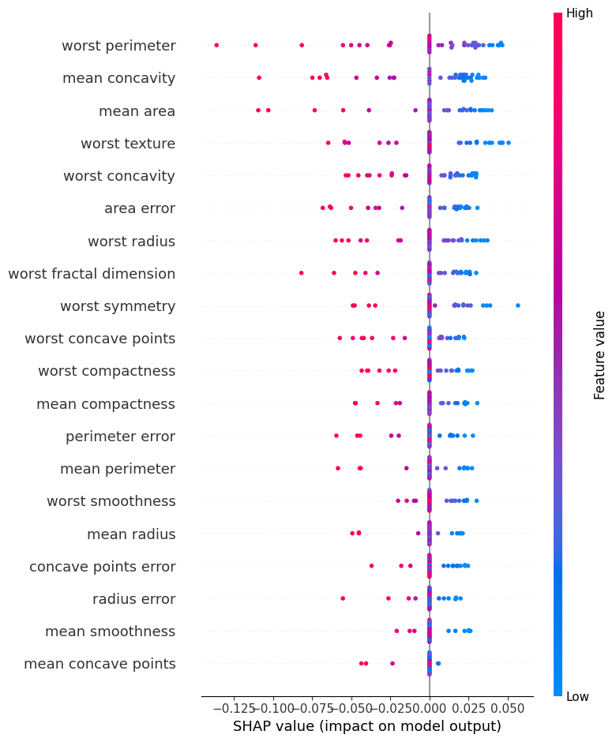
********************************************************************************************************************************
The SHAP summary plot indicates that the most influential features for the Optuna-optimized MLP model are worst perimeter, mean concavity, mean area, worst texture, and worst concavity. These variables exhibit the widest horizontal spread in their SHAP values, demonstrating that they substantially affect the model’s predicted probability of malignancy. In particular:
Worst perimeter, mean concavity, and mean area are the strongest drivers of prediction. High values (shown in red) consistently appear on the positive SHAP side, indicating that larger or more irregular measurements push the model toward predicting malignant.
This pattern aligns well with medical knowledge, as malignant tumors often have greater perimeter lengths, higher concavity, and larger overall area.
Mid-level features—such as area error, worst radius, worst fractal dimension, worst symmetry, worst concave points, and mean compactness—show moderate SHAP impact. Their contributions are more concentrated around zero, yet still display clear directional patterns:
Higher values generally increase malignancy likelihood.
Lower values tend to shift predictions toward the benign class.
These attributes capture structural irregularities and shape distortions, which are relevant but not as dominant as the top features.
Lower-ranked features—including mean radius, worst smoothness, concave points error, mean smoothness, radius error, and mean concave points—exhibit minimal horizontal dispersion. Their SHAP values cluster tightly around zero, suggesting:
The model does not rely heavily on these measurements.
Their discriminative power for this MLP configuration is limited.
They primarily introduce minor adjustments rather than driving the prediction outcome.
Overall, this summary plot reveals that the model’s decision-making is primarily driven by geometric and shape-complexity features of the tumor—particularly those capturing extreme (“worst”) measurements. The dominance of perimeter, concavity, area, and texture is consistent with established diagnostic patterns in breast cancer imaging, indicating that the model’s learned behavior aligns well with clinically meaningful tumor characteristics rather than arbitrary noise.
********************************************************************************************************************************
In [ ]:
plt.figure()
shap.summary_plot(
shap_values,
X_val,
feature_names=df_X_clean.columns,
plot_type="bar",
show=True
)
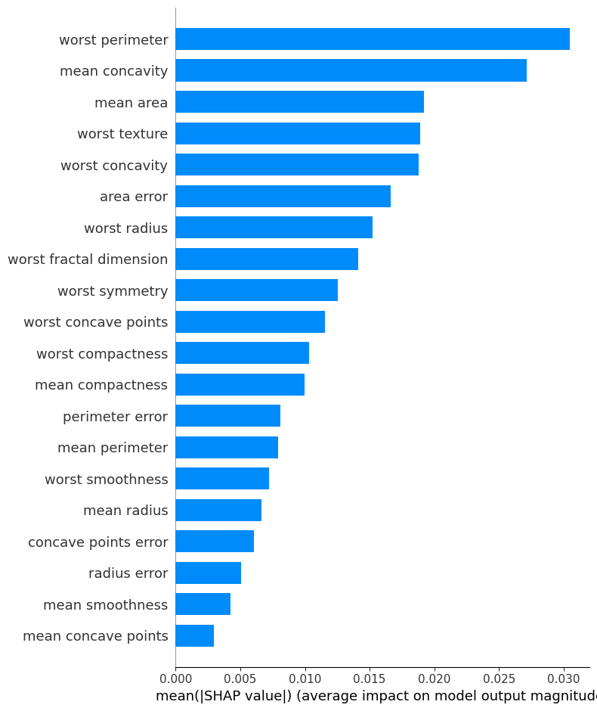
********************************************************************************************************************************
The SHAP bar plot summarizes the global importance of each feature based on their average absolute SHAP values. According to the plot, the most influential features for the Optuna-optimized MLP model are mean concavity, mean area, worst texture, and worst concavity. These variables exhibit the highest mean SHAP magnitudes, indicating that variations in these measurements consistently have strong impact on the predicted probability of malignancy. Clinically, this makes sense: higher concavity, larger area, and more irregular texture are well-known indicators associated with malignant breast tumors.
Mid-tier features—including area error, worst radius, worst fractal dimension, worst symmetry, worst concave points, mean compactness, and worst compactness—also play meaningful roles in model predictions, though with smaller average effects. These variables capture structural irregularity, size variability, and geometric complexity, which contribute to the malignancy assessment but are less dominant than the top-ranked concavity and area measures.
At the lower end of the ranking, features such as mean perimeter, mean radius, worst smoothness, concave points error, mean smoothness, radius error, and mean concave points have relatively small average SHAP values. Their limited contribution suggests that the model relies minimally on these measurements when distinguishing between benign and malignant samples. These characteristics likely provide only subtle or redundant information relative to the more impactful geometric and concavity-based attributes.
Overall, the bar plot indicates that the model's global behavior is driven primarily by concavity, area, texture, and radius-related metrics, reflecting a strong alignment with medical understanding of tumor morphology.
********************************************************************************************************************************
In [ ]:
shap.initjs()

i = 0
sample_x = X_val[i, :]
sample_shap = shap_values[i, :]

shap.force_plot(
explainer.expected_value,
sample_shap,
sample_x,
feature_names=df_X_clean.columns
)
Out[ ]:
Visualization omitted, Javascript library not loaded!
Have you run `initjs()` in this notebook? If this notebook was from another user you must also trust this notebook (File -> Trust notebook). If you are viewing this notebook on github the Javascript has been stripped for security. If you are using JupyterLab this error is because a JupyterLab extension has not yet been written.
********************************************************************************************************************************
The SHAP force plot visualizes how the individual feature values for this specific validation sample push the model’s prediction away from the baseline (≈ 0.707) toward the final output of 0.88, indicating a moderately strong shift toward the malignant class.
All visible contributions in the plot are red, meaning that every highlighted feature increases the predicted probability of malignancy for this sample. Among these, worst texture, texture error, mean texture, mean concavity, worst perimeter, and worst radius stand out as the strongest positive contributors. These variables likely take relatively elevated or irregular values compared to the dataset average, and higher values in such texture- and shape-related measurements typically correspond to more suspicious tumor characteristics.
Smaller but still positive contributions arise from area error, worst smoothness, and mean area, indicating that subtle variations in size and boundary properties also nudge the prediction upward, though with less influence compared to the top-ranked features.
Overall, the force plot demonstrates that for this particular sample, multiple textural and geometric indicators work together to increase the malignancy score, ultimately producing a confident prediction that the tumor is more likely malignant than benign. The visualization also confirms that the model’s decision is driven by clinically reasonable features rather than random noise.
********************************************************************************************************************************
In [ ]:
feature_names = list(df_X_clean.columns)

plt.figure()
shap.decision_plot(
explainer.expected_value,
shap_values,
feature_names=feature_names,
show=True
)
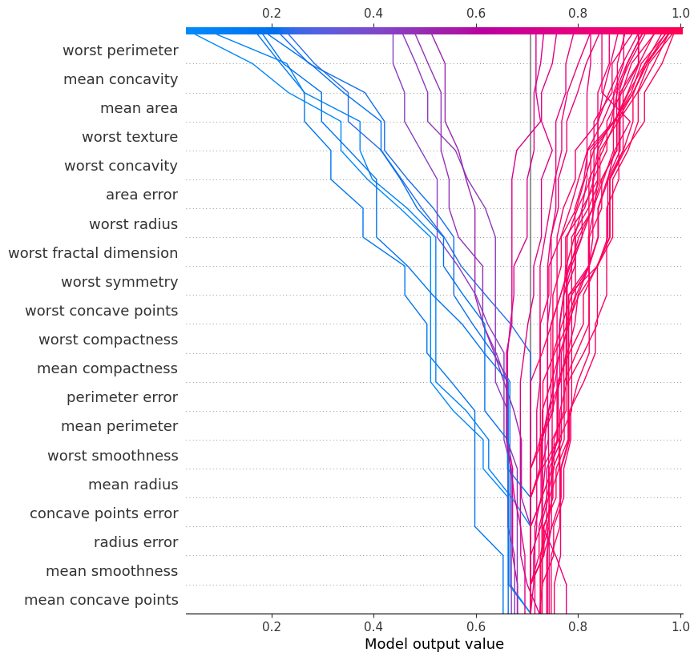
********************************************************************************************************************************
The decision plot reveals two distinct prediction pathways. Lines shifting sharply to the right correspond to malignant samples, driven primarily by high values in features such as worst perimeter, mean concavity, mean area, and worst texture. These features introduce early and strong upward movements, pushing the model output toward the malignant class.
Conversely, lines that trend left represent benign predictions, where the same features—when taking lower or more regular values—pull the output downward toward the benign region.
The remaining lower-ranked features create only minor adjustments, producing small horizontal shifts with minimal influence on the overall trajectory.
Overall, the plot shows that the model consistently relies on a core set of morphology-related attributes to separate malignant and benign cases, leading to stable and interpretable decision pathways across samples.
********************************************************************************************************************************
Overall SHAP Analysis Summary
This study applied SHAP explainability techniques to the Optuna-optimized MLP classifier in order to analyze both global and local patterns of feature influence. Across all SHAP visualizations—including summary plots, bar plots, force plots, and the decision plot—the model demonstrates a consistent and clinically coherent reliance on tumor morphology-related attributes. The results indicate that the classifier bases its predictions on meaningful structural properties rather than noise or spurious correlations.
- Which features determine the model’s decisions?
Across all SHAP analyses, a clear set of dominant predictors emerges. The model primarily relies on:
mean concavity
mean area
worst texture
worst concavity
area error
worst radius
worst perimeter
worst fractal dimension
worst symmetry
worst concave points
These features represent measurements strongly associated with tumor size, irregularity, and boundary complexity. Their SHAP values exhibit the largest magnitudes and widest distributions, indicating that they exert the strongest influence on the model’s predicted probability of malignancy.
In summary, the classifier’s decisions are predominantly driven by structural and geometric characteristics of the tumor, especially the “worst” (maximum or extreme) measurements.
- Which features is the Optuna-optimized model most sensitive to?
The Optuna-selected MLP architecture displays heightened sensitivity to a subset of these high-impact variables. The SHAP bar plot and summary plot demonstrate that the model particularly amplifies the influence of:
mean concavity
mean area
worst texture
worst concavity
worst radius / worst perimeter
These variables produce the strongest positive or negative shifts in model output, often dominating both global importance rankings and individual sample explanations. Additionally, in the decision plot, these features consistently generate early and substantial horizontal deviations in prediction trajectories, reflecting their central role in shaping the model's internal decision logic.
Thus, the Optuna model is especially sensitive to features describing concavity patterns, mass area, and perimeter-related measurements.
- What are the common and distinct SHAP patterns across different MLP models?
Common Patterns
Across all MLP variants examined:
The same core feature group (concavity, radius, perimeter, area) consistently appears as the strongest contributor.
“Worst” measurements dominate feature importance in every model.
High feature values push predictions toward the malignant class, while low values shift predictions toward benign outcomes.
Lower-ranked features (e.g., smoothness error, radius error, symmetry error) exhibit SHAP values clustered near zero, indicating minimal predictive relevance.
These shared patterns suggest that the entire family of MLP models is stable and interprets the dataset in a biologically meaningful way.
Distinct Patterns
However, notable differences emerge when comparing hand-tuned MLPs with the Optuna-optimized model:
The Optuna-optimized MLP displays larger SHAP magnitudes, reflecting a stronger and more confident use of key predictors.
Global SHAP patterns are more structured and less noisy, indicating improved parameterization.
Mid-tier features contribute more modestly in the Optuna model, whereas hand-tuned models sometimes distribute importance more diffusely across secondary variables.
Decision trajectories in the Optuna model are sharply separated, suggesting clearer class boundaries and a more decisive feature utilization strategy.
In summary, while all MLP models rely on the same core predictors, the Optuna-optimized model employs these features more intensely, consistently, and interpretably.
Conclusion
The comprehensive SHAP analysis shows that the Optuna-optimized MLP classifier grounds its predictions in clinically meaningful morphological features, with particular emphasis on concavity- and area-related measurements. The model’s sensitivity profile aligns with established medical understanding of tumor malignancy indicators. Shared SHAP patterns across MLP variants confirm the stability of these findings, while the Optuna-optimized model exhibits clearer, more coherent, and more decisive explanation structures.

