**WEB DEVELOPMENT**

**(Assignment II)**

**HORSE RACING JAVASCRIPT**

**(YEAR I)**

**CSY1018: Web Programming**

Due for Issue

(week commencing):

**Last Date for**

**Submission:**

**Sunday 15th**

**July 2018**

**23:59:59**

Std ID: 18413711

Rojen Tamang Module Tutor:

Mr. Ganesh Khatri

Aspect (&

weighting) Functionality (40%) Design (20%)

Evaluation (10%)

Testing (10%)

Code Quality and

Efficiency (15%)

Video Demonstration (5%)

Excellent

A

Good

B

Satisfactory

C

Needs some more work

D

Needs much more work

F

Specific aspects of the assignment that the marker likes:

Specific aspects of the assignment that need more work:

**Video Link :**

<https://www.youtube.com/watch?v=GrCxuV4uVeE&feature=youtu.be>

**Table of Content**

**1. Introduction…………………………………………………………………………………………………………….……... 1**

**2. Game design…………………………………………………………………………………………………………………... 2**

**3. Program design.……………………………………………………………………………………………………….…….. 4**

**4. Testing…………….……………………………………………………………………………………………………………… 7**

**5. Evaluation……….……………………………………………………………………………………………..…….……….. 11**

**6. Conclusion…………………………………………….……….……………………………………………….……………... 13**

**7. Reference…………………………………………………………….……………………………………………….………… 14**

**1. INTRODUCTION**

The assignment given was to access our ability to showcase our web development skills ,mainly javascript, CSS and HTML. Students were provided with the zip file including HTML and CSS. In this project, students are to build a horse betting or racing by implementing javascript code using provided HTML and CSS codes. Project provide four horses which should start running around the lap after pressing start button. There are more additional functionalities to be added according to the requirements.

For a bare pass (D-- D++) students should make the horses move one lap around the field. As soon as the horse starts horse should turn at the turning points and stop just after the finishing line. When the start button is pressed again the horse should again make another lap. For good pass, horse should run at different speed and turn at different position. Student should detect the winner and display the result by listing the position of the horse and button should also be disabled while race is going on. For a very good pas(B- A-), user should have option to bid on the horse by selecting it with the required amount starting at 100 pounds. If player wins they get double the money back otherwise loose the money. For a excellent pass(A- A+), game should have the option of odd betting, the layout could be changed into 8 shaped field. Player should also have option inserting number of laps. In addition, students could implement any extra code to make the game more interesting.

Assignment should be submitted on NILE by on 15th July, 2018 in three forms. One is the report, second is the source code and third is the video demonstrating the project.

**2. GAME DESIGN**

**- How did you come up with a solution to meet the brief?**

Ans : After going through the assignment brief, the author was finally able to come up with few solution in the initial stages. The author moved the horses according to the concept taught in week-3. By adding a interval function, finally horse was able to move automatically, fulfilling the basic need for the project. Going through weekly slides, many concepts were included. To turn the horse, author kept different turning point’s in the scenario(week-2) whereas for choosing the winner, author added the concept of ‘className’ function. With some further online research and study, the was able to meet basic, some parts of intermediate and advance features.

**1. What did you need to do to work out how to get the horses to stop/turn at the relevant points on the track?**

**Ans :** For this part of the assignment, author kept a condition at certain points. These were the turn points in percentage so that this game would also be responsive. If that condition was fulfilled, the horse would move in the corresponding direction eliminating the previous intervals.



Fig : *turning at relevant position*



Fig : *turning at relevant position*

**2. How did you design the game so that a differente horse won each time?**

**Ans :** For this part, the author used ‘Math.random’ function to retrieve random numbers so that each horse run in different speed. By following these rule, each horse would finish the line in different time intervals. Thus, making different horse win each time.

By moving the horses in different speed, the final outcomes would be different each time.



Fig : *variant final result*

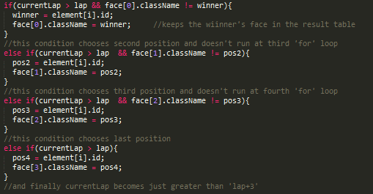

Fig : *displaying different final outcomes*

**3. How did you design the game to make it interesting?**

**Ans :** In order to make the game more interesting, author added a lap system, bidding function, showcasing the winner in order after the game, choosing the bid(horse) in the game.

**3. PROGRAM DESIGN**

**1. How did you use language tools to reduce repeated code?**

**Ans :** First of all, each similar methods were divided into functions. Then, loops(for loop) were used and global variable were also decleared in order to reduce the code.

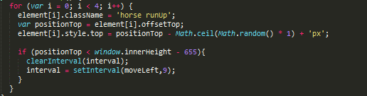

Fig : *using for loop*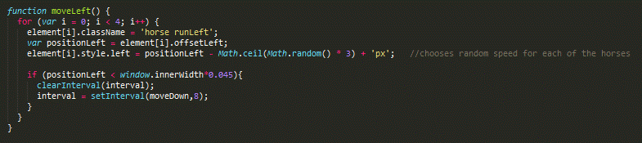

Fig : *creating methods*

**2. What did you have to do to account for different screen sizes?**

**Ans :** For this part of the assignment, author was able to fulfill the requirement by creating condition in percentage so that the game would support screen of different size.



Fig : *responsive code*



Fig : *responsive code*

**3. How did you break the problem up into different tasks?**

**Ans :** The author divided the section into five major tasks. Firstly, to move all the horses. Secondly, to turn the horse in the respective position of the screen and to make it responsive Then, to stop the horse in its final lap. Then, to display the respective winner in the results and at last, to final calculate the bid amount and display it in the table. Most of these task like moving the ball, turning the ball, etc. were converted into functions to make the code more reliable.

**4. How did you use the features of Javascript to do this?**

**Ans :** The author has used the features of javasccript like in-built functions, looping statements, control statements, of creating methods creation, etc. . Here, he has looped the code to run all the horses, to store the winner in the result table. Control statement has been used to redirect the flow of code. Using if-else statements author has been able to set many turning point in the code. He also used inbuilt function like click function to run all the horses(starting with ‘moveRigth()’).



Fig : *inbuilt function*



Fig : *inbuilt function*



Fig : *inbuilt function*

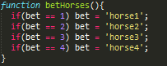

Fig : *control statements*

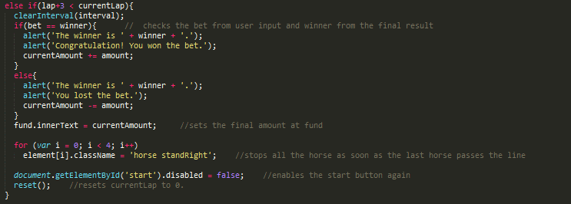

Fig : *control statements/ loops*

**5. Did you consider any alternative approaches? If so, why did you choose the approach you decided to use?**

**Ans :** No, the author has not used alternative approaches in building the game. By utilizing the resources provided from slides and proper researches about the topics provided, author has been able to fulfill the requirements of the project.

**4. TESTING**

**1. How did you test that your code worked?**

**Ans :** By utilizing the facilities provided by google developer tools, author was able to test whether his code worked or not. In google developers tools , there is a console window. With the help of this window, author was able to test his code line by line.

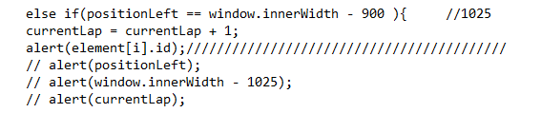

Fig : *alert function*



Fig : *alert function*

**2. Could you test certain aspects of the code without running the entire game and waiting for it to finish?**

**Ans :** Yes, author will be able to test certain part of the code without running the entire part of the game. But, there are certain types of tough, code which author would face problem to run individually.

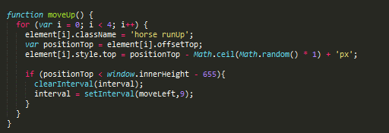

Fig : *test code*

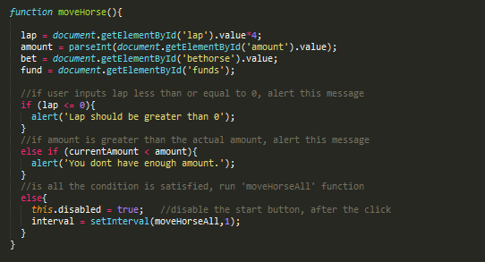

Fig : *test code*

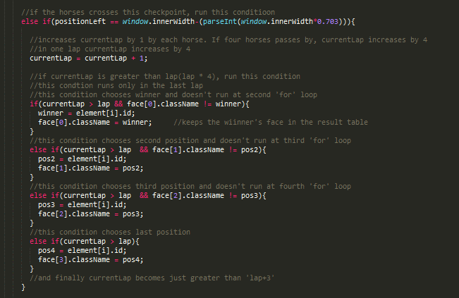

Fig : *test code*

**3. What tests did you carry out and what were the outcomes?**

**Ans :** Author tested functions by providing some input. He also carried out different alert pop up message to test the outcomes of the variables. Other than that author has not used testing sites like W3schools.



Fig : *alert function*

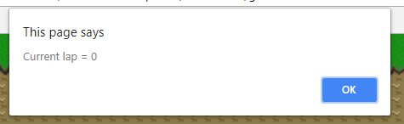

Fig : *alert result*

**4. What bugs did you discover during testing?**

**Ans :** The major bug that author found in his code is that the game fails to specify the winner when the game is run more than once. Other bugs were in the calculation part of the amount. If player doesn’t input any amount their final amount would be ‘NaN’.

**5. EVALUATION**

**1. A list of known bugs/weaknesses in the game**

**Ans :** The list of known bugs/weaknesses are:-

1. Fails to specify winner in second start
2. Calculation of amount displays ‘NaN’ when no amount is set
3. Horse stops at different location at the end making the game difficult to restart

**2. What works well?**

**Ans :** The things like lap, bet amount, displaying winners, betting on horses, running the horses, etc. works well. Other things like responsive game in different window size, running at different speeds(while turning left), are implemented by the author.

**3. What improvements could can be made?**

**Ans :** First of all, the restart button should be made to work properly after making this button many problem would be solved. Other than that, problem of displaying ‘NaN’ in the fund could be improvised and horses should be made to stop at the same location so that restarting the game would be appropriate.

**4. What else would you have done if you had more time?**

**Ans :** If the author had more time, author would have modified the race track to figure eight, would start the game to bet on the new horse, restart the by pressing restart button, and many more.

**5. How easy would it be to extend the game to add a 5th horse?**

**Ans :**  In authors point of view, adding a new horse would have been a quite a difficult task. But if students would have got more time to practice these slides, extending the game to 5th horse would have been easier.

**6. If you had to build a similar game in the future, what would you do differently and why?**

**Ans :** If author had to build a similar game in the future, he would have tried to complete these task using jquey because it is being popular day by day and many successful industries has used jquery to built its websites. In addition, the way of approaching the game would be different from the beginning.

**VIDEO DEMONSTRATION**

<https://www.youtube.com/watch?v=GrCxuV4uVeE&feature=youtu.be>

**6. CONCLUSION**

Taking things into consideration, author has been able to develop the horse racing game according the requirements of the project. After days of research and studies, author was able to make the game. All the concepts of module slides and online research has been fruitful author completed most of the requirement by moving the horse, implementing the amount and lap system. The game also displays the winner accordingly, The horse was moved and turned, calculation has also been done and final result has been displayed. And player could choose their bet horse. The final code was tested using google developers tool and bugs were identified some debugged. Although the game was completed, there were also some requirements to be fulfilled. The main error in this game is that when player restart the game, winner ill not be displayed in the result table. If player does not input any amount, then the final output would be ‘NaN’. The horse also move in equal speed while moving right and up but after horses run toward left, they start to run in different speed from then on. If author was given extra time he would try to overcome all those problems and add some more exciting features.

Altogether, any beginner could understand and would have no difficulty in playing the game. In order to play this game, player should only input the betting amount, number of laps and the horse that they would bet on.

**8. REFERENCE**

* Developer.rackspace.com. (2018*). Using querySelector and querySelectorAll on Elements.* [online] Available at: <https://developer.rackspace.com/blog/using-querySelector-on-elements/> [Accessed 1 Jul. 2018].
* work?, H. (2018). *How does the "this" keyword work?.* [online] Stack Overflow. Available at: <https://stackoverflow.com/questions/3127429/how-does-the-this-keyword-work> [Accessed 3 Jul. 2018].
* Hiljá, A. (2018*). JavaScript: adding and removing class names from elements – clubmate.fi.* [online] Clubmate.fi. Available at: <http://clubmate.fi/javascript-adding-and-removing-class-names-from-elements/> [Accessed 15 Jul. 2018].