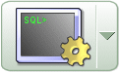

Exploring a
Relational Database
using
Oracle SQL*Plus

Activity 1 - Review

Your Login details

Before you start you should have the following: Student Login:
Write them down so you don’t forget them ! Course Work Login:
Password:
Host String: STUD

How to use this booklet

read this !

In order to get the most from these exercises you should attempt to:

- Read everything; don’t just skip to the questions!
- Complete all parts in the order presented
- Think about the nature of the application itself
- Keep referring to
- The ER diagram
- The table definitions

What to do in this book:

- Read the explanations and questions
- Fill in the results or answers

- At the SQL> prompt enter a single SQL or SQL*Plus command
- You should use an editor (eg Notepad) to type and edit your command
- Save the command with the extension .SQL or txt (ie example3.SQL)
- Do not use a word processor as the formatting interferes with the commands

- To get SQL*Plus to run the command file
ie if it was saved in subdirectory temp on drive C called example3, type:

@f:\databases\example3

The Database Application used in this guide

- The Entity relationship model is of a contract training department
- It is to be stored in an Oracle Object Relational Database

- There are ten normalised tables which make up the database
- These correspond to the entities shown in the Entity Relationship Diagram below:

Entity Relationship Diagram of the application

The naming conventions used in the database are:

- Table names are plural versions of entity names
- Use is made of underscore;
- ie the entity subject area corresponds to a table called SUBJECT_AREAS

- Primary and foreign keys are all called something_id, for example course_id
- Column names are often comprised of several words separated by underscores
ie: trainer_name, course_price
course
subject area
attendance
invoice_item_table
site
instructor
student
company
offering
invoice
address
Why isn’t that related to anything?
What is that?
- We are working with an Object Relational Database (ORDB) so there will be some key differences. Keep an eye out for them and highlight them if you need to.
Schema Entity Relationship Diagram

invoice
offering
site
student
company
course
subject_area
instructor
classroom_ varray_type
classroom_type
invoice_item_type
invoice_item_table
address
address_type
attendance

- Crows foot links denote entities (yellow),
- Arrow head links denote objects (lilac)
- Database Skeleton Table
- The tables will hold data representing the following information:

COURSE DATABASE

Tables  New! | attribute | Key | Datatype | Constraints \  Defaults
addresses | address_type:
 | street |  | VARCHAR2(25)
 | city |  | VARCHAR2(25)
 | country |  | VARCHAR2(20)
subject_areas | subject_id | pk | NUMBER(6)
 | subject_name |  | VARCHAR2(30)
courses | course_id | pk | NUMBER(6)
 | title |  | VARCHAR2(30)
 | subject_id | fk | NUMBER(6)
New! | duration |  | NUMBER(6)
 | cost |  | NUMBER(10,2)
 | brochure |  | Binary file LOB
instructors | instructor_id | pk | NUMBER(6)
 | instructor_name |  | VARCHAR2(15) | not null
 | address |  | REF OF address_type
 | mentor_id |  | NUMBER(3)
 | salary |  | NUMBER (10,2)
New! | commission |  | NUMBER (10,2)
 | date_hired |  | DATE
 | profile |  | CLOB
offerings | offering_id | pk | NUMBER(6)
 | course_id | fk | NUMBER(6) | not null
 | site_id | fk | NUMBER(6) | not null
 | instructor_id | fk | NUMBER(6)
 | start_date |  | DATE
 | max_no_students |  | NUMBER(6)
attendance | offering_id | pk fk | NUMBER(6)
 | student_id | pk fk | NUMBER(6) | not null
 | Start_date | pk | DATE
 | evaluation |  | NUMBER(6,2)
 | amount_paid |  | NUMBER(10,2)
sites  New! | site_id | pk | NUMBER(6)
 | address |  | address_type
 | classroom |  | classroom_varray_type
 | location |  | VARCHAR2(12)

Tables | attribute | Key | Datatype | Constraints \  Defaults
companies | company_id | pk | NUMBER(6)
 | company_name |  | VARCHAR2(15)
 | city |  | VARCHAR2(12)
 | industry |  | VARCHAR2(15)
 | no_employees |  | NUMBER(5)
 | revenue |  | NUMBER(10,2)
 | training_budget |  | NUMBER(10,2)
students | student_id | pk | NUMBER(6)
 | student_firstname |  | VARCHAR2(20)
New! | student_surname |  | VARCHAR2(20)
 | address |  | ref of address_type
 | phone_number |  | VARCHAR2(15)
 | fax_ number |  | NUMBER(10)
 | gender |  | CHAR
 | date_of_birth |  | DATE
 | description |  | VARCHAR2(250)
 | preferred_language |  | VARCHAR2(2)
 | company_id | fk | NUMBER(6)
invoice_item_ table_type | invoice_item_type:
New! | student_surname |  | VARCHAR2(15)
 | course_title |  | VARCHAR2(30)
 | start_date |  | DATE
 | end_date |  | DATE
 | amount |  | NUMBER(10,2)
invoices | invoice_number | pk | NUMBER(6)
 | company_id | fk | NUMBER(6)
New! | billing_date |  | DATE
 | due_date |  | DATE
 | invoice_item |  | invoice_item_table_type

There are some new tables
and datatypes in an Object Relation Database. Keep an eye on them there will be more on these as we go along.

New!

before starting

- Create a folder on your flash or personal area with the module name eg CSY2038 no spaces
- Files saved in this folder will have the path
NOTE: files, folders and paths names can not have spaces in them!
e:\CSY2038
- For example a script file called CreateTest.txt will have the path
e:\CSY2038\CreateTest.txt

logging on to Oracle

- To log on to the Oracle server
- You will need to open SQL* Plus

- On your client computer, select Oracle SQL*Plus.

The login window will appear. You need to connect your client-based SQL*Plus program to the Oracle server by completing your coonection details

You noted them down in the front of this book!

- At the prompt enter your username@student/password

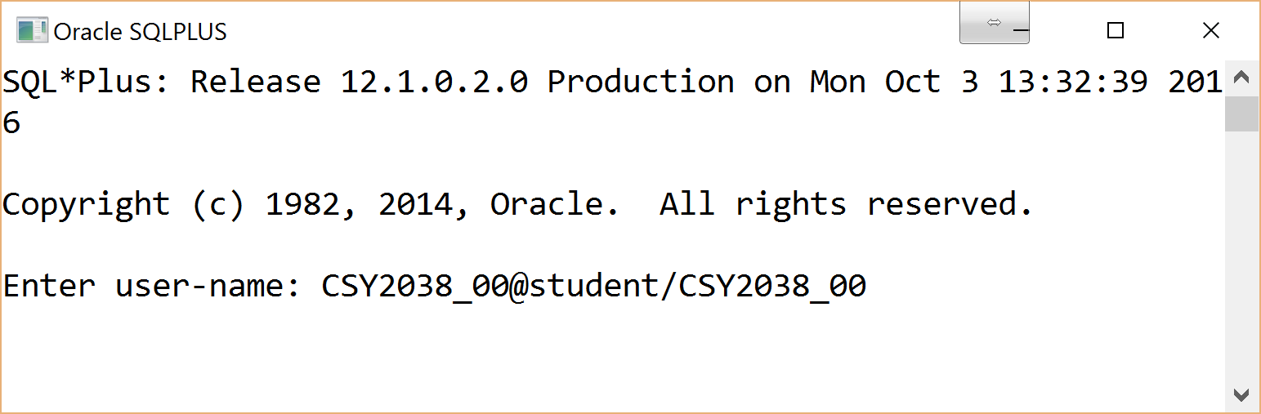
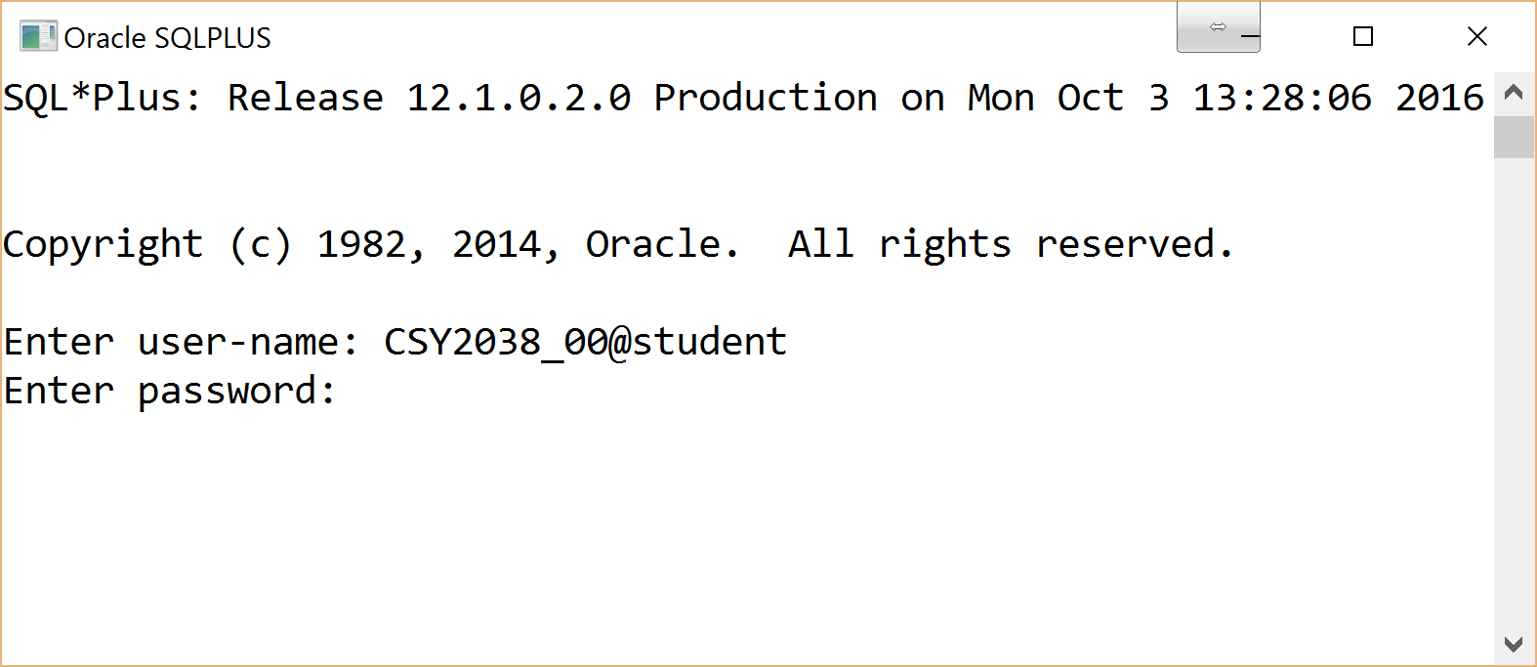
NOTE: you can enter the password on the second line if greater security

- At the SQL> prompt enter a command to get SQL*Plus to interpret the SQL program

- Type EXIT on the command line if you want to close SQL*Plus
- Or click the cross in the corner

changing your passwords

- The ALTER command is used in the data definition language to change table or user structure
- To change passwords the following structure is used

ALTER USER your_user_id IDENTIFIED BY your_new_password;

- To enter a number as a password it should be in double quotes ie "200"
This changes it to a text value!
- Passwords are case sensitive

- At the SQL prompt alter both your oracle passwords to your student number
- You need to log in to each account separately. You only have privileges to change your own password
NOTE: Passwords cannot start with a number. Use double quotes or letters

- Log off using the EXIT command

- Test logging in to both with your new passwords
- If everything works log out

- If you try to connect with an incorrect username or password you will get the following error message:

ERROR
ORA-01017: invalid username/password: logon denied
ERROR MESSAGES:
These can be helpful, always read them and try to correct the problem before hand waving!

creating your copy of the Oracle relational database

- To create your own version of the relational database on the Oracle server
- You will need to execute a copy of the script files
dropCourse.txt, createCourse.txt, alterCourse.txt and insertCourse.txt
- These contain SQL DDL drop, create, alter and insert commands

- Download all 4 files from the blackboard, into your CSY2038 folder
- Rename each file to include your login number ie createCourse_00
- Open the script files in notepad++ and look at them
help: There is an additional crib sheet file on the web. You should keep this and add to it during the course.
- Consider what each script file does, do they match the ERM?
- Identify the new tables and datatypes?

- What are the differences in this Object Relational Database from a normal Relation Database?

- Log onto Oracle using your two digit login

- To create some tables in our relational database on the Oracle server using the create table commands in the createCourse.txt script file, we could just copy and paste the files into SQL but the buffer may not be large enough to hold all the data. Only part of the data would be copied and it would therefore be wrong. Instead we can point SQL to our file and it will read from it!

- The @ sign is used to point SQL in the right direction, followed by the file path and name
ie: if your script file is on drive C: in the temp directory, the command would be:

@C:\temp\CSY2038\createCourse_00.txt
- What would the command be if the file is on your flash in your module folder?

- At the SQL> prompt enter a command to get SQL*Plus to run your script files

- Instructions are passed to the Oracle RDBMS to create the various database tables
- Wait until the SQL program has created all the tables
- Oracle RDBMS stores the names of your tables in one of its tables called TAB (tablespace)

- TAB is a table already on the database which will store all your tables

- When the run command is correct, copy it to the top of the script file and comment it out eg
-- @C:\temp\CSY2038\createCourse_00.txt

- At the SQL> prompt type SELECT * FROM TAB; on a single line

- What is the result?

- Now type each word on a separate line ie:
NOTE: SQL
does not like spaces between lines!

SQL> SELECT
2 *
3 FROM
4 TAB
5 ;

- What result does this give you? What does it tell you about the syntax?

- Do you have all the tables in the skeleton list provide on pages 4 and 5?

- The DESCRIBE command (desc for short) is used to describe the table structures
- The DESC command does not show the data stored in the tables

- Use the DESC command to view the tables stored in your database

- What attributes does the courses table have?

creating more tables

- To add additional tables to the database use the CREATE TABLE command and save it in an editor
- To create tables the following structure is used
Note: We have done all this before
CREATE TABLE table_name (
column_name1 datatype,
column_name2 datatype);

- The command may be written directly into SQL over several lines
- SQL*Plus outputs a line number (2) on subsequent command lines
- SQL*Plus looks for a semicolon (;) which terminates a SQL command
- When entering commands in an editor the prompt and line numbers are not used

- In the createCourse_yourlogin.txt file add the command to create the following table
- Give the table the name ‘companies’

ColumnName | Datatype | Constraints
company_id  Note!: Don’t forget that the tables and drops should go in the right order | number(6)
company_name | varchar2(15)
city | varchar2(12)
industry | varchar2(15)
no_employees | number(5)
revenue | number(10,2)
training_budget  Hint!:  DROP TABLE table_name ; | number(10,2)

- Save the script file
- At the SQL> prompt use the @ command to run the script file
- What are all the error messages about?

- At the SQL> prompt write a command to view all your tables
- If the companies table is there, write a command to describe your new table
- Does this look right?
- In the dropCourse_yourlogin.txt file, in the correct place add the command to drop companies

creating PKs and FKs
- In the alterCourse_yourlogin.txt file, write the command to create a PK for the companies table
- Use the ERD to find out which tables should have company_id as a FK
- In the alterCourse_yourlogin.txt file, write the command(s) to create the appropriate FKs
- Download and run the CompaniesInserts.txt, not copy and paste
- In the insertCourse_yourlogin.txt file add the company insert commands
- Think about where they should go in the script file, include comments

- Tidy up your script files
Include a header comment with your name, number, module, activity and date
Read through the script file and make clear notes throughout to help you understand

Activity Tasks

- At the SQL prompt> enter the command to run your
dropCourse_00, createCourse_00, alterCourse_00, insertCourse_00 files
- Practice the following commands in the TRAINING database
NOTE: You may
need to refer to your lecture notes and crib sheet to help you

- Enter the command SELECT * FROM TAB;
- Describe the sites and students tables

- What does this tell you? Any unusual data types?

- Describe the user_tables and user_types

- What does this tell you?

NOTE: Two pipes
|| are used to concatenated columns
- In a new script file called your_login_prac1.txt write the command to:
Create a listing of student names gender and telephone number
Concatenate first and last names

HINT: SELECT column_name1 ||' ,'|| column_name2, column_name3, column_name4

- Why is the heading to Gender shortened to G? (look at skeleton tables for a clue)

NOTE: One pipe ‘|’ Puts column names on two lines
- Format the output showing
“Last Name”, and “First Name” on two lines
Gender as “F/M” on one line
Change the format of gender to three characters so that the entire heading is shown

HINT:
COLUMN column_name1 HEADING 'Title1 |Title2'
COLUMN column_name2 HEADING 'Title1 |Title2'
COLUMN column_name3 HEADING 'Title1 | Title2'
NOTE: Formatting only last for the current session. It is overridden by formatting in select statements. ie the ||’,’||
COLUMN column_name1 FORMAT A10;

- Change the SQL to retrieve only the female students

HINT: WHERE column_name1 = criteria

- Change the SQL to list the answers in alphabetical order of the surnames

HINT: ORDER BY column_name1

- Save your script file
- Log out of SQL ☺
NOTES

- Extras

Extras - using the buffer

- The buffer is a work area that holds/stores the latest SQL statement
- SQL statements can be written in a single line or free flow as in an editor. A semicolon indicates to the compiler that the SQL statement is at an end and should be complied
- To view the content of the buffer the EDIT command is used
- The built in editor is used to edit the current statement after it has been created to correct errors and change the SQL
NOTE: The buffer takes up
a large amount of system resources so generally try not to use it

- At the SQL> prompt enter a command to call the buffer
- Return to SQL>prompt

- The buffer only hold the last set of instructions
- Changes can be made to the content of the buffer and it can be re run with the / sign
- Use the / to run the buffer
You may get some errors?

- There are several standard commands that can be used with the Oracle 8I buffer

Command | Description
L  NOTE: All SQL commands are operated at the local machine and do not update the server until the commit; command is executed | Lists the current content of the buffer
Ln | Displays text of line number ‘n’ and makes it the current line
I | Inserts a new line after the current line
A | Appends text to the current line*
DEL | Deletes the current line
C/<old>/<new> | Replaces first occurrence of the <old> text with <new> text on the current line
/ | Resends content of buffer
EDIT | Opens notepad and displays the buffer contents

* type two spaces after the A to leave one space in the SQL command eg:
A ,student_address - two spaces after A will generate one space before student_address

Using an editor

- Commands written in SQL are not stored, only the subsequent changes are stored in Oracle. Therefore typing commands into a file and saving them means that we have a backup of our code if anything goes wrong and a useful reference.
NOTE: Always
store you commands in a script file!
- To view the content of an editor the EDIT path command is used
- We need to point SQL at the correct file
ie: if a script file is on drive C: in the temp directory, the command would be
NOTE: Files can have the extension .sql or .txt

EDIT C:\temp\wk1.txt

- What would the command be if the file is on your floppy in your module folder?

- At the SQL> prompt enter the command to call the editor
- Call the script file your_login_prac1.txt ie CSY2038_00prac1.txt and save in your folder
Remember!:
Oracle will not accept spaces in file, folder or path names
- In the editor replace the code with a command to view your tables

- Changes in the editor must be saved before it is run
- Return to the SQL> prompt
- At the SQL> prompt use the @ command to run the new script file
- Copy the run command into the top of the script file and comment it out
ie
-- @drive:\folder_1\folder_2\file_name.txt

