**PRACTICAL – 9**

**Write a program to understand the use of Firebase with Raspberry Pie to control sensors.**

**Solution: Related Term:**

**What is Firebase?**

Firebase is Backend as a Service ( BaaS ) by Google.  
Firebase gives you many tools to develop high-quality apps, grow your user base, and earn more money. We cover the essentials so you can monetize your business and focus on your users.  
  
In This Project. We are focus on Realtime Database first.  
  
[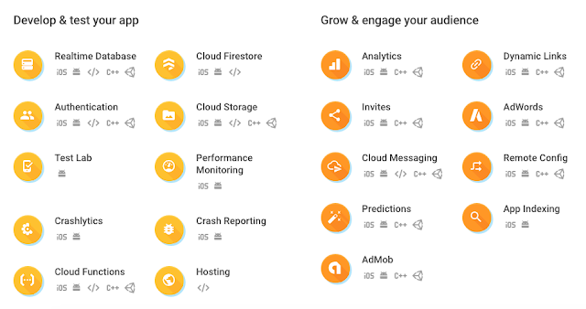](http://1.bp.blogspot.com/-7S93VjUYmKE/WizpaZXlt6I/AAAAAAAAv38/vJ3cGC-O7U8NbqBsR-zCk0Q3fR4xLjVswCK4BGAYYCw/s1600/Screen%2BShot%2B2017-12-10%2Bat%2B2.54.14%2BPM.png)  
  
**Real Time Database**

The Firebase Realtime Database is a cloud-hosted NoSQL database that lets you store and sync data between your users in realtime.  
  
Updated data syncs across connected devices in milliseconds, and data remains available if your app goes offline, providing a great user experience regardless of network connectivity.  
  
  
**Firebase Console**  
  
Go to Console

[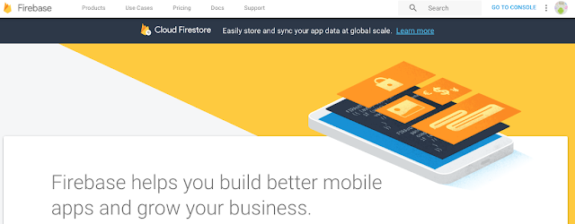](https://2.bp.blogspot.com/-aOMTtCaHQQM/WjI9q0jai2I/AAAAAAAAwEM/c-Q7lA6glcMZJk5nRigA2HiSKsBlkiiTgCLcBGAs/s1600/firebase_cons.png)

Add New Project

[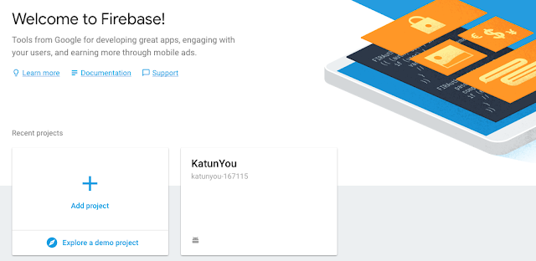](https://3.bp.blogspot.com/-xuSdECL2sMs/WjI9qCvy4nI/AAAAAAAAwEI/spoIZET_mpMZxk597wJpr8NES6Oidk1YQCLcBGAs/s1600/Firebase_add-new-project.png)

Add Project Name

[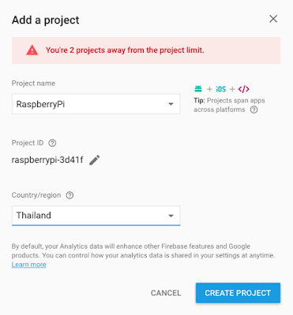](https://1.bp.blogspot.com/-SoWzuCfWEXI/WjI9qOySnzI/AAAAAAAAwEE/F7nzVwHHexgdLzfTA6VSOC83seGVwxQnACLcBGAs/s1600/Firebase_add-project.png)

Menu Database

[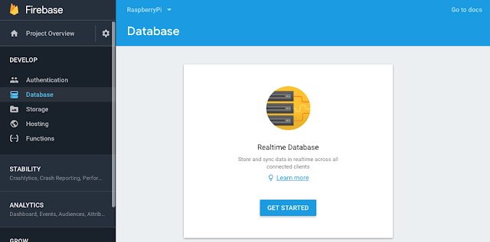](https://4.bp.blogspot.com/-PAdvVwJp6HM/WjI9rD1yJVI/AAAAAAAAwEU/lSqAn4rpOCUb2N9n68Z12__226Zwd06kwCLcBGAs/s1600/firebase_realtime-database.png)

Change Rules

// These rules require authentication

{

  "rules": {

    ".read": "auth != null",

    ".write": "auth != null"

  }

}

Change to this

Warning !!!  This is for test first. Anyone can read and write your database without authentication.

// These rules are not require authentication

{

"rules": {

".read": true ,

".write": true

}

}

[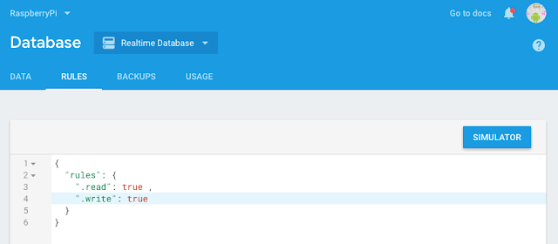](https://3.bp.blogspot.com/-Kjygrru141E/WjI9qMvlllI/AAAAAAAAwEA/nJ_HwPju4XkQzZWf2NmtZMYvmrOAigiXQCLcBGAs/s1600/firebase-rules.png)

Your Realtime Database is ready to use.  
and show URL Link for your firebase realtime database. ( https://raspberrypi-3d41f.firebaseio.com/ )

[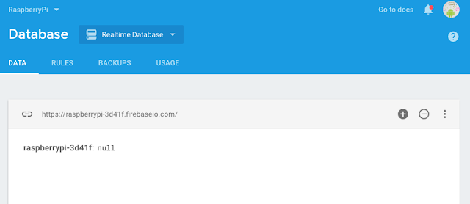](https://3.bp.blogspot.com/-3V4H-X-_UzI/WjI9q1fsfwI/AAAAAAAAwEQ/EDugRCbK0i0SR7psomamZ_kFS8n1X7y7wCLcBGAs/s1600/firebase_database.png)

Now Make Raspberry Pi sent data to Firebase Realtime Database  
  
  
  
**Wiring Diagram**

[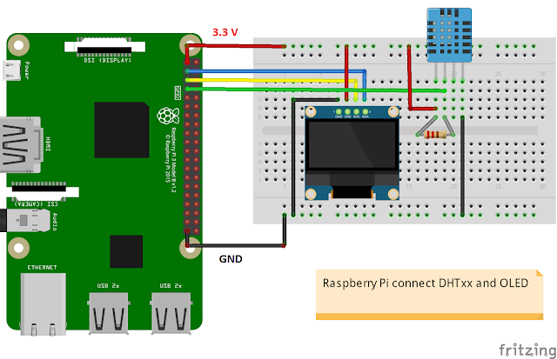](https://2.bp.blogspot.com/-TSHuYnX5MuY/WLZiR4tASgI/AAAAAAAAnrU/DCEMDYMoNjM-agZYYNO8ouba3XNk0lQVwCLcB/s1600/raspberrypi_dht_oled.png)

**Hardware**

[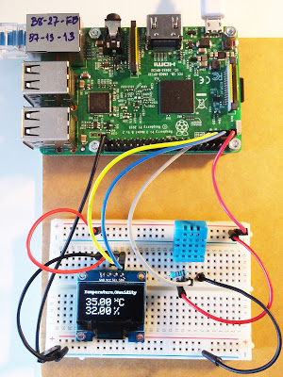](https://2.bp.blogspot.com/-JcPernpaB8U/WLZ8WJgaEGI/AAAAAAAAnrk/ZzTQe71jmJczyaaa0jfUuphaQe8WXxvQQCLcB/s1600/RaspberryPi_DHT_OLED.jpg)

* Raspberry Pi Board ( we use Raspberry Pi3 board ) + Accessories
* DHT11 Temperature and Humidity Sensor with Resistor 4.7 K Ohm ( or DHTxx )
* I2C OLED Display ( 128 x 64 0.96' SSD1306 chip ) for Option ( [Install OLED Library](https://raspberrypi4u.blogspot.com/2017/01/raspberry-pi-oled-i2c.html) )

**Programming Code**

|  |  |
| --- | --- |
|  | import smbus |
|  | import time |
|  | from firebase import firebase |
|  |  |
|  |  |
|  | bus = smbus.SMBus(1) #If I2C library detects the pull up then initialize the register using sensors |
|  |  |
|  |
|  |
|  |
|  | bus.write_i2c_block_data(0x44, 0x2C, [0x06]) |
|  |  |
|  | time.sleep(0.5) |
|  |  |
|  | data = bus.read_i2c_block_data(0x44, 0x00, 6) |
|  |  |
|  |  |
|  | temp = data[0] * 256 + data[1] #shifting data[0] to left side and adding data[1] xisting in right side |
|  | cTemp = -45 + (175 * temp / 65535.0) #formula mentioned in datasheet |
|  | fTemp = -49 + (315 * temp / 65535.0) #formula mentioned in datasheet |
|  | humidity = 100 * (data[3] * 256 + data[4]) / 65535.0 |
|  |  |
|  |  |
|  | print "Temperature in Celsius is : %.2f C" %cTemp |
|  | print "Temperature in Fahrenheit is : %.2f F" %fTemp |
|  | print "Relative Humidity is : %.2f %%RH" %humidity |
|  |  |
|  | time.sleep(5) #5milliseconds |
|  |  |
|  |  |
|  | firebase= firebase.FirebaseApplication('HOST ID') |
|  |  |
|  |  |
|  | result = firebase.post('Project Name', {'cTemp':str(cTemp),'ftemp':str(fTemp), 'humidity':str(humidity)}) |
|  | print(result) |

**Output:-**

