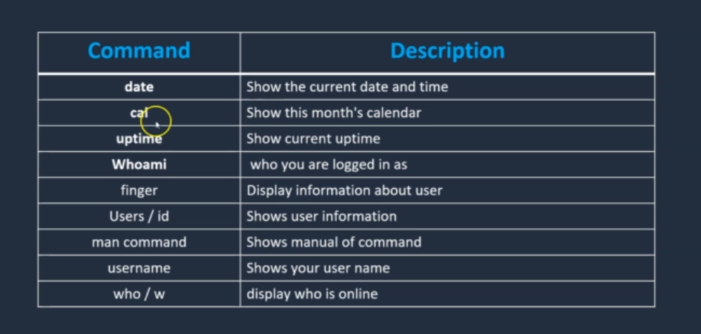

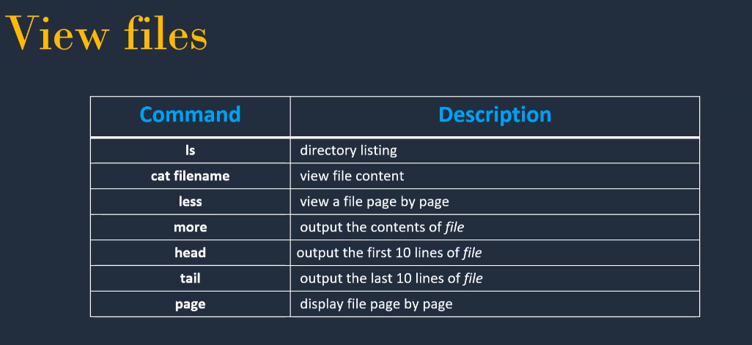

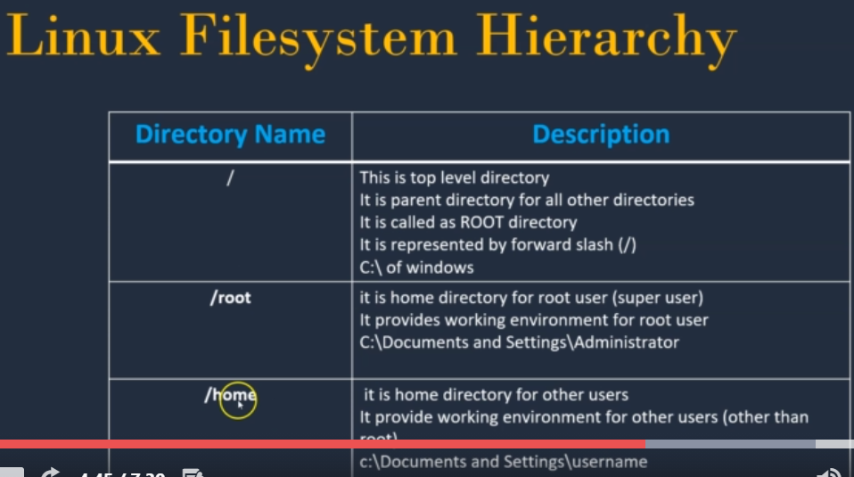

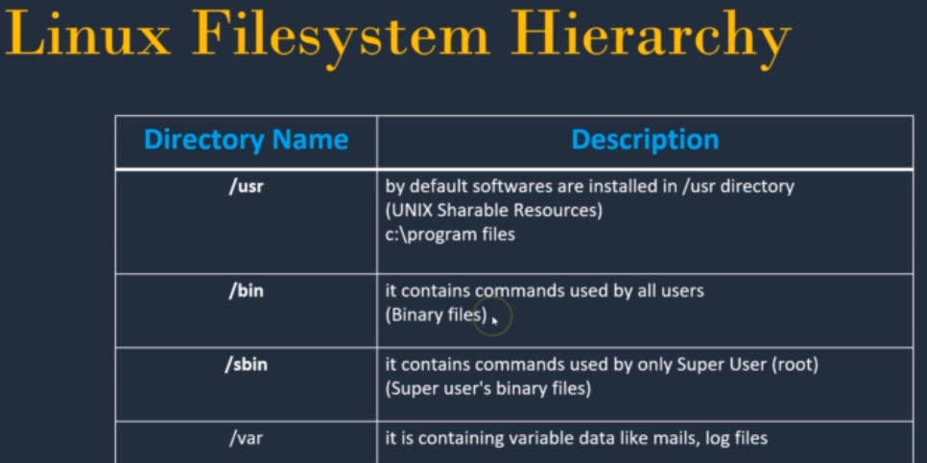

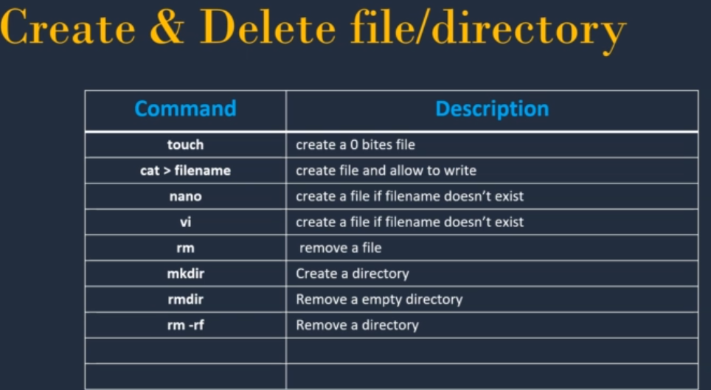

Flags

ls -l (long list) in alphabet order

ls -l -t (with timestamp order) ls -l -t -r (reverse)

ls -ltr

vi editor – esc :wq enter

cat > filename - New file can be written >> both file content can be shown