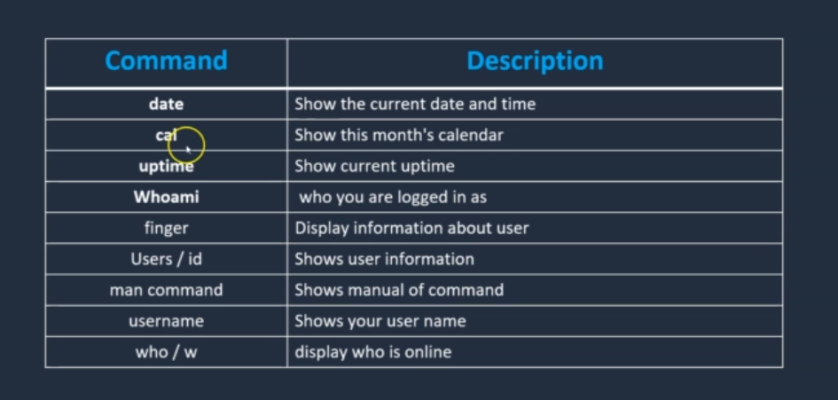

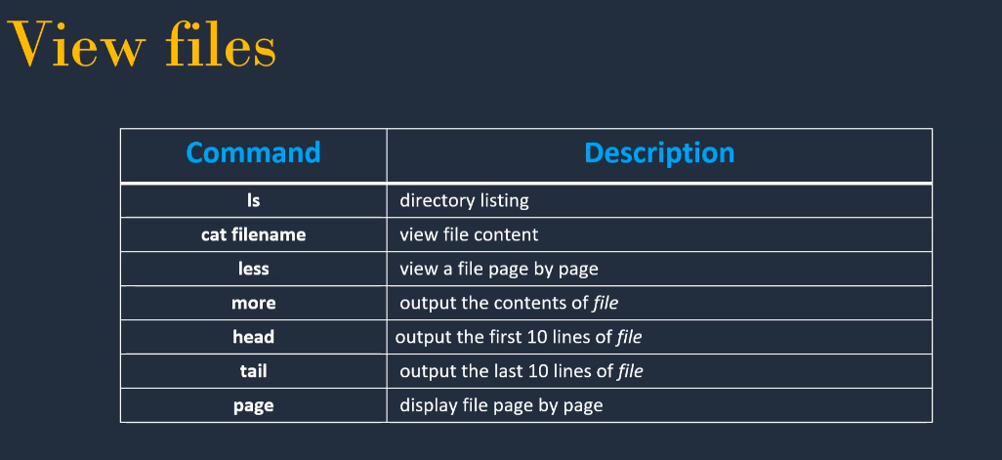

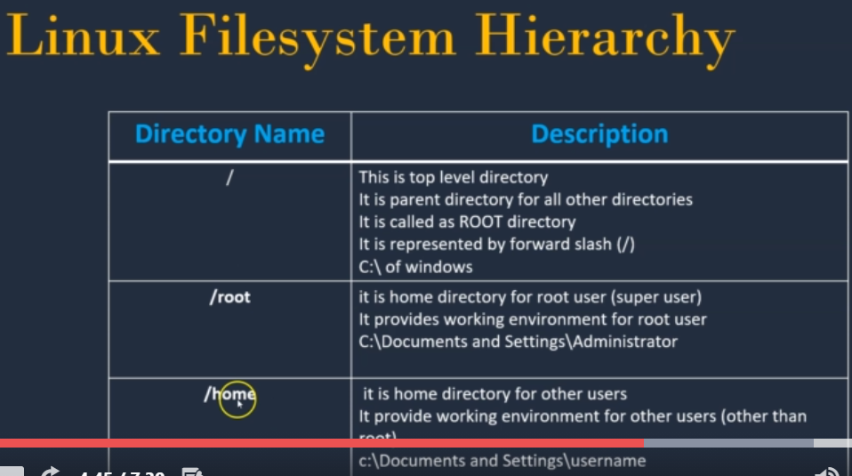

/bin - conatin bin executables

/dev – device files

/etc - where Linux system's configuration files live

/tmp /mnt /sbin /usr /lib /media

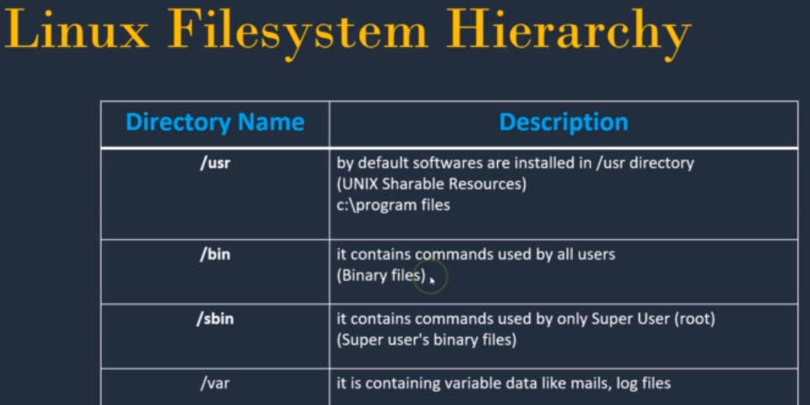

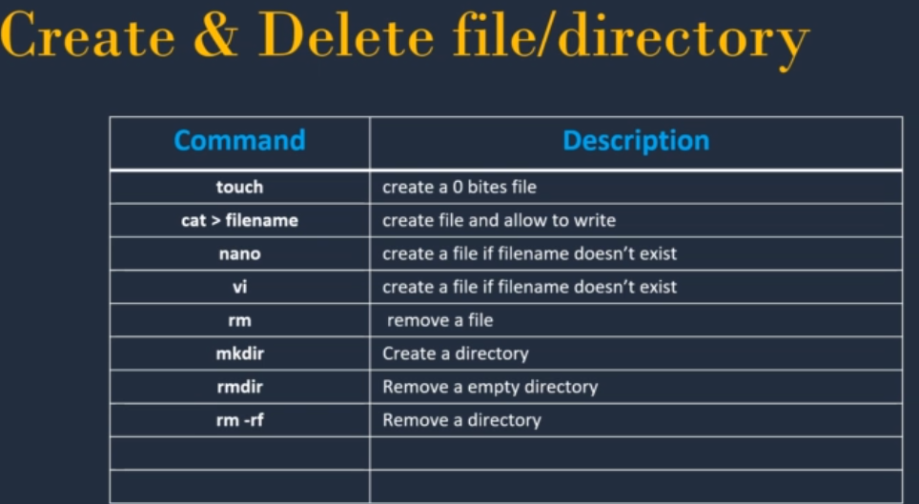

Flags

ls - to list files and directory within the file system

ls -l - long listing information of files and directory

ls -lt - Order Files Based on Last Modified Time

ls -ltr - Order Files Based on Last Modified Time (In reverse order)

vi editor – esc :wq enter

cat > filename - New file can be written >> both file content can be shown

mkdir – create folder

mkdir -p Demo/Test ----- create test folder inside Demo folder (2 folder will be created)

**Nano**

Simple text editor

nano filename

spell checking - /etc/nanorc

**ncal – calendar , ncal 2021 , ncal july 2021 ,**

**Remove files and Directory**

rm filename

rm -d directory name (remove empty directory)

rm -R directory name (remove everything from directory)

**Managing files and directories**

**cp** - copy a file

cp file1 file 2

cp file1 dir1 file1 will be moved to dir1 cat dir1/file1 -- to see the file in dirc

cp -R dir1 dir2 R - recursive Dir1 file will be moved to dir2

**mv** - moving a file

mv file2 dir1 cut and paste mv file2 file 1 file3 file4 Desktop/test many file will be move to test

**Rename**

mv file1 file 3 file1 will change to file3 with content

**cd** - switching between directories

cd root , cd tmp - it will be go to particular directory

cd /tmp - it will go directly to tmp from any directory

cd /root/usr - start with / is absolute path , without is relative path

**Find**

It is use to find the files or directory path

Syntax - find / -option filename

Find -size +1G

Option:

-name - For searching file with its name

-group - For file belonging to particular group

-user - For file whose owner is a particular user

**Difference** between two files

diff file1 file 2

**File** - type of file

file file1 - ASCII.txt file dir1 - directory

All file details will be there in cd /dev (device)

**Grep** - Global Regular Expression Print

It is used to pick out the required expression from file and print the output

Syntax:

grep <> filename

grep -i <> filename -i remove case sensitive -w match that word

grep -r “word” -r recursive search from current working dirc

ls -l | grep <> | pipe merge two commands and word can be find from files and dirc ls -l

ls -l | grep ^<> it will display starting character of line ^(caret)

|  |  |
| --- | --- |
| . | matches any single char |
| ^ | matches starting of line |
| $ | matches end of the line |
| [abc] | matches any char in a set |
| [^abc] | matches any char NOT in set |
| [A-Z] | matches character in a range |
| * | repeat previous expression O |
| \ | Escape meta character |

**Sed** (Stream Editor)

It use to search word in a file and replace it with a word required to be in ouput.

It will only modify the word but there will be no change in the orginal file.

$sed 's/oldtext/Newtext/' filename change only in particular word

$sed 's/oldtext/Newtext/g' filename change anywhere in that word

$sed -i 's/oldtext/Newtext/' filename change and update the file ,no output shown

$sed -n '5,10p' filename display 5-10 lines

$sed '10,20d' filename Delete 10-20 lines

**User** Management

Types of User:

Root User - Admin user

System User- user created by software or application

Normal user - user created by root user

User info will be in /etc.passwd

To create user:

useradd username

usermod - change existing attribute of user

usermod -G john Mark - add user to another group

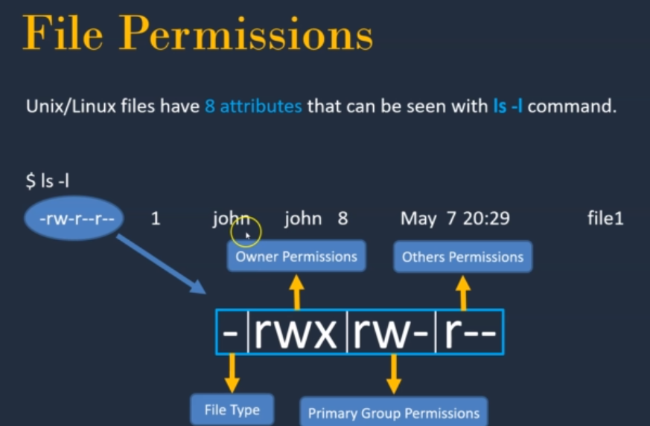

**Permission** can be set in two method:

Symbolic method (ugo)

Absolute method (Number)

Read -4 write -2 Execute -1

chmod 764 filename

7 -owner of file , 6 - group of file , 4 - others

**Changing** ownership

chown john(U):john(G) filename

**System Management**

**history** - list all commands by user

**free** - free memory of server

**proc/meminfo** - display memory info

**proc/cpuinfo** - display cpu info

**uname -a** - kernel info

**du** - directory space

**whereis** - where my command location

**Networking**:

**hostname** - name of the server

**ping ip** - availiblity of destination server

**wget** - download the package

**ifconfig** - ip address of system

**curl** - access the application as browser

**netstat -tulpn** - it tells what all ports are there in system

**telnet** - whether particular port is there or not **telnet localhost:80**

init 6 - to restart your system

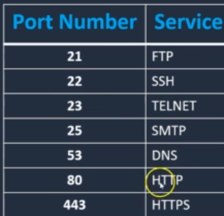

**Services** : It control the start and stopping of services

service <name of service> start

​service <name of service> stop

​service <name of service> restart

​service <name of service> reload

​service <name of service> status

chkconfig - this control which service are set to start on boot

gzip - zip the file

gunzip - unzip the file

tar - extract the tar file (dirc)

tar -cvf dir1.tar dir1 archiving directory dir1.tar - destination file dir1 - directory

tar -xvf dir1.tar Unarchive

**Crontab**

It is a system process that will automatically perform tasks as per the specific schedule

crontab -l

crontab -e

Syntax:

Minute (hold values between 0-59)

Hour (hold values between 0-23)

Day of Month (hold values between 1-31)

Month of the year (hold values between 1-12 or Jan-Dec, you can use first three letters of each month’s name i.e Jan or Jun.)

Day of week (hold values between 0-6 or Sun-Sat, Here also you can use first three letters of each day’s name i.e Sun or Wed. )

**Command**

Example:

Execute a job at 8.30 on everyday morning

30 8 * * * command

**LINK FILES:**

i) Soft link (Shortcut file) ii)Hard Link (Backup file)

i)If original file is deleted then link is broken and data is lost ln -s (source file) (dest file)

ii)If original file is deleted then link will contain data. ln (source file) (dest file)

**Shortcut:**

ctrl-l - to clear entire screen

ctrl-a - to move curson to the beginning of the line

ctrl-e - to move curson to the end of the line

ctrl-f - move cursor frwd one character

ctrl-b - move cursor backward one character

alt-f - move one word frwd

alt -b - move one word backward

cntrl -t - swapping

cntrl-k - kill the text from current to end of the line

cntrl-u - kill the text from current to beginning of the line

alt-d - kill the text from current to end of the word

alt-delete - kill the text from current to beginning of the line

cntrl-y - Reviving text

History - all commands can be viewed

!73 - to run 73 command from history

**Working with files:**

Cat filename - it will read the file

less filename - display the content of a file one page at a time

tac filename - print in reverse order

rev filename - print in reverse the word Ex: red in der

wc - it tells number of lines, words or bytes in files

wc -l lines

wc -w words

sort - display in alaphabetic order sort -r (reverse) sort -u (ignore duplicate)

**Redirection:**

Standard input ----- command ------- i) Standard output ii) Standard error

Redirect Standard output - Ex: date > output.txt (date will appear in this file)

Append Standard output - date >> output.txt (Both will appaear)

Redirect Standard input - Ex : cat < output.txt (Pass the content of file to std input)

Combo - cat < original.txt > output.txt

Redirect Standard Error - Ex: cat outputfile2 2> error.txt (Error msg are output to screen)

**Piping** - Output of the first command will be passed to standard input of the second command.

Ex: cat file | head | tail

tr - traslate the character Ex: cat msg | tr a A

tee - read standard input and copies to both std out and to file

ex: command1 | tee filename | command2

**Findings**:

Locate - find files by name Ex: Locate filename

find -type f limit the search to file

find -type d limit the search to dirc

Timestamp : mtime(modification) ctime(change) atime(access)

mtime - content last modified

ctime - rename,move,permission file

atime - when file is read by app like cat command

Logical operator - and , or , not find -name " " or find -name " "