# Adapt product price based on customer country or location (e.g. Price in € or $)

An international sales and distribution business network required accurate price conversion or the price rules according to the customer’s country. During quotation process some business prefer to have the rate conversion while some business wants to define the price based on the geographic locations irrespective of currency conversion. You can configure both business case using the pricelist.

## Business case

Odoo wants to apply pricing rules for the customer irrespective of the currency conversion based on the customer location. They divide whole world into three different region and specific price for each region.

|  |  |  |  |
| --- | --- | --- | --- |
| **Product** | **America (USD)** | **Europe & Middle East (EUR)** | **ASIA (USD)** |
| Odoo Enterprise (Users) | 28 | 24 | 16 |

## Configuration

Assumed that the **Sales Management** application installed, **Invoicing** application will be installed as an dependant of the sales application.

### Multi Currency

You need a multiple currency support, to prepare a quotation in foreign currency. **Multi-Currencies** feature can be activated from **Invoicing / Configuration / Settings** available under the **Currencies** section.

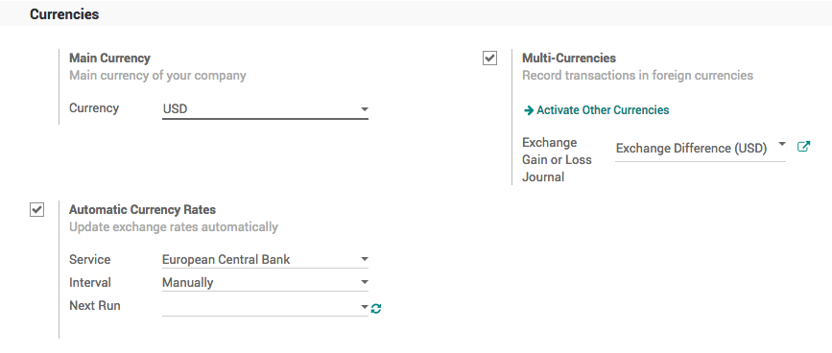

.. tip:: Select **Automatic Currency Rate** to get the accurate currency conversion rate when you do want a currency conversion to prepare the quotation, set *Daily* for the **Internal** field, the rate can be updated from different exchange services such as *European Central Bank*, *Federal Tax Administration* or *Mexican Bank*.

### Pricelist

To setup the price based on the customer segment or country, you have to enable the **Multiple Sales Prices per Product** feature available under the **Sales / Configuration / Settings** under the **Pricing** section. Keep the default option **Multiple prices per product (e.g. customer segments, currencies)** selected under the **Sales Pricelist** option.

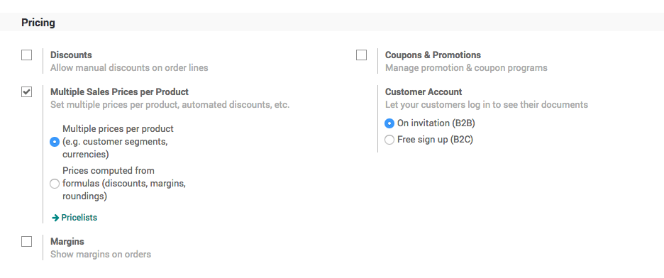

To create a new pricelist goto Sales / Catalog / Pricelist, create a three different pricelist, set the Currency field on each pricelist. Let’s create a pricelist for european and middle east customers where we offer the price in EUR (€).

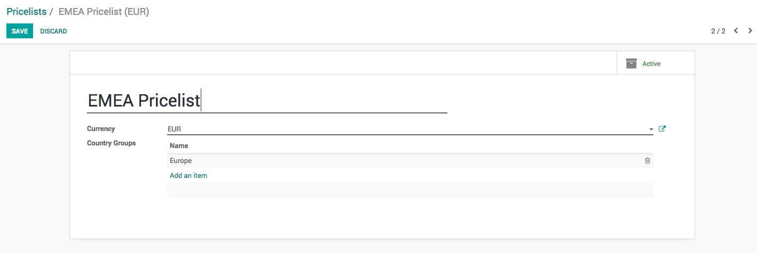

Enter *EMEA Pricelist* in the **Name** field*,* select *EUR* in the **Currency** field and add the *Europe* in the **Country Group** field.

.. note:: The country group is used to assign pricelist automatically when customer is being created. So, even if your salesman forget to assign pricelist the system will assign automatically when customer’s country is set on the customer.

### Product

Let’s create the product *Laptop*, goto **Sales / Catalog / Products** to create the product, enter **Name**, set **Image** and **Sales Price**, the country specific price or currency specific price can be defined under the **Sales** tab.

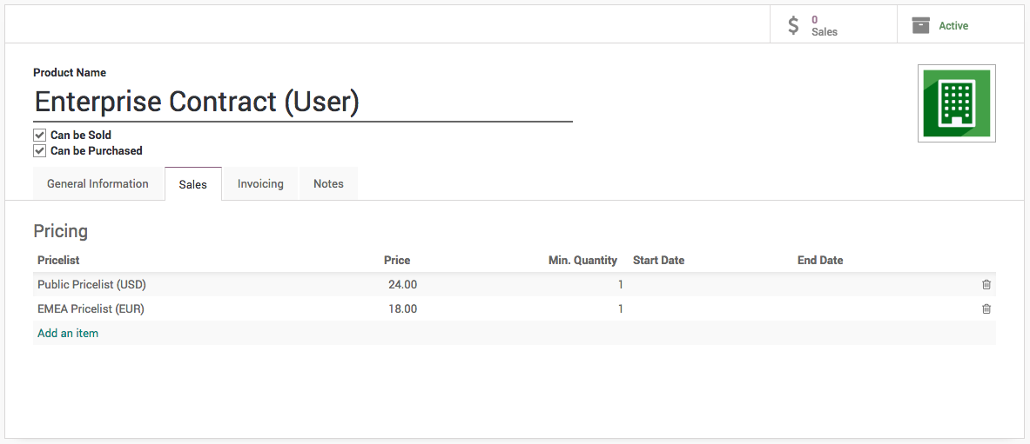

Select the Pricelist and enter the Price, the price enter is respective of the currency defined on the pricelist (i.e. in this case we have defined 24 USD and 18 EUR).

You can create a multiple lines for the same pricelist, in case you want to offer a special price to customers, when they buy more than 1 quantity.

The **Start Date** and **End Date** is used to limit the offer for a specific dates, assume that you want to offer a special price for the *Christmas* (i.e. **Start Date** to *20/12/2018* and **End Date** to *31/12/2018*)

### Customer

Create a customer, enter the name, city, country and other contact details such as email and mobile and save the customer detail, as soon as you save the customer the pricelist will be assigned on the customer automatically based on the customer’s country, review the pricelist set on the customer form under the **Sales & Purchases** tab.

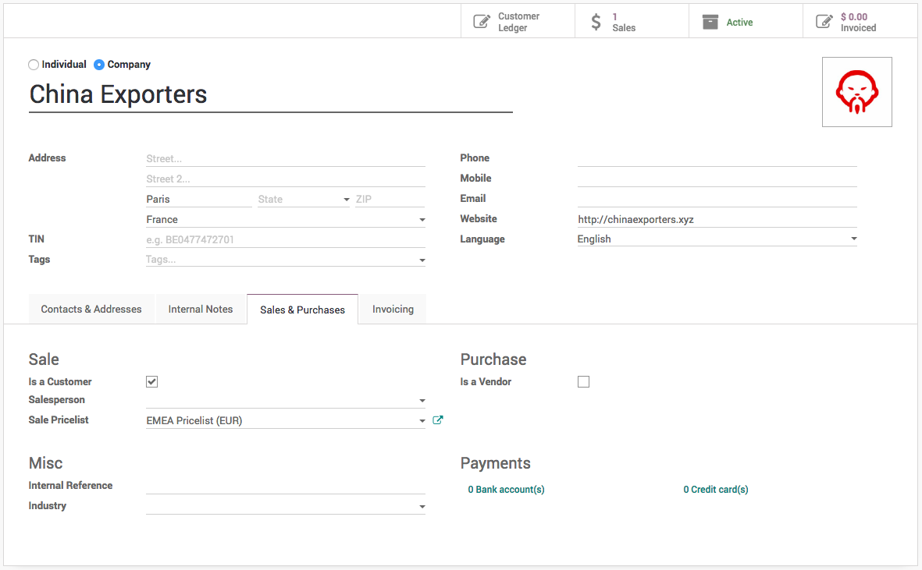

However, you can change it manually, if system detect wrong pricelist, you may choose same country on more than one country group which was assigned to different pricelists.

## Create a quotation

Let’s send a quotation to your european customer, create the quotation from **Sales / Orders / Quotation**, pricelist will be set on the quotation and currency of the quotation will be changed accordingly, the product price will be appeared accordingly, when you add products on the quotation.

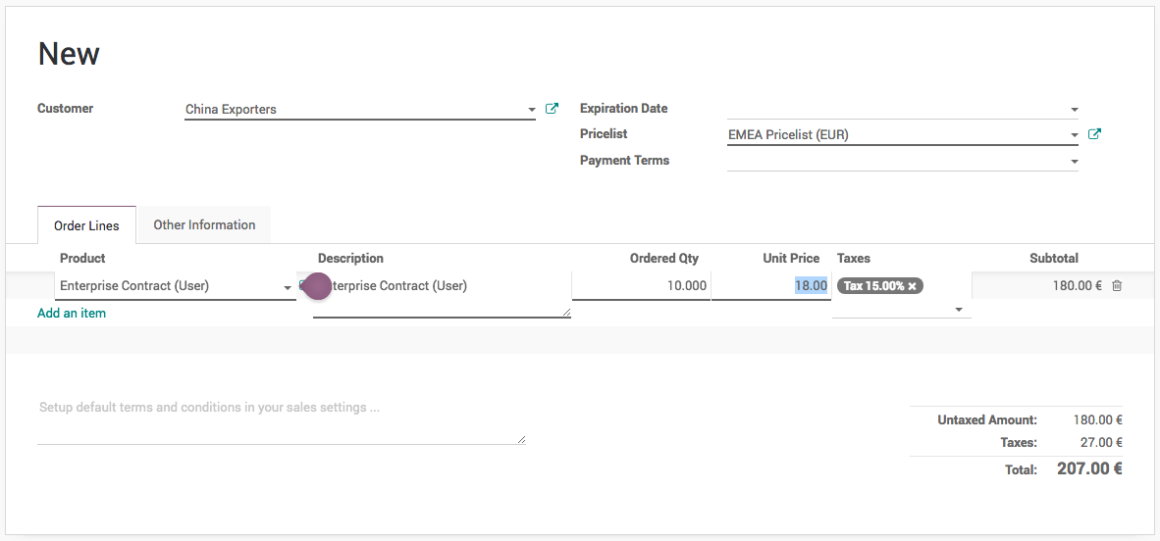

Create a quotation for *China Export*, add *10* quantity of *Enterprise Contract (Users)*, 14 EUR */user* applied as we prepare the quotation in EUR currency.

Now, a salesman can create quotations quickly regardless of the customer type and price offered to them, of course a correct pricelist have to be configured when you create customer, it can be reviewed later depending on the turnover.

## Price based on currency conversion

Remove all the lines on the product **Pricing** and set correct **Sales Price** on the product form.

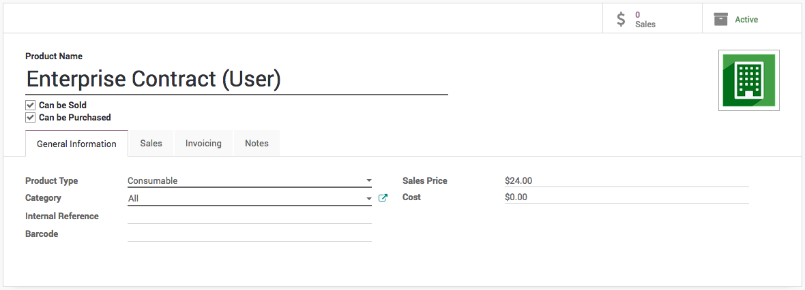

The price defined on the product is respective to the company currency (USD). Let’s create a quotation for the same customer and see what price will be proposed by the pricelist.

