# Apply default taxes on products or sales order

Taxes applied in your country are installed automatically for most localizations. Default taxes set in orders and invoices come from each product’s Invoicing tab. Such taxes are used when you sell to companies that are in the same country/state than you.

## Business case

Let’s set the default sales and purchase tax to Tax 15.00%.

## Configuration

All the new products created in the Odoo take the default tax set in the **Accounting/Invoicing** settings. To change the default taxes set for any new product created, goto **Invoicing / Configuration / Settings**.

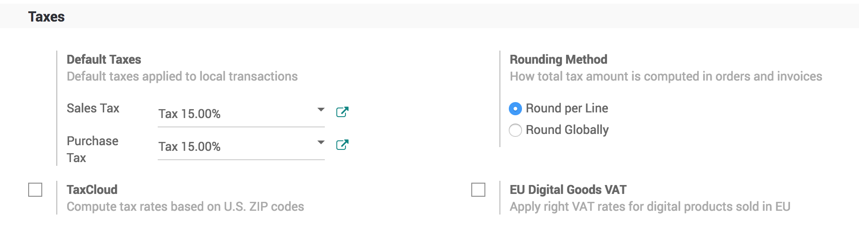

## Create new product

Let’s create a new product, the default tax which was applied should be applied on this product.

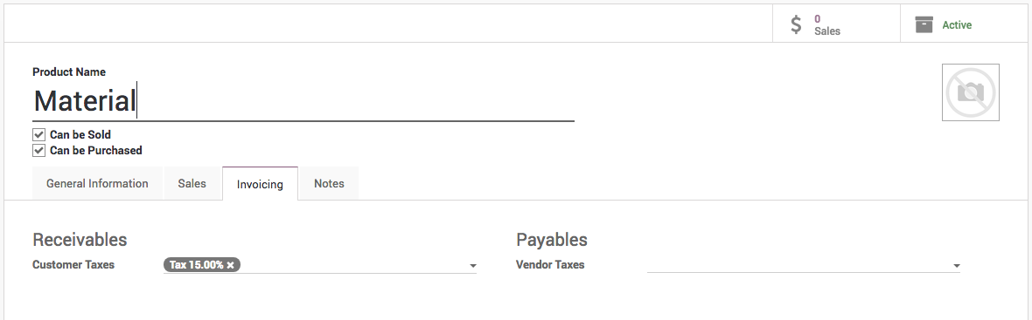

## Create sales order

Let’s create a new order and select the same product on the order line, the tax which was set on the products should be applied on the sales order line tax field.

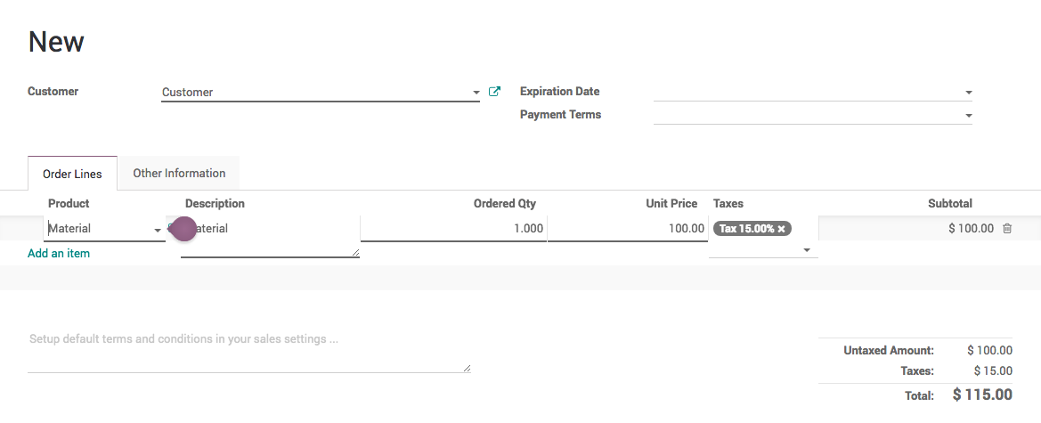

Now, your salesman do not have to remember that what taxes to be applied on which product.