# Apply default taxes on products or sales order

Taxes applied in your country are installed automatically for most localizations. Default taxes set in orders and invoices come from each product’s Invoicing tab. Such taxes are used when you sell to companies that are in the same country/state than you.

## Business case

Let’s set the default sales and purchase tax to Tax 15.00%.

## Configuration

To change the default taxes set for any new product created go to **Invoicing / Configuration / Settings**.

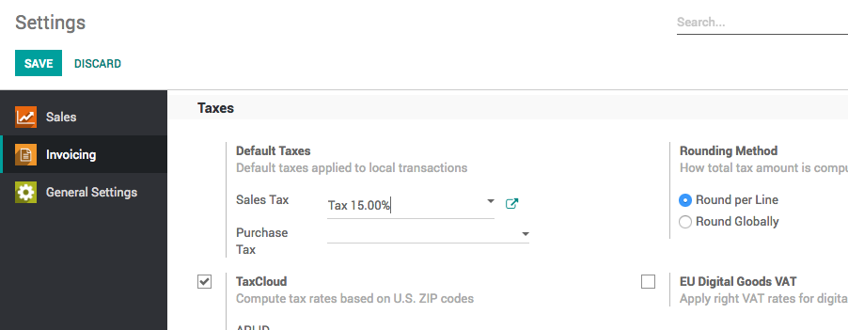

## Create new product

The default tax will be applied to all the products created after setting the default tax on the invoicing configuration.

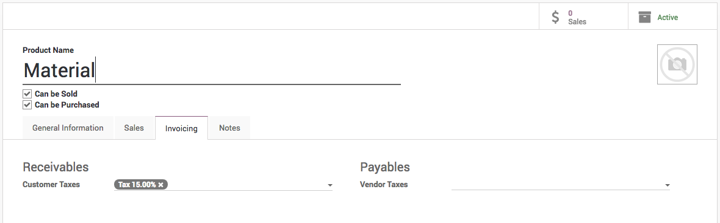

## Create sales order

The same tax will be applicable on the sales order which was previously set as a default tax on the product form.

