# Apply discount on quotation

Allowing discounts on quotations is a common sales practice to improve the chances to convert the prospect into a customer, adding discounts on the quotation encourage the prospect to close the deal quickly.

## Business case

My company would like to send a quotation for an *iPad Mini* at a sales price of *320 USD* per *iPad* at a **5% discounted** price.

## Configuration

Assumed that the **Sales Management** application installed.

### Discounts

In this business case, we would like to offer 5% discount to our customer on the sale price.

**Discounts** feature can be activated from **Configuration / Settings** , under the **Pricing** section.

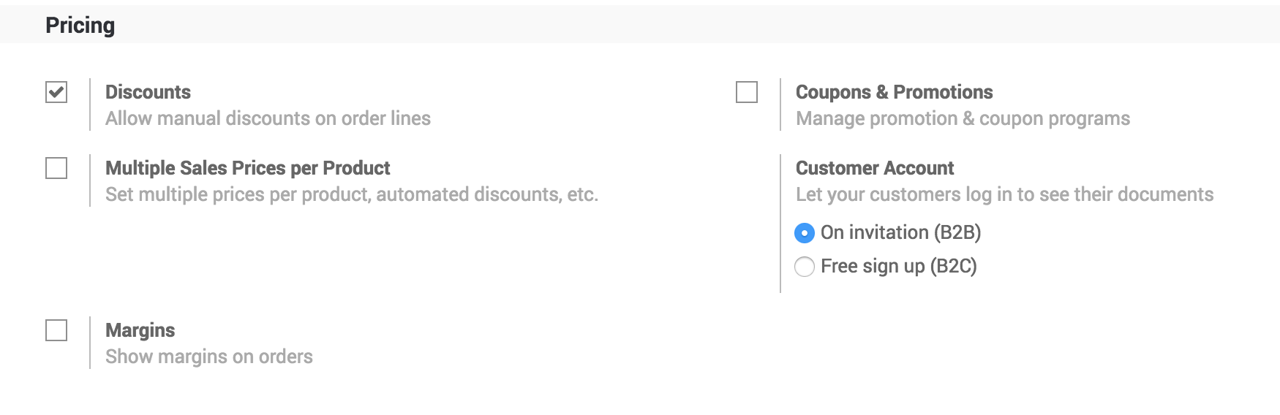

## Create a quotation

Quotation can be created from **Sales / Order / Quotations**, click on **CREATE** button to create a new quotation, select customer and add product *iPad Mini* on the quotation, the default price you will see is 320$.

### Apply discount

By default the discount will not be applied as we choose to apply manual discount, to apply 5% discount enter 5 in the **Discount (%)** field for iPad Mini product in the sales order line.

.. tip:: The discount should be entered between 0 to 100, it computes discount in percentage. The price will change automatically when you enter the discount.

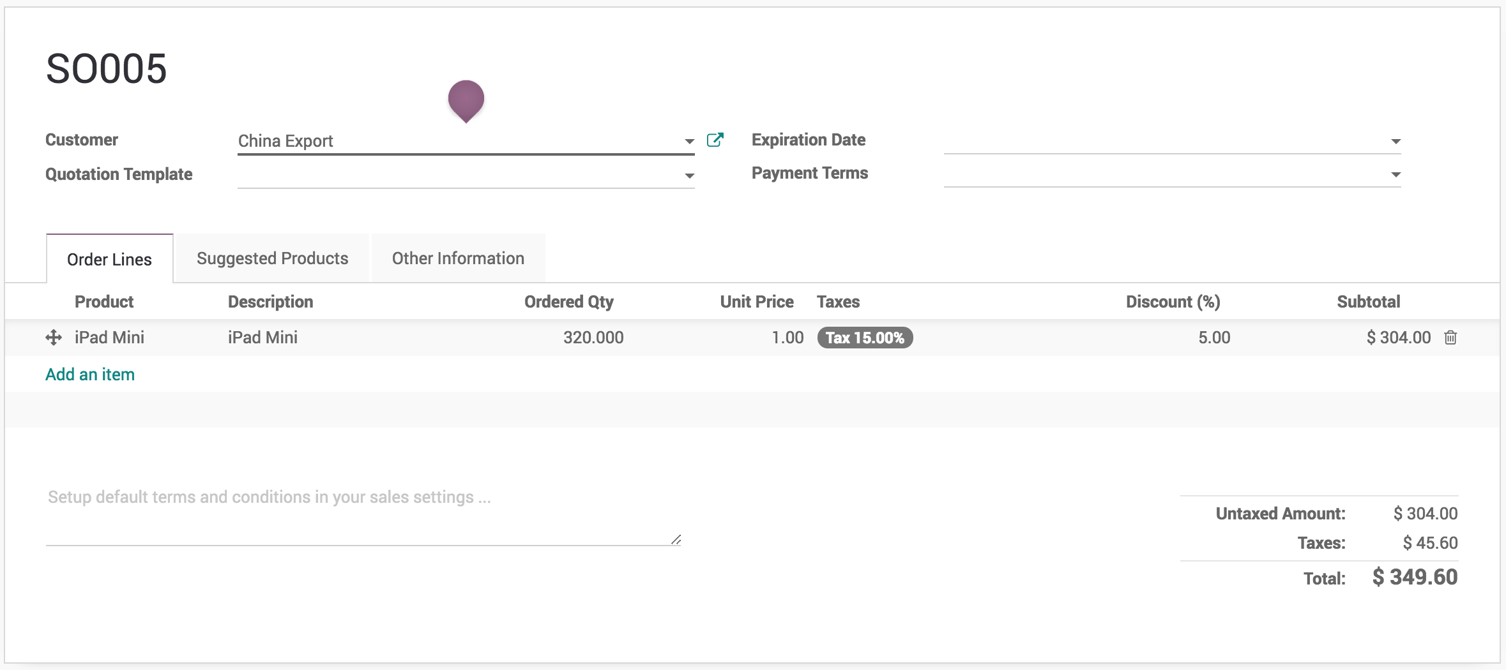

### Printing quotation

Discount column will be appeared on the quotation when you have applied discount on any of the product on quotation. Don’t be surprised if you don’t see the discount column on the quotation, which means that you have not applied discount on any of the product on quotation as you don’t want to offer discount to your customer.

.. tip:: All the taxes applicable on the product will be computed on the discounted product price (i.e. Taxes will be computed on **Subtotal**)