# Change your quotation layout

All the legal documents such as sales order or invoice required to be printed on the company letterhead with header and footer. You can choose a document layout from 4 different layouts available in Odoo according to your need.

## Business case

Let’s use the beautiful quotation layout.

## Configuration

The quotation layout can be changed from the **Settings / General Settings** under the **Document Template** section you can change the document layout.

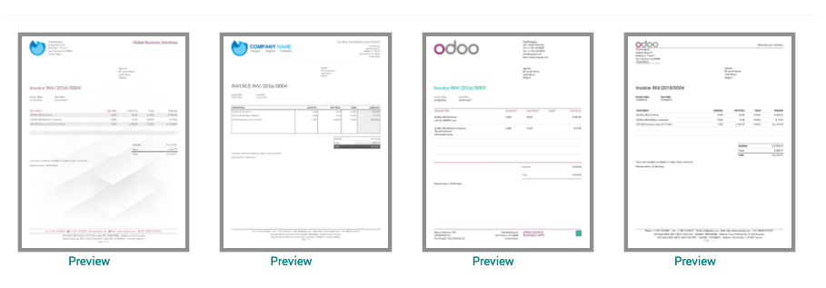

Enter the company information such as name, address, currency and logo. Bottom of the popup windows you can choose the layout for all your legal document which will be printed with header and footer.

.. tip:: Do not forget to select the company logo, you can click on Preview link to check how it looks before you choose.

Choose the appropriate layout and apply the setting.

## Print quotation

The default layout will be switched to the selected one on the configuration, now your quotation will be printed with the new layout. 