# Compute and apply discount automatically based on the pricelist

Allowing discounts on quotations is a common sales practice to improve the chances to convert the prospect into a customer, when you are not offering discount to all the customers, keep it manual and offer when customer demands.In case you have to apply discount for specific customer or products every time, it is quite difficult for salesman to remember those products or customer and apply the discount manually on each quotation.

## Business case

The trading company “*My Company*” manufactures the *Computer Desk* and selling to their distributors and to retail customers.

They sell to retail customer at a public price of 3200 but when they sell to distributors the price would be 2240, and they show the percentage of the discount which was offered on the public price.

## Configuration

Assumed that you have installed the **Sales Management** application.

### Discount

By applying discount on the quotation, the product price will get decreased, the discount will be visible to the customer on quotation, this will encourage the customer to close the deal quickly.

The discount feature has to be enabled to show the percentage of the discount offered to the customer on quotation, it can be activated from **Sales / Configuration / Settings**.

### Product Pricing

You need a pricelist to apply the product price based on the business rules such as discount or periodically price variations for a product(s). Let’s go to **Sales / Configuration / Settings** and activate the **Multiple Sales Prices per Product options** as of now we will keep the **Multiple prices per product (e.g. customer segments, currencies)** option selected by default.

Let’s create a *Distributor Pricelist,* the Public Pricelist available as a default, the pricelist can be accessed from **Sales / Catalog / Pricelists**. Create pricelist name it as *Distributor Pricelist* and change the **Discount Policy** to *Show public price & discount to the customer*.

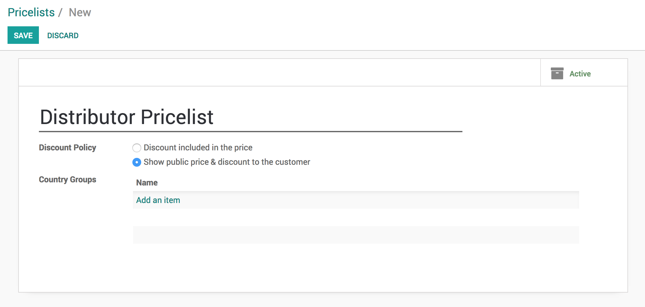

The discount policy decides, whether the discount will be computed based on the pricelist and will be visible to customer on quotation or not. When you choose *Discount included in the price* the product price will be computed by applying the discount (%) and discount will not be visible to customer on quotation.

.. tip:: The *Discount included in the price* option can be used to apply the price variation such as commodity price, it may decrease or increased.

### Create a product

Let’s create the product and define the pricing rules so depending on the customer the price will be applied automatically. The **Pricing** rules can be applied under the **Sales** tab on product form.

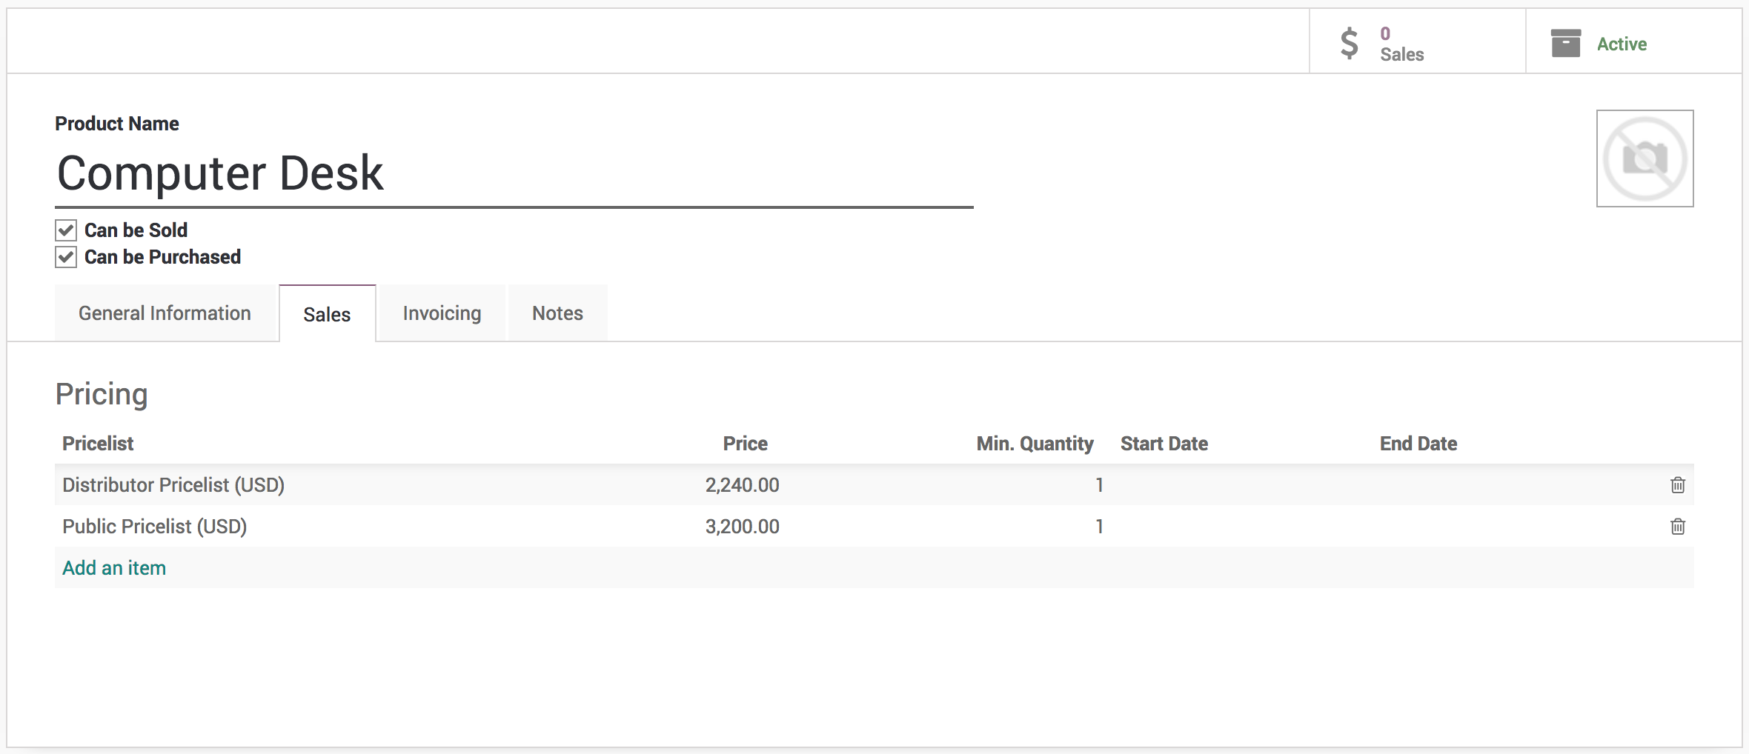

I have created two pricing rules, one for *Distributor Priclist* and another for *Public Pricelist*. The customer which do not comes under any of those pricing rules the **Sales Price** defined on the product will be applied in that case.

### Create a customer

Create a customer *China Export* of type distributor, we will offer the *Computer Desk* to them at a special price.

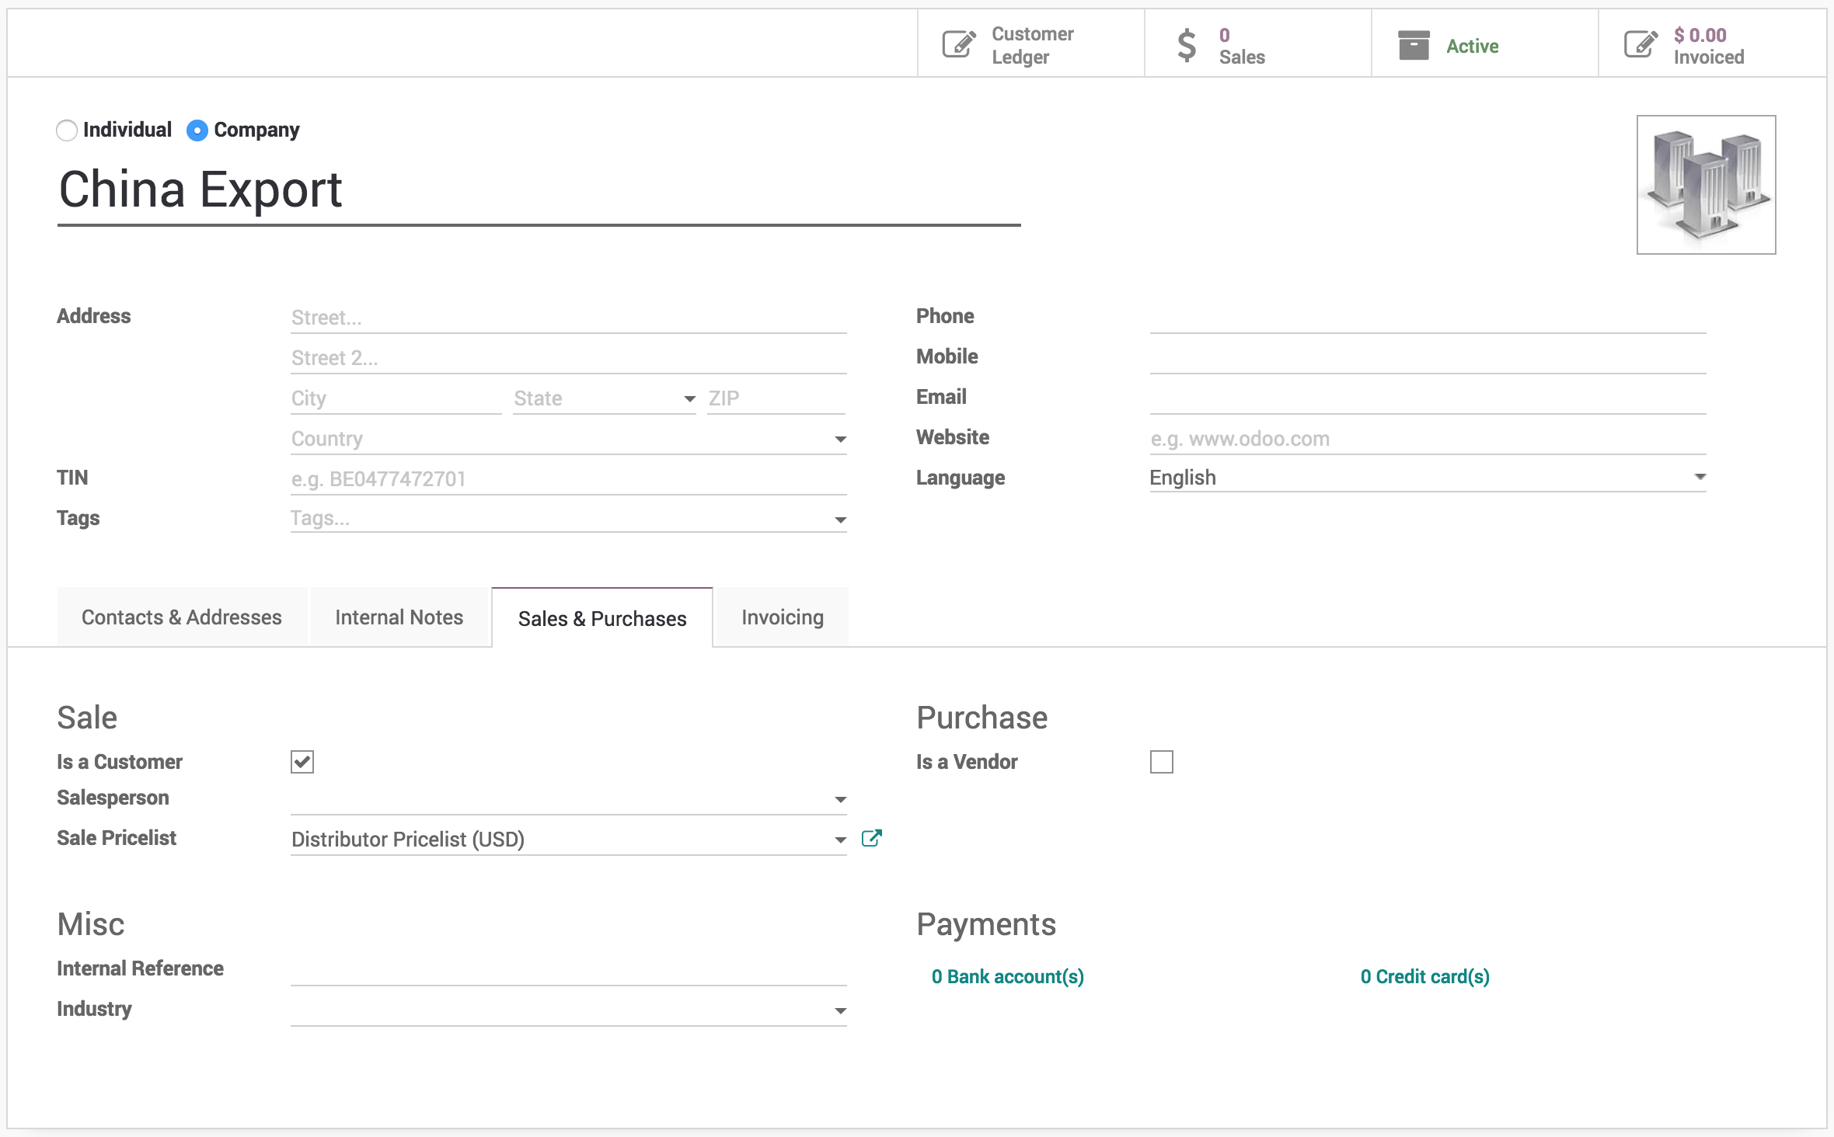

To define this customer as a distributor, select the *Distributor Pricelist (USD)* in **Sales Pricelist** field available under the **Sales & Purchase** tab.

## Create a quotation

Create a quotation from **Sales / Orders / Quotations**, select the *China Export* as a customer, a *Distributor Pricelist (USD)* will be selected automatically on the quotation. Now add the product *Computer Desk* on the order lines, **Unit Price** will be set to *3200* but **Subtotal** computed and shows *2240* as an automatic *30%* discount computed and set on the **Discount** field based on the *Distributor Pricelist*.

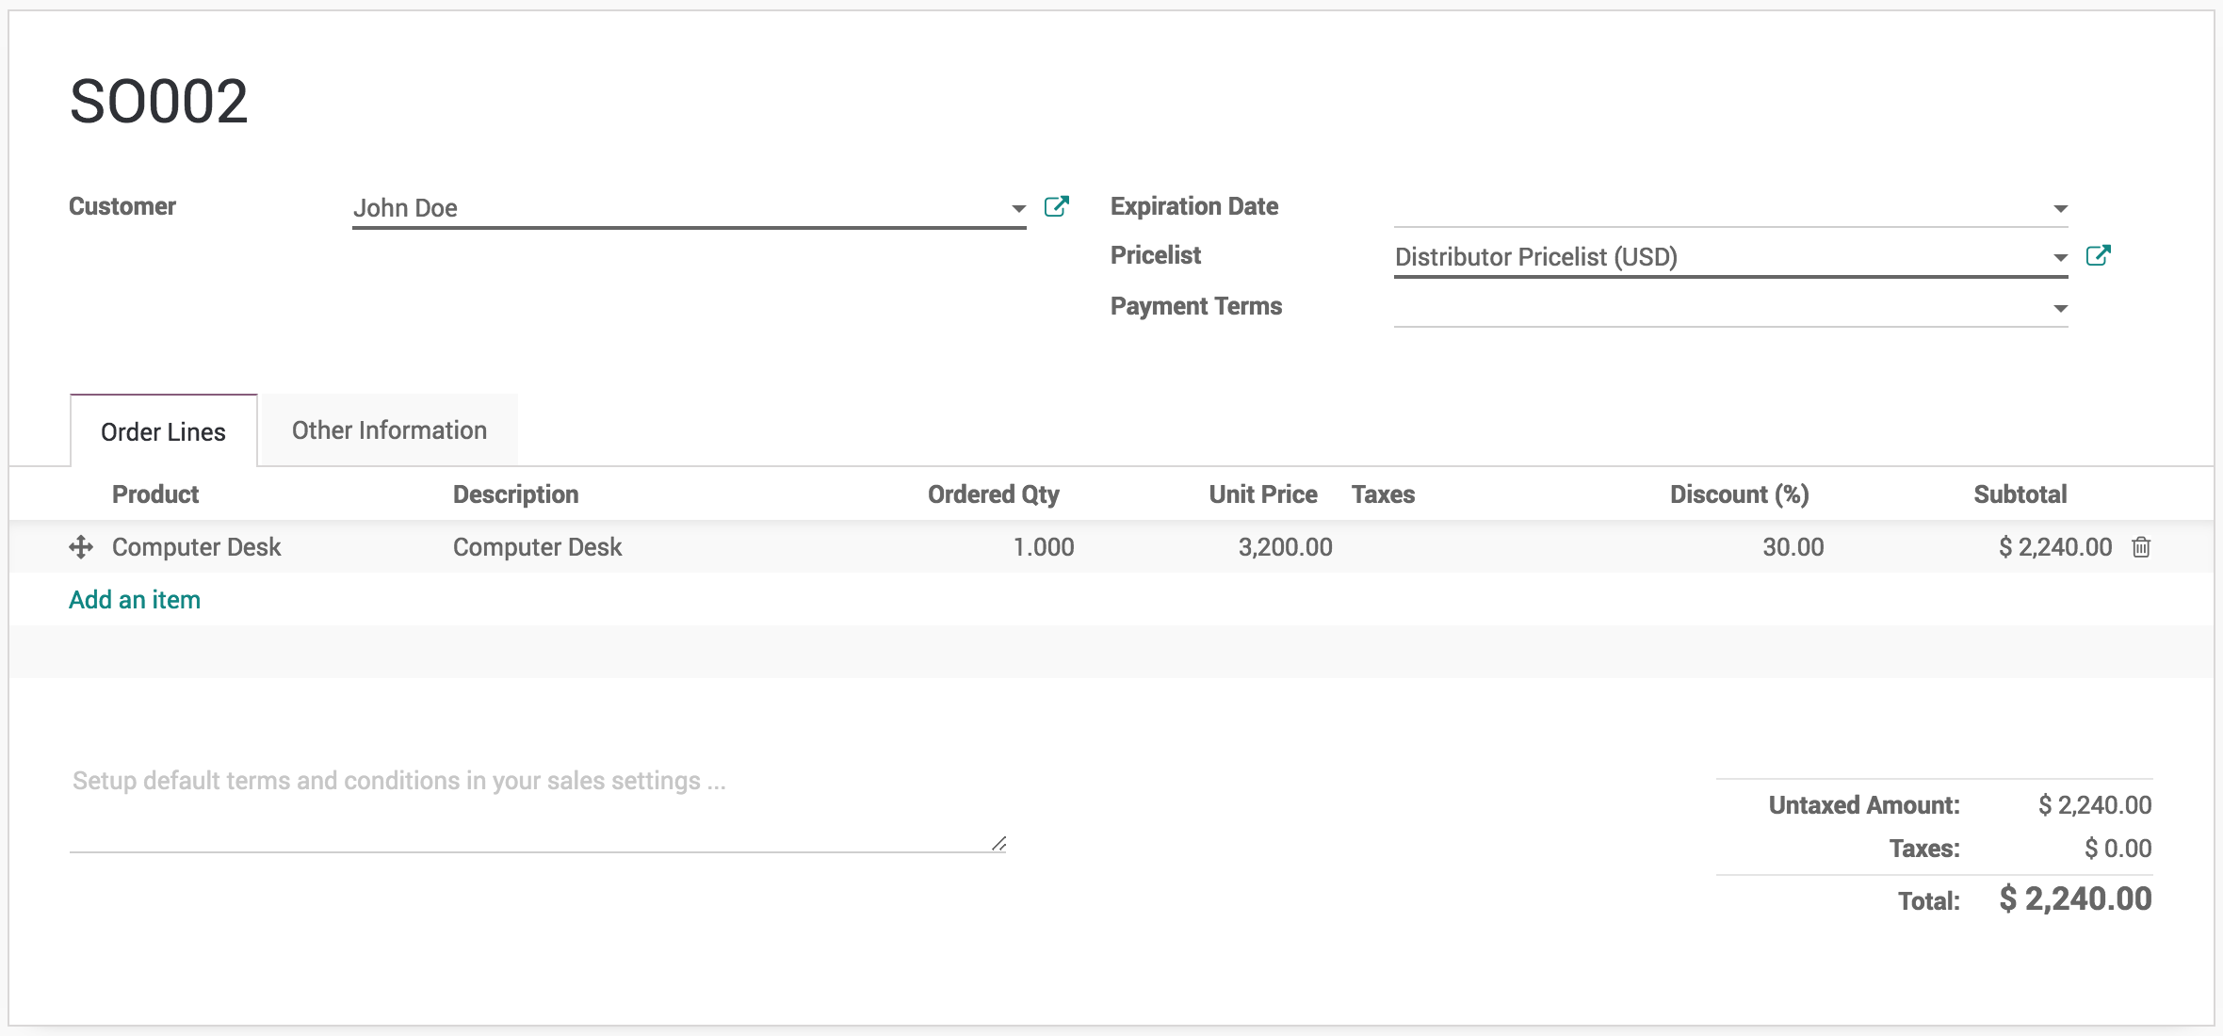

The 30% is computed based on the difference between price offered to distributors and the product **Sales Price**. *I.e. 3200 - 2240 = 960 which is 30% of the 3200 price*.